Bernice Templeman

CIS 5740/ Spring 2016

Program 4-3

Program 4-3: Product Maintenance with a database using JDBC

For this project, you’ll enhance the application described in the previous programs by modifying it so it uses a database instead of a text file to store the product data. You’ll use JDBC to work with the data. (*Prerequisites: chapters 1-12*)

The Products page

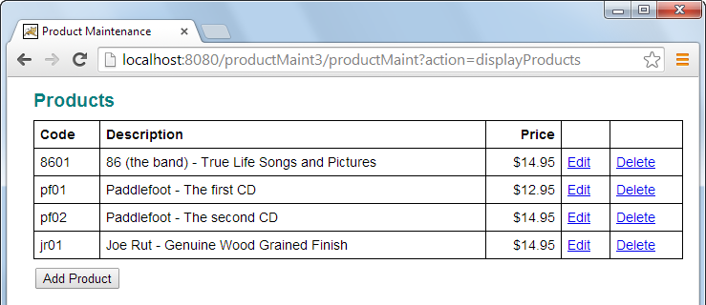

Specifications

* Use a class named ProductDB that’s in the music.data package to add, update, and delete the products in the Product Maintenance application. This class should use JDBC.
* Use a connection pool as described in chapter 12.
* Use the music database that’s created when you follow the procedures described in appendix A (PC) or B (Mac).

Program 4 (Part 3) Chapters 1-12

(a) Input/Output - Screen shots showing input/output for each part.

**TC1: Add a Product**

(1) Start Application

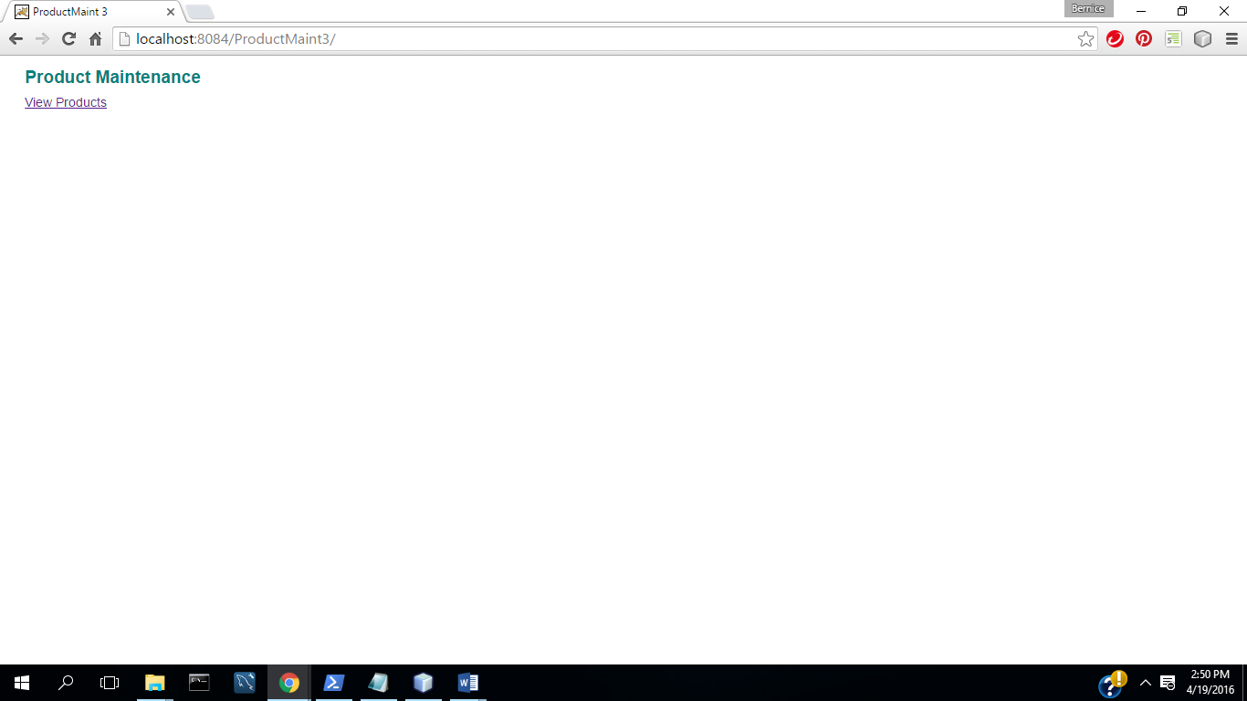

(2) Select View Products

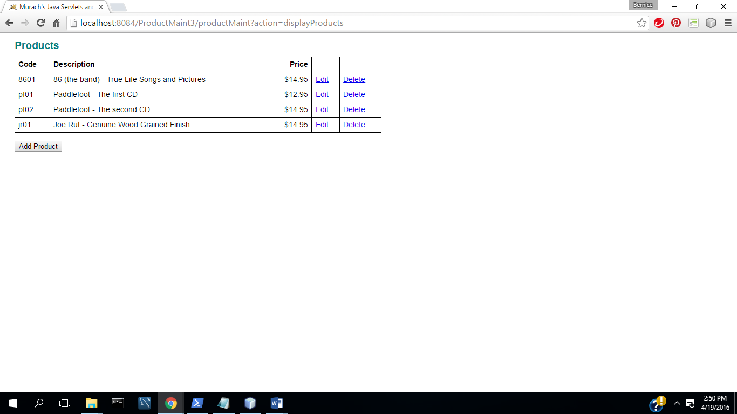

(3) Select Add Product

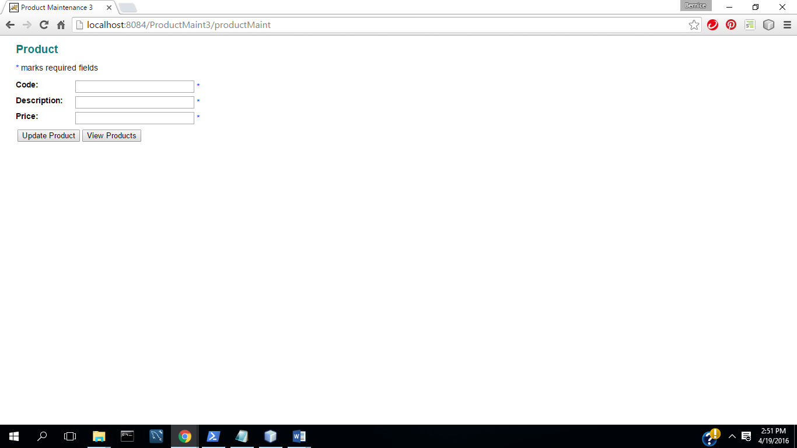

(4) Complete fields with valid data

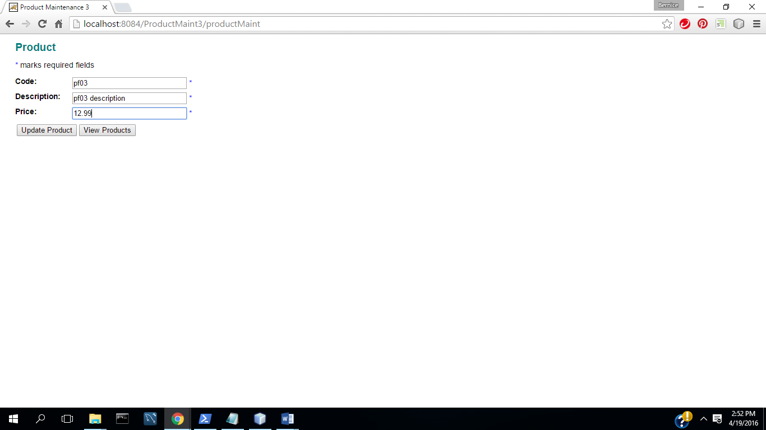

(5) Select Update( Commit Transaction & Update Inventory)

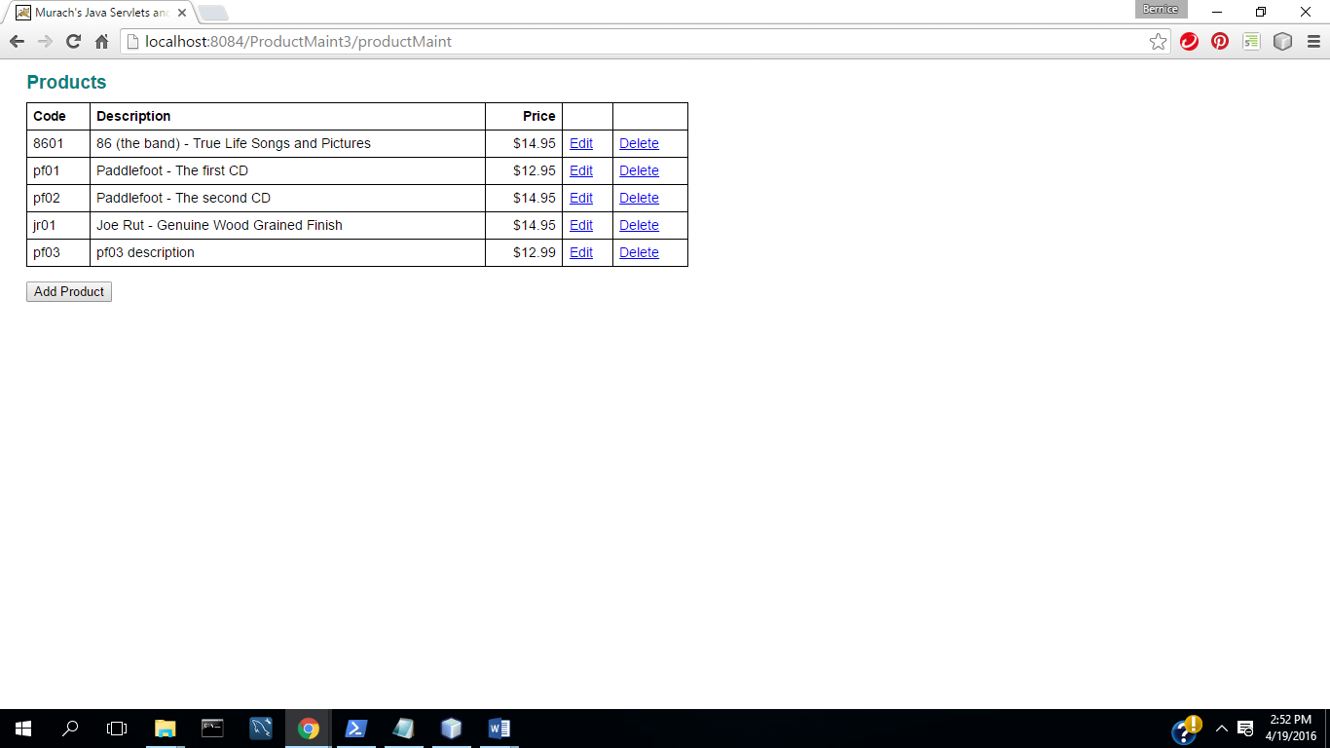

**TC2: Update a Product**

(1) Select Edit Product

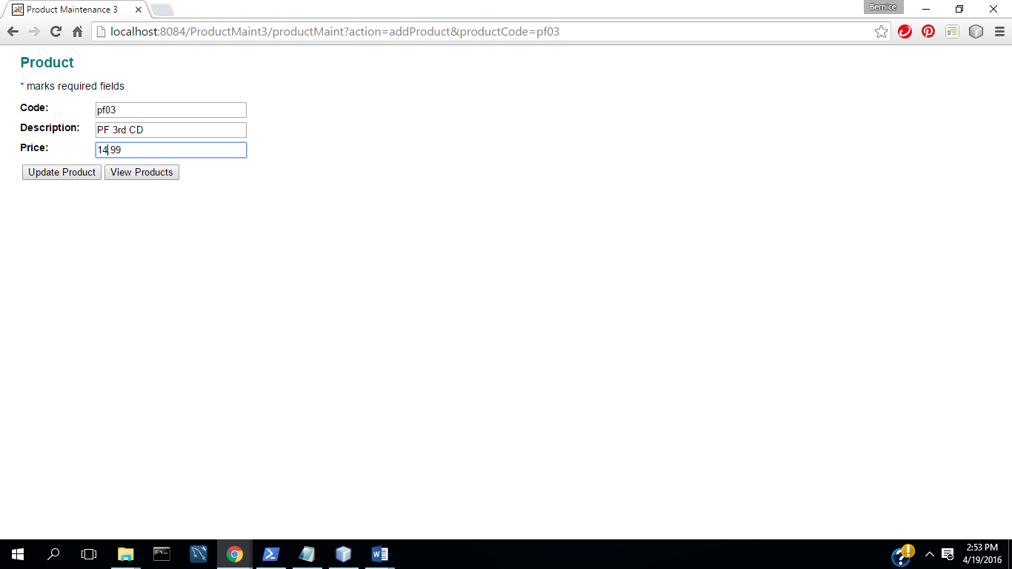

(2) Change description and price

(3) Select Update( Commit Transaction &Update Inventory)

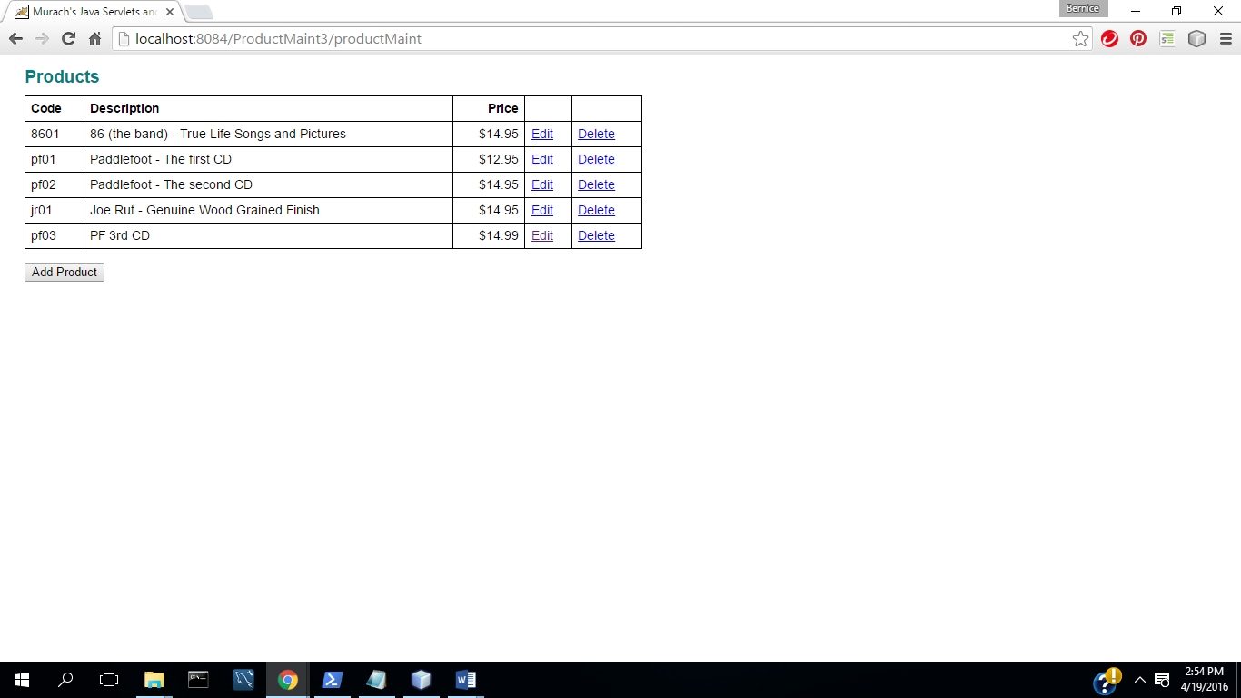

**TC3: Delete a Product**

1. Select Delete Product

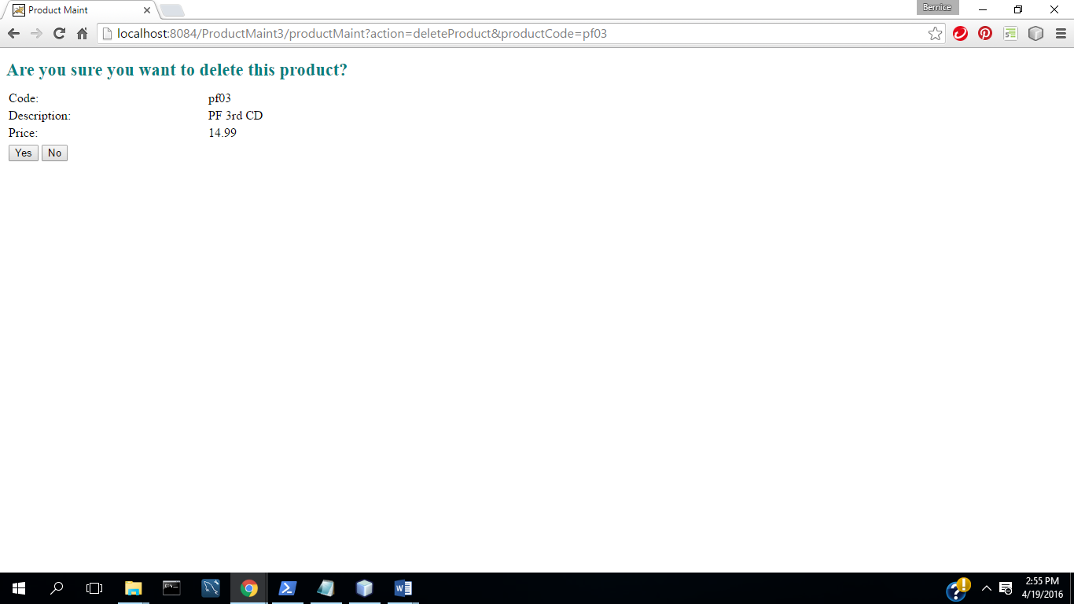

1. Select No

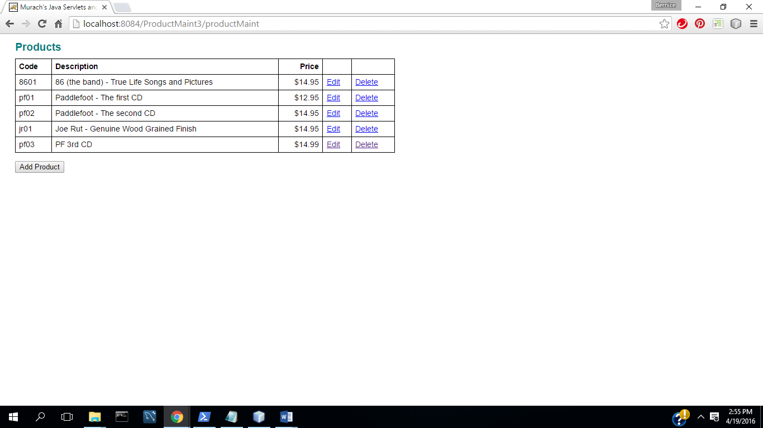

1. Select Delete Product

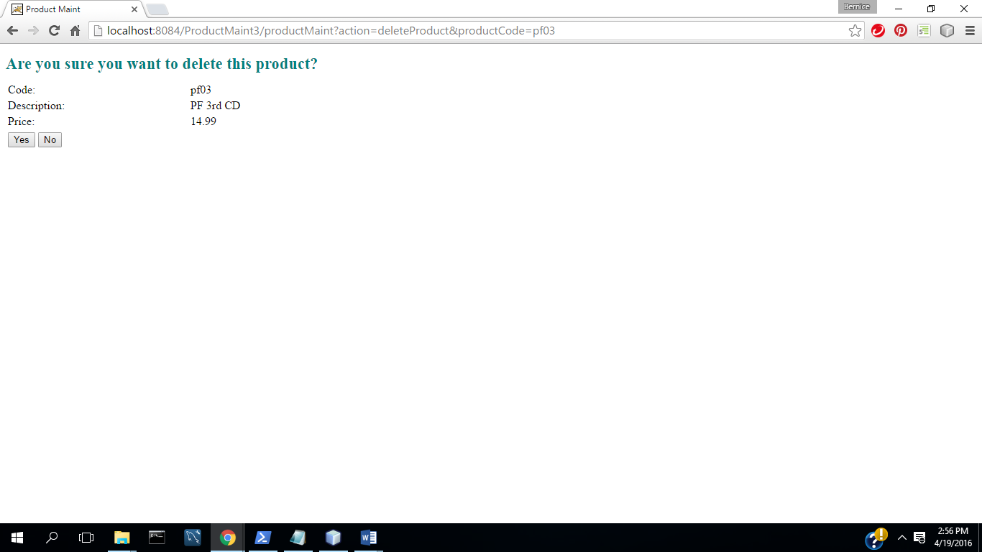

(4) Select Yes (Commit Transaction &Update Inventory)

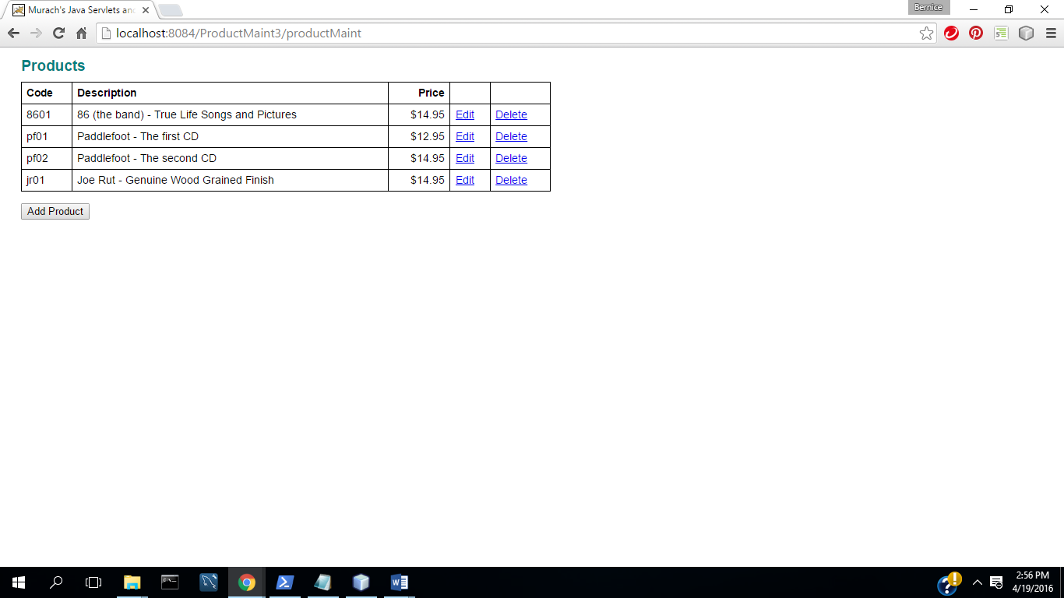

**TC4: Input Validation : All Fields Complete**

(1) Start App

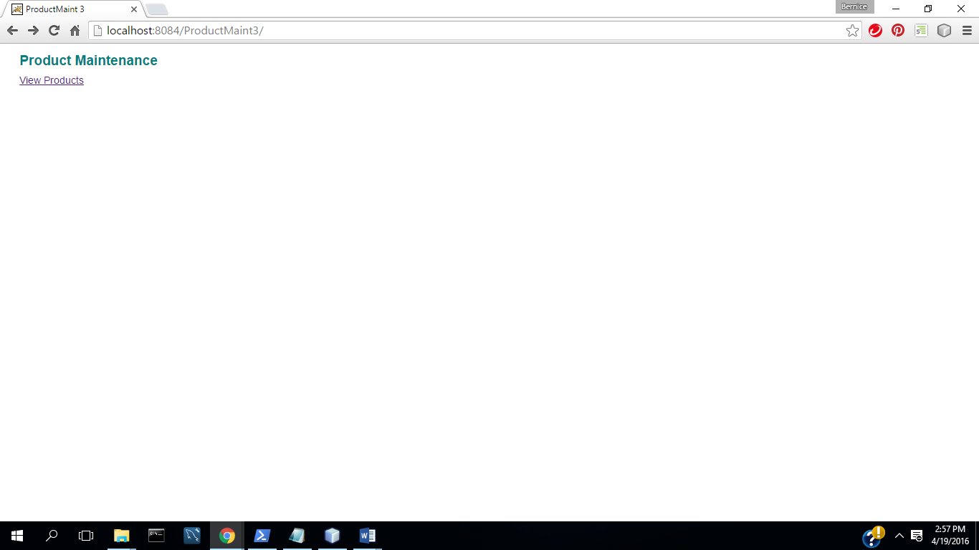

(2) Select View Products

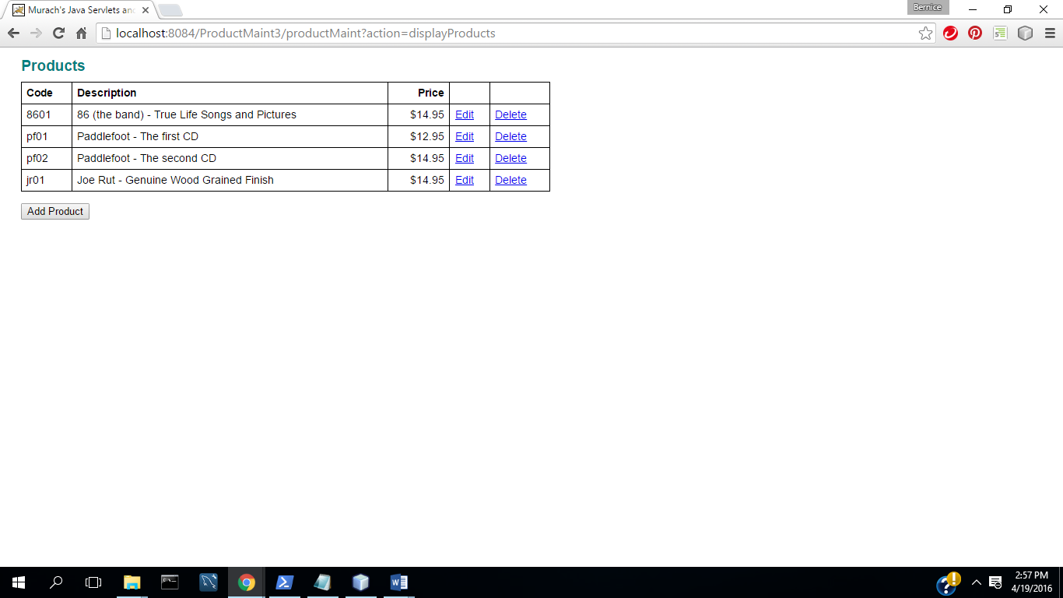

(3) Select Add Product

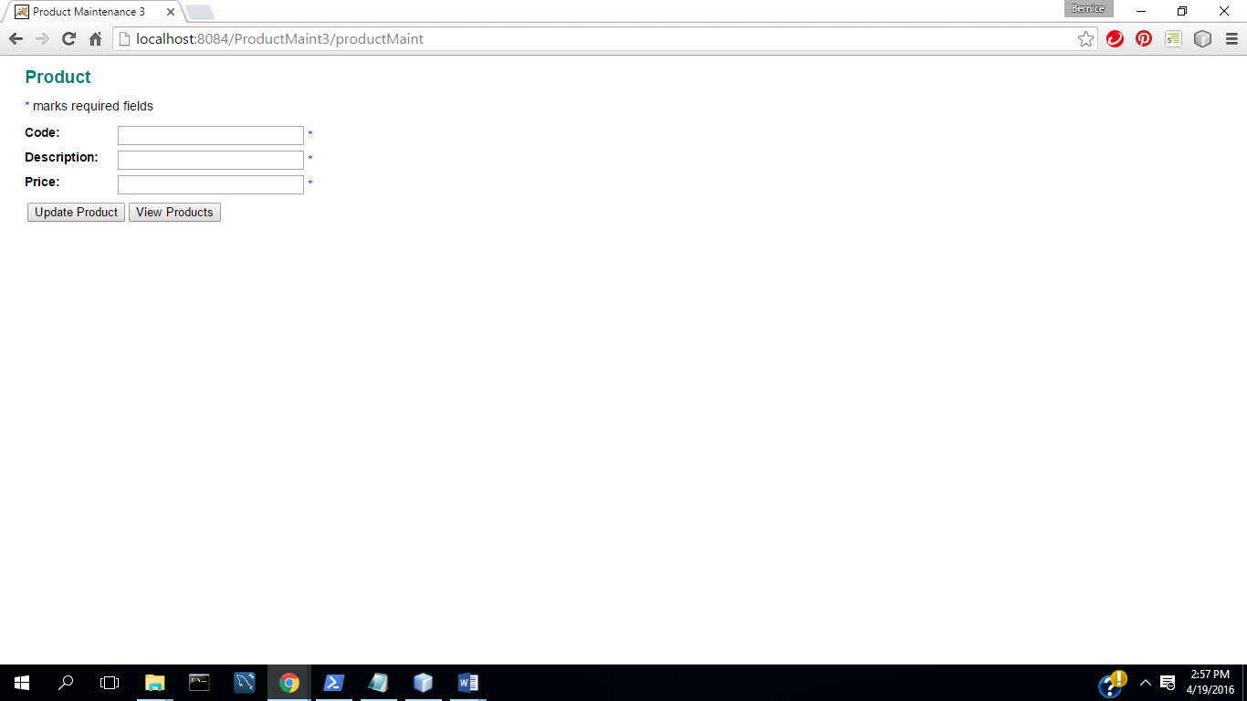

(4) Select Update

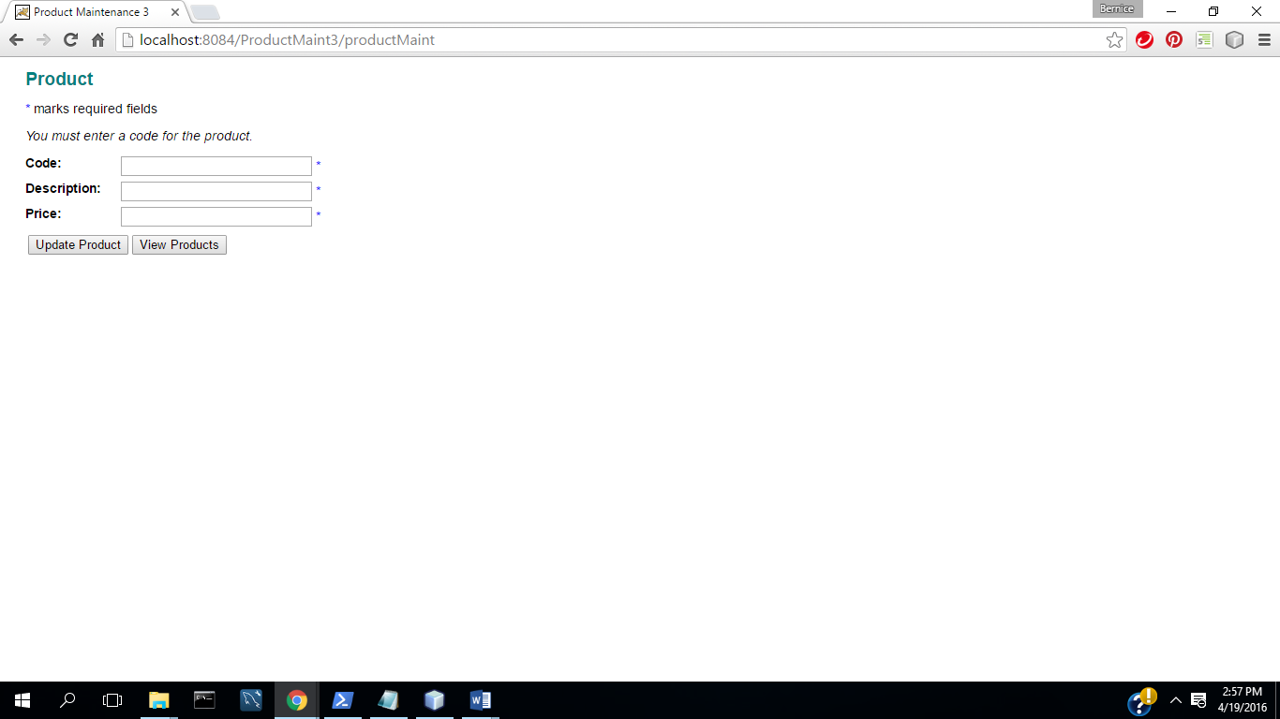

(5) Enter Code

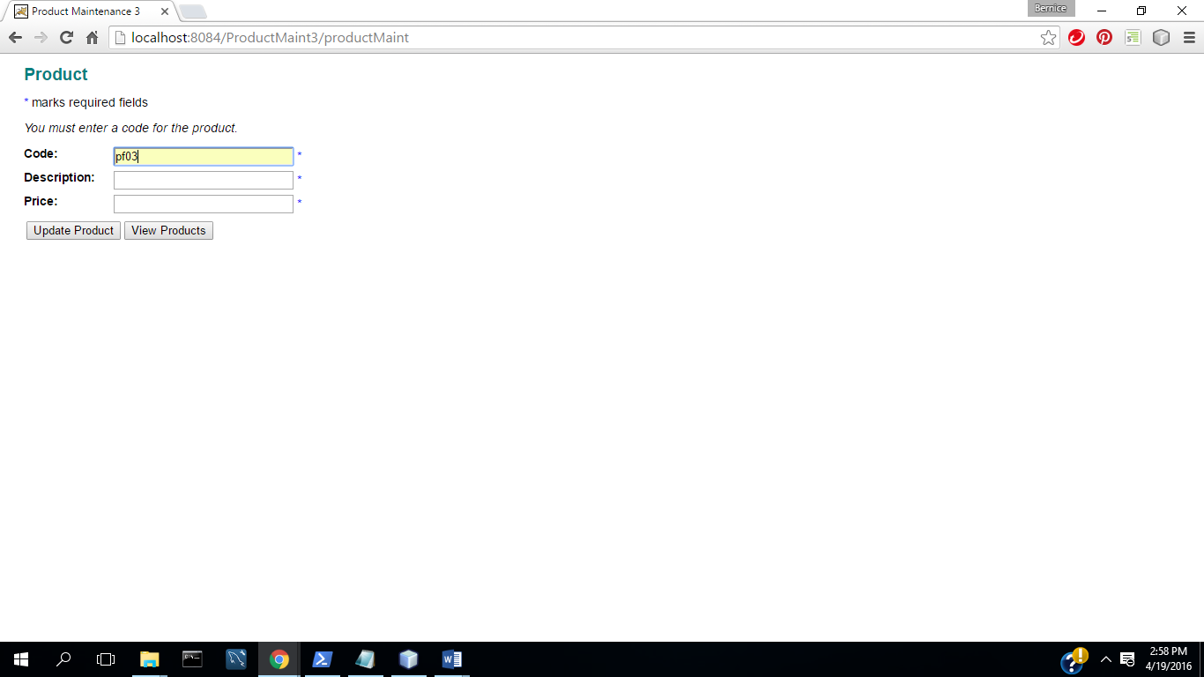

(6) Select Update

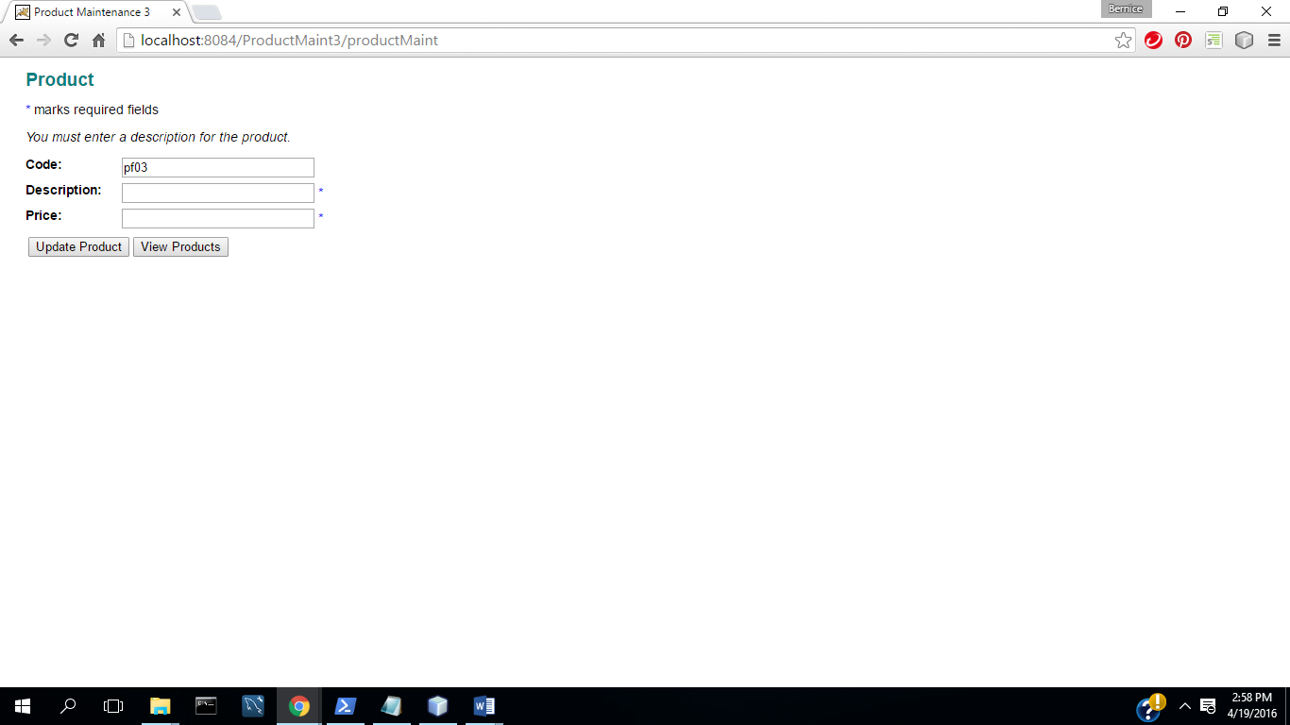

(7) Enter Description

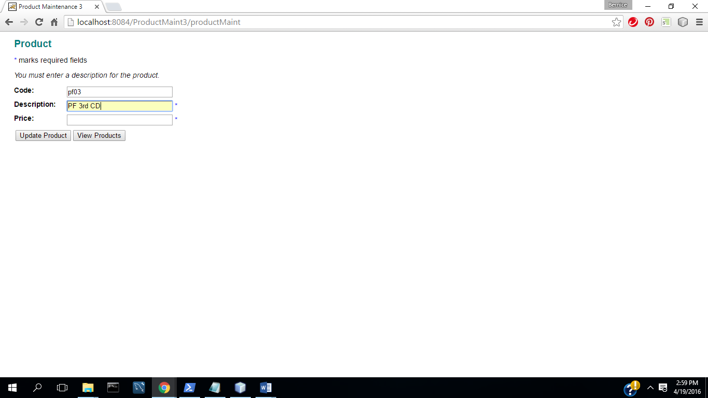

(8) Select Update

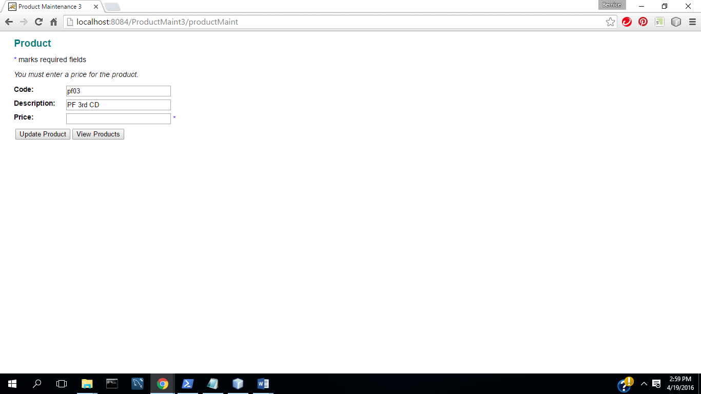

(9) Enter Valid Price

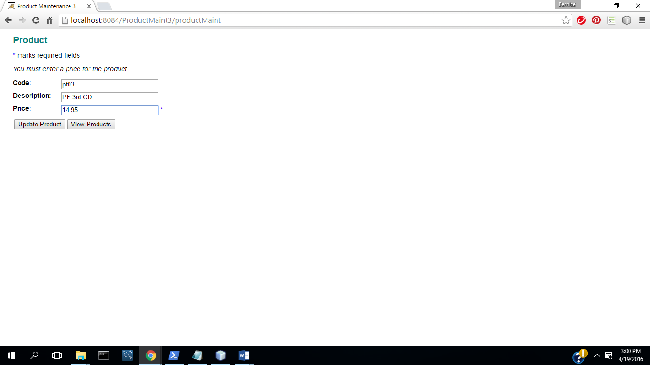

(10) Select Update

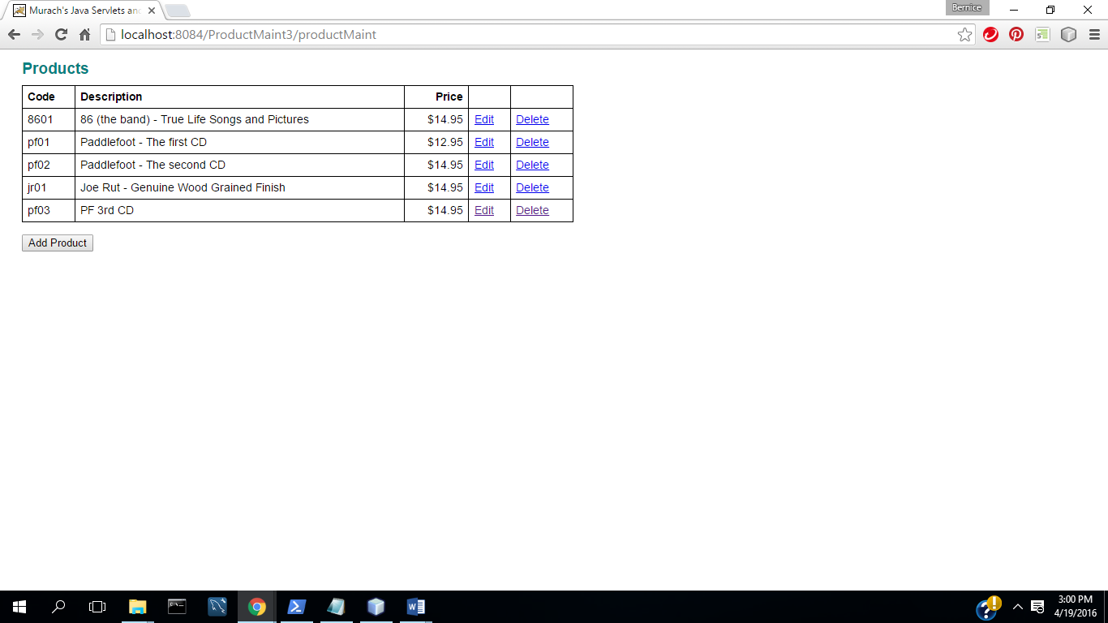

**TC5: Input Validation: Valid Price**

(1) Start App

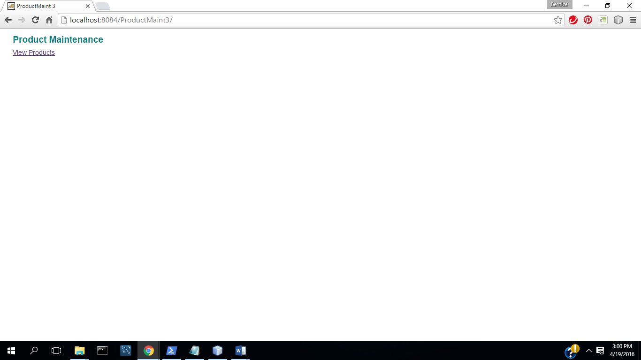

(1) Select View Products

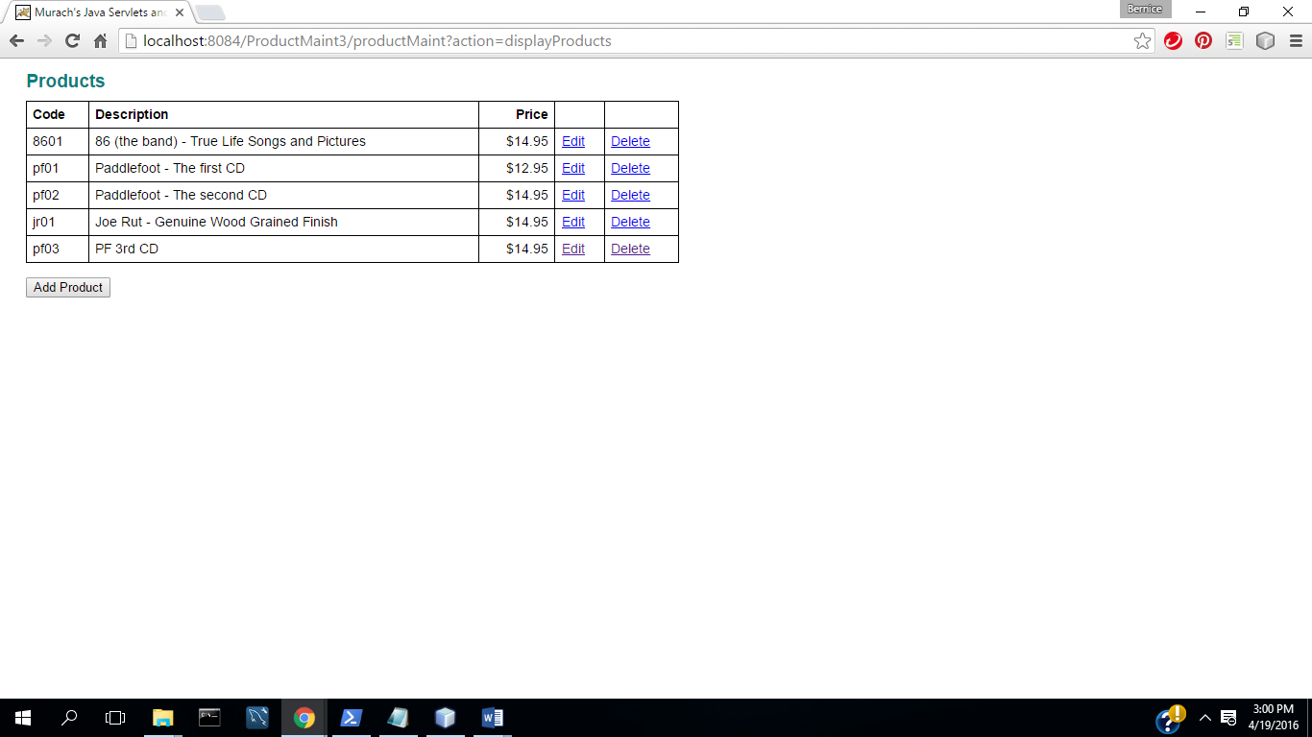

(2) Select Add Product

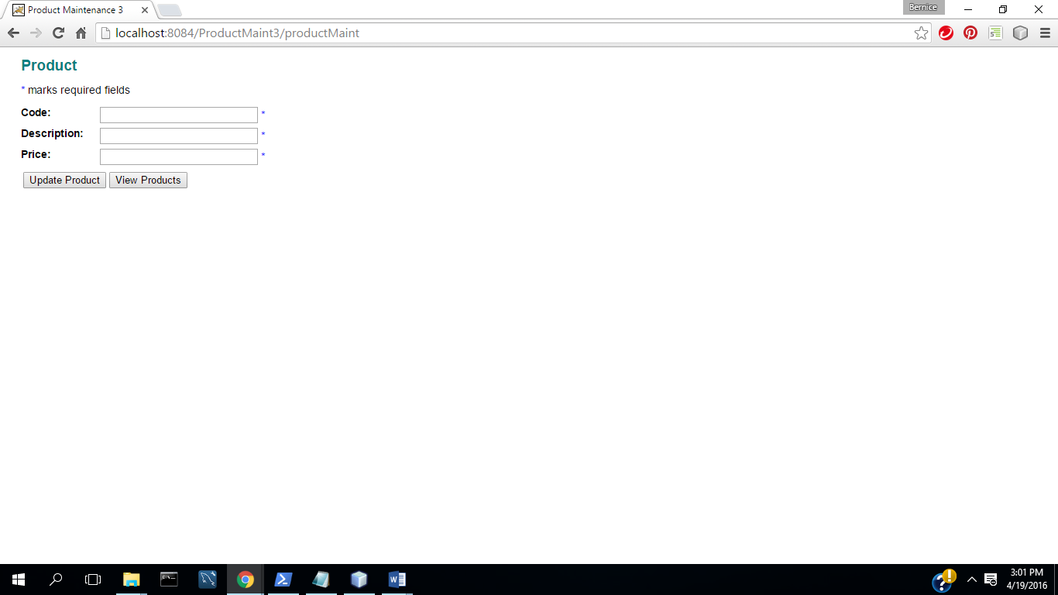

(3) Enter code, description, and invalid price

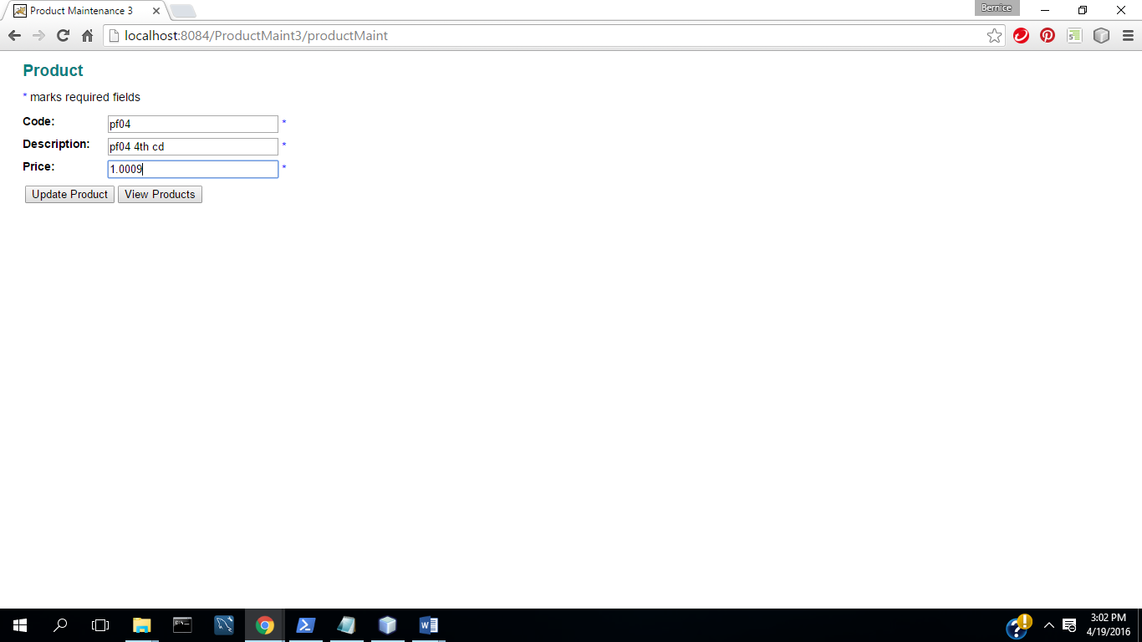

(4) Select update

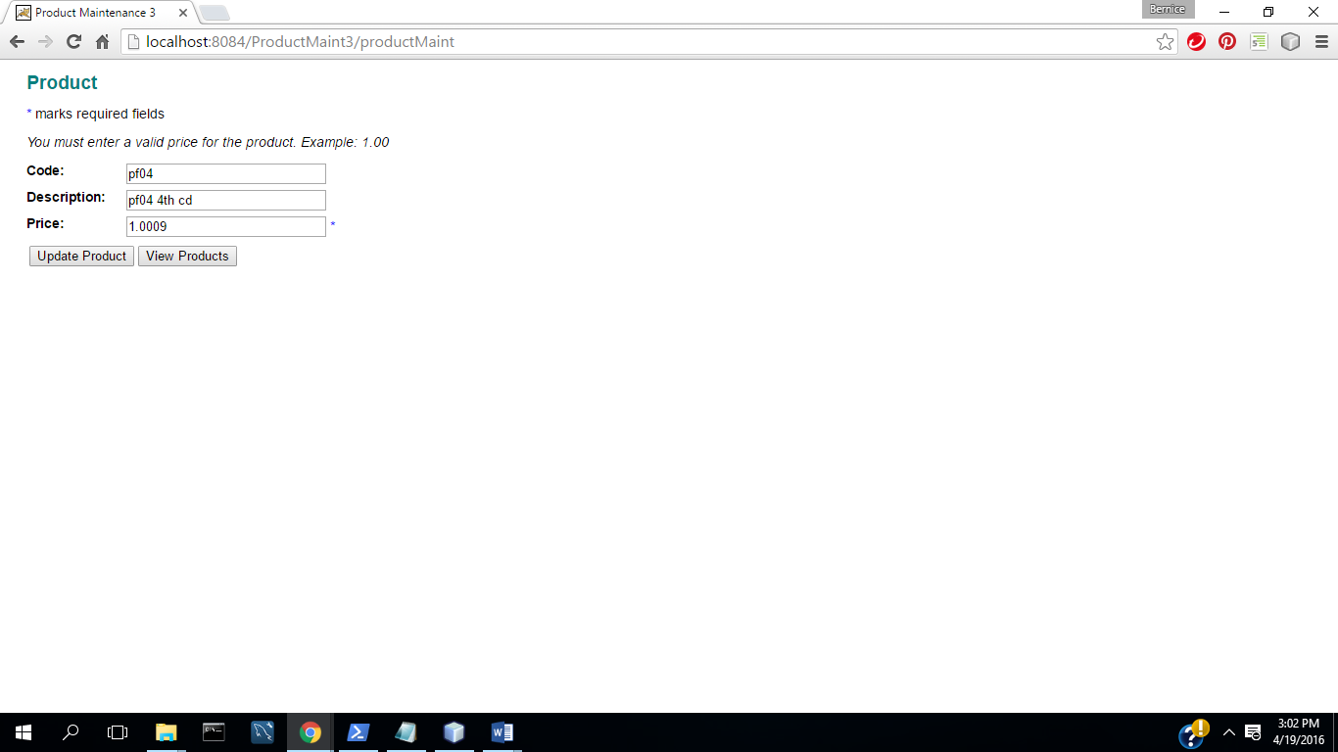

(5) Enter valid price

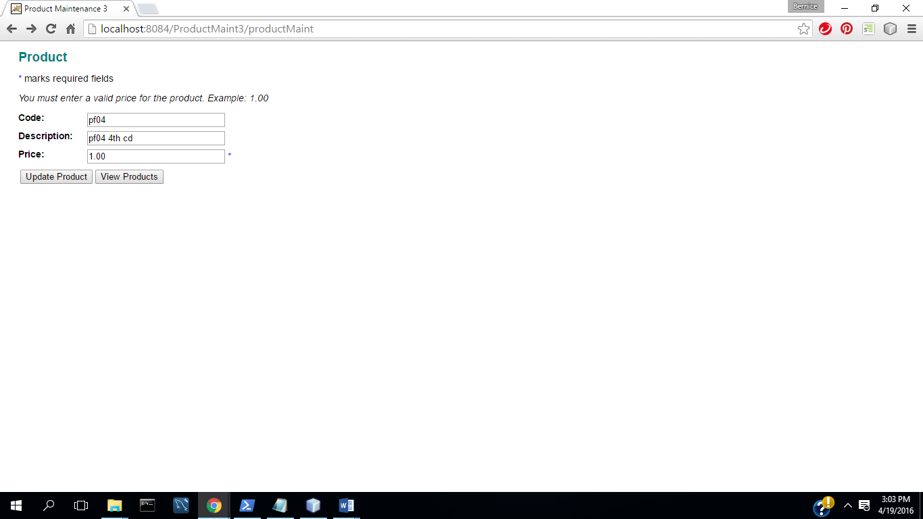

(6) Select Update

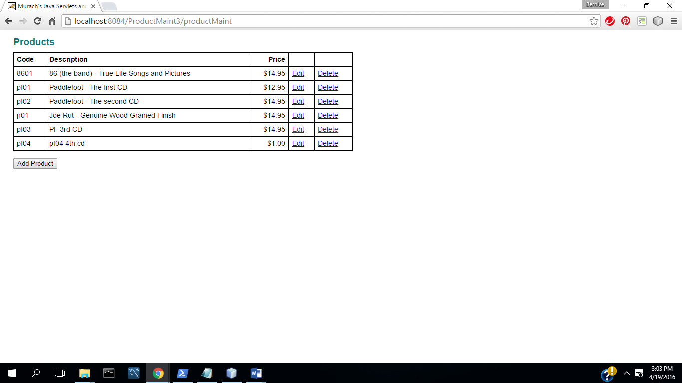

**(b) All program code for each part.**

In zipped file of NetBean project directory.

**(d) Test procedure/plan and implementation. What did you do to the test the program fully.**

**TC1: Add a Product**

(1) Start Application

(2) Select View Products

(3) Select Add Product

(4) Complete fields with valid data

(5) Select Update( Commit Transaction & Update Inventory)

**TC2: Update a Product**

(1) Select Edit Product

(2) Change description and price

(2) Select Update( Commit Transaction &Update Inventory)

**TC3: Delete a Product**

1. Select Delete Product
2. Select No
3. Select Delete Product

(4) Select Yes (Commit Transaction &Update Inventory)

**TC4: Input Validation : All Fields Complete**

(1) Start App

(2) Select View Products

(3) Select Add Product

(4) Select Update

(5) Enter Code

(6) Select Update

(7) Enter Description

(8) Select Update

(9) Enter Valid Price

(10) Select Update

**TC5: Input Validation: Valid Price**

(1) Start App

(1) Select View Products

(2) Select Add Product

(3) Enter code, description, and invalid price

(4) Select update

(5) Enter valid price

(6) Select Update

**(e) Overall Block diagram showing high level design**