Bernice Templeman

CIS 5740/ Spring 2016

Program 5-2

Program 5-2: Product Maintenance with SSL and authentication

For this project, you’ll enhance the application described in the previous programs by modifying it so it uses a secure connection and only allows authorized users. (*Prerequisites: chapters 1-13, 15, and 16*)

The Index page

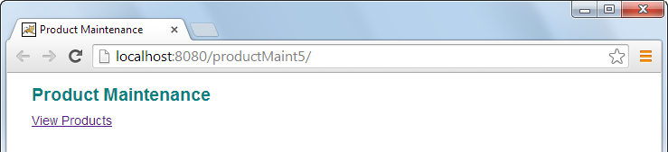

The Warning page for a secure connection

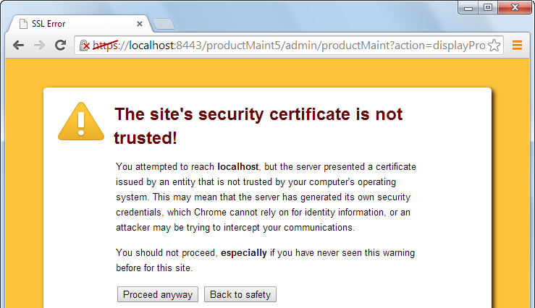

The Login page with a secure connection

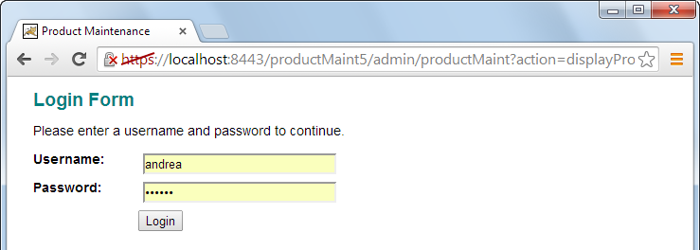

The Products page with a secure connection

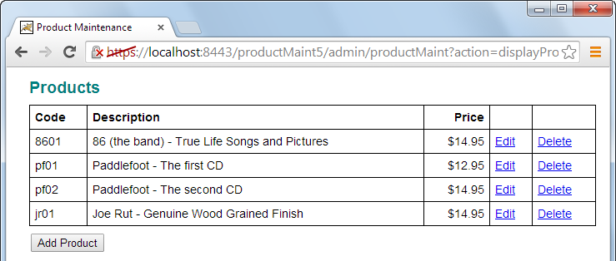

Specifications

* Restrict access to all pages except the Index page. Only allow users in the programmer role and customer service role to access the rest of the pages in the Product Maintenance application. To do that, use the UserPass and UserRole tables in the murach database to define the usernames and passwords for these roles.
* Use a secure connection for all pages except the Index page.

Index Page:

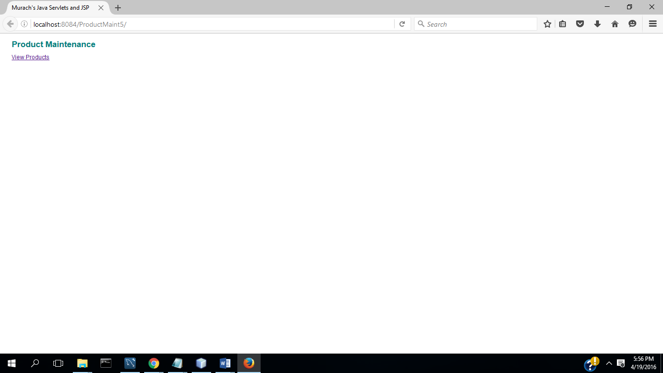

Warning Page:

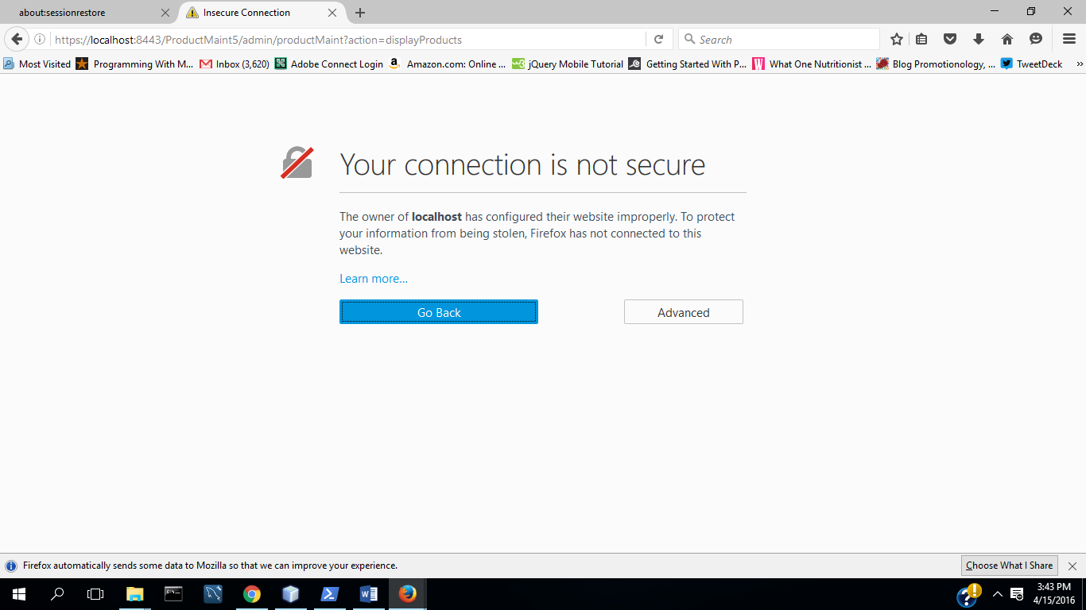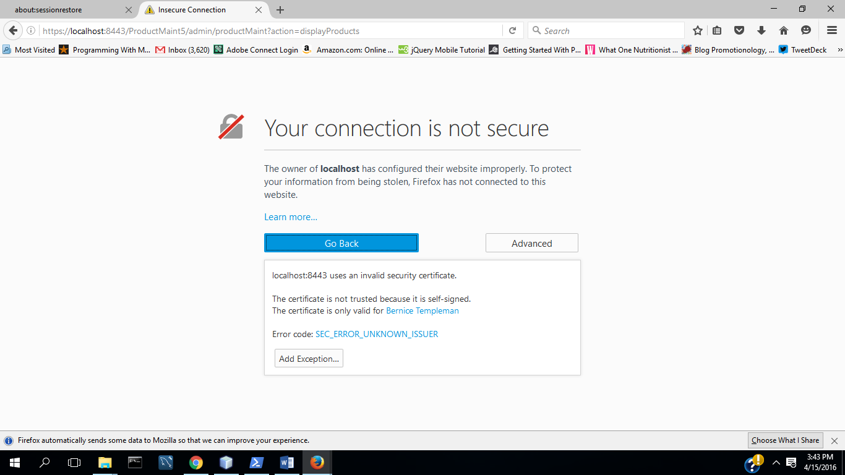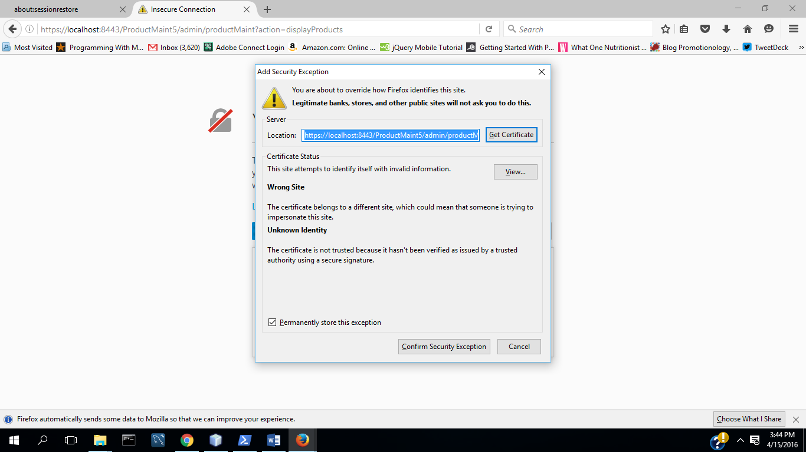

Login Page with a Secure Connection

Chrome:

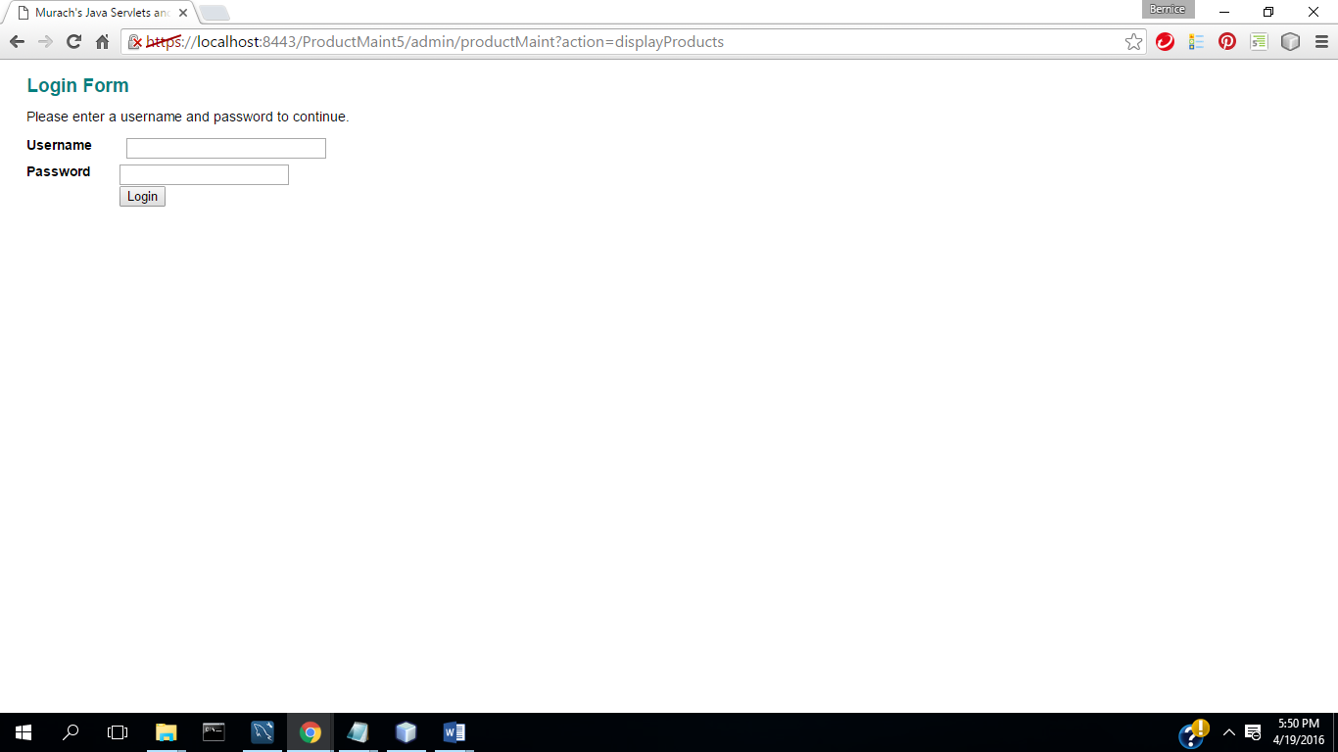

Firefox:

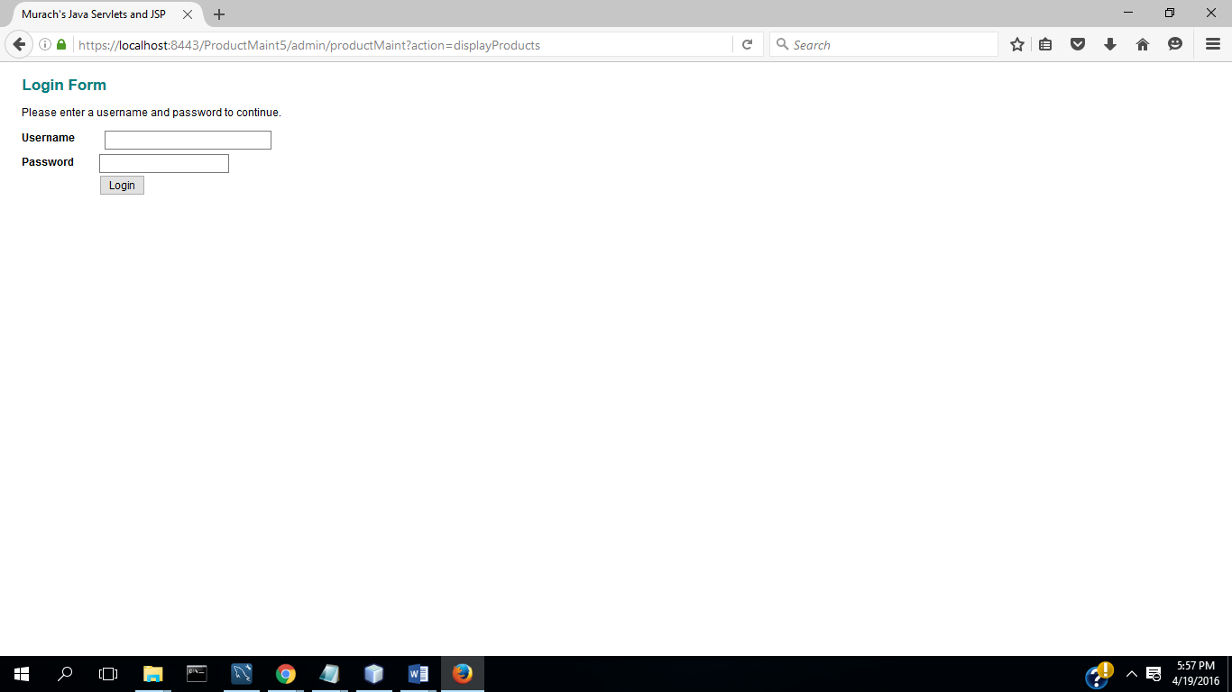

Enter login & password:

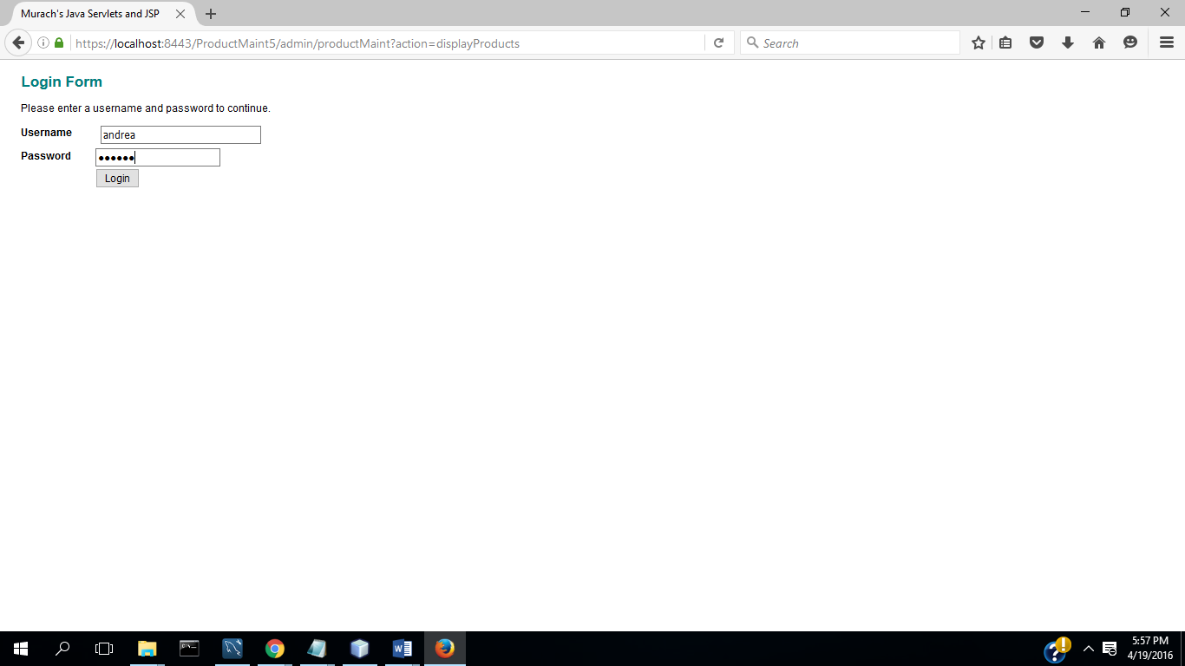

Select Login:

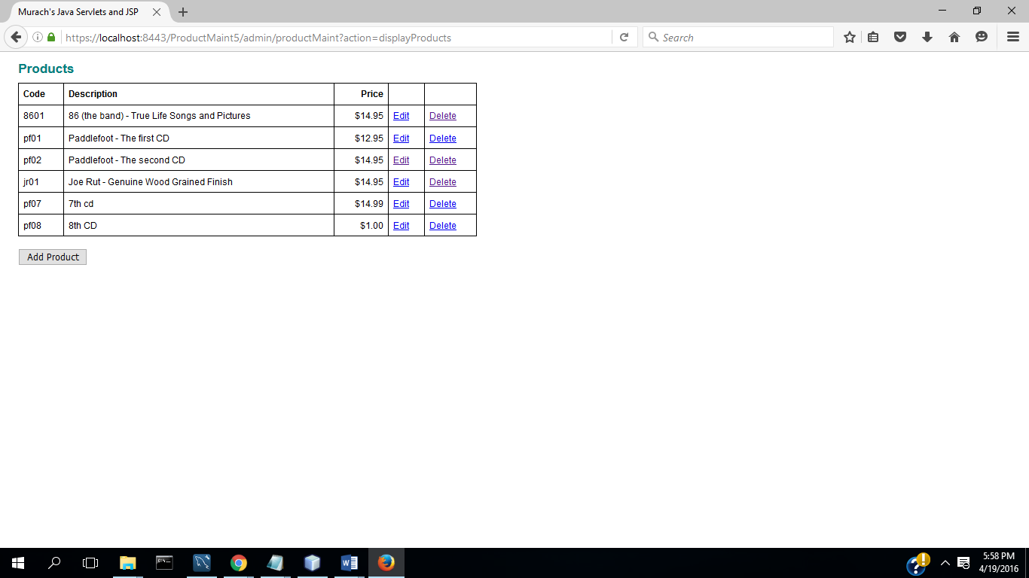

Add:

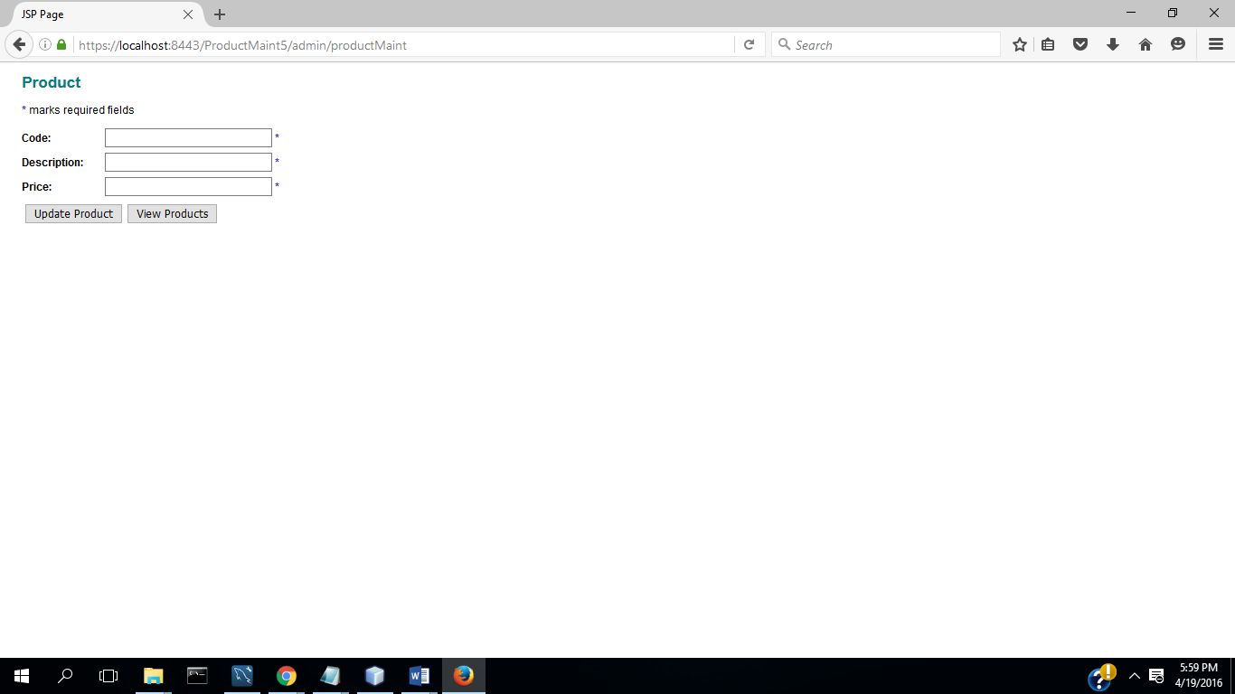

Update:

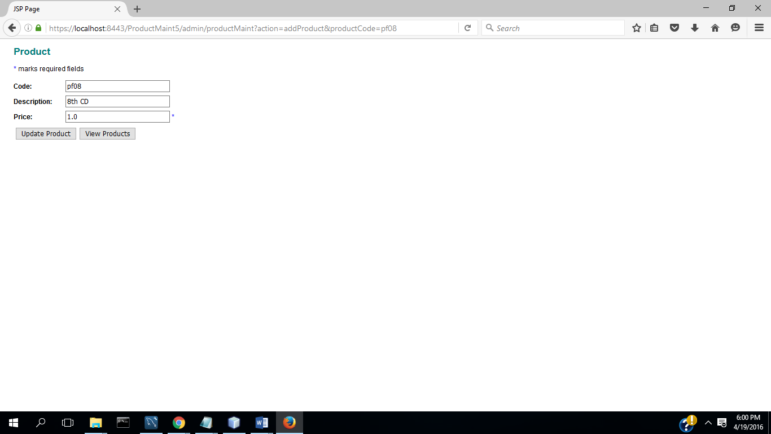

Delete:

