Bernice Templeman

CIS 5740/ Spring 2016

Program 5-3

Program 5-3: Product Maintenance within the Music Store web site

For this project, you’ll enhance the application described in the previous programs by adding it to the admin section of the Music Store web site. (*Prerequisites: 1-13,15, 16, 22 and 23*)

Specifications

* Add the JSP files for the Product Maintenance application to the admin directory of the Music Store web site.
* Add the controller servlet for the Product Maintenance application to the music.admin package of the Music Store web site.
* Modify the admin/index.jsp file of the Music Store web site so it includes a button that starts the newly added Product Maintenance application.
* Modify all necessary JSP, CSS, Java, and XML files within the Music Store web site so they work with the newly added Product Maintenance application.
* In the controller for the Product Maintenance application, use the getRequestURI method to determine which action to process as shown in chapter 22. If the URL doesn’t match any actions in your application, use the sendError method of the response object to send a 404 error to the user to indicate that the page isn’t available.
* Don’t break the other applications in the existing Music Store web site.

**(a) Input/Output - Screen shots showing input/output for each part.**

**TC1: Admin**

**(1)Start App (Home Page):**

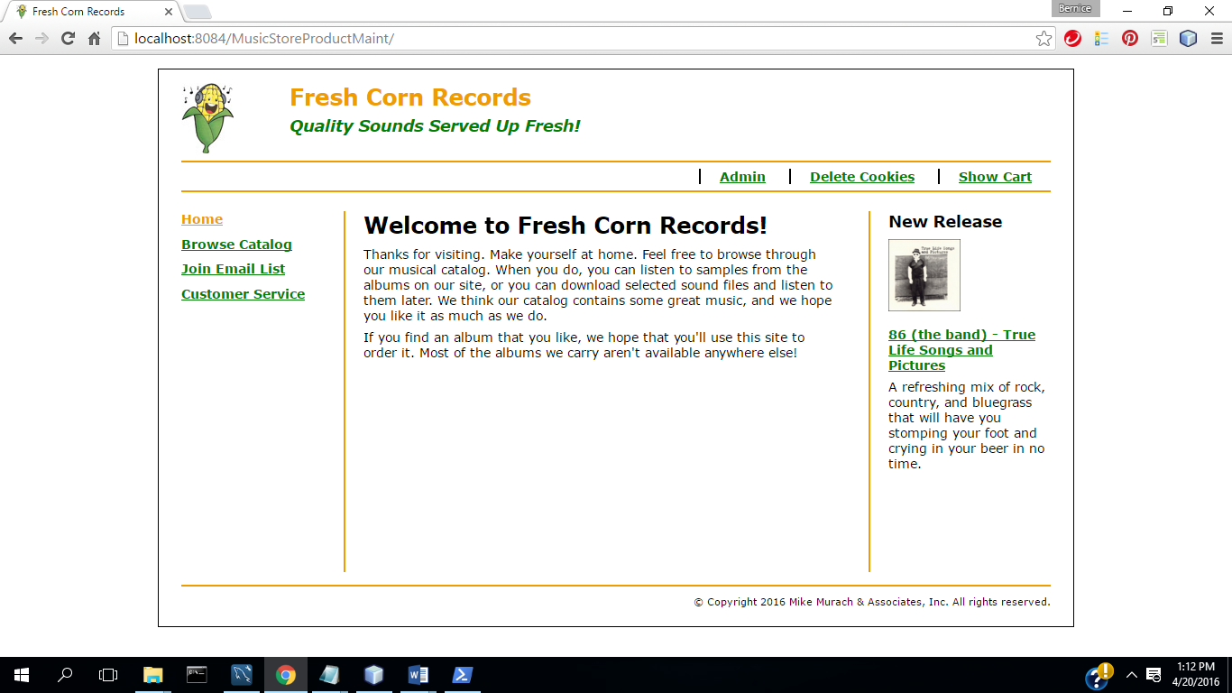

(2) Select Admin

**Admin Login:**

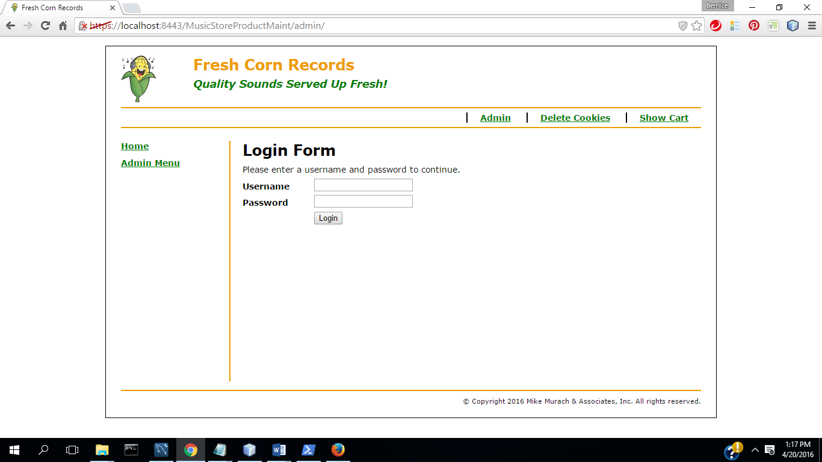

(3) Login: **Admin Menu**

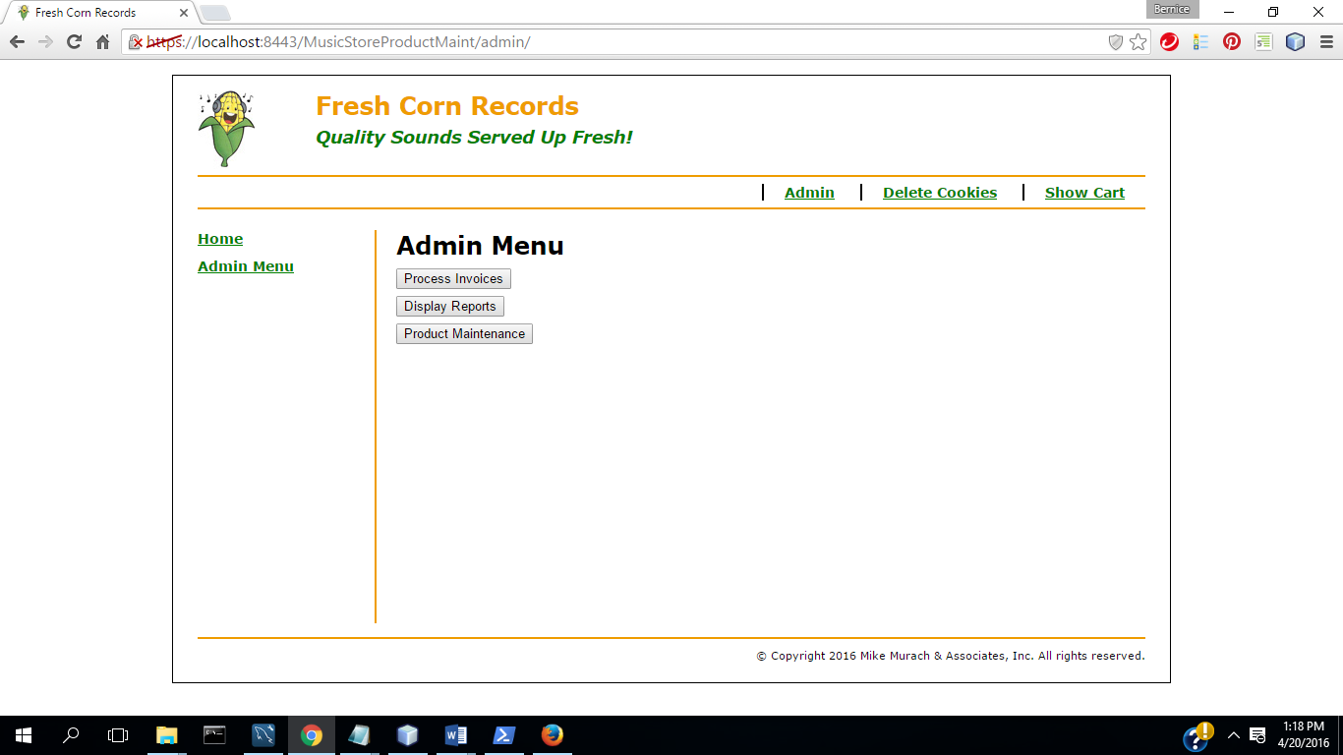

(4) Select Product Maintenance

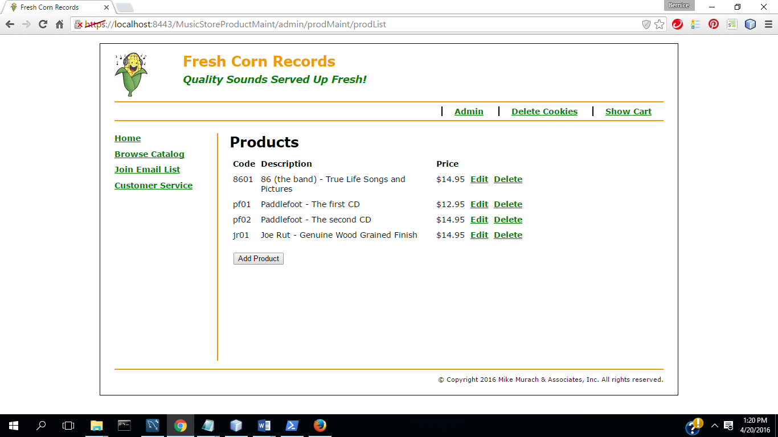

(5) Select Add Product

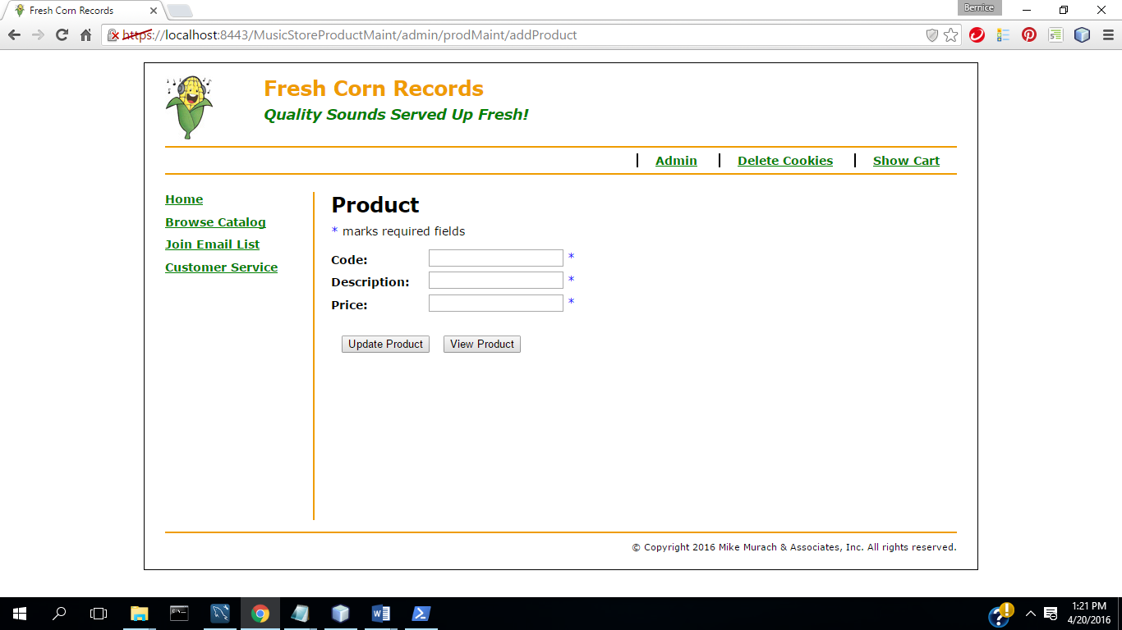

(6) Select Update

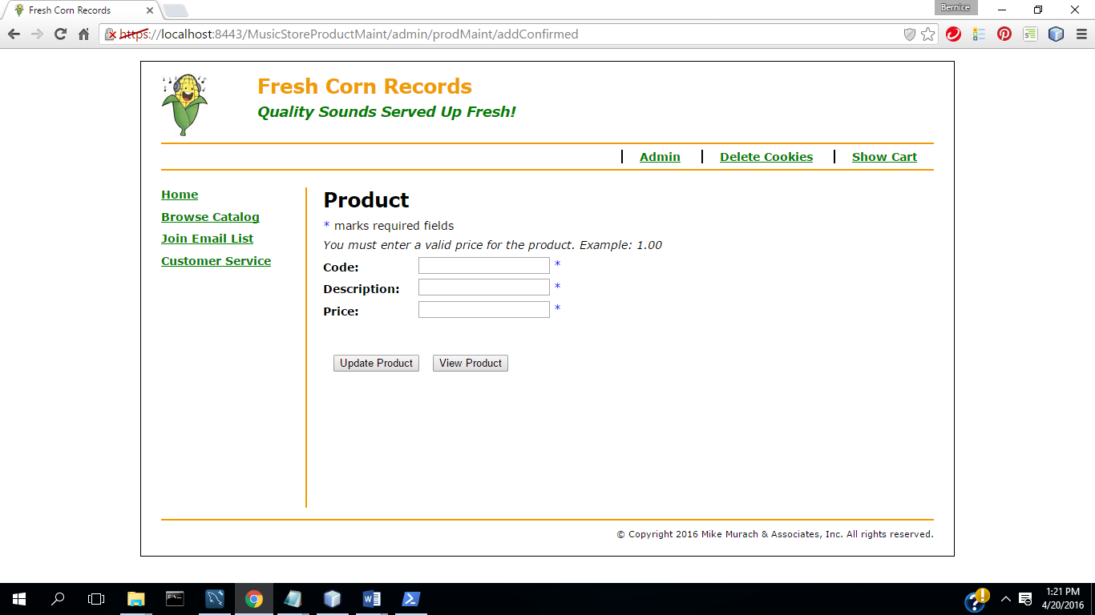

(7) Complete fields with valid data

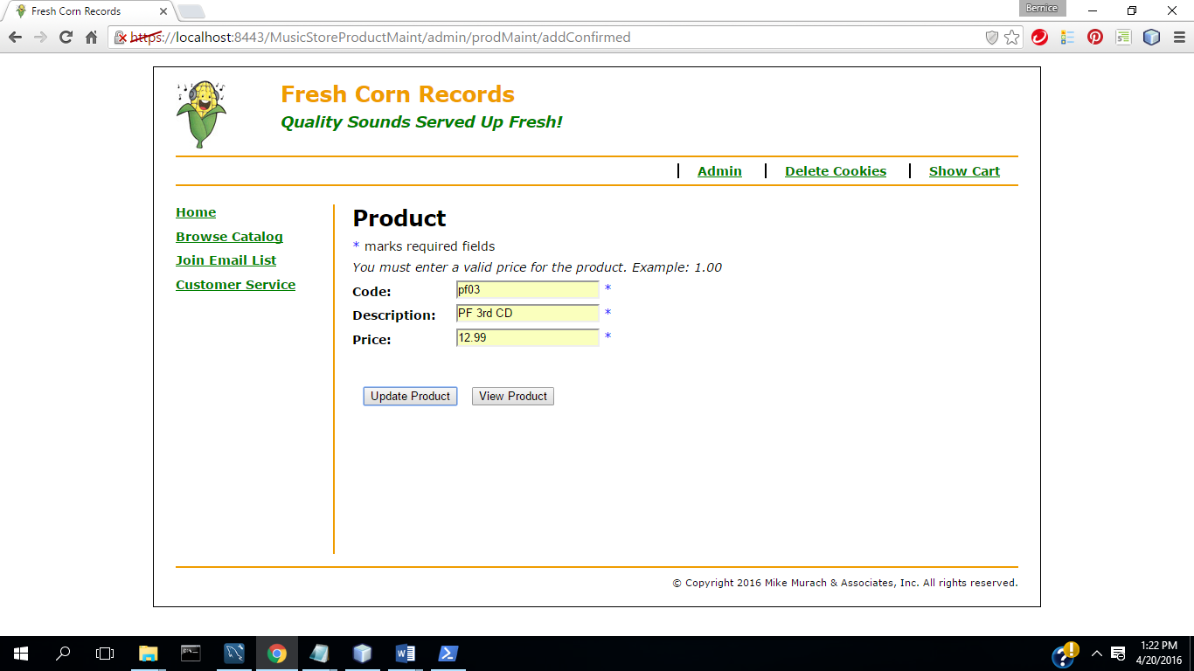

(8) Select Update( Commit Transaction & Update Inventory)

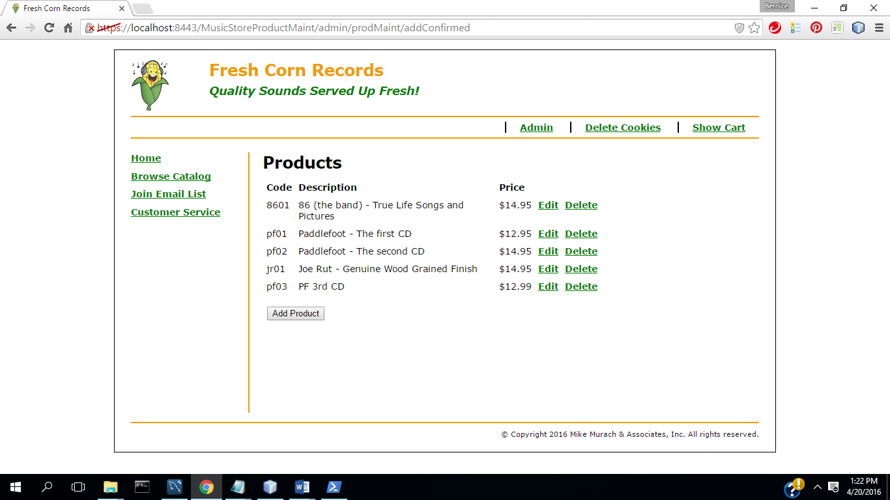

(9) Select Delete Product

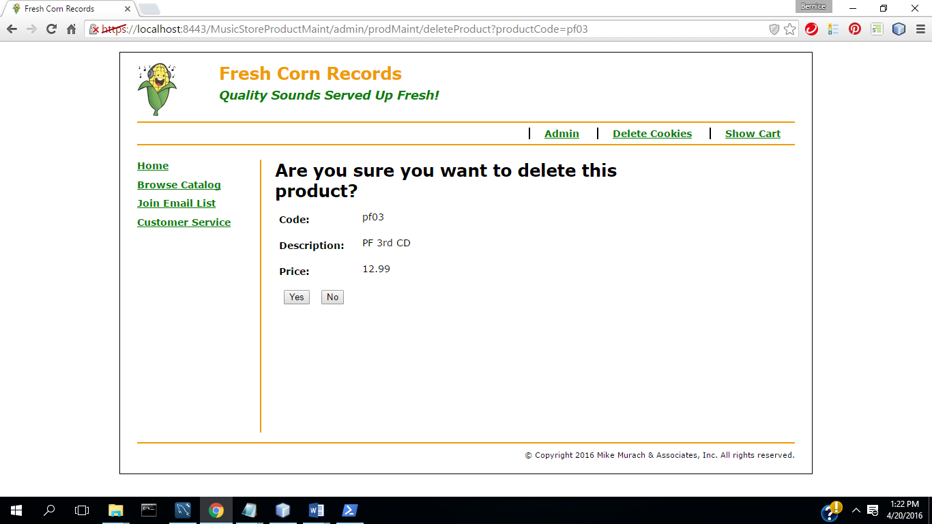

(10) Select No

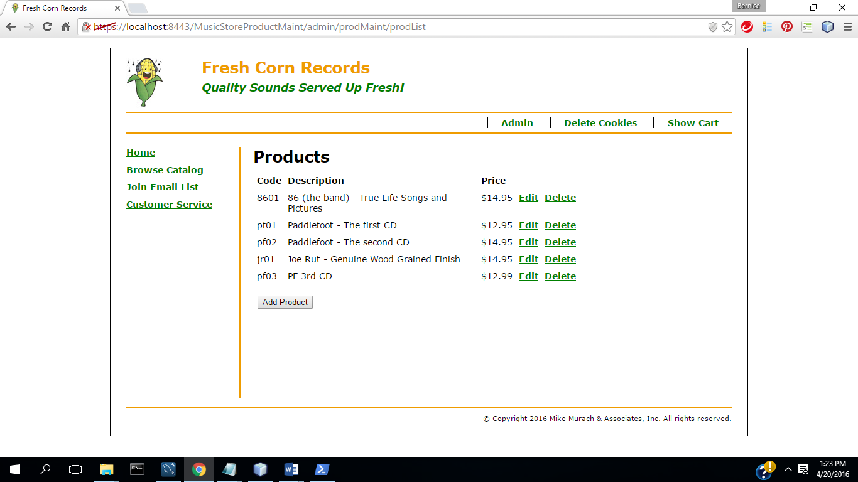

(11) Select Delete Product

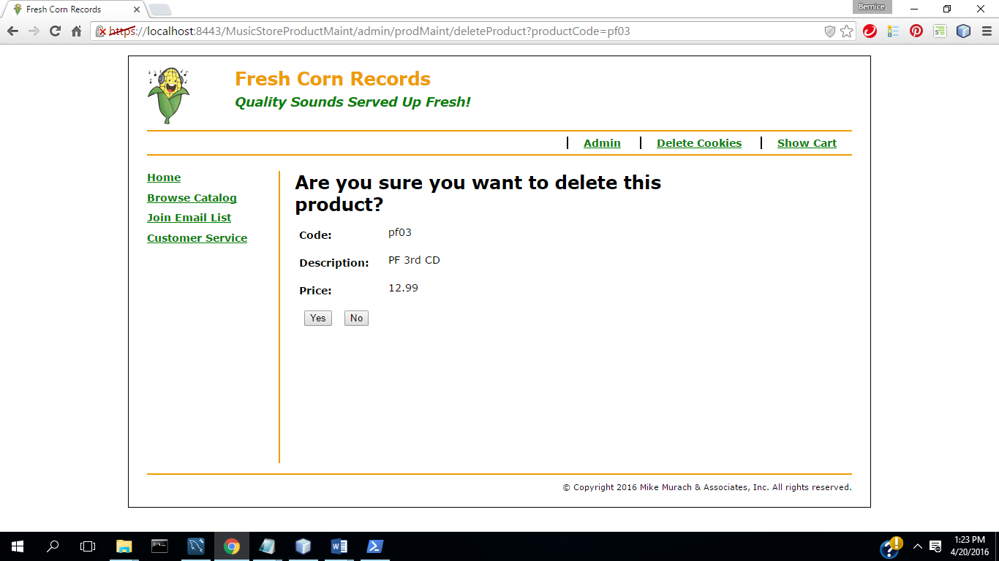

(12) Select Yes (Commit Transaction &Update Inventory)

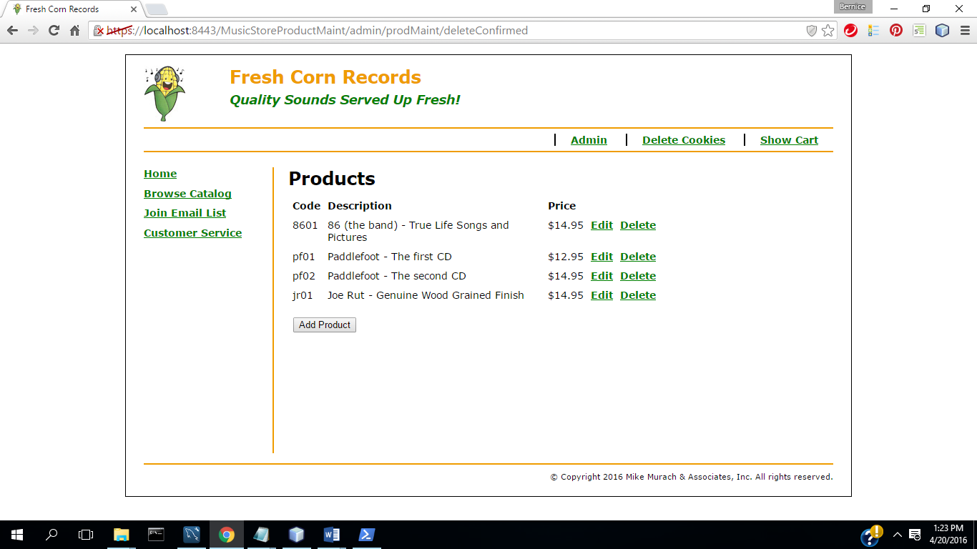

(13)Select Admin

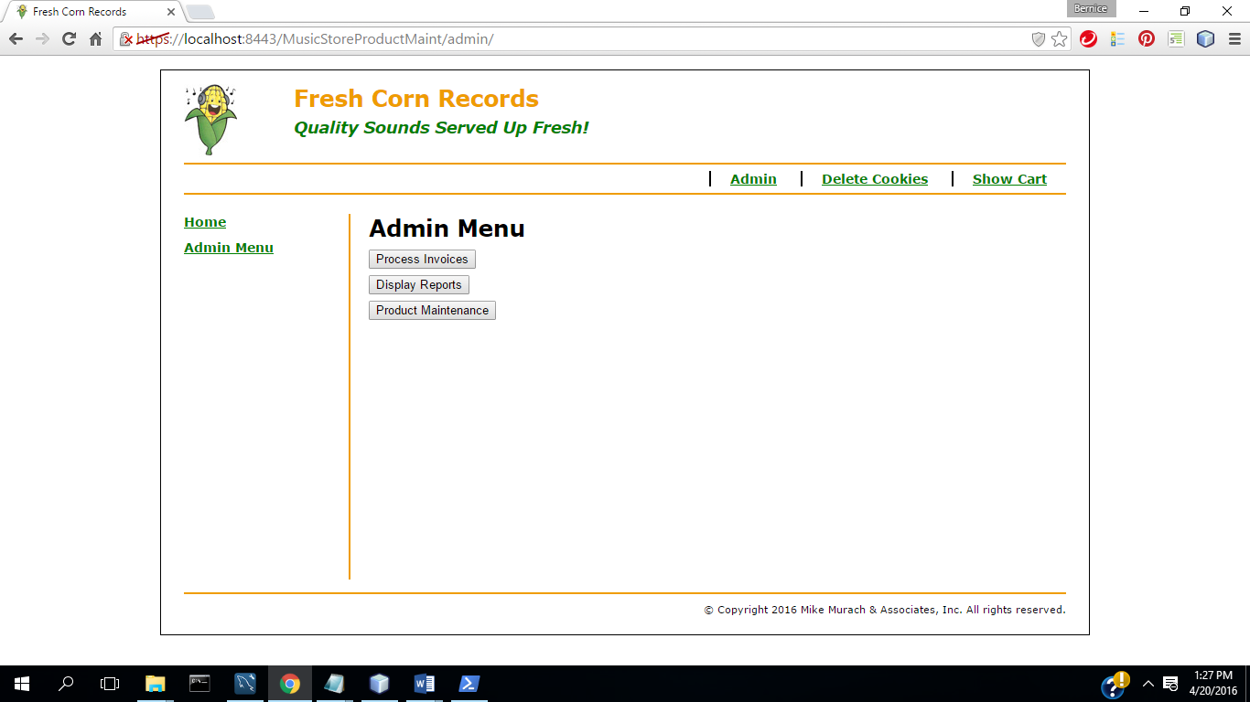

(14)Select Process Invoices

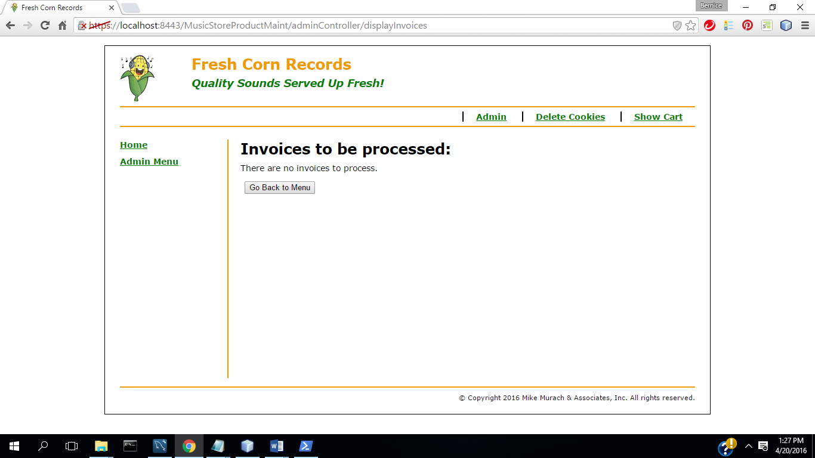

15 ) Select Go Back to Menu

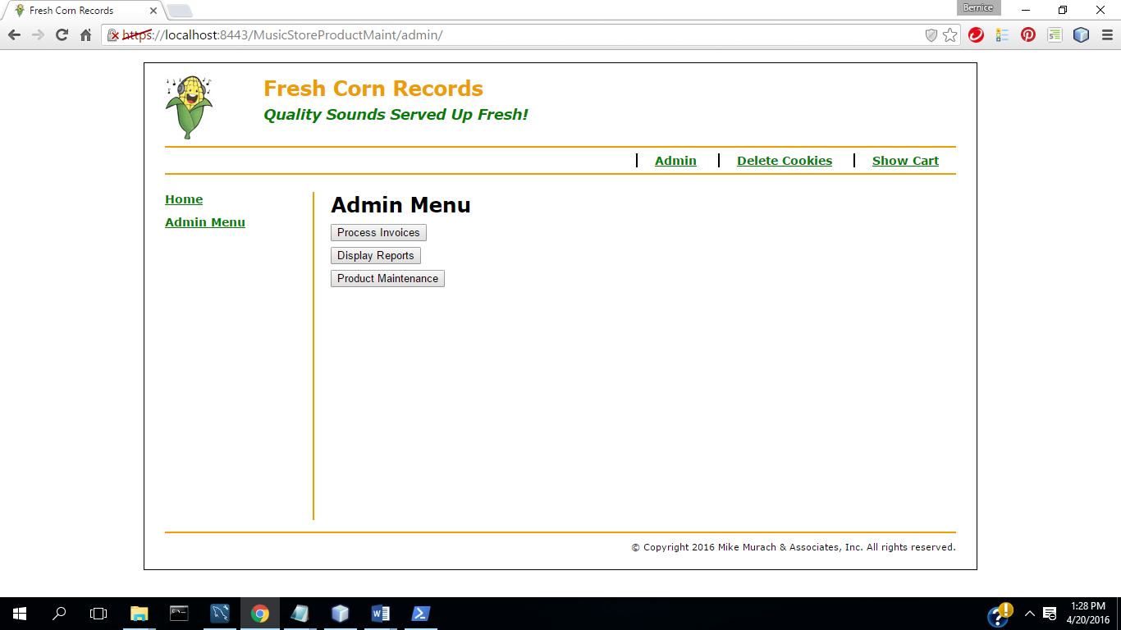

16) Select Display Reports

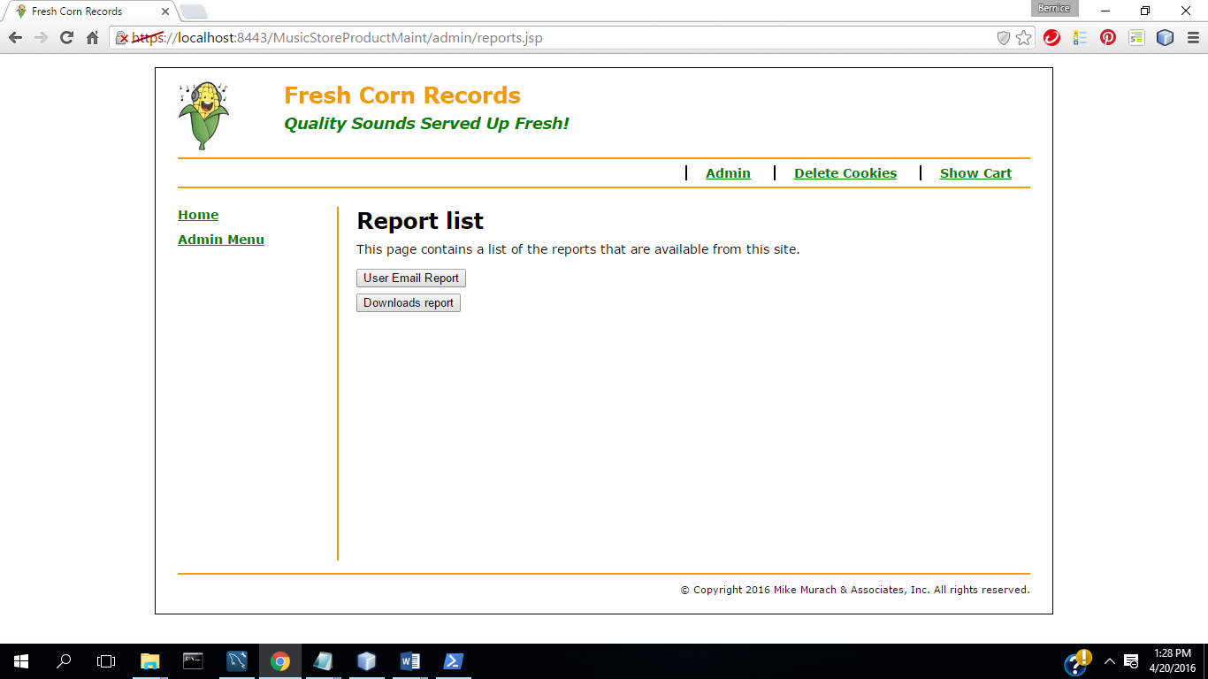

17)Select User Email Report

18)Download & open in excel

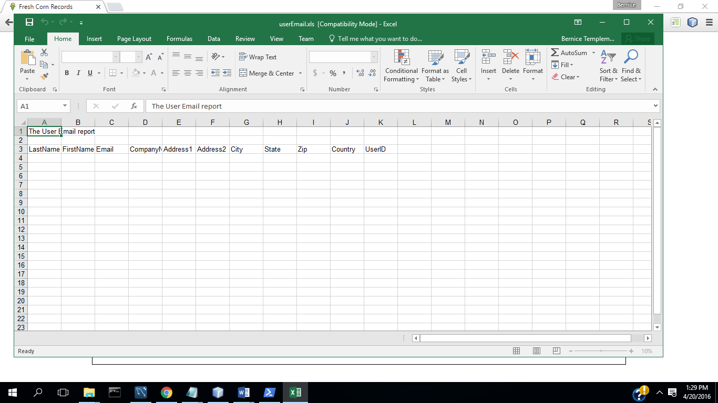

19)Select Downloads report

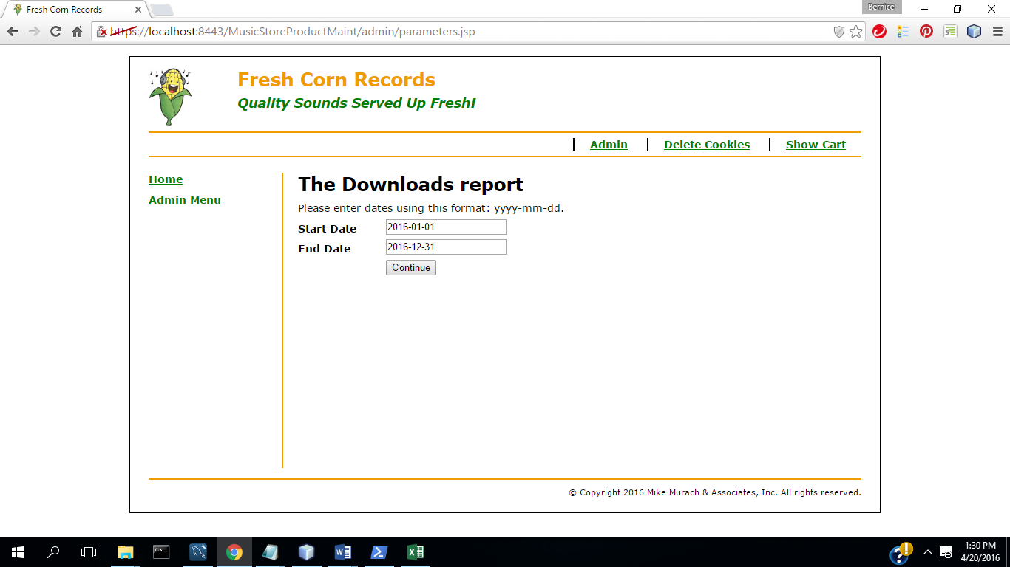

20) Continue

21) Save and open in excel

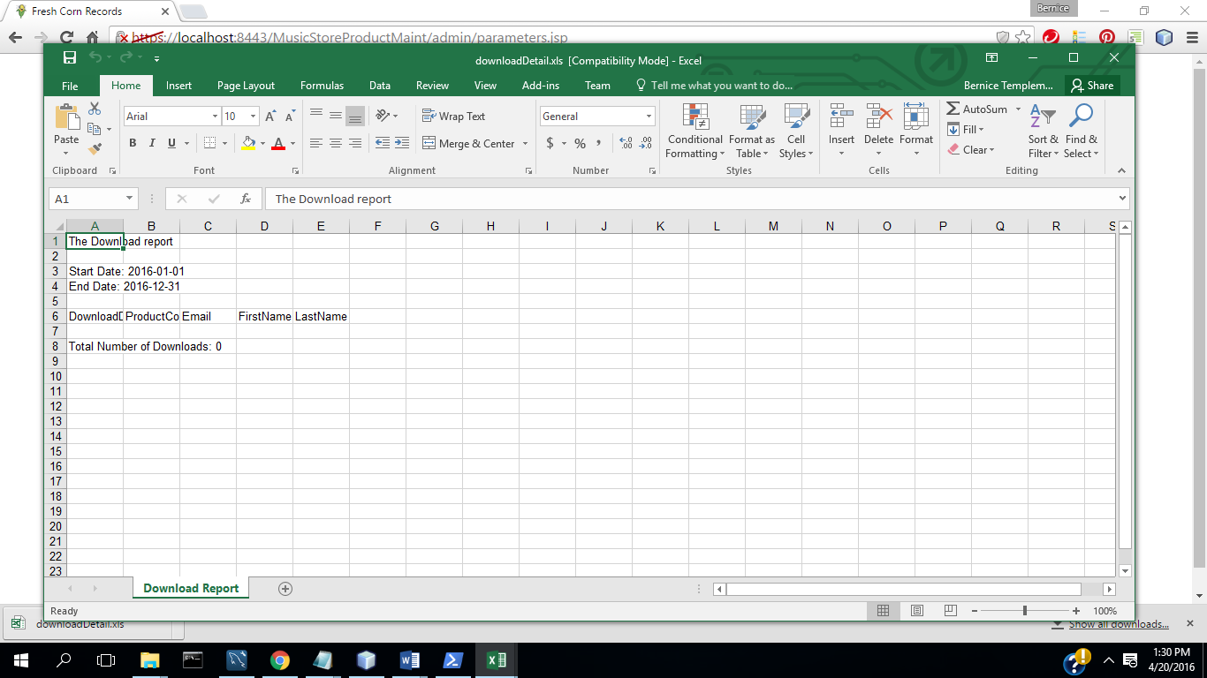

**TC2: Music Store App**

(1) select Home

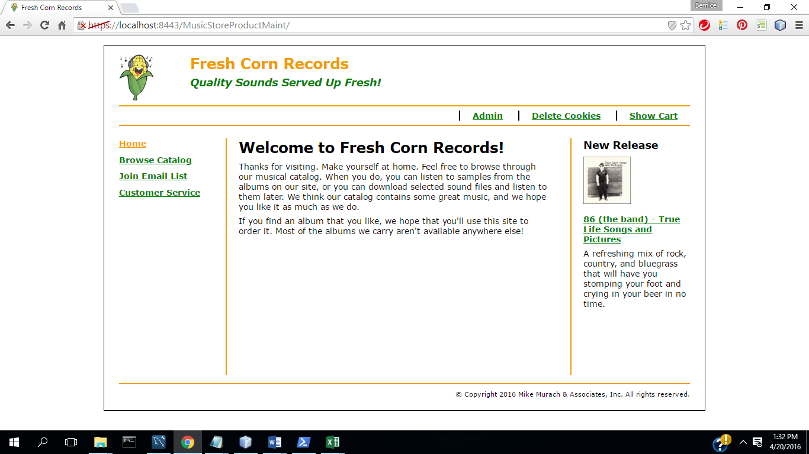

(2) Select Browse Catalog

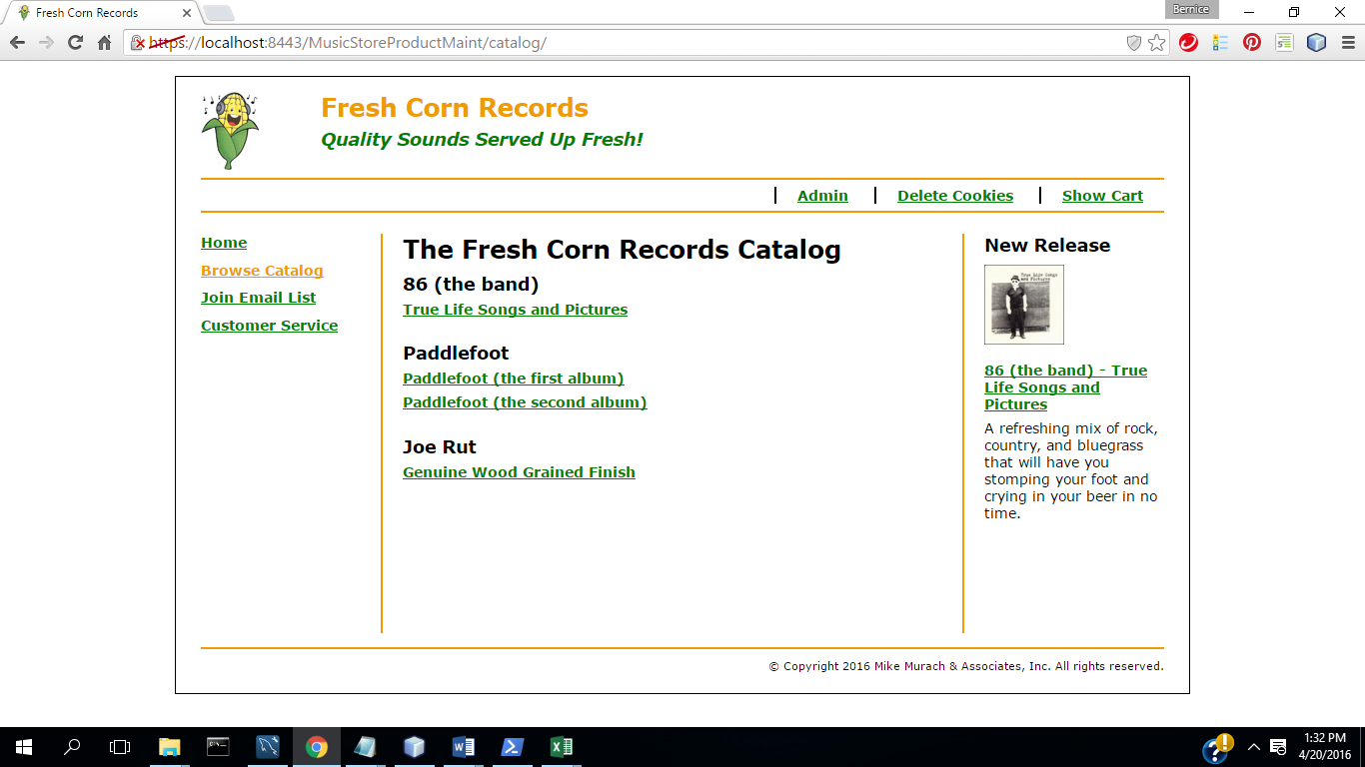

3,) Select Product

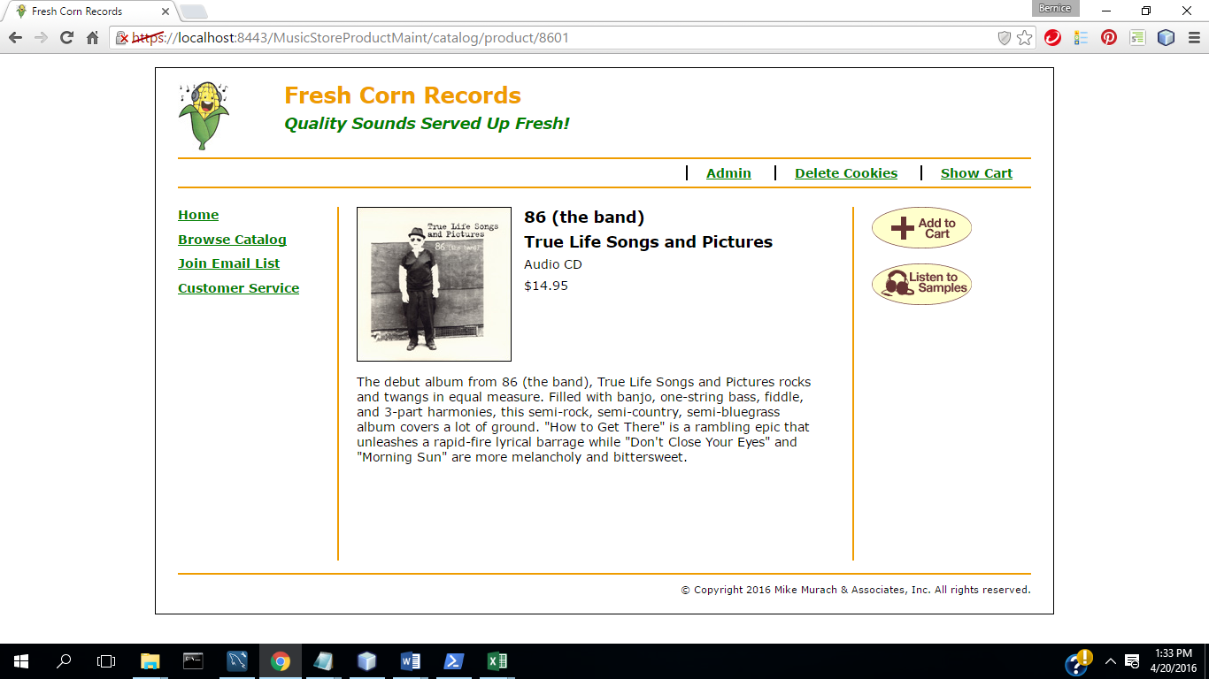

4.) Select Listen

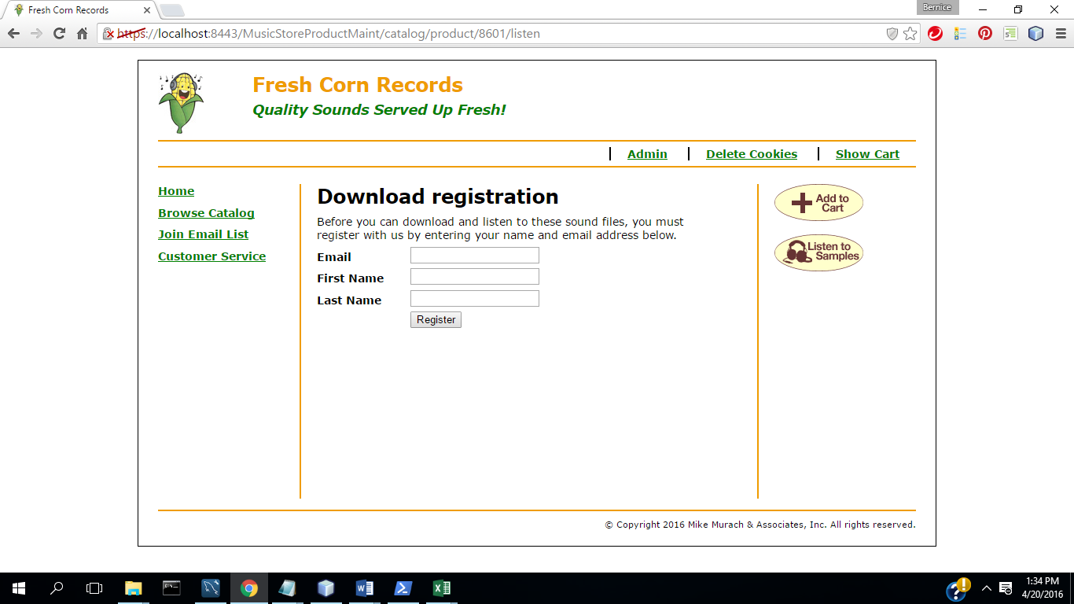

5.) Enter Information

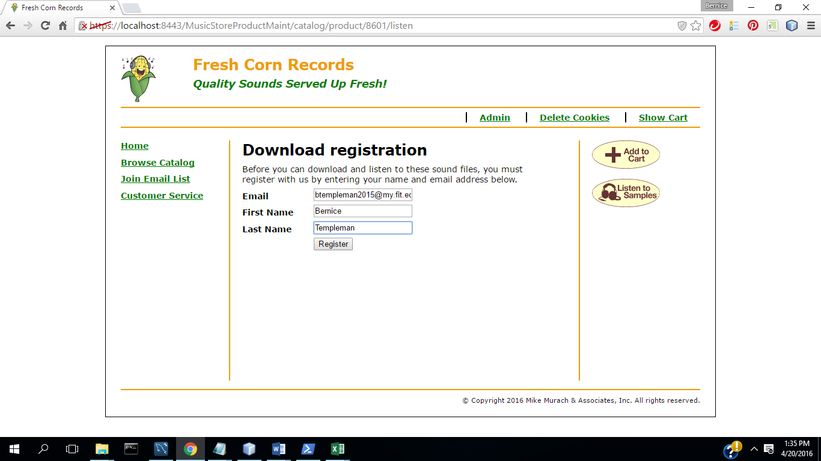

6) Select register

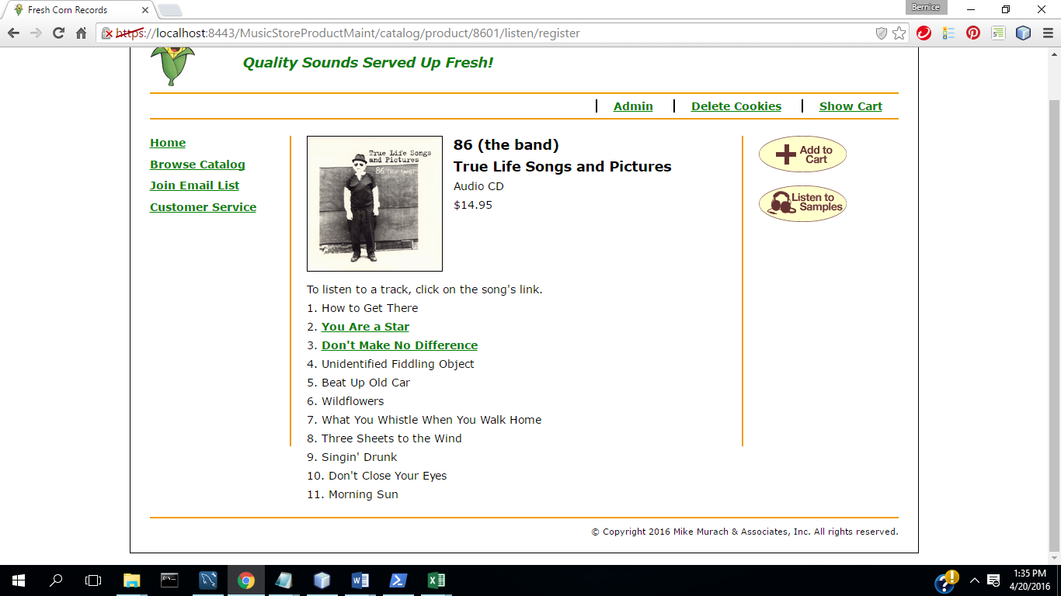

7) Select Song

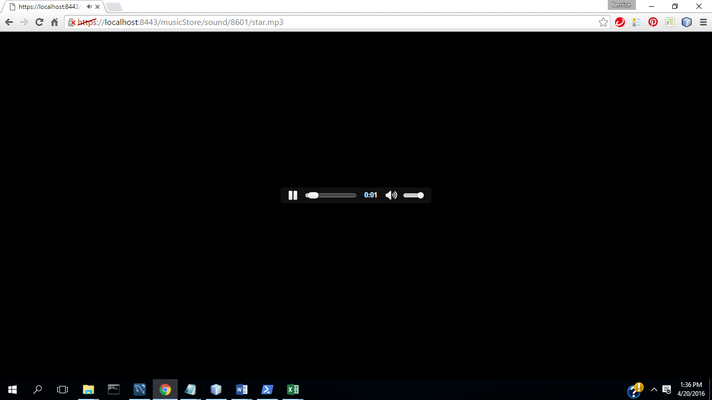

8.) Select Back in Browser until get back to page

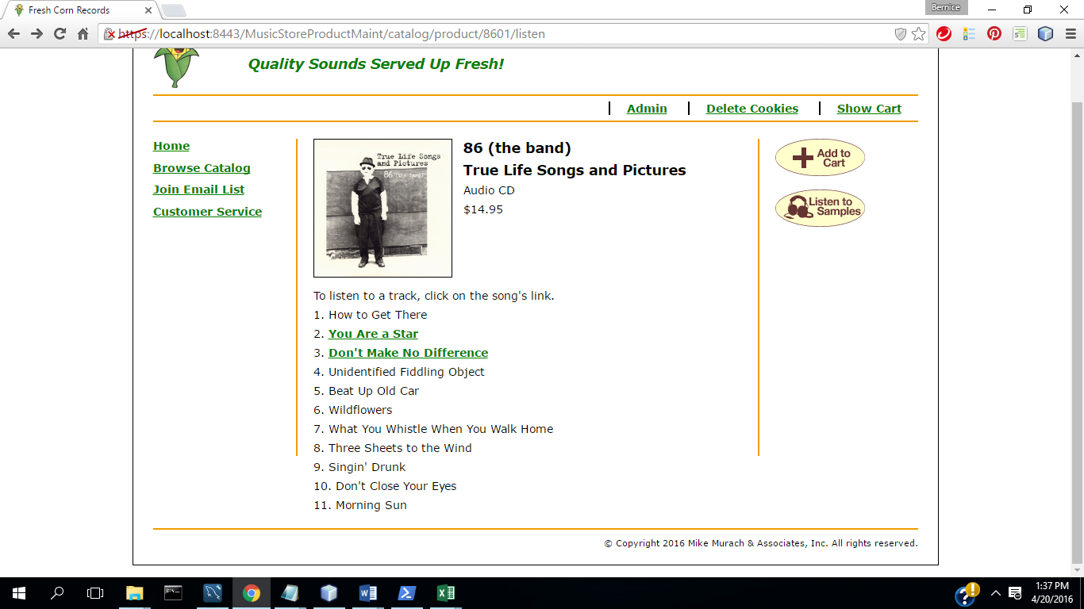

9.) Select Add to Cart

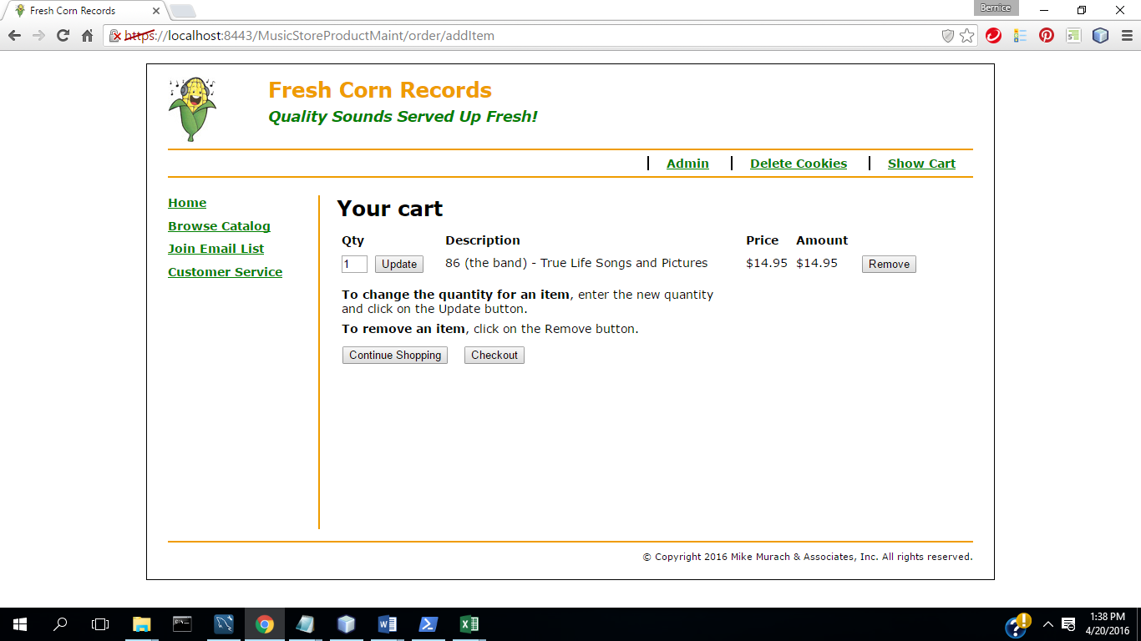

10.) Select Checkout

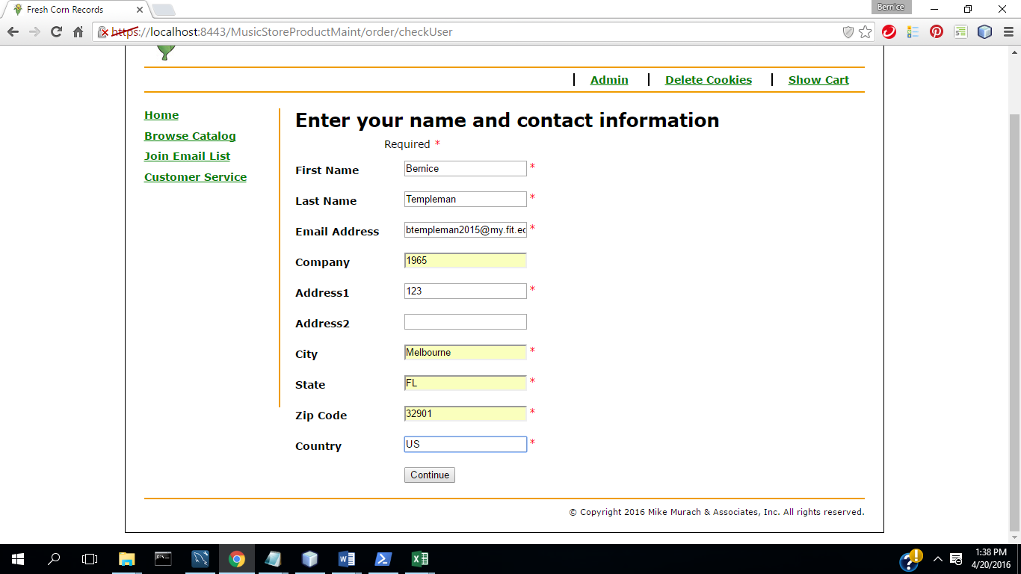

11.)Select Continue

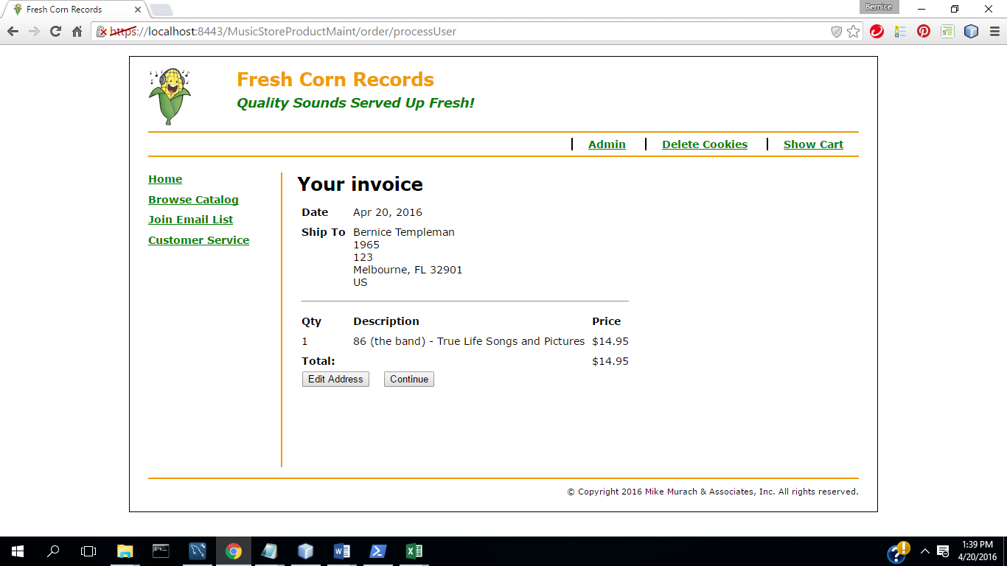

12.) Select Continue

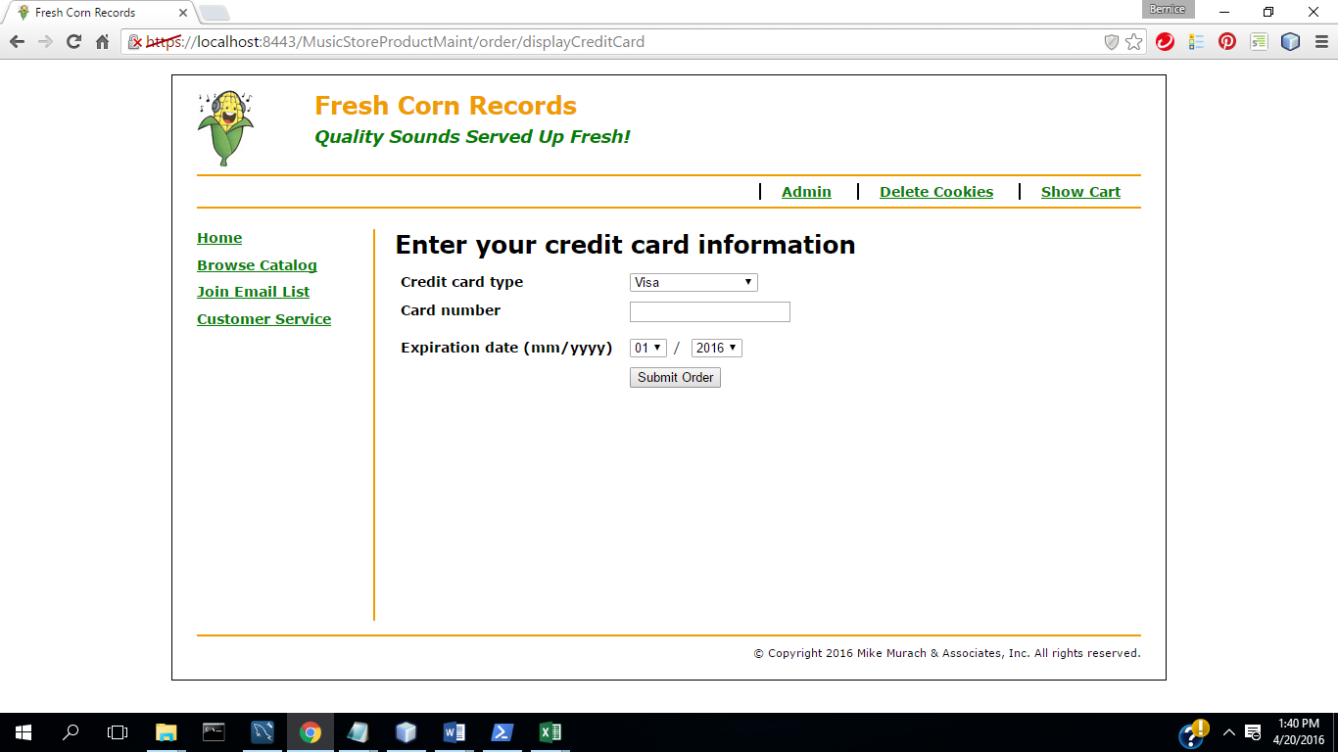

13) Complete fields

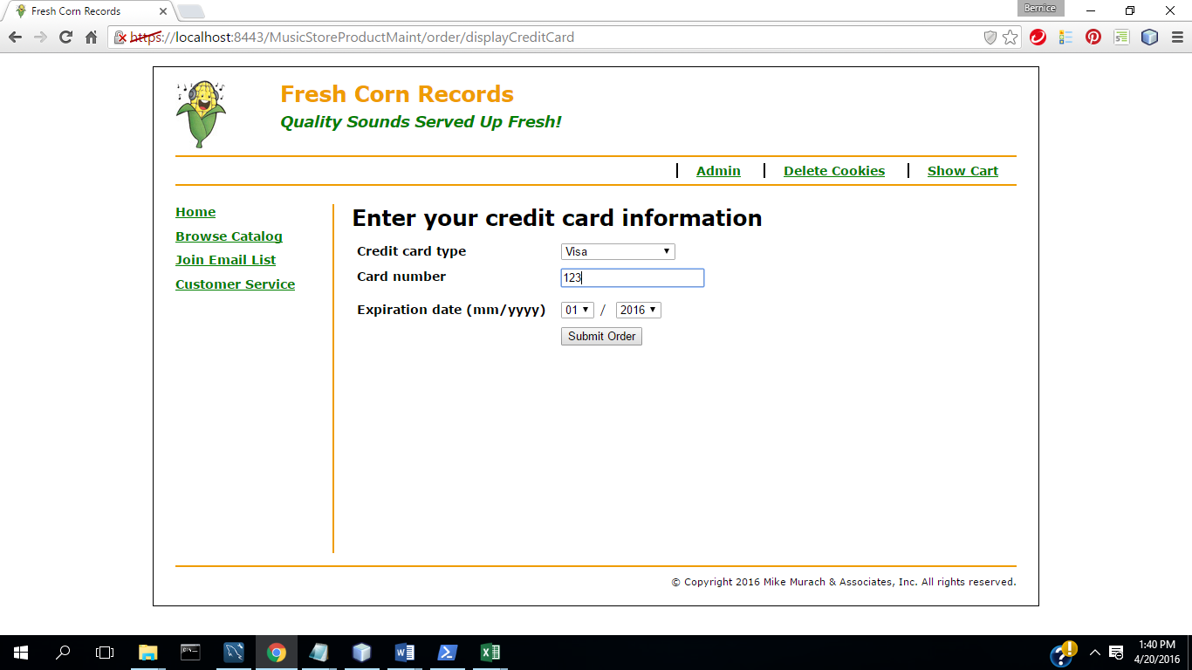

14.) Select Submit Order

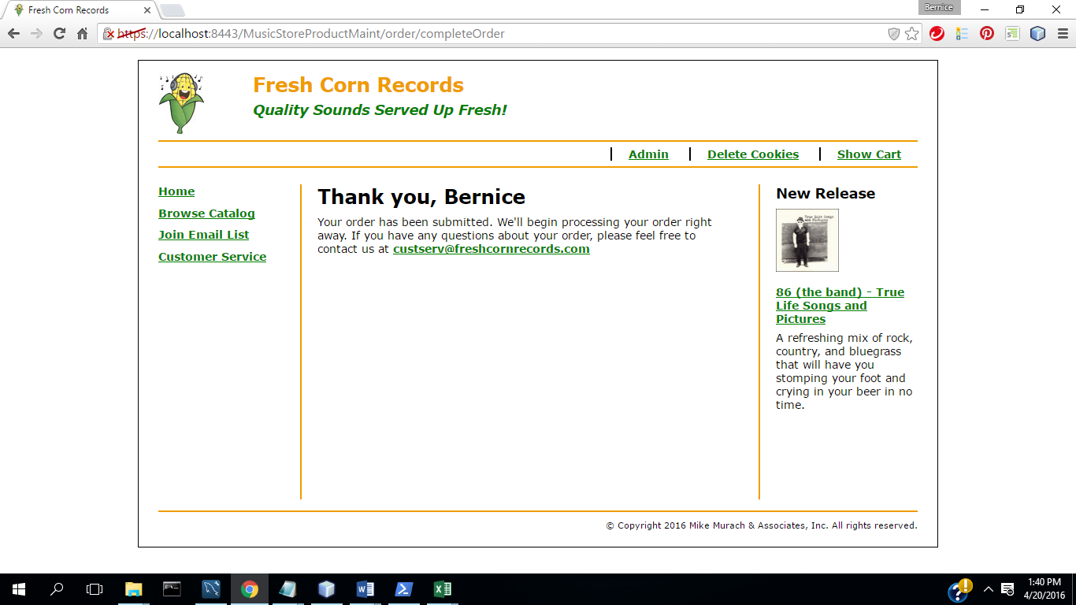

15) Select Join Email list

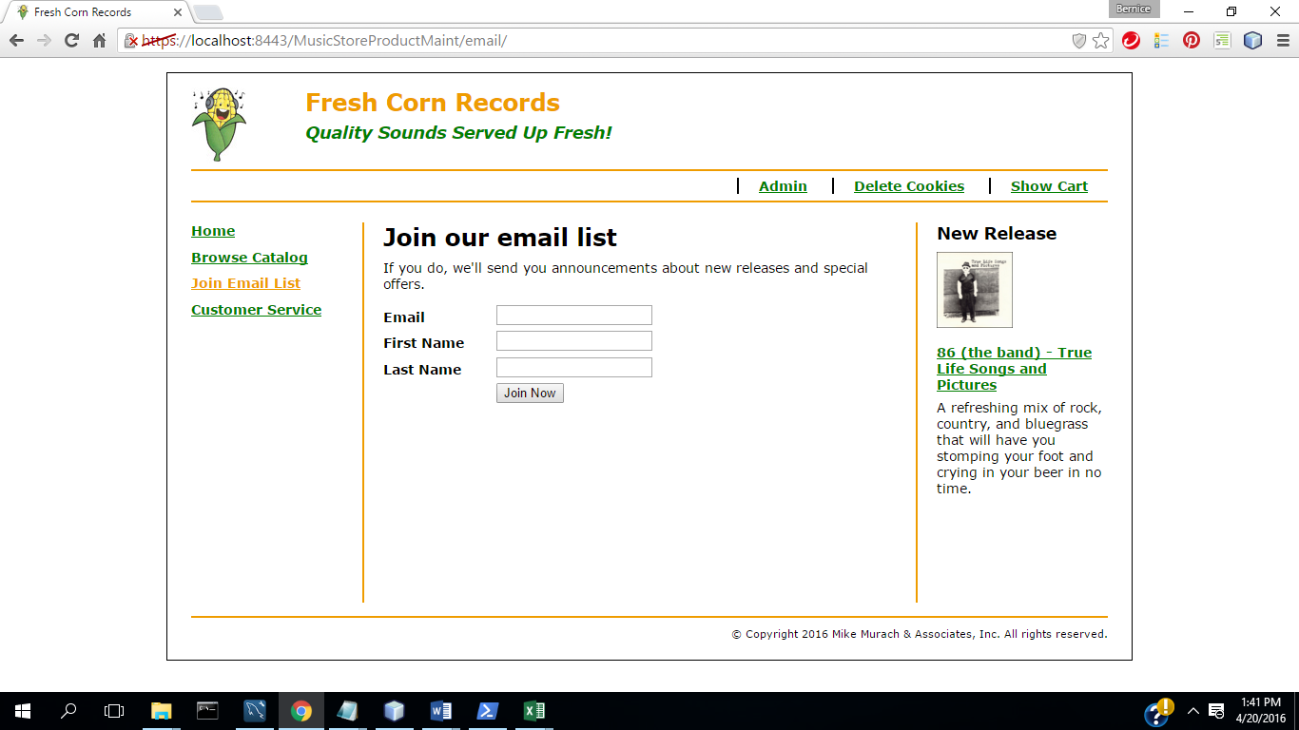

16) Select Customer Service

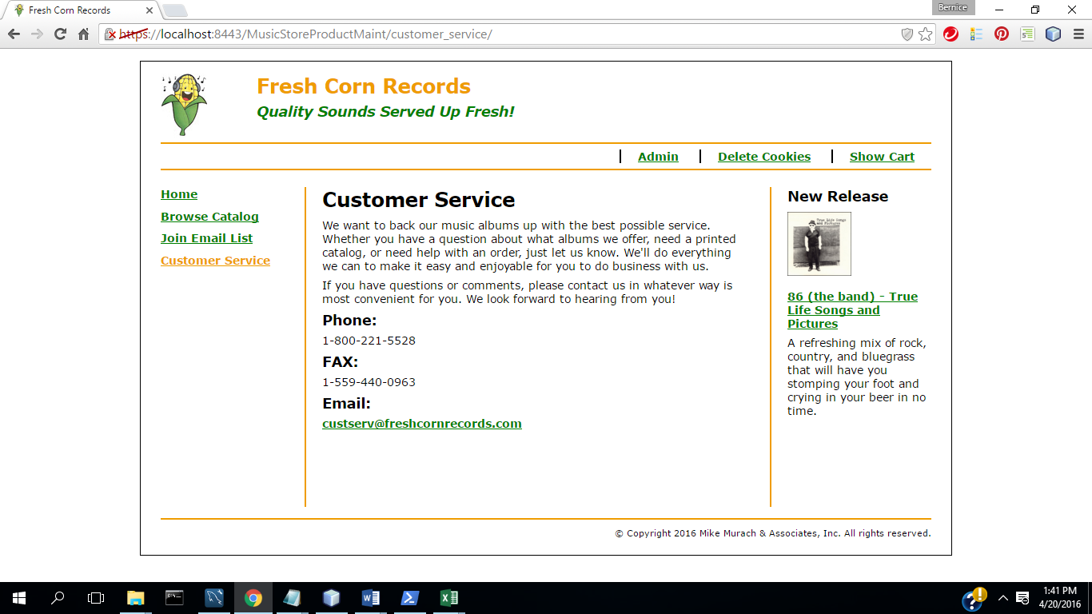

**(b) All program code for each part.**

In zipped file of NetBean project directory.

**(d) Test procedure/plan and implementation. What did you do to the test the program.**

**TC1: Admin**

**(1)Start App (Home Page):**

(2) Select Admin

(3) Login: **Admin Menu**

(4) Select **Product Maintenance**

(5) Select Add Product

(6) Select Update

(7) Complete fields with valid data

(8) Select Update( Commit Transaction & Update Inventory)

(9) Select Delete Product

(10) Select No

(11) Select Delete Product

(12) Select Yes (Commit Transaction &Update Inventory)

(13) Select Admin

(14) Select Process Invoices

(15 ) Select Go Back to Menu

(16) Select Display Reports

(17) Select User Email Report

(18) Download & open in excel

(19) Select Downloads report

(20) Continue

(21) Save and open in excel

**TC2: Music Store App**

(1) select Home

(2) Select Browse Catalog

(3) Select Product

(4) Select Listen

(5) Enter Information

(6) Select register

(7) Select Song

(8) Select Back in Browser until get back to page

(9) Select Add to Cart

(10) Select Checkout

(11) Select Continue

(12) Select Continue

(13) Complete fields

(14) Select Submit Order

(15) Select Join Email list

(16) Select Customer Service

**(e) Overall Block diagram showing high level design**