Explanation and hint for Exercise 5.20

The number π (mentioned sometimes as Pi) has an irrational value. In basic calculations we usually just use the value of 3.14. However, in some cases a much more accurate value should be determined. For example, the number π accurate to 16 places is:

3.1415926535897932

Mathematicians proved that there is an infinite series resulting in the value of π.
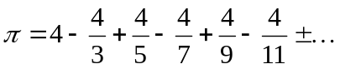
Let’s define 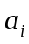 as the i^{th} term:
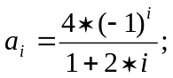
then let’s define

The following table contains some values of 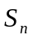:

n | 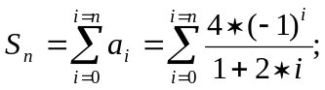
0 | 4
1 | 2.666667
2 | 3.466667
3 | 2.895238
4 | 3.339683
5 | 2.976046
6 | 3.283738
7 | 3.017072
8 | 3.252366
9 | 3.04184

It can be proved that if n goes to infinity, then the value of Sn converges to π.

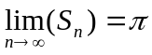;

Exercise 5.20 asks you to calculate the values of when it has 1 term (n=0), 2 terms (n=1), 3 terms (n=2) etc. Then, the program should print the value of n, where ’s first three digits are 3.14 first time in the iteration. It can be determined so that the difference between and 3.14 is less than 0.01.
Similarly, when first reaches 3.141, its difference from 3.141 becomes less than 0.001 first time. When reaches 3.1415, the difference becomes less than 0.0001. When reaches 3.14159, the difference becomes less than 0.00001.

