Florida Institute of Technology
MS/CIS Program
CIS 5100 Data Structures and Programming (Java)
Midterm Exam
Thursday, October 8, 2015

Name: Bernice Templeman Student Number (last 4 digits): 3207

REVIEW
Total: 99/100.
Congratulations!

1. A (5 points) Define the term “algorithm”.

An algorithm is a procedure or set of steps, in order, to solve a problem.

What are algorithms good for? (Use your own words.)

Algorithms are good for solving problems
and for being able to duplicate those results.
Once you have an algorithm you can re-use it.

They can perform exact calculations, process data and solve problems.

OK.
5/5.

B (5 points) What is UML?

UML is the Unified Modeling Language.
It is a graphical scheme for modeling object oriented systems.
It is used to visualize and document software systems.
It can also be used to document business processes and requirements.

What is it good for?

UML is good to use when working on the requirements for systems.
UML helps to to develop models.

It is the main language used in software design.

There are tools that can generate code from UML, perform analysis and other tasks.

It is portable. You can save them in a standard format.

It is flexible. You can tailor it to your needs.
You don’t need to use all the different types of UML diagrams.
The most common are the class, sequence, and use-case diagrams.

Software Architecture is the blueprint for the software systems.
So it is good to spend time on the Architecture to have a good system.
UML contains the information about the system so it can be communicated to others.

Acceptable.
5/5.

C (3 points) Write a program that decides whether integer number input1 can be divided by integer number input2 without remainder. The program should output “No Remainder” if there is no remainder and “Remainder is: ” if there is any. In this latter case, the program should output the value of the remainder as well.

import java.util.Scanner;

public class CIS5100_Midterm {

public static void main(String[] args) {

int choice = 1; //initialize choice to 1 to get user input

//create scanner to obtain input from the command window
Scanner input = new Scanner(System.in);

//loop to get user input for input1 & input2
while( choice == 1)
{
// ask for input1
System.out.printf("\nEnter integer input1: ");
int input1 = input.nextInt();

//ask for input2
System.out.printf("\nEnter integer input2: ");
int input2 = input.nextInt();

// check if input2 is 0 (can't divide by 0)
if (input2 != 0)
//check if there is no remainder
if( input1 % input2 == 0)
System.out.println("No Remainder");
else
System.out.printf("Remainder is: %d", input1 % input2 );
else //print error message
System.out.println("Error: input2 cannot be 0");

//ask if the user wants to continue
System.out.printf("\n\nDo you want to continue (enter 1 for yes, 2 for no): ");
choice = input.nextInt();
}
}
}

Nice.
3/3.

D (6 points) Write a program line that generates the following stream output:

First Name: My_First_Name;

Last Name: My_Last_Name;

System.out.println("First Name: My_First_Name;\n\nLast Name: My_Last_Name;");

Good!
6/6.
2. A (6 points) What is compilation?

Compilation is the action of producing something by assembling information from
other sources.

Compilation is the act of compiling by the compiler.

What does the compiler do? (Explain with your own words.)

A compiler is a computer program that translates a computer program from one
language to another language. Often source code is translated into binary or
object code. The resulting code is the code that will run (The executable).
Object code is platform dependent.

They java compiler translates source code to bytecodes that
represent the tasks. The Java Virtual Machine (JVM) runs the bytecodes.
Bytecodes are platform independent (they are portable and don’t require
re-compiling).

OK.
6/6.

B (7 points) How many control statements does Java have?

There are 7 control statements in Java:

Java has 3 kinds of control structures
- Sequence (1 control statement in Java)
- Selection (3 types of control statements)
- Repetition (3 types of control statements).

Name the control statements of Java.
- Sequence (sequential)
- if
- if/else
- switch
- while
- do/while
- for

Give at least 1 example for each.

//variables
int total=0, grade=0, counter=0;
int aCount=0, bCount=0, cCount=0,dCount=0,fCount=0;

// 1. Sequence:
total = total + grade;
counter = counter +1;

// 2. If:
if (grade >= 60)
System.out.println( "Passed" );

// 3. If/else:
if (grade >= 60)
System.out.println( "Passed" );
else
System.out.println( "Failed" );

// 4. Switch:
switch (grade/10)
{
case 9:
case 10:
++ aCount;
break;
case 8:
++ bCount;
break;
case 7:
++ cCount;
break;
case 6:
++ dCount;
break;
default:
++fCount;
break;
}

// 5. While:
int product = 2;
while( product < 10)
product++;

// 6. Do/While:
int i = 0;
do
{
System.out.printf("%d",i);
i++;
}while( i < 10);

// 7. For:
for(int j = 0; j < 10; j++)
System.out.printf("%d",j);
OK.
7/7.

C (5 points) Draw an activity diagram for the following piece of code:
while ( studentCounter <= 10 ) {
System.out.print( "Enter result (1 = pass, 2 = fail): " );
result = input.nextInt();
if ( result == 1 )
passes++;
else
failures++;
studentCounter++;
}

Attached a Visio diagram also.

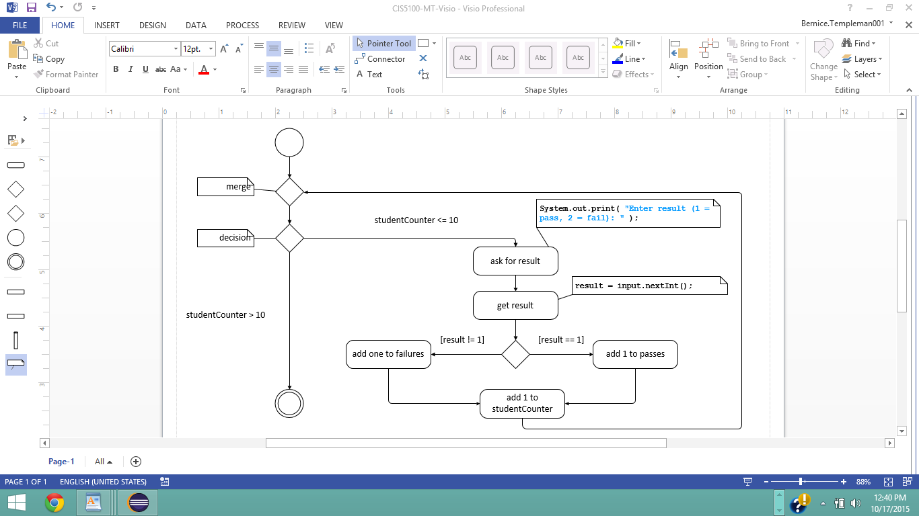

Beautiful.
5/5.

D (8 points) Write a FOR loop that sums even integers from 4 through 54 AND prints out the FINAL result only.

int sum = 0;

for(int i=4; i<=54; i+=2)
{
sum +=i;
if(i == 54)
System.out.printf("%d", sum);
}

OK.
8/8.
3. A (3 points) Write a piece of code in Java that sets the value of “int Number” randomly from the following set: {404, 405, 406, 407, 408}.

import java.security.SecureRandom;

public class CIS5100_MT_3A {

public static void main(String[] args) {

SecureRandom randomNumbers = new SecureRandom();

int Number = 404 + randomNumbers.nextInt(5);

System.out.printf("%d ", Number);

}

}

OK.
3/3.

B (5 points) Write a program segment in java that sets the value of “int Number” randomly from the following set: {404, 405, 406, 407, 411}. !

import java.security.SecureRandom;

public class CIS5100_MT_3B {

public static void main(String[] args) {

SecureRandom randomNumbers = new SecureRandom();

int Number = 404 + randomNumbers.nextInt(5);
if (Number == 408)
Number = 411;

System.out.printf("%d ", Number);
}

}

OK.
5/5.

C (11 points)Pythagorean Triples. The set of three integer values for the lengths of the sides of a right triangle is called a Pythagorean Triple. These three sides must satisfy the relationship that the sum of the squares of two of the sides is equal to the square of the hypotenuse.
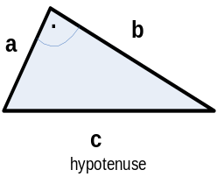

Specifically:
a*a + b*b = c*c
is true if and only of the triangle is a right triangle.

Write a method that gets 3 input integers and checks whether those in any order represent a Pythagorean Triple. The method returns ‘p’ if the numbers are of Pythagorean Triples and returns ‘n’ otherwise.

//method to check if 3 sides are a pathagorean triple
public static char triple( int side1, int side2, int side3)
{
if((side1 * side1) + (side2 * side2) == (side3 * side3))
return 'p';
else if ((side1 * side1) + (side3 * side3) == (side2 * side2))
return 'p';
else if ((side2 * side2) + (side3 * side3) == (side1 * side1))
return 'p';
else
return 'n';
}

OK.
11/11.

D (11 points)Write a program that prints out primes in a decreasing order between 1 and 59. (1 is considered to be a prime here.)

public class CIS5100_MT_3D {

public static void main(String[] args) {

//loop to print prime numbers in decreasing order between 1-59
for(int i = 59; i > 0; i--)
{
//check if number is prime
if(isPrime(i))
System.out.printf("\n%d", i);
}
}

// method to check if number is prime (1 is prime)
// primes are integers greater than one
//with no positive divisors besides one and itself.
public static boolean isPrime(int number)
{
// negative numbers can not be prime
if (number <1)
return false;

//1 & 2 ARE prime
if ((number == 2)||(number == 1))
return true;

//numbers>2 that are divisible by 2 ARE NOT PRIME
if (number % 2 == 0)
return false;

//check if number is divisible by other numbers
else
{
// find the square root of the number, round up & cast to int
int numberSqRt = (int) Math.ceil(Math.sqrt(number));

// loop to check
for( int i = 3; i <= numberSqRt; i+=2)
{
if (number % i == 0)
return false;
}
return true;
}
}
}

Value ‘1’ should be considered as a prime here.

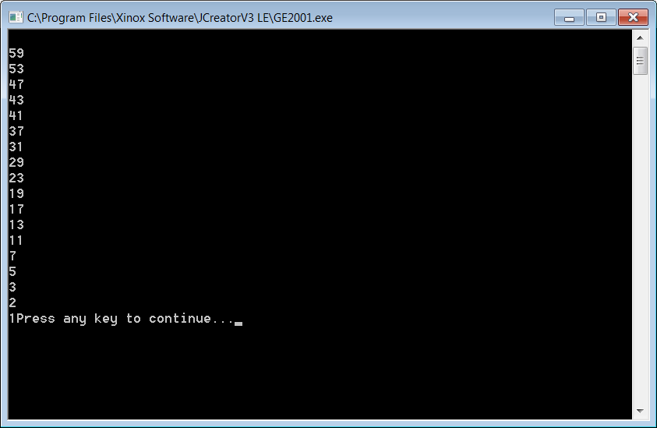
Correct anyway.
10/11.
4. A (7 points) An enhanced for statement loops through an array. The syntax is
for ( parameter : arrayName )
statement
How would you use a regular for statement to replace an enhanced one?
for(int i = 0; i < arrayName.length; i++)
statement;

Example:

int arrayName[]={1,5,3,7,9,0,2,6,4,8};

Enhanced for:
for ( int parameter : arrayName )
System.out.printf("%d", parameter);

Regular for:
for(int i= 0; i < arrayName.length; i++)
System.out.printf("%d", arrayName[i]);

Draw the activity diagram of the enhanced for. (Parameter goes in order for first to last, no index needed)
[parameter]
[no more parameters?]
Parameter=1st value inarray
Next parameter
Determine whether the last parameter has been reached
System.out.printf("%d", parameter);
Establish initial value of parameter
Statement
Next parameter in array

OK.
7/7.

B (7 points)Write a program that prints the following array’s values in descending order:
int a[]={1,5,3,7,9,0,2,6,4,8};

import java.util.Arrays;

public class CIS5100_MT_4B {

public static void main(String[] args) {

int a[]={1,5,3,7,9,0,2,6,4,8};

//sort array
Arrays.sort(a);

//reverse array
for(int i = 0; i < a.length / 2; i++)
{
int temp = a[i];
a[i] = a[a.length - i - 1];
a[a.length - i - 1] = temp;
}

// print array
for ( int parameter : a )
System.out.printf("%d ", parameter);
System.out.println("\n");
}
}
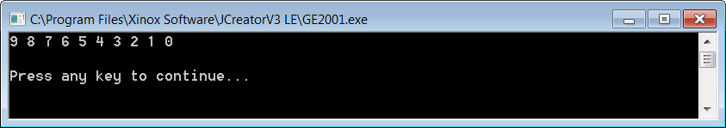
OK.
7/7.

C (7 points) A palindrome is a number or text phrase that reads the same backwards as forwards. For example, each of the following five-letter words is a palindrome: abcba, ghihg, bbbbb.
Write a program containing a method that determines whether a five-digit word is a palindrome.
char ch[] = {'a', 'b', 'c', 'b', 'a'}; // it is a palindrome
char ch2[] = {'a', 'b', 'c', 'd', 'e'}; // it is not a palindrome

public class CIS5100_MT_4C {

public static void main(String[] args) {

char ch[] = {'a', 'b', 'c','b', 'a'};
char ch2[] = {'a', 'b', 'c', 'd', 'e'};

if(isPalindrome(ch))
System.out.printf("ch is a palindrome\n");
else
System.out.printf("ch is not a palindrome\n");

if(isPalindrome(ch2))
System.out.printf("ch2 is a palindrome");
else
System.out.printf("ch2 is not a palindrome");
}

// method to check if a character array is a palindrome
public static boolean isPalindrome(char [] a)
{
// loop to compare 1st half with reversed 2nd half
for(int i = 0; i < a.length / 2; i++)
{
// check letters are not the same
if (a[i] != a[a.length - i - 1])
return false;
}
return true;
}
}

OK.
7/7.

D (4 points)What does the following program do?
Explain line-by-line and
then give the output.

public class Program
{
public static void main( String args[] )
{
int Table [ ];
Table = new int[ 6 ];

for ( int i = 0; i < 6; i++ )
Table[ i ] = i * ( i + 1 );

for ( int i = 6; i > 0 ; i-- ) {
System.out.printf( "%d \t ", Table [6-i] );
if ( i%2 != 0 )
System.out.print( "\n" );
}
}
}

/**********Explanation**************/

//begins class declaration for class CIS5100_MT_4D
public class CIS5100_MT_4D {

// main method begins execution of a Java program
public static void main(String[] args)
{
// declares an integer array variable Table
int Table [ ];

// creates the array Table; assign to array variable
// Table is an array of 6 integers (0-5)
Table = new int[ 6 ];

// loop through array index values 0-5
for ( int i = 0; i < 6; i++ )
// set the value of the index to index * (index+1)
//first time i = 0, index 0 = 0 * (0 + 1) = 0
//second time i = 1, index 1 = 1 * (1 + 1) = 2
//third time i = 2, index 2 = 2 * (2 + 1) = 6
//fourth time i = 3, index 3 = 3 * (3 + 1) = 12
//fifth time i = 4, index 4 = 4 * (4 + 1) = 20
// sixth time i = 5, index 5 = 5 * (5 + 1) = 30
Table[ i ] = i * ( i + 1 );

//loop through i in reverse ( 6-1)
for ( int i = 6; i > 0 ; i-- )
{
// print value in Table at index 6-i,1space,tab,space
//first time i = 6, 6-6 = 0, Table[0] = 0
//second time i = 5, 6-5 = 1, Table[1] = 2
//third time i = 4, 6-4 = 2, Table[2] = 6
//fourth time i = 3, 6-3 = 3, Table[3] = 12
//fifth time i = 2, 6-2 = 4, Table[4] = 20
//sixth time i = 1, 6-1 = 5, Table[5] = 30
System.out.printf( "%d \t ", Table [6-i] );

// if i is odd then go to next line
// 2 values printed per line
// 1st line is: Table[0] <tab> Table[1]
// 2nd line is: Table[2] <tab> Table[3]
// 3rd line is: Table[4] <tab> Table[5]
// 4th line is blank
if ( i%2 != 0 )
System.out.print( "\n" );

} //end for loop
}// end main
}// end class

/**********Output*******************/

0 2
6 12
20 30

OK.
4/4.

