9. Trouble Shooting V.2.6

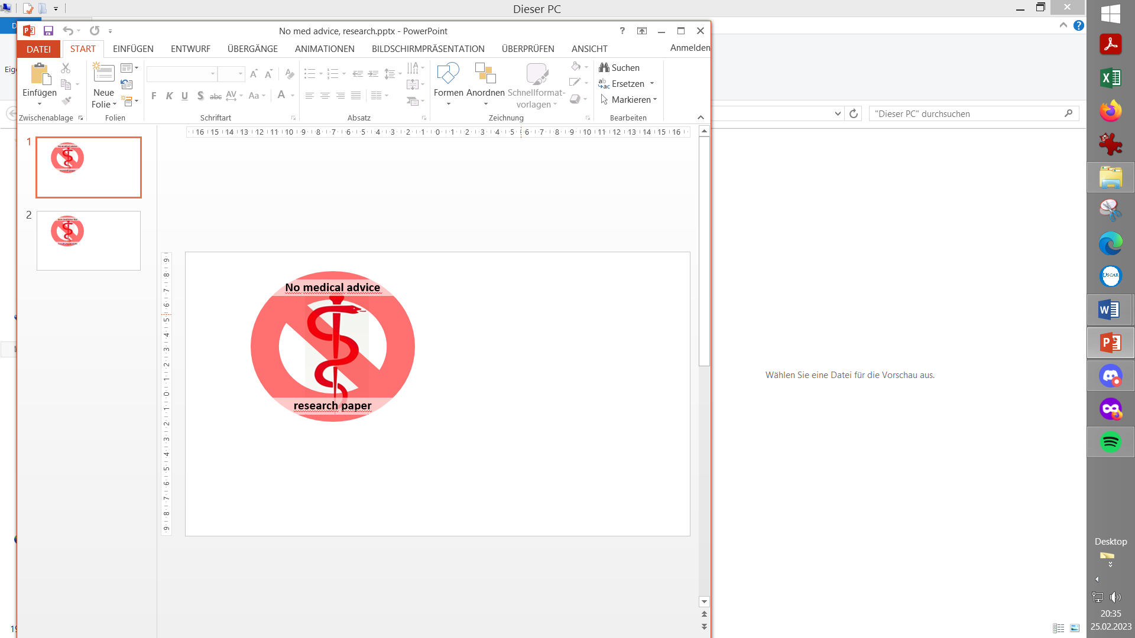

**Please note that with autoISF you are in an early-dev. environment**, where the user interface is **not optimized for safety** of users who stray away from intended ways to use.Good safety features exist, but these are only as good as the development-oriented user understands and implements them. This is not a medical product, refer to disclaimer in section 0

9.1 How to get back into Hybrid Closed Loop

Available *(related)* case studies:

(none yet)

9.2 Are the pre-conditions for FCL still given?

9.3 Glucose goes too high

9.4 Glucose goes too low

9.5 Glucose goes too high and too low

9.6 Staying out of Trouble

9.1 How to get back into Hybrid Closed Loop

You can go back to bolussing for meals (+/- making carb inputs) again at any time just by

* Going into AAPS Preferences/OpenAPS SMB/autoISF and switch „Enable ISF adaptation by glucose behaviour“ OFF.

You might need to re-install your insulin button via AAPS Preferences/Overview/Buttons

* Pressing on the **violet Full Closed Loop circle** and select the green Hybrid Closed Loop circle (easier, in case that user interface element is already included).

This will automatically bring back your buttons “Insulin, Calculator…” you always had at the bottom of your AAPS HCL main screen

Be aware that now it is again up to you to bolus for meals

Note that even if you had an established Hybrid Closed Loop *with autoISF*, the HCL you switch back to would be normal OpenAPS SMB (without autoISF ISF modulation).

That is the safest bet in absence of sufficient data whether tuning the _weights in autoISF would have to differ between FCL and HCL mode. According to a n=1 observation they might work with the same setting (see <https://github.com/ga-zelle/autoISF/blob/A3.2.0.2_ai3.0/To%20prebolus%20or%20not%20to%20prebolus.pdf>) but more data are needed, notably also the variance with size of pre-bolus, and kind of meal.

It can also be wise, especially in your initial months, to do FCL only for certain meal time slots, and use an **Automation** that shuts down

* either bgAccel_ISF utilization,
* or all of autoISF _ISF modulations („Enable ISF adaptation by glucose behaviour“) for the rest of the 24 hour period. In that case, the loop button will automatically adjust its color violet <-> green to show which state your loop operates under (in case that user interface is already included)..

For instance, it is perfectly possible, without any extra steps involved, to do FCL only for dinners, while breakfast and lunch are done in hybrid closed loop, as you are used to.

9.2 Are the pre-conditions for FCL (still) given?

* Can you pin problems to **Bluetooth** instability (e.g. not always carrying phone with you), lost pump connection, or other technical issues?
* Has the **CGM quality** deteriorated?

It may be worth analyzing data

* + without sensor-day-1
  + without cannula(pod)-day>2.0

to see whether problems have to do with your autoISF settings at all, or with “pre-requisites” not fully met

* Did you observe the necessary **sequence in your FCL set-up** ?
  + Preparing for bigger SMB sizes according to section 2
  + *Then* finding settings for bgAccel_ISF_weight *first*, then pp_ISF_weight, according to section 4

Note that trying to do too many things at once (like immediate inclusion of options from sections 5 and 6) can make it difficult to judge the core settings.

* Is the basic **profile** (still) correct ? Was it correct when you started, or could it be the case you started with incorrect settings that were camouflaged by other settings, or by dynamicISF?

It may be worth

* + going into Open Loop and doing an ISF test at a crucial time of day
  + testing FCL performance with a temp. changed %profile (if you suspect your insulin sensitivity has changed)
* Did you set a sensible **iobTH** (via iobMAX and iob_threshold_percent settings in /preferences) ?

Note that iobTH **dynamically adapts** whenever you run with modified sensitivity:

* + Very easy to recognize by one or more of the top buttons in your AAPS home screen being temporarily yellow (see section 5.4.1)
  + The Activity Monitor (section 5.1.5 and 6.6) could do it also

(To be discussed: In a future update we could make the exercise button yellow also *without* a yellow TT, to differentiate exercise from "activity", regarding a modified sensitivity running).

* + In decisive moments (or later, reviewing logfiles) look up in the AAPS SMB tab, how exactly your profile_ISF is modified. Note that any modulating factors, but also your set profile_ISF might be the problem. (This is why, throughout this e-book, we keep emphasizing that you should get your FCL started only with proper profile_ISF).
* Consult section 1 for potential other missing pre-requisites.

9.3 Glucose goes too high

* Meals are not recognized asap
  + Check regarding Bluetooth (in)stability
  + Experiment with an aperetif, soup a couple of minutes before meal start
* First SMB(s) seem a bit delayed
  + Check whether SMB got blocked by the 30% rule (refer to section 1.3), and what the underlying cause may be
  + Check whether an odd bg target or TT (maybe in context with an Automation) interfered
  + Check pump connection (BT, and physical)
  + Check stability of regular CGM values (notably: was phone in proximity at meal start?)
* SMBs are too weak
  + Check acceleration detection (e.g. CGM, BT or smoothing related)
  + Check (real-time) in SMB tab what (“safety”?) setting limits allowed SMB size
  + Check whether your autoISF_max is set too low in AAPS preferences
  + Check (real-time) in SMB tab whether bgAccel_ISF_weight or pp_ISF_weight should be set higher
  + Check potential interference from sensitivity modulations (e.g. exercise mode active)
  + Check in preferences whether, after a FCL pause, you “forgot” to re-activate “Enable ISF adaptation by glucose behavior” , or whether an Automation could have temp. deactivated it, and hence you had received SMBs only from the basic oref(1) SMB+UAM algo, without boost by autoISF
  + In case you are (e.g. due to an on-coming infection) more insulin resistant currently, consider – as in Hybrid Closed Loop – a temp. profile switch to >>100% and do not shift other settings (that would be wrong when your general sensitivity bounced back to your normal)
* Default iobTH (or: modulated iobTH) might be (or: go) too low, and therefore cuts SMBs too early

Check whether your FCL *really* operates with the iobTH you think it uses. Observe the Caution notes (e.g. in section 5.1.4) about needing re-sets to default, after an Automation had lowered the effective iobTH.

* An important observation by pilot users was, that how your glucose and iob curves approach meal start matters a lot regarding how you peak from carbs:  
  Going down (e.g. towards a set EatingSoonTT), building some iob, and curving already towards strong positive acceleration seems very helpful to keep peaks low.
* When all trouble shooting ideas are exhausted, notably all measures to pull powerful SMBs earlier are exhausted, and the tail of insulin activity already pushes you close to a hypo: Then you simply must **find your personal balance** between
  + Accepting *sometimes* trending higher than you would like to, for not going low.
  + Change diet (probably to something with lower amounts of carbs, and higher amount of protein and fibre).
* A pretty benign way to improve bg development after meals could be to just take a walk (notably if starting before/ when glucose seems “stuck” high).
* Some users resort to using a small pre-bolus in their “FCL” (maybe just for to-them-known troublesome types of meals). However, this interferes with how glucose curve and hence detection of rises and triggered SMBs behave. It is therefore not easy to implement with convincing overall benefit.(See discussion in section 4.1 underneath the bg / autoISF graph).

9.4 Glucose goes too low

* **M**eals are falsely recognized
  + Check whether this occurs outside of usual meal times and can be averted by e.g. setting an odd profile target for that time of day.
  + Check whether your bg_Accel_ISF driven first SMBs are too big and lead to too much iob when the bg rise turns out just a temporary bumb.
  + Try to exclude the problematic situation via an Automation that, for a couple of minutes only, sets an odd TT and thus prevents a SMB.
  + To prevent snacks from triggering SMBs as for a meal, use the FCL cockpit for an appropriate temp. setting (low iobTH ;or odd TT for SMBs off; or pre-set “snk” button).
* SMBs deliver overall too much insulin
  + Check whether you operate with a too high iobTH.

If an Automation might have elevated the effective iobTH, check whether your FCL *really* operates with the default iobTH again afterwards. Observe the Caution notes (e.g. in section 5.1.4) about needing re-sets.

* + Check (real-time) in SMB tab whether SMB range extention or autoISF_MAX should be set smaller
  + Check (real-time) in SMB tab which of the autoISF …_weight should be dialled in smaller . Often it will be a too strong dura_ISF. However, that one inheritantly gets stronger with higher and longer lasting highs. Therefore the best remedy is to first try to be more aggressive before, in the glucose rise phase and limit height and duration of the high, then tweak the dura_ISF_weight (downwards).
  + SMB delivery ratio probably can be set smaller. Note in this case, it works across the bord for all SMBs (all time slots),
  + In case you are (e.g. due to a preceding sports day) more insulin sensitive currently, consider – as in Hybrid Closed Loop – a temp. profile switch to <<100% … and do not shift other settings (that would be wrong when your general sensitivity bounced back to your normal)
* Problems with insulin “tail” after meals
  + *See* *2 bullet points higher* *up*: dura_ISF tuned too strong?
  + You may need to take a snack (seeing hypo prediction) or glucose tablets (if already in hypo zone). But note that the grams of carbs required that the loop might tell you at some point are very likely exaggerated as the loop has no info *) on your carb intake (while you may be able to guess how much more, incl. from fats and proteins) is still waiting to be absorbed. ( *)The loop makes assumptions based on past minutes carb deviations, see reference given in section 4.5)
  + A valueable information would be whether the problem originates mostly in the bg rise phase already. Then setting a lower iobTH might be an easy remedy.
  + If the need for additional carbs happens frequently, note down how many grams were needed (not counting what you eventually took too much which required extra insulin again). Then use your profile IC value to estimate how much insulin *less* the SMBs should have delivered, and go with this info into your tuning (regarding the % profile in the Automations, or maybe also your set iobTH). This may relate to the SMBs given when glucose was high, or also extend regarding the SMBs during the glucose rise.
  + When all trouble shooting ideas are exhausted, you simply must **find your personal balance** between
    - Accepting *sometimes* trending too low and needing a <10 g snack. (There are worse things in life, and if you are weight conscious, eat these grams less at the meal itself. Over time you should learn at which type of meals – probably those *low* in fibre, fat, and protein - this scenario arises)
    - Accept on average a bit higher glucose peaks, for not going low.
    - Change diet (probably to something with lower amounts of carbs, and higher amount of protein and fibre).

9.5 Glucose goes too high and too low

Frequent roller coasters point to serious problems with your set-up.

* **Try not do master everything at once**. Is your eating and general life style just so extreme, and your expectation into the capabilities of the system too high / your understanding of its limits too low? Then you could consider giving the FCL another serious try for periods that are less varied (e.g. just one of your daily meal times, only weekends, not days with Xtreme sport …). Make it work there, then gradually expand. Sections 5. and 6. describe a mind boggling number of ways to deal with special “disturbances”. Just occasionally try one that interests you. Stay connected with others that are in the same boat.

Even when basic pre-conditions (see 9.2) seemed given, and you “tried already everything”:

* Was your autoISF FCL built based on true and experimentally proven ISFs?
* Did you follow the sequence of tuning steps (sections 2, then 4 ; bgAccel_ISF-weight first?)
* How often did you consult SMB tab or emulator, to gain an understanding what is/was happening?

With the multitude of inter-acting parameters and settings (that already after a short time would be burdened with counter-balancing errors) it is extremely difficult to untangle and correct this. Best idea then might be

* an entire new start. (There is emphasis all over this paper that with autoISF FCL you are in a development project. So, taking some steps back and starting over from there should be acceptable.)
* going back into your prior Hybrid Closed Loop (potentially with some benefits from autoISF also there)
* or resorting to another method as e.g. mentioned in section 13
* or switching to a simpler loop system as fully supported by your doctor, and wait for improvements the industry will provide over time, too.

9.6 Staying out of Trouble…

In closing this chapter we like to remind everyone that interfering with a closed loop should be kept at a minimum.

Also, „optimizing“ parameters for just *one* specific meal type or other experience is a **flawed „fine-tuning“ concept** when you are in FCL, and can easy backfire (see case report 8.2 as an example). What we want is settings that get us „good-enough“ through (nearly) all scenarios in our personal everyday lifes.

This is a good time to throw in a reminder, where the real world of T1Ds stands, and the consensus in the medical community, regarding desirable %TIR (or HbA1c, as only a minority would have TIR data).

Weigh for yourself what it is that you try to achieve. For instance, 80%TIR was reached in a study even with a much simpler FCL (AAPS with Automations, Fiasp, no autoISF), and no meal announcements whatsoever.

* **Do the basics right, keep it simple.** Resist the temptation to embark always on the latest craze without knowing how extra features might topple your carefully set balance.
* Learn to use FCL in some times, and not in others that you believe may be too challenging, or you have already a bad experience with (and no time, interest, skill, to resolve it for now. That is fine, too.).
* Stay in touch with the community of developers and other users
* **Relax and enjoy** as/when/while good-enough. „Just eat!“