5. Time Blocks in which No Aggressive autoISF Should Run V16

Once the initial tuning according to section 4. is done, you are ready to use autoISF for your automated meal management.

You will have two major other challenges to manage:
- recognize and manage (partial) occlusions, or other technical (CGM or BT related) obstacles
- deal with times when the loop should be set "milder" as a precaution.
How big this challenge is depends very much on your individual lifestyle. Sections 3 and 4 discuss this in more detail.

In order to run the loop fully automatically around the clock, the times outside the meal blocks must also be precisely analyzed, and solutions to problems must be sought.

5.1 Manage Time Blocks of Different Aggressiveness w/ Automations and/or setting odd TT

Personalized Automations tailor the loop exactly to your data so fully automated handling of time blocks with different aggressiveness of the loop can be made.

In setting up your FCL, you therfoire now have another difficult and time-consuming job at hand, to define automated solutions for any of your „other“ situations, outside of meal management.

5.1.1 Using Automations to reduce FCL aggressiveness outside of meal times
A widely used ACTION that strongly modifies how fast your FCL can add more iob is setting an odd-numbered temp. glucose target which makes the loop operate without giving any SMBs (%TBR modulation only).
Ensure the even/odd logic in the settings is toggled on in Preferences> openAPS SMB> autoISF settings> smb delivery settings>: "Enable alternative activation of SMB depending on TempTarget" ON as well as "Enable...depending on profile target" ON.
So, from patterns you find in YOUR data, at times where you want your loop act differently, you need to carve out CONDITIONS that describe the respective situations (and either for how long it typically lasts, or at which other CONDITIONS you want your loop get back to default FCL operation).

From, autoISF 3.0 onwards, also the following parameters are provided as CONDITION and/or as ACTION for defining YOUR Automations:
- Enable ISF weights / Disable ISF weights => Allows temp. ON/OFF for the key ISF modulation parts of autoISF
- Trigger/set iobTH percent => Keeps default aggressiveness, but only until a modified iob threshold is surpassed
- Trigger/set bgAccel_ISF_weight => Modifies the default aggressiveness

Recommended solution for nights
The recommended solution for nights is to set an odd profile target that prevents SMBs.
If you do have nights that would benefit from a couple of SMBs (to treat temp. highs from a late fatty pizza, raclette and such): Define suitable Automations like the two „night“ ones in this list:

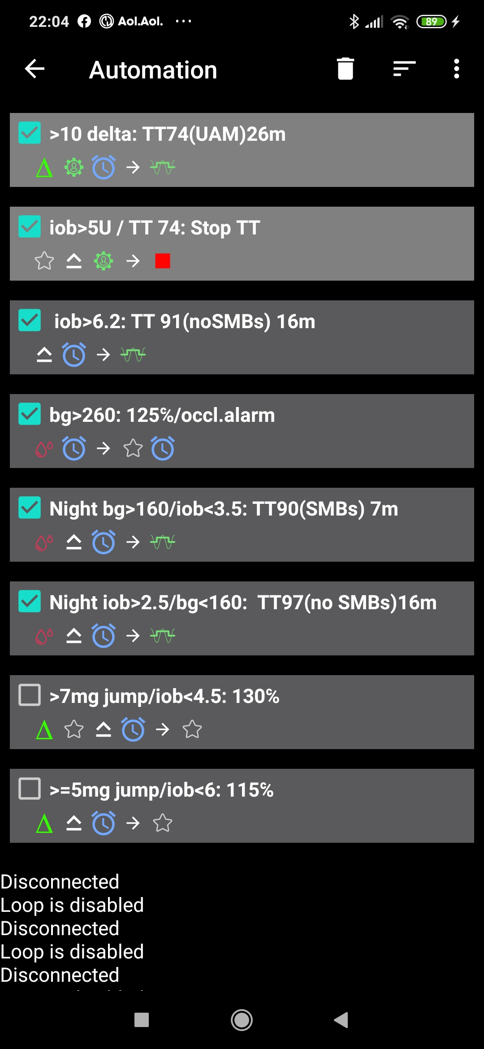

Do not underestimate the „trickyness“ of getting these Automations „right“.
Night data (with your thought-out Automations in place) need to be analyzed to see
- whether the bg and iob limits defined in the given example work sensibly
- whether the TT duration is chosen appropriately
- Swapping the sequence in which the automations appear in the automation list would also lead to different SMB impacts.

5.1.2 Using Automations to focus (or differentiate) FCL aggressiveness to (in) meal time windows

If, aside from meal management, you were rather happy in hybrid closed loop, you could continue to run in that mode, and just focus your new autoISF FCL on management of meals (on all meals, or only on a sub-set of them, like only dinners – which might make sense especially in your initial transitioning phase).

For this, you define Automations

- that set meal time windows in which autoISF gets fully turned on
- or: that turn off autoISF (or just bgAccel_lSF off) in time windows in which surely no meal occurs.

Other early DEV AAPS variants (see section 13.3) all work with meal-time windows. The window is either set by time of day in the settings, or it always must be „set“ by the user via giving a mandatory small pre-bolus before any meal starts. Outside of these time windows, these loops then runs with less aggressive SMBs like oref(1) SMB+UAM in AAPS Master.
This mode is not really FCL, but an advance over traditional HCL that often achieves satisfying degrees of automation and performance.
The term Meal Announcement (MA) is often used to label this closed looping mode.

5.1.3 Activity Monitor
If you choose to make use of your smartphone‘s stepcounter, you can (automatically) adjust insulin sensitivity ratio to activity level in the past minutes to one hour time frame.

This is another little tuning opportunity, in which you study your body’s response to light exercise (like walking) or to not moving at all (like desk, couch), and select appropriate settings which, in the future, will automatically adjust insulin delivery to suit activity state of the past minutes (up to 1 hour).(AAPS Preferences/OpenAPS SMB/Activity modifies sensitivity/ -> set two scaling factors.)

This autoISF feature (new since V.3.0) is much quicker responding than Autosens or dynamicISF to adjust insulin sensitivity to your current „lifestyle state“.

More see sections 3.5 and 6.5

5.1.4 Completely hands-off Full Closed Loop?

Remaining 24/7 in a „hands-off“ FCL can be a realistic goal with autoISF 3.0 if special challenges - as discussed in section 5.1.1 were analyzed and adressed.

Clearly it depends very much on your lifestyle, and how interested, willing, and capable you are to recognize, deal with, (and in the future avoid?) situations that get you outside of your desired %TIR on occasion.
So, this is also about what %TIR you are aiming at, and can accept, as it averages out for the week, for instance.

Even if a principal capability for a fully automatic running FCL is given, this still
means that
- the user should be knowledgeable about what exactly is going on, and
- has a capability to „nudge“, or even to take over.
In section 5.2 that immediately follows, we discuss the options the FCL cockpit on the AAPS home screen gives you, to occasionally tweek your FCL aggressiveness, should you see a need to do that.

5.2 FCL Cockpit: AAPS home screen as primary access point for modulating aggressiveness in daily use

Note: autoISF 3.0 is an early dev variant of AAPS, and as user you are participating in an on-going development. Of note, autoISF 3.0 is first launched without many of the described cockpit features that are presented below.
For the time being, multi-step work-arounds may become necessary. In many cases, going into AAPS Preferences and changing settings would be needed (…plus not forgetting to change these settings back, afterwards).

This is also an open invitation for you to contact us in case you could help program a module for one of the required user interface extras.
For future integration into AAPS Master, an eye should be kept also on the question which other modes (like FCL using Automations, or dynamicISF etc.) might benefit from some of the extra features.

The loop can run fully automatically without any user interaction (after the initial tuning phase, and related settings made in AAPS /preferences/SMB/autoISF).

But, just like in the airplane cockpit: Cruising in full auto mode should involve having an eye on the instruments, and on potential disturbances ahead in the environment. E.g.: storm ahead => instruct your plane to climb to another flight height.
Anology: exercise ahead => setting an exercise TT, or => pressing a button that activates a sequence of instructions (some of them probably hinging on conditions, like actual iob) how to manage through that exercise situation).

So, for the occasional „disturbance“ coming up, you should find an easy way to
- call up a pre-programmed routine for automatic management, with auto-adjusted aggressiveness, or:
- tweak a setting or two, to temporily adjust the aggressiveness
- There may also arise a desire to just exit the FCL mode, and be your own captain for mastering a special situation.
All this is facilitated within seconds right from the AAPS home screen’s cockpit features (to the extent they are already incorporated):

- The button that is integrated into the violet FCL icon serves as emergeny off button, to quickly stop FCL, or to at least to immediately stop any more SMBs (…just for a couple of minutes, or for the remaining meal time: pick from the options offered with just one keystroke).
Via the violet FCL icon on your AAPS home screen, you also can access a temp. switch-off button for SMBs (see section that next follows below).

- The three top fields (%profile, exercise, TT) provide access to temp. tuning of core parameters, and/or to some pre-programmed routines.
Taken together with some new indicator fields about your loop state, this makes the AAPS home screen your cockpit for Full Closed Looping.

Let us look on each of these cockpit elements in some detail:

5.2.1 Violet FCL icon and underlying buttons

Novices to FCL, or really anyone running into a very special situation, may appreciate that the new closed loop icon on the AAPS home screen in pink (for FCL) has buttons to quickly shut off getting more SMBs (1st row), or to enter other loop modes (second row).

It functions very much as the other ones that you know from HCL already, and in fact you get offered some of the same options (for instance, to switch the (full) closed loop off for 15 minutes for going to take a shower)

Note that in FCL you leave all BG regulation, notably against meal spikes, to the loop. So, try not to disconnect in phases when your FCL must ramp up your iob.
The required insulin would still be supplied after you reconnect. However, without the user pre-bolussing, the delay would be more of an issue in FCL than it had been in HCL.

Just pressing on the FCL icon, a dialogue box comes up:
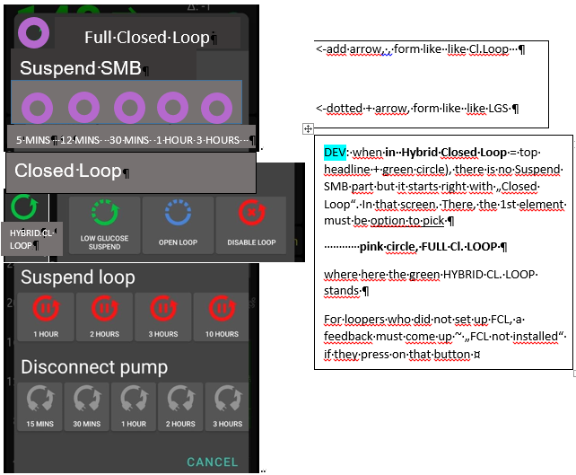
5 MINS 12 MINS 30 MINS 1 HOUR 3 HOURS
Closed Loop
Pressing „Suspend SMB“provides fast and easy „emergency braking“ regarding delivery of more SMBs:
Select the one with the desired number of minutes: 5 or 12 for just blocking the potential next SMB(s), and up to 3 hours to manage the entire rest of this meal with %TBR from then on.
Whenever, and whyever, your FCL is in „no SMBs allowed mode (e.g. automatically after surpassing an iobTH also, or might be triggered by an odd TT), the FCL icon will turn into a dotted one.
Instead of remaining duration to end time it indicates in the middle „the condition“, „iob“ or „TT
Add an indication if suspend SMB comes from an Automation, e.g. add an „ (A) „ underneath the #minutes, iob, or TT in the middle of the dotted violet field.
So, as in other (already in HCL existing) cases, those icons show in the middle the minutes left that they will be running, or the condition which would have to go away for this temp. setting to stop.
It always auto-reverts into the FCL state and FCL icon, when time (or other condition) has elapsed.
Pressing „HYBRID CL. LOOP“ or other buttons from the 2nd row provides fast and easy „emergency exit“ into other modes.
This enables beginners an easy „temp. escape“ into their well-known HCL (green) at any point of time. bgAccel_ISF_weight is set to zero when going FCL->HCL. HCL can run with autoISF (for instance dura_ISF) uninhibited otherwise. (check implications for HCL users of autoISF ?? ).
Note: These options from row 2 have no time limit. Loop will not by itself go back to FCL. You see the different loop icon as a reminder to manually revert, when ready.

5.2.2 Buttons „Insulin“, „Calculator“ etc at bottom of AAPS home screen

These buttons are not useful any longer in FCL, and automatically disappear whenever in FCL mode (also in Suspend SMB state), and re-appear when leaving FCL. This applies also when an Automation or technical system failure shut off FCL.
Users who, maybe in the beginning phase, feel better having those buttons, can override the removal (of the insulin button, or any other) by going into /preferences/overview/buttons and forcing them on. They only remain on until the next re-entry into FCL mode, when auto-off happens again.
The reason why we do this: It really is important to let the loop loop, and not interfere more than absolutely needed. Any bolus the user gives will sure distort the bg curve, on which autoISF, especially when aggressively tuned for FCL, builds a lot of its decisions!

5.2.3. Three top fields (%profile, exercise, TT)

Depending on the variiedness of lifestyle, the desired %TIR, and the initial tuning effort put in, the user may want occasionally to „tweek“ the aggressiveness of her/his FCL.

The top 3 fields (grey in default mode, yellow when temp. in mode with changed agressiveness) serve as quick and easy entry points to make temp. switches (as users will be used to for %profile switches, or for setting an EatingSoonTT in HCL, .. which they still can do in FCL … but more:)
Expert FCL users might need this feature rarely, but probably at least to manage activity after meals: Each require opposite aggressiveness, and the switch has to come in a certain point in time that would be difficult to capture. (More see section 6.4 )

5.2.3.1 TT dialoque field (if extended design for FCL cockpit is already launched)

The TT field (top right of AAPS home screen) is the primary daily interface, and a dialogue field opens when pressing on it:
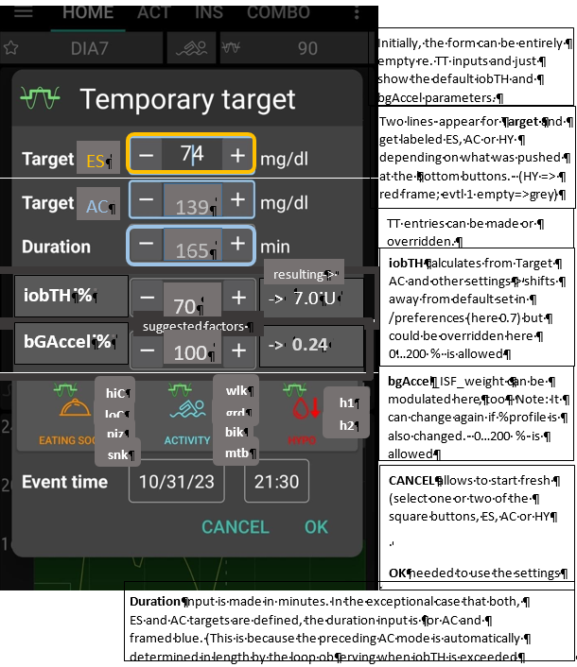

This looks complicated but only because it allows 4 different modes of use. Each user will primarily use her/his preferred one.
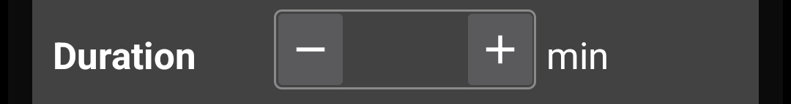
139
165
iobTH %
-> 7.0 U
ES
AC
iobTH calculates from Target AC and other settings-> shifts away from default set in /preferences (here 0.7) but could be overridden here 0…200 % is allowed

TT entries can be made or overridden.
CANCEL allows to start fresh (select one or two of the square buttons, ES, AC or HY

OK needed to use the settings
bgAccel_ISF_weight can be modulated here, too - Note: It can change again if %profile is also changed. 0…200 % is allowed
bGAccel %
-> 0.24
resulting->
suggested factors
70
100
hiC
loC
piz
snk
wlk
grd
bik
mtb
h1
h2
- Who is happy with the initially well tuned FCL and does not have huge variations in daily eating and moving around, will not use the TT at all. FCL is possible without an intervention via the TT button in your cockpit. Actually 4 of 8 modes (list at line 700) are not making use of TT.
- Super easy is also, to just input any odd-TT (odd-numbered temporary target) that will shut out any SMBs for the set duration. That can be a good idea when having a snack, for instance.
Super quick access to stop SMBs is possible also via the loop icon (section 5.2.1).
Specifically, an EatingSoon TT can be activated here (limited relevance see section 2.5). It is time-un-critical, can be manually set, or come up via an Automation.
The cockpit enables you to set the iobTH differently (override) for the current meal.
(If the described feature is not yet included in your software version, change setting in /preferences or using an Automation)
Temp. iobTH will always revert to default when the TT expires. If another TT immediately follows, like in the example of the screen above, it will calculate, (then) show and use a new temp. iobTH.
- The third way is to use the input mask (if already ncluded in your software version see picture above) to freely modulate the loop aggressiveness for a declared number of minutes. Click the bottom big square(s): Either HYPO, or ACTIVITY, or EATING SOON, or ACTIVITY and EATING SOON (example in the pictured screen above). Make or override entries in the offered fields. Press OK.
- The fourth way is to exclusively use one of the 4+4+2 little buttons seen in the bottom part of the TT dialogue box (if already included in your software version). They provide a set of settings (as will immediately show in all input fields above) that the user has set up in Preferences/SMB/autoISF/FullLoop (refer to section 6.3), and can freely label there. For instance „hiC“ at high carb EatingSoon, „piz“ for Pizza/fatty meals, „grd“ for garden work, „mtb“ for mountain biking …
Capturing good settings for not-everyday situations in /preferences (if already included) allows calling them up within 1 second, from your cockpit on the AAPS home screen (…and won’t ruin the FCL experience at all , especially because in most cases it is not time-critical, how long before the intended exercise the buttons are pressed).
The example picture given above is the most complicated (but also most useful) case, when exercise follows after a sizeable meal. It is then that you need (a) aggressive FCL initial performance at the meal, but, exactly when (!) a (for the intended sport already temp.lowered) iobTH is exceeded, you need (b) to have SMBs automatically switched off and go into the „milder“ mode, as defined for the exercise (with high instead of lowTT, that automatically significantly reduces iobTH again, and insulin sensitivity(resistance) settings too).
Pressing exercise related buttons will automatically also light the exercise button on the main screen yellow.
To summarize, the TT dialogue field offers easy but powerful ad-hoc modulation of loop aggressiveness for FCL (if already included).

(tbd: Which of these UI elements will also be available in HCL autoISF ?)..

5.2.3.2 Exercise button (see more in section 4.)

The exercise button automatically lights yellow when exercise related TTs are activated in the TT dialogue box. 4 of 8 modes (list at line 670) are making use of the exercise button.
If pressing on the exercise button, a dialogue box appears (if extended design for FCL cockpit is already launched) with info on exercise setting first ( and opportunity to override), plus below the activity monitor (experimental for auto-tracking of lighter movement during the day, and effects on sensitivity that may have. See section 4.5).
So, first the exercis settings (as set under TT) are there to read. Example :
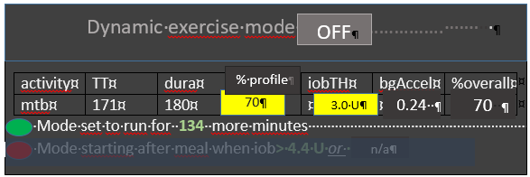

The exercise (here mtb) is selected in the dialogue box of the neigboring TT field, and there auto- filled with settings made in the set-up and tuning stage by the user under preferences (see above,….). They are reported also under the exercise button here, and TT, duration, and % sens (which also shows active on the %profile field on the left side of the exercise button) can be temp. changed there. iobTH, bgAccel_ISF and overall resulting sensitivity ratio is given in the other fields.
The middle field of the table, „% profile“ either picks up the % set under the %profile button, or an input can be made here, in the exercise button domain, which will:
- turn the neighboring %profile button on yellow and show that inputted % on it, too
- be multiplied with the result from the exercise mode settings per se, and change the % overall, accordingly.
So, if this middle field of above table (dialogue box of sports button) contains a figure other than 100, input field becomes yellow,and you are operating with a combination of traditional PLUS new exercise mode (with all three top buttons of your FCL cockpit yellow). This maximally will soften aggressiveness, for which you get an idea by the last calculated figure.

The mode is either running already (for another number of minutes, as probably also shown in the yellow TT field anyways). Or it is scheduled to run, after insulination for a started meal reaches iobTH (as in table). Or, no exercise is scheduled (both points red, no entries.

The lower part of the exercise dialogue box (not pictured above, but see in section 6.5) is dedicated to the Activity Monitor

5.2.3.3 Profile button
The profile button can still be used to set a different profile, or profile%, for instance to adjust for days with sickness (as you are used to from hybrid closed looping). 4 of 8 modes (list at line 670) are not making use of the profile button.
Any inputs made here will be used to modify profile_ISF on which all further changes are made on (multiplied with).
The profile field remains grey if standard profile is applied.
It turns yellow, displaying a %figure relating to any altered loop overall aggressivenes:
- When no inputs (changes from 100% profile) are made here, but inputs in the TT field, e.g. for exercise, automatically lead to different insulin sensitivity ratio (see sections … and …) , that ratio is shown here
- when% is changed by input in the profile button itself, it will be multiplied with with profile_ISF and be used in place of profile_ISF by the algorithm.
However, for exercise (sports) you no longer must make an entry here, because reasonable %reductions should be automatically provided, driven by your set TT (and half-basal exercise target), see section 6.

5.3 Recognizing your loop state in the AAPS home screen

5.3.1 Color scheme of top cockpit buttons tells kind of closed loop that is running
3 Buttons (%profile; exercise; TT) each in 2 states (yellow Y, or grey G) makes 2 exp 3 = 8 possible combinations:
GYY = dynamic exercise mode
YGY = not-dynamic „traditional“ exercise mode (if <100%) or hypo mode (if >100%)
GYG = basic closed loop with Activity Monitor running
GGG = basic closed loop (FCL or HCL) without any altered sensitivities etc
YGG = basic closed loop but with a „long wave“ sensitivity shift (e.g. sickness)
GGY =temp. target like e.g. EatingSDoonTT is set; or Hypo mode
YYG = closed loop with „long wave“ sensitivity adjustement and Activity Monitor running
YYY = dynamic exercise mode in time with additional „long-waved“ sensitivity shift

5.3.2 Information printed on the top buttons (if extended design for FCL cockpit is already launched)
The yellow TT field shows the currently valid TT (and further duration):
(profile) stands for the abbreviation you labeled your selected running profile
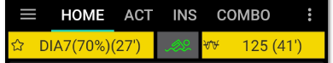
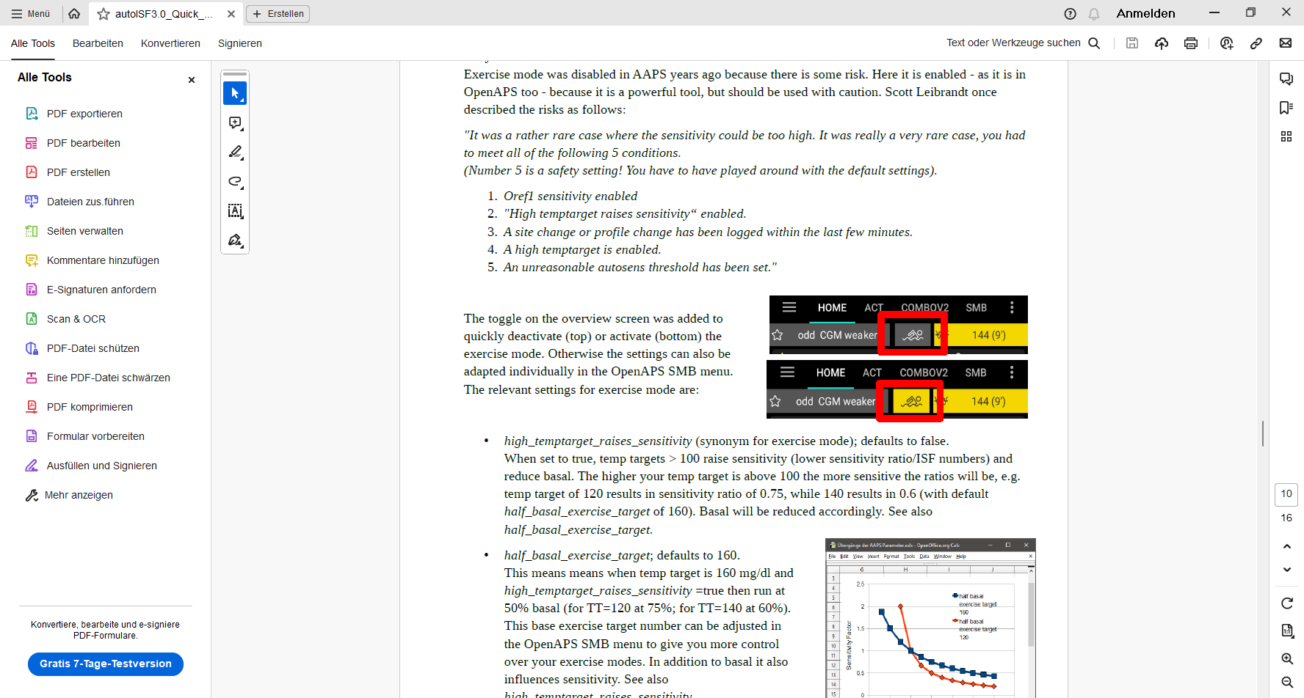
(profile)
In the special case of settings for meal preceding sports, the field will look slightly differently:
…and …
74 (iobTH 139)
(profile)

… when iobTH is first time exceeded, this automatically switches to:
139 ( 2h 45m)
(profile)

Likewise, if on the AAPS main screen just an EatingSoonTT is set (e.g.72), this is entered with the desired duration. Afterwards, it automatically reverts to profile target and the display turns grey again there with e.g. 90 on it (and no time limit).
Without sports context, the middle field remains grey.
72 ( 1h 10m)
(profile))

Independently from setting a TT, the user can choose to set a %profile in the left top field, for an independent number of minutes, e.g. 70% in this screen example: Also, or additionally, this will influence the resulting ISF and sensitivity%

(profile))

The % might change and turn yellow also in context of making TT inputs in the related dialogue box (see chapter TT dialogue field, above). Still, the % (or the length of time the profile switch shall be active) can be independently overriden in the top left field, if so desired.

If an Automation sets a %profile, and/or a TT (e.g. automatic detection of meal start at condition e.g. when delta >10) , this would automatically show in respective field(s) turning yellow and showing the temp. setting. To show the set parameter comes from an Automation, „ (A) „ is added in the end of button text.
Note that an Automation is usually/often/always (?) only permitted to temp. change default profile settings, not other pre-existing temp. settings. This is for a good reason : Why should a sometimes in the past thought-out Automation supersede your - just for the occasion specified – temp.settings that you consciously activated for the day?
Advice: Try to stay away from Automations that also aim at temp. modifying aggressiveness. For the reason just given in above note, they often will not kick in anyways. Generally, it also is no good idea to double up sub-algorithms for tweaking loop behavious.

Try to keep things as simple and clear as possible.

That said, a limited number of Automations can be of help in distinct scenarios (that differ in purpose and in applicable time of day).
A good one could be for night time, when your odd profile TT has SMBs shut off, but your experience after pizza nights tells you that, under certain condition patterns (bg, iob), an SMB or two should be „allowed in“. Another good example, if you go usually FCL without any use of the TT button (which you could call a meal announcement of sorts), is to define an Automation that, after detecting a meal start, automatically sets a low TT to get maximally aggressive first SMBs.

5.3.3 FCL related indicator fields in the AAPS home screen
In extra data fields of the AAPS main screen you can always see (not change) the key „aggressiveness“ parameters your loop currently operates operates with (see also home screen example below):
- how profile sensitivity (ISF) changes by the %profile input, by autoISF, and/or a set exerciseTT.
- next to current available iob number is an indication of your valid iobTH (the iob above which no more SMBs will be given)
- The AAPS home screen additionally shows, above the deltas, the current acceleration

5.3.4 Overall home screen: (The violet FCL button might not yet be launched; bottom buttons can also be manually eliminated via AAPS Preferences/Overview/Buttons)
