Pre- and early meal phases in Hybrid Closed Loop
Meal Management, section 2 – V.0.2

In the second main chapter we look into the initial meal phase, where in hybrid closed loop, the user issues a bolus.
Very much like in conventional diabetes management, the bolus size is calculated from the carbs, by dividing through a user-specific (and time-of-day-specific) carb ratio (IC, unit: g/U).
How to determine your ICs, see section 3.2 in: https://github.com/bernie4375/HCL-Meal-Mgt.-ISF-and-IC-settings/blob/HCL-.-settings-main-repo-(pdf)/IC%20(carb%20ratio)_V.3.1.pdf
The kinetics of carb absorption vs insulin activity must be considered for timing the bolus right.
This does really not have much to do with looping. So this would be a brief chapter. However, when the user bolus begins to fade out in activity, the loop increasingly plays an important co-management role, and things get tricky.

Table of contents
Delayed control – The meal challenge -> Meal Mgt., section 1
Pre- and Early meal phases: Hybrid Closed Looping w/ bolus = Meal Mgt., section 2
The initial meal challenge: Nautical equivalent
Pre-bolussing for the meal
EatingSoon TT
Carb inputs for user bolus (Calculator; Bolus wizard)
Timing of the user bolus
Trouble shooting the early phase
Transition into looping
Additional bolussing for dessert or 2nd course?
Hybrid Closed Looping, pros and cons
Enabling the loop to manage the late phase of a meal -> Meal Mgt., section 3
Simplified solutions when looping with oref(1) -> Meal Mgt., section 4
The initial meal challenge: Nautical equivalent
The start of a meal, with carbs getting absorbed, can be compared to a river streaming in sideways on our paddling tour on the lake.
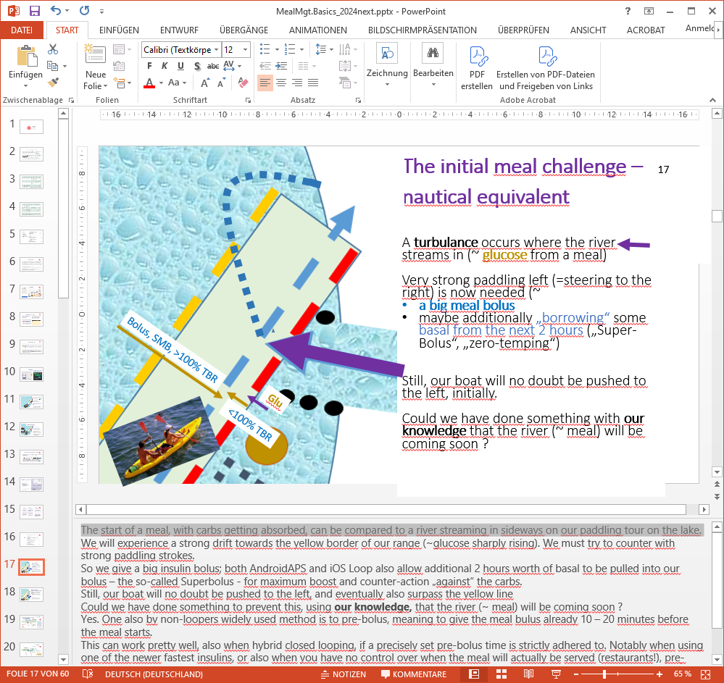
We will experience a strong drift towards the yellow border of our range (~glucose sharply rising). We must try to counter with strong paddling strokes.
So we give a big insulin bolus. All DIY loops allow additionally 2 hours worth of basal to be pulled into this bolus – the so-called Superbolus - for maximum boost and counter-action „against“ the carbs.
Still, our boat will no doubt be pushed to the left, and might also surpass the yellow line
Could we have done something to prevent this, using our knowledge that the river (~ meal) will be coming soon?
Yes. One (also by non-loopers widely used) method is to pre-bolus, meaning to give the meal bolus already 10 – 20 minutes before the meal starts.
This can work pretty well, also when hybrid closed looping, if a precisely set pre-bolus time is strictly adhered to. Notably when using one of the newer fastest insulins, or also when you have no control over when the meal will actually be served (restaurants!), pre-bolussing can be dangerous!

When we loop, there is a much safer option:
Instead of, briefly before the stream strikes, going full speed against the red border (~pre-bolussing) we could also do the following:
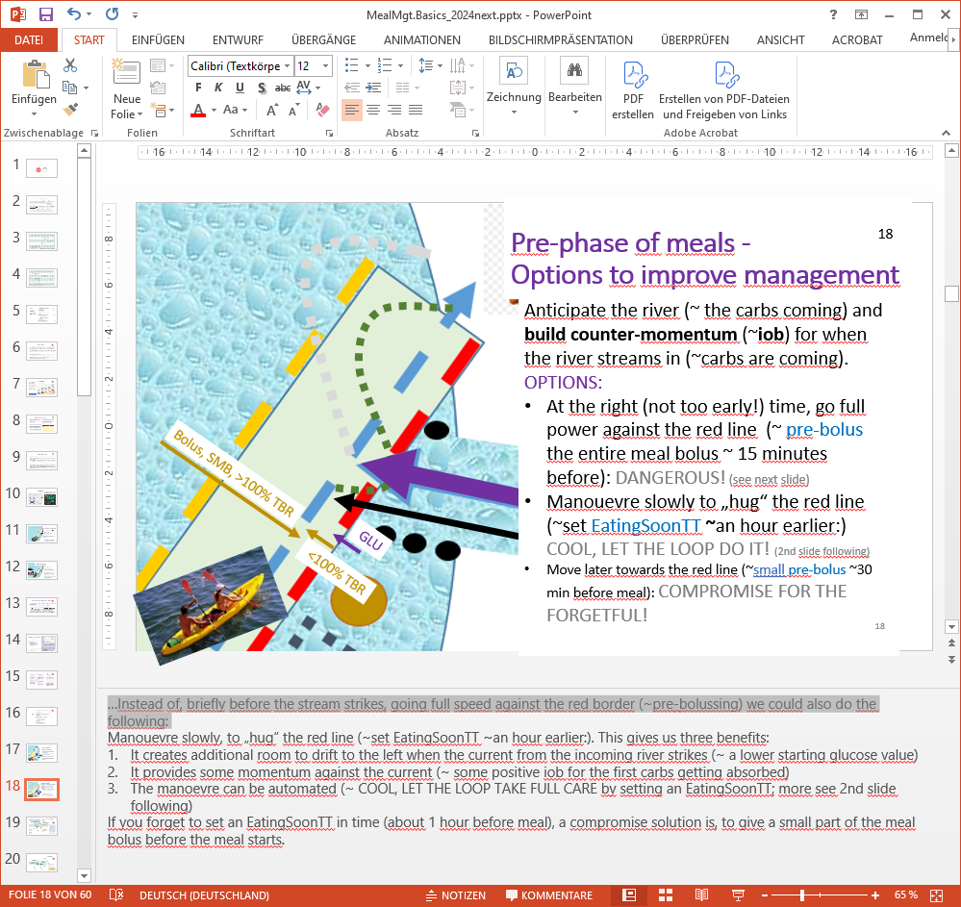
Maneuvre slowly, .
Maneuvering slowly, to „hug“ the red line (~set EatingSoonTT ~an hour earlier:), gives us three benefits:
- It creates additional room to drift to the left when the current from the incoming river strikes (~ a lower starting glucose value)
- It provides some momentum against the current (~ some positive iob for the first carbs getting absorbed)
- This maneuver can be automated (~ COOL, LET THE LOOP TAKE FULL CARE) by setting an EatingSoonTT; more see 2nd slide following)
In case you forgot to set an EatingSoonTT in time (about 1 hour before meal): A compromise solution is, to give a small part of the meal bolus before the meal starts.

Pre-bolussing for the meal
This slide shows the strategy to give the (entire) meal bolus about 15 or 20 minutes before meal start. (The number of minutes depends on the insulin in use, and on the actual glucose level).
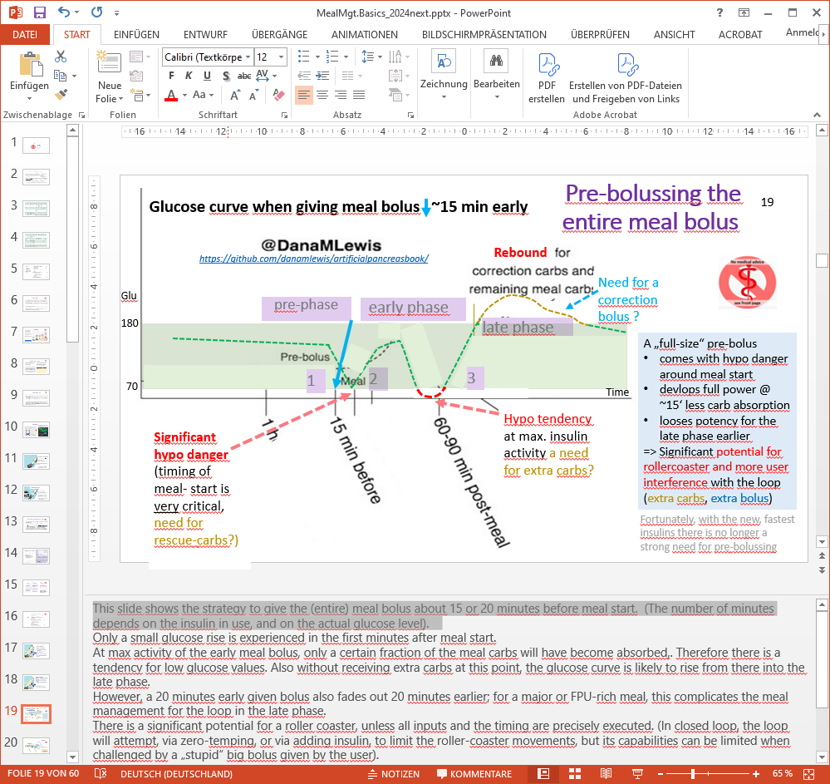
Only a small glucose rise is experienced in the first minutes after meal start.
At max activity of the early meal bolus, only a certain fraction of the meal carbs will have become absorbed,. Therefore there is a tendency for low glucose values. Also without receiving extra carbs at this point, the glucose curve is likely to rise from there into the late phase.
However, a 20 minutes early given bolus also fades out 20 minutes earlier; for a major or FPU-rich meal, this complicates the meal management for the loop in the late phase.
There is a significant potential for a roller coaster, unless all inputs and the timing are precisely executed. (In closed loop, the loop will attempt, via zero-temping, or via adding insulin, to limit the roller-coaster movements, but its capabilities can be limited when challenged by a „stupid“ big bolus given by the user).
Fortunately, with the new, fastest insulins, there is no longer a strong need for pre-bolussing many minutes before meal start.

EatingSoon TT
So, here is the alternative that looping pioneer Dana Lewis proposes https://github.com/danamlewis/artificialpancreasbook/), based on her findings that:
- In the pre-phase it is important to build up a bit of active insulin for the time of meal start. (Note, that giving even an impressive amount of iob via a bolus, does not get you any active insulin in the next 10 or even more minutes!)
- Carb absorptions is typically (limited at) 30 g/h
- Absorption runs at a relatively even speed
- The glycemic index of meal components plays a minor role (except in iOS Loop, for absorption times, for the late phase)
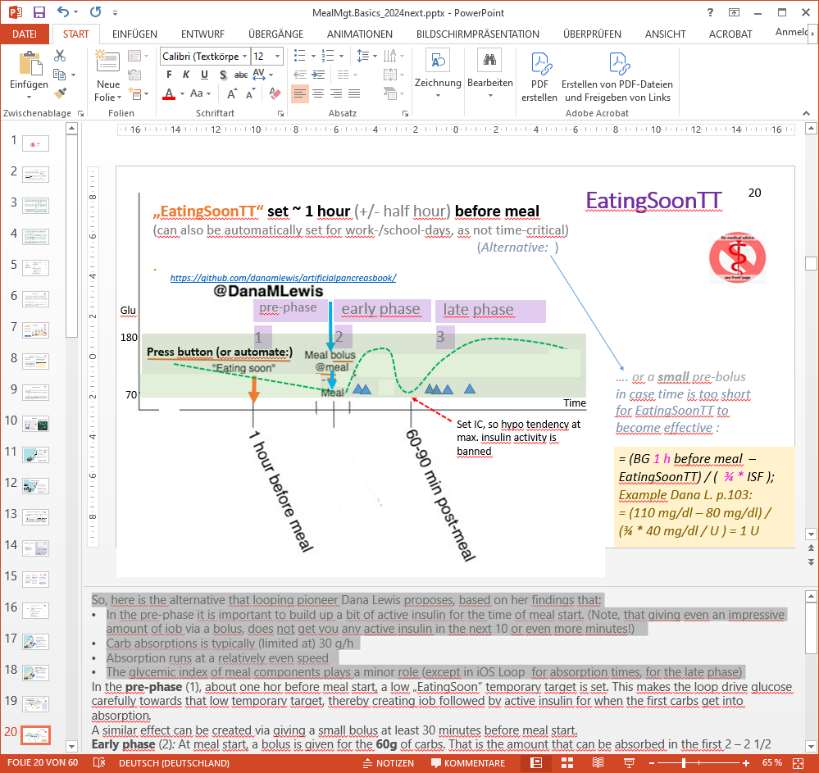
In the pre-phase (1), about one hour before meal start, a low „EatingSoon“ temporary target is set. This makes the loop drive glucose carefully towards that low temporary target, thereby creating iob followed by active insulin for when the first carbs get into absorption.
A similar effect can be created via giving a small bolus at least 30 minutes before meal start.
Early phase (2): At meal start, a bolus is given for up to about 60g of carbs. That is the amount that max. can be absorbed in the first 2 – 2 1/2 hours. (YDMV, gastroparesis?)
Variants for determining the bolus for the early phase:
- Enter in the bolus calculator the grams of carbs that can be absorbed while the intended bolus is highly active, usually no more than 60g, and bolus for it. Input the extended carbs/FPUs elsewhere (e.g. with an extra carb button, as so-called extended or e-Carbs), including info about absorption time window (and, ideally, pattern) - without triggering a bolus for these.
- Enter grams of carbs in total (early carbs, extended carbs incl. FPU).
Plus input a percentage to which these shall be covered by an upfront meal bolus. Make sure what the exact provisions of your loop system are to also declare absorption time for these later carbs.
It may be necessary to tune the IC value so the swinging of the glucose curve in the early phase remains in the desired green band.
Another strategy would be to employ a „Superbolus“, meaning, 2 hours worth of basal are pulled into the bolus, followed by two hours of zero-temping.
In the late phase (3) not yet absorbed carbs and transformed fat and protein components are absorbed, and the loop must now provide suitable insulin activity. The challenge there is that the activity from the meal bolus is fading out, and the loop algorithm must move front stage now to manage the meal. This will differ between systems, and is discussed in section 3 on the late meal phase.

Carb input for user bolus (in Calculator,Bolus wizard)

The on-board bolus calculator will suggest a bolus suitable to the carb input.
A complication can arise there, about whether and how to take any pre-existing iob into account (i.e. which boxes to tick in the calculator or wizard). Basically, the question is whether that iob is there to balance for not yet absorbed carbs from the preceding meal or snack. Refer to related readthedocs (like for AAPS here: https://androidaps.readthedocs.io/en/latest/DailyLifeWithAaps/AapsScreens.html#bolus-wizard) or to group discussions!

YOU giving a bolus essentially PAUSES LOOPING:
The loop only watches what is happening with YOUR intervention, and tries to co-manage - which is virtually impossible at first. As a consequence, the Loop is setting 0% basal in response to your dangerous looking bolus. It is entirely YOUR responsibility that your bolus suits carb amount and absorption in this early phase of the meal.
It is important to enter only as many g carbs for determination of the meal bolus into the bolus calculator as can be absorbed while the meal bolus is strongly active.
Many loopers do this wrong, and the consequence is: To avoid going low around max. activity from their given bolus, their IC must be dialed-in milder (than what a proper determination would suggest).
So, only at super big meals >>60g, they get a bolus that is big enough to actually cover the ~60g that really come to absorption, while their bolus is very active. But smaller meals will get user boli that are too small, making it frustrating to either accept high running bg after smaller meals (or, after correcting IC for those, going low on big meals.)
So, it is really worth the effort to do proper IC determinations for your major meal times, e.g. following section 3.2 in: https://github.com/bernie4375/HCL-Meal-Mgt.-ISF-and-IC-settings/blob/HCL-.-settings-main-repo-(pdf)/IC%20(carb%20ratio)_V.3.1.pdf).
Even in case you really intend to go full closed loop, please do not skip over doing a proper HCL with carb inputs and bolussing first. It will be your “blueprint” when you transition into FCL.

Carb entry for calculating the user bolus can be done in two ways:
- Limit any inputs into the calculator (bolus wizard) to max. 60g (that can be absorbed during the~2hr of strong activity of fastest insulins, or to maximum up to 90g for ~3hr of slower insulins).
- An alternative would be to add all carbs in the calculator, and define (enter also) a %age to which they shall receive an insulin bolus.
Mode (B) leads to higher cob when the late meal phase starts, and should actually be beneficial for loops (iOS Loop) that act strongly on carb inputs.
For oref(1) loops, (A) provides clearer data handling (not needing to come up with different %figures at different meals; option to make more than one e-Carb input, with associated grams and absorption time windows).
However, see section 4, regarding limited importance of carb data in oref(1), altogether.

You can fine-tune your IC factors also in closed loop, until – for a range of your meals - you achieve glucose remaining in range (70-180 mg/dl) in the first 2 hours after meal start. Shortly after maximum insulin activity of your bolus, your glucose ideally would be below target (see 60-90 min low, in last chart shown above).
Note, though, that fine-tuning your IC makes limited sense when your timing (when you give the bolus relative to meal start) has not been looked at.
Timing of the user bolus
The early meal management in hybrid closed loop resembles very much that of doing multiple daily injections. All HCL looping systems are similar in this early phase (because, largely, the user bolus defines what is happening, often with loops automatically shut-off, “zero-temping”). Some important differences, though, exist and relate to:
- how, and by how much, the algorithm of the loop will co-manage
- how important exact user inputs regarding carb amount and absorption times are
- how flexible the user is, to set different „aggressiveness“ and targets (e.g. if exercise follows)
If you use one of the fastest insulins (Lyumjev, Fiasp), or eat low carb/high fat, or have unusual slow digestion (gastroparesis, GLP1 drug), it is usually OK to bolus right at meal start.
In all other cases, giving the bolus before meal start can lead to a better result. The number of minutes before meal start must bridge the gap of how much faster your first carbs get into absorption, compared to when given insulin develops activity to take care of these carbs. See how you can optimize the bg curves in the 1st meal hour, by shifting pre-bolus times.
AAPS comes with a neat supporting feature: Switch the thin yellow insulin activity curve on in your main screen, and you see the power of your loop (how the insulin activity from your bolus did, and will further, develop, over its DIA period, on top of any remaining older active insulin). Looking at the bg curve, you then can easily estimate - just from looking at the graph - by how many minutes you would want to shift the insulin activity curve ”to the left”, i.e. earlier, so you have “the bite” early enough to prevent a steep bg rise. Then try pre-bolussing about that much earlier.

Caution: If you cannot control when the meal will actually start (e.g. in restaurants), or how much you / your kid will really like it and eat (and “keep in”, also), pre-bolussing can rapidly result in acute dangerous hypoglycemia, and especially so with our novel fast insulins.
In AAPS you should keep an eye on the insulin activity curve after pre-bolus injection. It clearly points to the time when you latest must have carb absorption going, in balance. (Nibble on apple juice or such if you must bridge over to the actual meal).

Trouble shooting early phase
We broadly discussed the problem that constantly matching carb absorption and insulin activity is virtually impossible, and therefore we always will encounter ups and downs in our glucose level. Moreover, a lot of other factors can interfere. A list of 42 such factors is included here https://github.com/bernie4375/HCL-Meal-Mgt.-ISF-and-IC-settings/blob/HCL-.-settings-main-repo-(pdf)/42%20factors%20influence%20bg.pdf
Trouble can manifest in both directions: Hypoglycemia, or too high glucose.
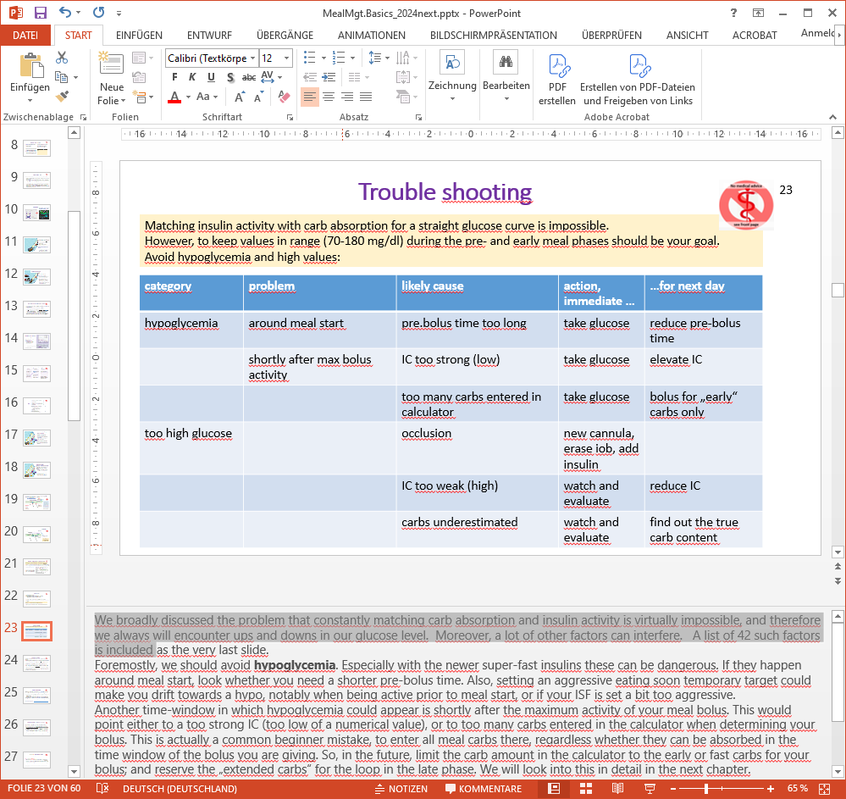
Foremostly, we should avoid hypoglycemia. Especially with the newer super-fast insulins it can be dangerous.
If it occurs around meal start, look whether you need a shorter pre-bolus time. Also, setting an aggressive eating soon temporary target could make you drift towards a hypo, notably when being active prior to meal start, or if your ISF is set a bit too aggressive.
Another time-window in which hypoglycemia could appear is shortly after the maximum activity of your meal bolus. This would point either to a too strong IC (too low of a numerical value), or to too many carbs entered in the calculator when determining your bolus. This is actually a common beginner mistake, to enter all meal carbs there, regardless whether they can be absorbed in the time window of the bolus you are giving. So, in the future, limit the carb amount in the calculator to the early or fast carbs for your bolus; and reserve the „extended carbs“ for the loop in the late phase. We will look into this in detail in the next chapter.
Regarding glucose running high beyond 180 mg/dl (or even over 250 mg/dl, with meals rich in high BG impact foods): After excluding an occlusion as the cause (this is not our topic here; but see https://github.com/bernie4375/HCL-Meal-Mgt.-ISF-and-IC-settings/blob/HCL-.-settings-main-repo-(pdf)/Occlusion_V5.pdf ), there are two highly likely causes, a too-weak IC, or underestimating your carbs.
Tweak your IC only if you were able to rule out gross underestimation of carb amount (which I believe happens quite frequently).
Actually, if you “live in your own world”, consistently erring with your carb estimates, and using IC values that were determined with this bias, that will actually work, too… until you hit reality, bolussing for a meal using info on “real carb content” given by the manufacturer.

Transition into looping
As our meal bolus fades out in power, our loop must increasingly take charge to keep glucose under control, while being faced with a stream of late carbs and sometimes by ugly effects from so-called FPUs (fat and protein units).
Besides it being a principal challenge, to provide seamless performance when management totally changes - from YOU in the driver‘s seat, to the loop *) – …
*) There is an interesting related debate between HCL and FCL loopers:
One theory goes that FCL, despite getting first boli for meal coverage later, can, as “seamless manager”, do an overall as good job as HCL, with its optimized early pre-bolus, but then the struggles in the “management take-over” transition phase, after necessary zero-temping etc (See also last sub-chapter, HCL pros and cons).
The author (in the oref and FCL camp) could see iOS Loop make a point regarding the transition phase: That more carb-centric loop thrives on correct data on quantity and absorption characteristics (!) of carbs. So to the extent that could be micromanaged (every day, for every meal) really well, a superior performance might be achieved. As we shall see in section 4, oref loopers go exactly the opposite way, to enjoy, every day, being very sloppy, if not totally neglecting, regarding carb inputs, and still have their desired %TIR etc.

… we specifically have the following issues:
„As a measure of courtesy“ we should not hand management over to our loop with ridiculously high glucose value, towards the end of the early phase (see last two lines of the table on the preceding page). The loop is faced with a tough job anyways:
In response to our bolus, the loop‘s safety system took away large part of the basal needs for the coming hours. The resulting lack of activity “from fresh insulin” was probably further aggravated by pre-bolussing, which logically leads also to earlier fading-out of insulin activity from our bolus. So, the loop does not have a lot of active insulin when it must take over.
In fact, even with an aggressive ISF, it might have a hard time to come up with required insulin simply on basis of elevating temporary basal rates.
SMBs (oref(1) systems) or Autoboluses (iOS Loop) enable the loop for faster control. We will look into this in more detail in the next section.
(It might actually be tempting sometimes to do another user bolus. See next sub-chapter).

Very often, lots of insulin, with a long „tail“ of activity, is used in the pre- and early phases. This can present additional problems:
- The loop‘s power to do corrections AT HIGH GLUCOSE will be limited by the fact that any insulin activity you would want ((and might actually be able to provide => roller coasters!!)) for bg peak control, will inevitably come with strong activity still hours afterwards. The loop knows this and leans towards allowing highs, to prevent later hypo.
- Towards the END of the LATE meal PHASE there are no more carbs to be absorbed, yet “the tails” of all insulin amounts given within the last DIA period will hit, potentially with hypo danger.

Additional bolussing for dessert or 2nd course?
If you are having a substantial second (or third) course, or a desert, you could be tempted to bolus for that yourself, instead of „waiting for the loop“ to take care.
In case your loop has only temporary basal rates to work with (i.e. no Autobolus or SMBs), this can actually be a good idea,
To define the appropriate bolus for the next course or dessert:
- Assume that you need not interfere with the situation from your last bolus and carbs from the prior course, no matter what the glucose, iob and cob levels currently are
- Divide the new amount of carbs by the IC (carb ratio) to calculate the new bolus. (To do this in the bolus calculator, un-tick the boxes that, otherwise, would consider current glucose level, iob and „old“ cob). Do not enter more grams of carbs than can be absorbed while your new bolus is very active! For the rest, plus for any FPU equivalents, make carb entries with absorption time in the next hours.
- A tricky problem arises, if the amount of new „extra“ carbs is high, and/or the time gap to the previously taken carbs (and bolus) is short. Then look into:
(a) whether a dangerously high iob, followed by an insulin activity maximum, might result – which could lead to a hypoglycemia …
(b) whether there is a bottleneck, so the extra carbs can really not be absorbed right away. (Usually there seems to be a 30g/h limit; and less in gastroparesis).
In that case, reduce the bolus for the second course, and input some of the carbs, and any fat and protein units from the second course, into a new future carbs entry for the loop to take care of later, when your 2nd bolus begins to fade out.

Note that in case exercise follows after a meal, this requires special considerations: Loops always provide enough iob to reach (or remain at) target. But exercise tends to lower bg further, and notably so when positive iob is present. Reducing iob is therefore the cornerstone of most exercise management (with exceptions, e.g. when a lot of excitement is involved). Higher temp.glucose target and lower basal, milder ISF will provide lower amounts of insulin for meals, or for any bg corrections.

Hybrid Closed Looping (with a user bolus): Pros and Cons
We have seen that generally it can be a good idea to use our knowledge about when we start eating, and what our meal will contain, to give an initial meal bolus. Else insulin activity has no chance to keep up with carb absorption initially, resulting in strongly rising glucose.
The initial bolus should cover those carbs that are getting absorbed in the time window in which our bolus has most of its activity.
Lyumjev and Fiasp have about 75% of all activity in first 2 hours after injection (=> up to 60g carbs absorbed @ 30g/h (according to findings reported by Dana Lewis here: https://www.artificialpancreasbook.com/8.-tips-and-tricks-for-real-life-with-an-aps)
Humalog and Novorapid have over 2.5 - 3 hours of strong activity (=> 75 -90g carbs are absorbed @ 30g/h)
In the hybrid mode, the user is really in the driver‘s seat for the first hours of any meal. The loop calculates every 5 minutes how much sense it all makes what it sees developing, and, for safety, interferes usually with reducing basal to zero after that big bolus given by the user. As time progresses and the user bolus begins to fade, the loop takes over:
„Later“ carbs (and FPU) cannot be reasonably covered by the meal bolus. This is when the loop increasingly takes over
A user-initiated bolus can help bring in sync
- how fast our carbs are digested
- and how sluggish insulin activity comes into play, and fades out.
And, it is what we were used to before looping. (Actually, we might first miss some of the refinements we had, like multi-bolus).
However: A user bolus disturbs the loop.
The loop has a set of rules (an algorithm) how to deal, every 5 minutes, and based on mathematical predictions, with any situation. And then YOU come in, with a very coarse idea, and brute bolus. (Think of a ship, with 2 captains, with extremely different views…). …
- The user induces a hypo risk that the loop might not be able to manage (except for giving alarm)
- For safety, the loop must shut down basal supply (fully, or partially) for some time, in response to a bolus the user issued
- Specifically when pre-bolussing, pulling the bolus to an earlier point of time leads to even earlier fading insulin activity, which – especially after the just mentioned shutting down of basal - increases the difficulties for the loop to take care of LATE carbs and FPUs (e-Carbs).
Still, it can be a good strategy to focus on the immediate problem first (to pre-bolus against a strong glucose rise). Any „side-effects“ from that, plus new occurring challenges, can be managed (in more than 1 way), thereafter.
Managing that late meal phase is the topic of our next section.

Doing away with user-boli in Full Closed Loop seems possible with a very fast insulin, a suitable CGM and algorithm, carefully determined, not too-unstable „profile“, and avoiding meal extremes. Carb absorption and insulin activity can be brought good-enough in sync for looping the entire meal period (more see in section 4).
Some medical authors even postulated that, in principal, they could see full closed loop outperform hybrid closed loop: „As algorithm design for closed loop systems continues to develop, the strategies employed in the OpenAPS algorithm (known as oref1) as implemented in AAPS for unannounced meals may result in a better overall control for full closed loop systems.” (Source: https://www.researchgate.net/publication/351273207_Full_closed_loop_open-source_algorithm_performance_comparison_in_pigs_with_diabetes)

