Simplified solutions (towards automated meal management)
Meal Management, section 4 – draft V.0.2

In sections 1-3 we discussed strategies and measures that can be taken in an effort to optimize %TIR in closed loop systems. The next slide sums up the related options for meal management. Consider it a „toolbox“ of new ideas, to manage any arising challenges.
In the end, everybody must decide for her/himself how to handle meals in looping. Suitable solutions depend on a variety of factors: The algorithm in use; the prevalent kinds of diet, the lifestyle, the targeted %TIR, and the accepted effort.
Some systems or modes require more upfront effort to get the system going well, but less of an effort everyday, and vice versa. The extreme case in this respect is the full closed loop we will look into in the last chapter.
Rather than ever refining (and complicating) things, users with systems that incorporate the oref(1) algorithm (OpenAPS, AAPS, Trio, iAPS) could substantially „ease up“, after investigating for themselves, whether:
- the „good (enough) practice“ suggestion for easy meal management in hybrid closed looping
- one of the variants that replace detailed carb inputs with one or the other form of a Meal Announcement (MA) (e.g. by just giving a small bolus)
- or even going all the way into full closed loop (FCL)
might work for them. However, it should be noted that the every-day “easing up” must be earned by going through a learning and setting-up phase that, notably for FCL, can amount to a substantial upfront project.
Also, it is not advisable to “leap-frog” into one of the simplified methods:
Notably if you come from iOS Loop or from a commercial loop to your oref loop, please FIRST work out your exact meal management in a well tuned hybrid closed loop (following section 1-3 advice). THEN expect to reach about same %TIR in one of the solutions that are radically simplified regarding every day data inputs.

Table of contents
Delayed control – The meal challenge -> Meal Mgt., section 1
Pre- and Early meal phases: Hybrid Closed Looping w/ bolus -> Meal Mgt., section 2
Managing the late phase of a meal -> Meal Mgt., section 3
Simplified solutions towards automated meal management = Meal Mgt., section 4
  - General solutions toolbox
  - Good (enough) practice suggestion for oref(1) loops in HCL
  - Meal announcement (MA) methods
  - Full closed looping with oref(1): No carb inputs, no boli
  - Body weight control
  - Closing remarks

General solutions toolbox table needs some re-work
Each column of the following table shows alternative ways to go about the top issues (see column headlines). Most can be freely combined into a strategy. You can go either way (also different ways on different days): Make complicated add-ons for enhanced performance needed in special situations; and seek easiest-possible daily way to handle meals.
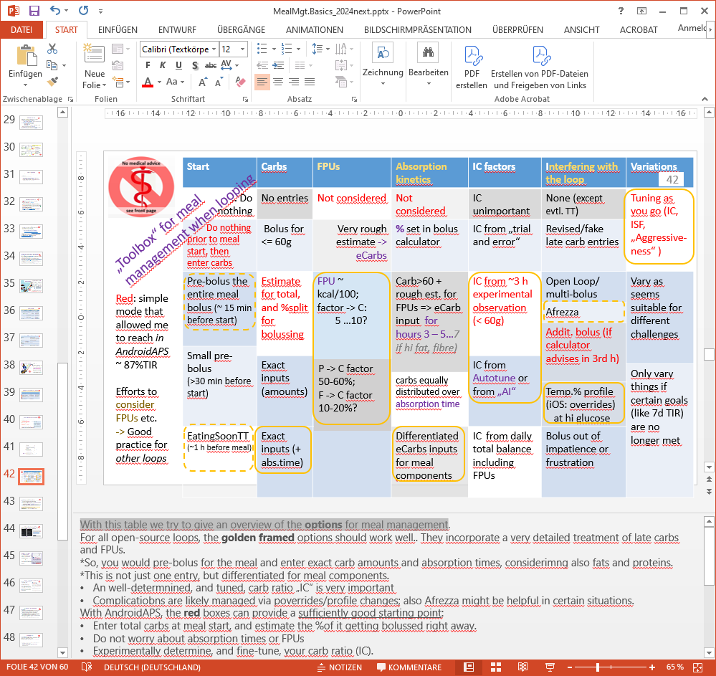
- The yellow frames combine to a strategy that follows most suggestions as developed in sections 1-3, and should work well for all open source loops.
  - They incorporate a very detailed treatment of late carbs and FPUs. So, you would pre-bolus for the meal and enter exact carb amounts and absorption times, considering also fats and proteins. This is not just one entry, but differentiated for meal components.
  - A well-determined, and tuned, carb ratio „IC“ is very important
  - Complications are likely managed via overrides/profile changes; also Afrezza might be helpful in certain situations.
- In red writing is a simplified strategy the author used a couple of years ago. With oref loops, the red boxes can provide a sufficiently good strategy:
  - Enter total carbs at meal start, and estimate the %of it getting bolussed right away.
  - Do not worry about absorption times or FPUs
  - Experimentally determine, and fine-tune, your carb ratio (IC) and profile ISFs.
  - If not (yet) in SMB mode, giving a late second bolus can be considered
The next chapter will build on this, to define an easy but good-enough solution for oref loops.

„Good Practice“ suggestion for oref(1) Hybrid Closed Loop
The oref(1) loop is included in OpenAPS, AAPS, Trio and iAPS. This algorithm reacts primarily on glucose values, and carb inputs play only a minor role.
However, tuning the profile (and/or tuning also extra features that act on glucose values, evtl in combination with other data like TDD or acceleration data from recent bg development) is of great importance for the oref(1) loops to work well.
Main components of the profile are the insulin model (peak time, DIA), the 24 h basal profile, and the IC and ISF profile reflecting the personal 24h sensitivity pattern.
Meal management then can be simplified with these systems in hybrid closed looping as follows:
- In the pre-phase, setting EatingSoonTT to get a low glucose and some iob when you actually start eating.
Of note, in contrast to pre-bolussing, this is not time-critical at all, and can be automated e.g. for school or work days.
Also, if you (did not automate and) forgot, you can give a small (!) pre-bolus to achieve the same situation closer to meal start.
Even doing nothing at all (“forgetting” to set your EatingSoonTT) is viable. The likely resulting 30-40 mg/dl higher peak can still be compatible with the desired overall time-in-range.
To summarize, this is a “low maintenance” option for starting any meal.
- Use the bolus calculator to define a meal bolus for the early phase of roughly 2 hours into the meal.
While your meal bolus works with high activity, for most of us (and depending a bit on the insulin in use), around 60g of carbs are digested.
Do not input in the calculator, and bolus for, more than that.
Note we are strictly talking here on simplifying meal management in oref loops. For iOS Loop, higher inputs can be made, see in section 2, option (B) under “Carb input in Calculator”.
Tune your IC, so you will hit a glucose in the low-normal range shortly after time of maximum insulin activity.
At meal start, also input any number (e.g. 30g) of “e-Carbs” for hours 3-5.
This entry is just to not go into cob=0 prematurely. Only if you make strong use of Autosens, you might see a benefit from differentiating amount and absorption time of eCarbs.
In the late phase, SMBs (Auto-Boli) and TBRs will automatically take care. Tune you ISFs, so this works well.
3…You might need extra-strong ISF when “stuck” at high glucose:
Better than any “rage bolus”: Let the loop take care via an AUTOMATION that switches . to higher profile% FOR A FEW MINUTES to account for temp. reduced insulin sensitivity . after fatty meals (see e.g.
https://androidaps.readthedocs.io/en/latest/AdvancedOptions/FullClosedLoop.html#stagnation-at-high-bg-values )
To summarize: Do not worry about carb counting, absorption times, carb vs fat etc. Sizeable meals can "always" be announced as: 60g (less if low carb), plus anything in eCarbs, say 30, stretching like hour 3-6 (just so the loop sees no cob=0 prematurely).
The reason why this can work is: In “UAM+SMB” mode, oref loops are able to figure out carbs absorbed better than you could everyday tell your loop. More detailed explanation see in section 1.2 of “IC carb ratio..pdf” at: https://github.com/bernie4375/HCL-Meal-Mgt.-ISF-and-IC-settings/blob/HCL-.-settings-main-repo-(pdf)/IC%20(carb%20ratio)_V.3.1.pdf
As warned on page 1, the simplified solution only works well if your loop was well tuned before. So, you have to count carbs, before you can forget carb counting (using this solution, or one of the more sophisticated solutions that we come to next).

Meal Announcement (MA) methods

A hybrid closed loop without any daily carb inputs might get you to a solution that removes most of the everyday burden associated with having to co-manage meals.
This ”Meal Announcement” could also be an intermediary step, from which to progress into FCL as soon as a currently missing pre-requisite resolves for you in the future
A study based on AAPS Master yielded TIRs in the low 80% for all three modalities, Hybrid Closed Looping, Meal Announcement, and Full Closed Looping (see https://androidaps.readthedocs.io/en/latest/AdvancedOptions/FullClosedLoop.html#what-to-expect or First Use of Open-Source Automated Insulin Delivery AndroidAPS in Full Closed-Loop Scenario: Pancreas4ALL Randomized Pilot Study)
Meal Announcement can take many forms, from just “telling” the loop when it shall interpret a certain bg delta as a meal start, to giving a (symbolic, or partial) pre-bolus around meal start.
Refined MA methods that experienced loopers successfully use (with higher %TIR than the novices in the quoted study), are for instance:
https://github.com/bernie4375/FCL-potential-autoISF/blob/FCL-e-book/07_MA%20w%20bolus__Adv.HCL_FCL-book_V3.5.pdf

https://github.com/bernie4375/FCL-potential-autoISF/blob/FCL-e-book/13_Other%20Avenues%20to%20FCL_FCL-book_V%202.4.pdf
chapter 13.3
- based on autoISF
- Boost -
- AIMI
- EatingNow
- Tsunami

Automatic meal management in Full Closed Loop

Did somebody say „Just eat ?“(https://www.youtube.com/watch?v=IEpEgMdnrAA; SnoopDog)
With a very fast insulin, a suitable CGM, carefully determined, not too-unstable „profile“, and avoiding meal extremes, carb absorption and insulin activity can be brought good-enough in sync for looping the entire meal period.
Since Sep.2023, AAPS Master was the first broadly available loop to offer this FCL mode: https://androidaps.readthedocs.io/en/latest/AdvancedOptions/FullClosedLoop.html#what-to-expect. Experience with that was e.g. reported in: https://www.diabettech.com/oref1/lyumjev-a-fully-closed-loop-case-study-with-oref1 and https://bionicwookiee.com/2021/04/16/no-bolus-for-4-months
Among refined methods for FCL, autoISF stands out. It is, as an early dev variant, available based on AAPS as well as iAPS and Trio: https://github.com/bernie4375/FCL-potential-autoISF/blob/FCL-e-book/00_Introduction_FCL-book.V%203.1.pdf
autoISF comes with over a dozen additional parameters to tune. To set it up is a difficult project, analyzing your personal data, and following a sequence of steps (see preceding link).

An increasing number of loopers ( see on https://discord.gg/TCDp69QQjT ) manage to do a full closed loop if certain pre-requisites are given (https://androidaps.readthedocs.io/en/latest/AdvancedOptions/FullClosedLoop.html#pre-requisites-for-full-closed-looping):
- Fast insulin (Lyumjev or Fiasp
As really the relative speed of insulin activity vs carb absorption is relevant, we can also assume that diets without fast absorbing carbs, or probably utilization of novel drugs that slow down digestion, would be of great help in establishing a successful FCL. (Currently we do not have enough data to prove that).
- Reliable iob data (no leaks or occlusions)
- Excellent CGM
- Technically stable loop (Bluetooth!)

Body weight control

Most of us will strive to not gain body weight. This brings up two other strong pre-requisites for a successful FCL:
- Avoid erratic patterns of snacking (or of consuming drinks that lead to a bg rise),
- Prepare for exercise
In FCL, negligence in these respects will result in frequent need for extra carbs to prevent hypoglycemia.

Loopers certainly can successfully integrate a weight control goal into their diabetes management.

Closing remarks

Regarding what the future might hold for us (dual hormone loops, further accelerated insulins, machine learning and AI), see section 13.6 in FCL e-book at: https://github.com/bernie4375/FCL-potential-autoISF/blob/FCL-e-book/13_Other%20Avenues%20to%20FCL_FCL-book_V%202.4.pdf
and also discussion in section 5. of : https://github.com/bernie4375/HCL-Meal-Mgt.-ISF-and-IC-settings/blob/HCL-.-settings-main-repo-(pdf)/Insulins_DIA%20and%20other%20settings_V.3.0.pdf

There will always be setbacks by diet sins, illness, stress, or just plain forgetfulness. Also technical system instability can in times be challenging.
It is absolutely worth it to stay motivated for a well running loop. But nobody needs to rush always into the next possible refinement that comes along. We are in this for years to come, maybe for life. So frequently take a breath (no need to understand, to try or even to master everything that may be offered).
Don’t forget to share important success and failure stories, so we can learn from one another.
Most importantly, enjoy eating while remaining (mostly) in range, and stay healthy!

