Managing the late phase of a meal
Meal Management, section 3 – V.0.4 (draft)
needs more work

Now we are getting to the late phase of a meal which is where the loop really takes over the management, and takes care of the late carbs and fat/protein units (FPU). How that is done differs by the used algorithm, so we can only roughly sketch the common key points, and must give some references for further study.
We then touch on common troubles in the late phase, notably hard-to-correct high values, and options to deal with those.
This includes a critical view on some interventions into the loop, which may or may not be smart when we are dissatisfied with our loop.
Finally we look into how exercise demands modified management

Table of contents
Delayed control – The meal challenge -> Meal Mgt., section 1
Pre- and Early meal phases: Hybrid Closed Looping w/ bolus -> Meal Mgt., section 2
Managing the late phase of a meal = Meal Mgt., section 3
Carb entries for late phase
Fat Protein Units (FPU)
Insulin for the late phase (supplied by the loop)
Why is it often difficult to resolve a high post-meal glucose
Nautical equivalent to temp. insulin resistance
Trouble shooting in the late phase
Co- managing the loop in the late phase
Afrezza to the rescue
Temptation to cheat the loop via „fake“ data entry
Challenge: Meal followed by activity
Simplified solutions when looping with oref(1) -> Meal Mgt., section 4

Carb entries for late phase

For the late phase, i.e. the time window when our meal bolus lost most of its power (Rule of thumb: 75-80% is lost about 3 hours after bolus for Humalog; or 2.5 hours for Fiasp; or 2 hrs with Lyumjev ) we must enter the carbs that will be absorbed after this time window. Roughly, carbs exceeding ~ 60g (with slow insulins 75-90g) come to absorption now.
We just inform the loop of how much (gram amounts) and about when (absorption times) more carbs will be absorbed and require insulin activity. We do not bolus for those, and – this may depend on your looping system – you do not enter them into the calculator but via a special „eCarbs“ entry (e.g. via Carbs button in AAPS).
The „eCarb“ amount consists of:
- Carbs exceeding ~ 60g (with slower insulins: exceeding 75-90g)
- plus a „FPU“ contribution from proteins and fats
…which can be counted as grams of e-Carbs (using factors 50-60% * g (protein); and 10-20% * g (fat)). Also lower %age for protein and higher %age for fats, or a different approach via kcal, is sometimes suggested (see next chapter, “FPU”)
Notably iOS Loop systems also require details about absorption times. These are derived for the e-Carbs by major food component, and considering:
- Limited total absorption capacity (~ 30g/h)
- Absorption is slowed by fibre
- Absorption is slowed by fat
- Proteins take long to digest

Carb and e-Carb entries (amounts and absorption time info) can also be partially automated and connected to food databases like Sugarmate.
This can be valueable for iOS Loop.
As we will further elaborate on in section 4, detailing the eCarbs carefully is not necessary with oref(1) systems.

Fat Protein Units (FPU)
There are two principal approaches how to count protein and fat:
- Calculation of e-Carb equivalents via kcal from fat and protein.
With the following table we like to show for a meal rich in protein, how fat and protein can be counted into late carbs, and what reasonable late (e-)Carb entries would result (2g from fat + 23 g from protein, plus a bit also considered in the calculator or bolus wizard by adding 1g resp. 4g in for the first 2.5 hours):
Formula (1) to calculate g eCarbs
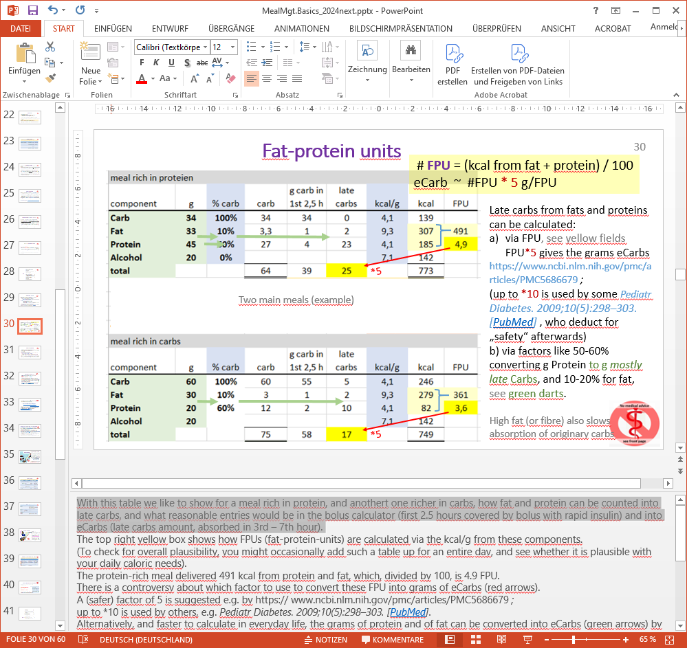
60%
0%
The top right yellow box shows how FPUs (fat-protein-units) are calculated via the kcal/g from these components.
To check for overall plausibility, you might occasionally add such a table up for an entire day, and see whether it is plausible with your daily caloric needs.
The protein-rich meal delivered 491 kcal from protein and fat, which, divided by 100, is 4.9 FPU.
There is a controversy about which factor to use to convert these FPU into grams of eCarbs (red arrow).
A (safer) factor of *5 is suggested e.g. by https:// www.ncbi.nlm.nih.gov/pmc/articles/PMC5686679
while *10 (orig.“Warsaw method”) is used by others, e.g. Pediatr Diabetes. 2009;10(5):298–303. [PubMed]

As caloric information on components on your plate is not easy figured out, in daily T1D life mostly the other route is taken:
Formula (2) to calculate g eCarbs
eCarb = 50…60% * protein + 10..20% fat

- Using factors 50-60% per gram of protein, and 10-20% per gram of fat.
As our example in the table above shows, this (green arrows, effects adding up to 25g eCarbs) can be fairly consistent with the caloric-derived values, when using the *5 factor (red arrow arriving at 25g eCarbs, too).
As the *factor, also the % applied for fat is discussed quite controversially.
This is actually quite understandable, because fats bring about two effects that increase insulin requirements in the late meal phase:
- There is an additional effect from fat (and also from fibre) to slow down absorption of “real carbs”, so it may seem that fats translate to a higher % into late carbs.
- Often, fats create complications several hours after a meal through intermittent insulin resistance at high glucose values).
Important here is, that the reasonable conversion factor depends on the used strategy (A or B) to deal with these effects:
- Strategy (A): Apply a bigger % for the conversion, and in consequence exaggerate carbs from fats, and this way also gets them covered with more insulin.
For iOS Loop, this method (A) is preferable.

- Strategy (B) is to use the suggested low 10 … max 20 % for fats; plus apply stronger ISF temporarily, only when glucose is stuck on high values.
This method (B) is preferable for oref(1) loops, which do not react directly on grams of „e“-carbs entered, but do have special features that can even automatically address temporary insulin resistance (dynamicISF, Automations, and especially the dura_ISF component of autoISF).

----------------------------------------------- References: ----------------------------------------------------------Balancing Carbs, Protein, and Fat. Clinical review by Mary Hanson, registered dietitian. Kaiser Permanente. 03/01/2014 https://wa.kaiserpermanente.org
General overview, effects from proteins and fats: https://www.youtube.com/watch?v=4_5K9zH9CFc
FPE calculator via GooglePlay: EasyFPU. FPU calculators für iOS:: https://www.icloud.com/shortcuts/ac31808d809f40e1a9e63175f27152ac ICLOUD.COM Loop FPU Robert's video explaining his method: https://youtu.be/k8amkz9E66k Loop FPU Food Entry (iOS Shortcut version)
Food databases: https://sugarmate.io or Fleisch - Tierische Produkte - Kalorien – Fddb
Reference for Automations: https://androidaps.readthedocs.io/en/latest/AdvancedOptions/FullClosedLoop.html#stagnation-at-high-bg-values
…and for dura_ISF: Section 4.5.5 in “ 04_Meals.ISF_weights…pdf” at https://github.com/bernie4375/FCL-potential-autoISF
Insulin for the late phase

In the late phase of the meal, which can last several hours, the loop must provide insulin as required – but without the „tails“ of the aggregated TBRs and microboli dipping the glucose level into the hypo zone later, when the flow of to-be-absorbed carbs has ceased.
I like to mention here a principal solution to neutralize “too much insulin (activity) in the late phase”, that is in development, and makes use of a 2nd hormone, glucagon:
- Either fully (?) automated, in form of a complicated hi-tech “dual hormone loop” (e.g. by the Dutch company Inreda). This is discussed a bit in section 13.6 of FCL-e-Book at: https://github.com/bernie4375/FCL-potential-autoISF
- Or “DIY” via manual mini-doses of glucagon (instead of snacking) against low trending bg (e.g. before exercise, or e.g. after fatty meal when insulin tends to overshoot). More see: https://discord.gg/atTABUX9RR

Based on the insulin activity curves, the loop has always a pretty good picture how much insulin activity it has to work with in all upcoming 5 minute segments, and how to increase it via extra TBR>100%, or via Autobolus/SMB, or to decrease it via TBR<100%.
The challenge then is the carb absorption.
The carb absorption can either be inferred from the glucose movement in light of insulin activity. That is the basic approach of the oref(1) algorithm (more see section 1.2 in “Carb ratio … pdf” in: https://github.com/bernie4375/HCL-Meal-Mgt.-ISF-and-IC-settings ).
Or absorption follow largely from inputs about carbs eaten and their absorption times *), which is the basic approach of iOS Loop. More see https://www.youtube.com/watch?v=4_5K9zH9CFc

Of course, in the end, both systems take into account all available information. As user errors as well as a myriad of secondary influencing factors play into it, the so-called deviations play a big and similar role in both approaches . Deviations try to explain discrepancies the model sees, by saying, one of the parameters, e.g. carbs, must have been misjudged (in quantity or absorption time). Depending on which factor „gets the blame“, predictions for the next 2 hours can look vastly different … but will converge, as uncertainties decrease over several next 5-minute periods.
Predictions are the key part that drives the loop‘s conservative behavior regarding hypo prevention from the „tail“ of remaining active insulin (from insulin that had been used earlier “to fight high bg”).

How calculating the required and to-be-delivered (or withdrawn) insulin is exactly done, differs in many details between the open source loops, but it can be looked up **). Of note, in AAPS much of it can be read (over like 5 full screens on the smartphone) in the SMB tab, every 5 minutes, if one desires to completely understand the loop‘s decision.
Loops differ also in how they can deal with fluctuations of user‘s insulin resistance. DIY have in-built (AAPS) or add-on options (IFTTT, Automate!, middleware for iOS systems) to automate ISF and other parameter modulations. Loops may also include code that self-adjusts (Autosens, Autotune, dynamicISF, autoISF, Machine Learning/Artificial Intelligence), although with more or less hours of time-delay

--------------------------------- footnotes------------------------------------------------------------------------
*) In one minute, Kenny explains why absorption time matters in iOS Loop:. https://youtu.be/UGtwnugWfKQ.
“Absorbing too fast, which is what you are seeing, generally leads to highs. If it doesn't, then your ISF is probably far too low and helps compensate for the incorrect settings.
When carbs absorb too quickly, the settings that could be impacted are:
1) basal too weak. Not enough insulin all around.
2) Carb ratio too weak (big). Most obvious from being high as well.
3) ISF too low/small. Sometimes leads to highs, but not if way too low.” (Kenny F., L&L-FB, 16Jan’22)
**) More on algorithms: https://www.diabettech.com/looping-a-guide/comparing-the-loop-and-openaps-algorithms/ and (partially cited below): https://www.ncbi.nlm.nih.gov/pmc/articles/PMC8087942/

Calculation of Insulin_Required (differs between algorithms):
- AAPS (and similar OpenAPS, Trio, iAPS):
PRINCIPLE CALCULATIONS: The algo knows exactly how much insulin is consumed in each 5 minute segment. And it sees the bg delta. From there it can simply calculate, using the ISF, how much of the consumed insulin went for bg correction. The remainder, then, must have been consumed for carb decay- Based on the trend seen in the past 5-minute segments, the loop can predict where bg is headed and whether insulin other-than- profile basal need is required. (For more, see chapter 1.2 in in “Carb ratio … pdf” in: https://github.com/bernie4375/HCL-Meal-Mgt.-ISF-and-IC-settings).
PREDICTIONS; The current heuristic algorithm of oref1 generates multiple future blood glucose predictions based on (i) action of approximated insulin remaining in the body; (ii) the scenario in which all carbohydrate intake ceases, and the system stops insulin delivery; (iii) action of approximated carbohydrates remaining in the body; and (iv) unannounced meal absorption. The predictions are then combined to estimate the lowest predicted glucose, and insulin delivery is adjusted to ensure that the local minima remain within a pre-specified target. The user, similar to standard insulin pump therapy, inputs their personal basal rate, carb ratio (IC), insulin sensitivity factor (ISF), and curve of insulin pharmacodynamics.
AAPS and the other oref loops also enable automated insulin coverage of meals without carbohydrate announcement via the “unannounced meal” (UAM) feature, whereby meals are anticipated based on available data suggesting an otherwise unanticipated glycemic excursion.
The actual used data (every 5 minutes) can be looked up „live“ in the AAPS SMB tab; or, for any 5 minute segment in the past, in YOUR AAPS logfiles; -> phone storage/emulated/0/Android/ data/ info.nightscout.androidaps/files. There: „AAPS.log“ contains the most recent data, and „AAPS_yyyy-mm-dd_(time in univ.time zone)_#.zip“ are the „historic“ ones ). Note this is not easy-to-read stuff. There are tools for analysis that load desired files from a time window of interest to you. If you look in https://github.com/ga-zelle/APS-what-if /: The emulator offered there (for AAPS) even allows what-if analysis on some changed settings you may like to investigate on paper … or even „live“, with a voice telling you every 5 minutes what would have been done differently! So, even that could be done, before jumping right into trying it out.
(b) iOS Loop See https://www.youtube.com/watch?v=4_5K9zH9CFcv
The other open‐source AID system, iOS Loop, uses a different algorithm that employs coincidence point control (model predictive control), ¹⁶ and generates a single future prediction based on insulin delivery history, carbohydrates entered, and other entered settings, including the basal rate, IC, ISF, and curve of insulin pharmacodynamics. When used in humans, users enter not only carbohydrate counts but also an estimate of the absorption time of that particular meal or food. Loop uses two forms of short‐term adaptation called “glucose momentum” and “retrospective correction” to enact temporary basal rates to push the projected glucose toward a specified target range. Glucose momentum uses the 5‐min rates of change from the prior 20 min to influence future predictions, with most weight given to the most recent rate of change. In retrospective correction, glucose differing from the predicted value causes that difference to be added to the next prediction. An extension of this feature called “integral retrospective correction” takes not only the difference but also the accumulated differences into account for more rapid adaptation.

Loops also differ in how they can deal with fluctuations of the user‘s insulin resistance. DIY systems have in-built (AAPS) or add-on options (IFTTT, Automate! for iOS Loop) to automate ISF and other parameter modulations. Loops may also include code that self-adjusts (Autosens, Autotune, dynamicISF, autoISF, Machine Learning/Artificial Intelligence), although with more or less hours of time-delay.

Why is it often difficult to resolve a high post-meal glucose – and why, then, the sudden declines toward a hypo?
A post-prandial glucose rise can lead to insulin resistance (elevated insulin need). This often happens after fatty meals, and mechanisms behind it seem to be the following:
Stage 1: Free fatty acids (FFA) can block insulin receptors . More insulin is needed „to shovel them free“ (A post-dinner walk can be very helpful, too).
Stage 2: Lipolysis: Insulin deficiency leads to cleavage of body fats into FFA and other components in order to obtain energy. When insulin deficiency is resolved, also the FFA must be removed (see stage 1)
In the moment when FFA were successfully removed using insulin, insulin sensitivity returns to normal.
Source about FFA (in German): Loopercommunity.org/ LongboatAline / Dr. Teupe. Mehr zu FFS: s. S.19-25 in: geb.uni-giessen.de › volltexte › pdf O. Wüsten, Beeinflussung der Insulinresistenz durch freie Fettsäuren

Any insulin becoming active now (be it from a „rage bolus“, or also what remains active from the last micro boli) can rapidly bring down glucose, sometimes ending in a hypo.
AAPS offers the option to customize the loop control by the user defining an „Automation“: If a certain „pattern“ was recognized, the loop can be told to react, when seeing such pattern, in certain ways:
Example: If in (def. time window after a meal) a (def. duration, slope) incline happens, change to other factors (e.g. higher-.% profile „override“) for (duration, or until glucose smaller than … ). See also https://androidaps.readthedocs.io/en/latest/AdvancedOptions/FullClosedLoop.html#automated-big-smbs-at-bg-rise
In all open-source loops, similar things can be automated with either so-called middleware code, or by using 3rd party add-on apps, like IFTTT or Automate!

Nautical equivalent to temp. insulin resistance

The situation with temporary insulin resistance because of blocked insulin receptors that we just discussed, is paralleled in nautical terms as shown here:

We had used the nautical parallel before, to understand the implications from the sluggish and delayed nature of control. Even just the momentum from pausing after the last executed paddle stroke on the right, could make our boat, as symbolized with the blue ellipse in the picture, turn away from the blue target line.
To get back on course, we would have to paddle strongly on the left (=to the right) (~give SMBs or Autoboli); still, this would keep us drifting over the yellow border (~ „Fiasp works like water at high values“…). Why?
The equivalent of the receptor blockages is here, that we need to somehow move about one ton of water from the front right side of our boat to the other side, in order to face towards our goal line again with our boat. (Calculation see sketch and blue insert)
Only when heavy paddling has achieved this, it is all of a sudden easier again (~ sudden return to normal insulin sensitivity) to stir our course.
It is a typical beginner mistake to keep „correcting“ until success is obvious,. But that is too much, and the boat will head into the red zone next. (~ glucose roller coasters triggered when neglecting the delayed control implications).

Trouble shooting for the late meal phase

If you frequently face troubles in the late phase of a meal, one logical approach would be to first solve major problems that might carry over from the early meal phase, so you do not start with a super high glucose value into the late phase (and also not with a burden of too high iob, in a meal situation with not many eCarbs to deal with).
Generally it is a good strategy to develop a stable loop with meals that do not push the limits. So, limiting the amounts of components with very high glucose impact (see chart p.xxx) should help to dial in all parameters right.
This table gives some basic ideas what might be wrong if certain problems are encountered.


Specifically for iOS Loop, see also “Loop Settings Review in Nightscout with Kenny Fox #2”: https://www.youtube.com/watch?v=wMR2Zbc5ZX4
For super big meals with lots of fat and protein, problems might surface again, or get worse. Then your choice would be to accept that and „ride it out“. Or to prepare some of the immediate or even „next day“ actions from the table. My (author B.) favorite one is to provide my loop an automated response to high glucose values *) , something like „if glucose >170, switch for 12 minutes to 20% lower ISF“.
Consult also „Loop tips - stuck on high“: https://loopkit.github.io/looptips/how-to/high-bg/
Trouble very often is coming also from user interferences, notably from rage bolussing when the glucose seems to stay too high for too long. We were not sure whether even to include small (!!) extra boli (using the pump, or Afrezza) in the immediate remedies column. Try to manage without it, your loop should have a better idea on where things are heading, notably for hypo prevention an hour or more down the road.
------------------------------------------------remark--------------------------------------------------------------- --*) Generally though, try to avoid „home constructing“ a loop within the loop! The justification here is, that we do know of short-term elevated insulin resistance after fatty meals, as just discussed on the preceding 2 pages, and a short-term (e.g. 12 minutes = 2 ABs or SMBs) strengthening of ISF, only when values became high after a meal, can therefore be justified (and has nothing to do with a sloppily set-up loop being patched over with new tricks). Actually this flexibilization is being developed as a user tune-able new feature within the AAPS algorithm for 2022 („autoISF“); but users of current iOS or oref(1) master looping software can meanwhile coarsly „home construct“ it via an Automation add-on.

Co-managing the loop in the late phase

While the user took center stage with her/his bolus in the early meal phase, now, in the late phase, the loop is supposed to manage the remaining meal time. However, we are often tempted to „help“ the loop.
The traffic light symbol on the left of the table symbolizes what we can (or maybe better, should not) do in a desired co-manager role.
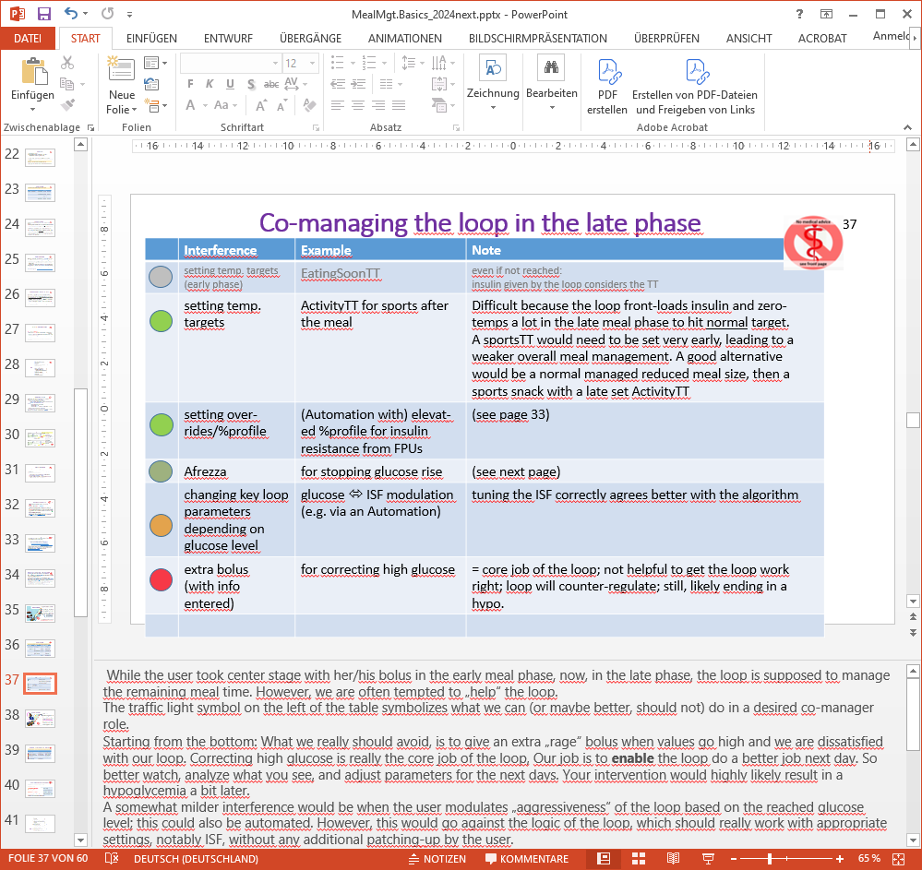
Starting from the bottom: What we really should avoid, is to give an extra „rage“ bolus when values go high and we are dissatisfied with our loop. Correcting high glucose is really the core job of the loop. Your job is to enable the loop do a better job next day. So better watch, analyze what you see, and adjust parameters for the next days. Your intervention would highly likely result in a hypoglycemia a bit later.
A somewhat milder interference would be when the user modulates „aggressiveness“ of the loop based on the reached glucose level; this could also be automated. However, this would go against the logic of the loop, which should really work with appropriate settings, notably ISF, without any additional patching-up by the user.
To stop a glucose rise with the inhaleable insulin Afrezza is a possible, but somewhat ambivalent, choice. It will be discussed in the next sub-chapter.
Setting stronger ISF when temporary insulin resistance from fat happens, is a good co-managing strategy that was already discussed.
Setting temporary targets is a benign way to „nudge“ the loop in a desired direction. We had discussed this already in context of EatingSoonTT in the pre-phase. Now, in the late phase, setting a high ActivityTT might be helpful, not so much for meal management, but in case activity follows that requires room for sinking glucose values. Actually, this can be quite a challenge for people who do have meal management under good control: The loop front-loads insulin and zero-temps a lot in the late meal phase, to hit the normal glucose target. An ActivityTT would need to be set very early, but lead to a weaker overall meal management. A good alternative would be a normal managed reduced meal size, then a sports snack accompanied by a late set ActivityTT.

Afrezza to the rescue!

Afrezza is an inhaleable very fast (and also short) acting insulin which could be useful to correct high glucose levels.
In our nautical analogy: The tip of our boat has drifted to the left (blue ellipse). We move it back to the right when „my girlfriend Afrezza“ does a CANNONBALL JUMP next to the front left side of our boat. The resulting >>>-wave orients our boat back towards target

Pro: Afrezza addresses a temporary extra need, and even without the hours-long tail of effects.
Con: Afrezza spray is hard to dose. Also it is not adviseable to enter data into loop because the kinetics of this insulin are very different. Available data (see charts on next page) suggest that Afrezza solves a problem in the first 60 minutes of application. However, things get worse thereafter, as both, previous loop insulin AND Afrezza fade out quickly just as (around minute 90 …120 after a meal) there is still strong carb absorption requiring active (!) insulin:
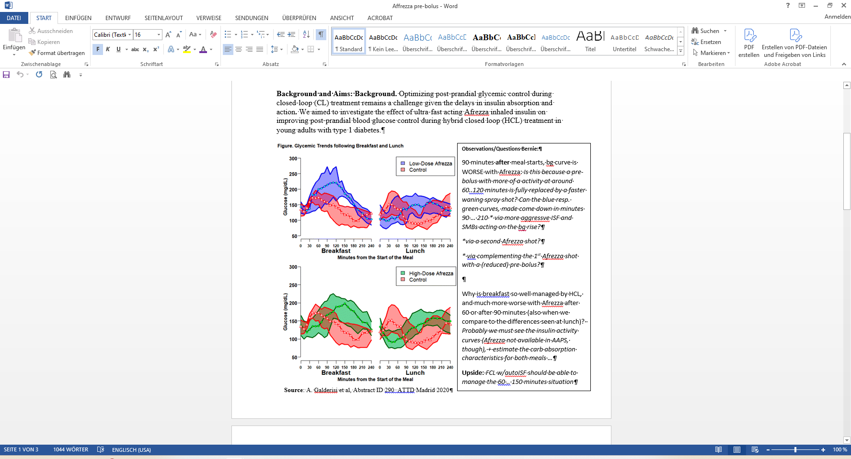
In the 60 minutes after Afrezza application the loop saw bg movements but probably lacks the proper iob data going with it:
- In absence of related iob info (Afrezza contributions missing for the calculations). It is a problem when up to about minute 60 after Afrezza application the loop sees good bg control at supposedly low active insulin; But immediately afterwards (Afrezza effects then faded away quickly), data look like suddenly super high insulin sensitivity - for which the loop can not suddenly provide active insulin. Hence the glucose rises in minutes 90…120. This situation would also result in false Autosens (if in use), with negative consequences in the upcoming hours from skewed calculations
- iOS Loop offers the option to make entries for a non-pump insulin (https://loopkit.github.io/loopdocs/loop-3/features/#non-pump-insulin
and even provides Afrezza parameters (that you can click on). This resolves most of the afore mentioned problems.
Afrezza can be a reasonable remedy in times. Solving the problem at hand as best as we can, even if it makes the time afterwards a bit more complicated, is the name of the game. We and our loop do this all the time (for instance, by giving more upfront insulin, then reducing basal (zero-temping)).
A second shot when bg rises again could actually help, too.
But preferably, seek strategies that make you stay better in range, and avoid crazy extra moves with Afrezza. (Experienced navigators can do without cannonball jumps by their crew!)

Temptation to cheat the loop via „fake“ data entry

Generally, we want our loop to work smoothly, and have the best information we can give it.
To try to provoke a certain behaviour of the system via „nudging“ it with fake inputs can certainly work for some intended effect; however it is likely to create an imbalance and develop, at least within the time frame of carb absorption from the given meal, and DIA of the insulin on bord, errors and suboptimal further regulation capability of the loop. The most prevalent cases probably are:
- the user rage bolus from a pen, without announcing it to the loop
- the un-announced anti-hypo snack.
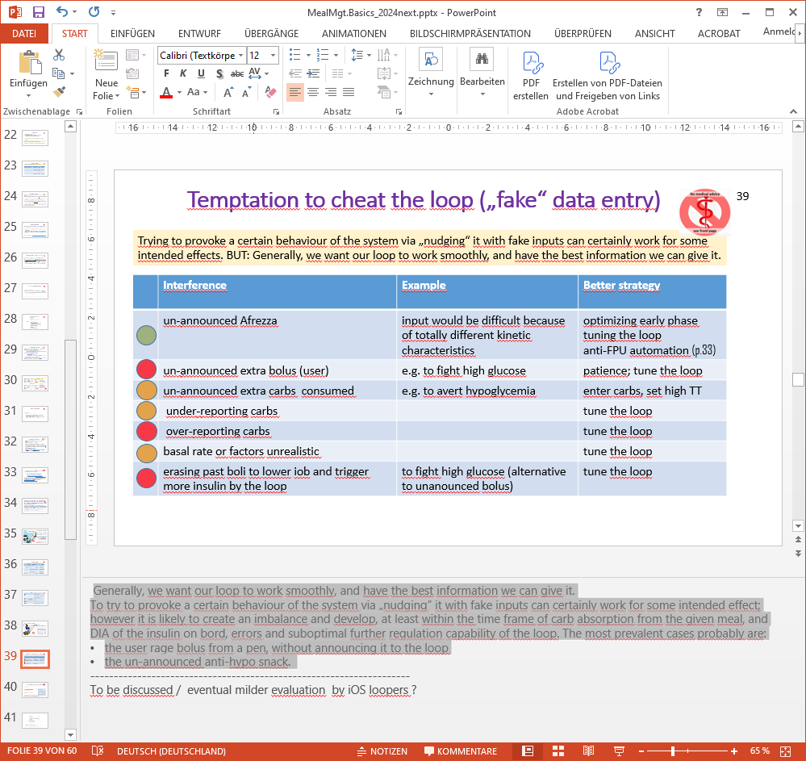

Special challenge: Meal followed by exercise

Generally for exercise you will benefit from getting less insulin, and from having an elevated glucose level - with „room“ for it to go down
Exception: In very stressful (or super exciting) situations, glucose may be rising temporarily and might even briefly require extra insulin

The blue box describes a standard situation with reduced insulin need…

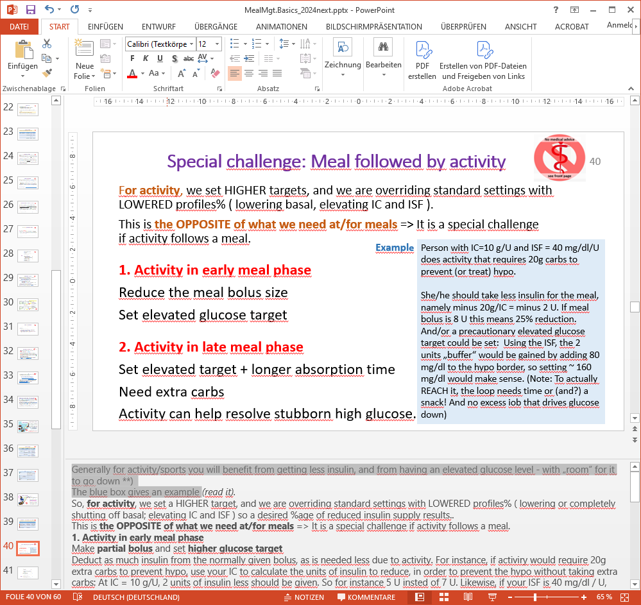
So, for exercise, we set a HIGHER target, and we are overriding standard settings with LOWERED profiles% ( lowering or completely shutting off basal; elevating IC and ISF ) so a desired %age of reduced insulin supply results..
This is the OPPOSITE of what we need at/for meals => It is a special challenge if exercise follows a meal.
1. Activity in early meal phase
Make partial bolus and set higher glucose target
Deduct as much insulin from the normally given bolus, as is needed less due to activity. For instance, if activity would require 20g extra carbs to prevent hypo, use your IC to calculate the units of insulin to reduce, in order to prevent the hypo without taking extra carbs: At IC = 10 g/U, 2 units of insulin less should be given. So for instance 5 U insted of 7 U. Likewise, if your ISF is 40 mg/dl / U, you may want to be about 80 mg/dl above hypo warning and should set a target around 160 mg/dl during activity.
So you need to collect knowledge, for each of your typical activities, how much glucose you (!!) typically need extra. Then use your (!) factors to estimate needed modification of inulin for meal, and for set glucose target.
If it is unclear in the beginning how strenuous the activity will be, your options are to reduce bolus for the meal even stronger, or to risk going low and requiring sports snacks (or sweet drink etc) later.
2. Activity in late meal phase
If activity starts when your loop is mostly zero-temping after having delivered the insulin as likely needed for (most of) the meal, this is unfortunate. You have a risk of going low as is, and the loop cannot do anything for you now. Before starting activity, be sure you do (or can) cover your needed extra energy, for instance the 20g in the example used above.
On a positive note, a bit of activity (like the post-dinner walk) can actually be good to control glucose in case you tend to go high for hours after meals, for instance, to resolve fat-induced high glucose values due to increased resistance as sometimes seen 3-4 hours after a fatty meal (as discussed p.34).
Depending on the amount of caution applied to prevent hypo during activity, a correction bolus may be required when activity comes to an end.
If the activity is not too strenuous, you still may require insulin for late carbs. In that case, use an override (a reduction of %profile), so the loop gives TBRs or microboli at a reduced rate, when glucose gets above a certain BG #. In iOS loop, you can also play with extending the absorption time of carbs.
Overall, it's a personal experiment to find what works good enough for you. Regarding exercise, it very much depends on kind, duration, starting time relative to the meal.

General (meal-independent) exercise related settings
This is a bit off-topic in this paper focused on meal management. But it is probably worth losing a few words regarding how the DIY loops can take care of higher insulin sensitivity when you exercise.
Note: There are also special situations where insulin sensitivity goes in the opposite direction (e.g. from excitement or stress). If you can characterize these situations in your loop data patterns, you can (very easy to do in AAPS/Automations) define how your loop shall, for a couple of minutes, react differently, to resolve that special situation.
But we like to look at the standard case here.

Lighter exercise might be sufficiently handled by your loop via automatic self-adjusting. Autosens, and an Activity Monitor that softens ISF with step-count are examples.
More substantial exercise (including hard muscular work) will benefit from 1) starting at elevated bg (setting an elevated temp. glucose target before and during exercise) 2) low iob (e.g. reducing meal boli, as already discussed) 3) reducing basal and 4) increasing (=softening) ISF. Furthermore, 5) it can be a good idea to shut SMBs (auto-boli) off during exercise.
- There are extra resources (videos, blogs, FB posts) on sports management when looping. Certainly the open source (DIY) systems offer much more adjustability to all kinds of also extreme sports.
https://diyps.org/.../how-to-exercise-when-exercise-is.../
Facebook: Type 1 Diabetic Athletes Group
Book recommendation (English): https://amzn.eu/d/0dJxaoxM Book recommendation (in German): https://www.diashop.de/diabetes-und-sportfibel-mit-diabetes-weiter-laufen-5-auflage-1-buch.html
Mark Green https://beyondtype1.org/diabetes-and-exercise/
- Specifically on after-effects: https://www.diabettech.com/openaps/what-conclusions-can-we-draw-when-investigating-insulin-sensitivity-using-the-autosens-function-within-openaps-an-n1-study/
- Also, there are other groups discussing specifically kids, with their sometimes unpredictable eating and hopping-around habits. See e.g. section “Exercise” (p.22) in: https://www.facebook.com/groups/AndroidAPSUsers/permalink/3558700247684700/
ISPAD Clinical Practice Consensus Guidelines 2018: Exercise in
children and adolescents with diabetes (Peter Adolfsson et al.), http://bnsde.org/wp-content/uploads/2018/10/14.pdf

- With suitable DIY software and after some iterations to find your personal suitable settings (read: after a lot of “work”), all this can even be automated. A “Full Closed Loop” example is given in “Case Study 6.2…pdf” here: https://github.com/bernie4375/FCL-potential-autoISF

Extreme exercise (up to ultra-marathon level) is discussed …
- by Dana Lewis here: running ~82 miles in ~25 hours, all in one go!

