學號：R11921A16 系級：電機所碩一 姓名：何秉學

1. (1.5%) 請說明RNN、GRU、LSTM等模型之間的異同。另外，如果你Kaggle上最佳的預測結果並不是使用上述三種模型產生的話，請額外說明你使用的model為何，以及簡介其背後的原理/機制。

Ans:

* RNN Model VS GRU Model VS LSTM Model

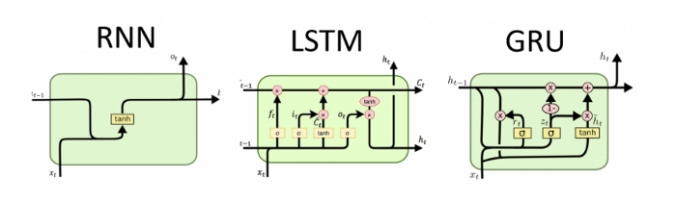

* The detailed formula of RNN is $h_{t}=tanh⁡(U∙X_{t}+W∙h_{t-1})$ and it usually has much more parameter to compute text data. Generally speaking, RNN has some problems about gradient vanish and gradient explode and it’ll cause the long term memory lost (because of gradient vanish).
* LSTM’s model can handle these problems by two techniques – using gate to handle gradient vanish and control long term memory.
* Meanwhile, there is a simplified version made from LSTM named GRU, which discard $h_{t}$. It thought that $c_{t}$ contained all message from $h_{t}$, so in order to cut off the number of parameter, it can be discarded.
* Reference

[RNN vs LSTM vs GRU -- 该选哪个？](https://zhuanlan.zhihu.com/p/55386469)

1. (0.5%) 請解釋為何RNN模型會發生gradient vanishing以及gradient exploding，以及這兩個現象對training可能會有什麼不良影響。

Ans:

* In RNN model, it’s a simple activation function that given previous $h_{t}$ and data $x$. So, for instance as below, we have 4 layer of neural network that each layer has one node and each layer activation function is sigmoid, that is $y_{i}=σ\left(x_{i}w_{i}+b_{i}\right)$ where $z_{i}=x_{i}w_{i}+b_{i}$. So, according to back propagation, we can compute the gradient like this: $\frac{∂C}{∂b_{i}}=\frac{∂C}{∂y_{4}}\frac{∂y_{4}}{∂z_{4}}\frac{∂z_{4}}{∂x_{4}}\frac{∂x_{4}}{∂z_{3}}\frac{∂z_{3}}{∂x_{3}}\frac{∂x_{3}}{∂z_{2}}\frac{∂z_{2}}{∂x_{2}}\frac{∂x_{2}}{∂z_{1}}\frac{∂z_{1}}{∂b_{i}}$.



* And, derivative of sigmoid function is as below $S^{'}\left(x\right)=\frac{e^{-x}}{{(1+e^{-x})}^{2}}=S(x)(1-S(x))$. The maximum of the derivative result is 0.25 and we’ll set the initial value of our weight as a random value less than one, so $\frac{∂y_{i}}{∂z_{i}}\frac{∂z_{i}}{∂x_{i}}=σ^{'}\left(z_{i}\right)w_{i}<0.25$ and it’ll getting smaller as your layer getting deeper. And this is gradient vanish problem that we want to solve. For our model, it’ll cause that our parameter can not be updated.
* Then, if we set the initial value bigger, we’ll get $\frac{∂y_{i}}{∂z_{i}}\frac{∂z_{i}}{∂x_{i}}=σ^{'}\left(z_{i}\right)w_{i}>1$. That is, if our network get deeper, the back propagation result will times together, and all these value which are all bigger than one will obtain a huge value. This is gradient explode problem that we want to solve. For our model, it’ll get NaN easily that means we can not converge our model.

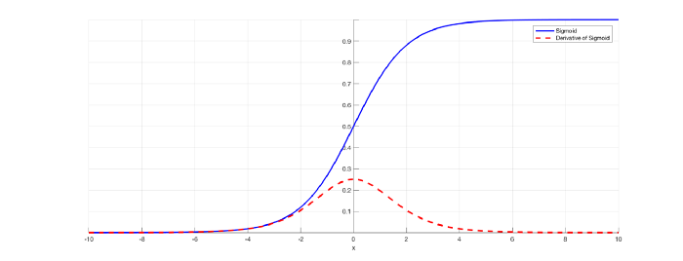

* Reference

[RNN的梯度消失问题](https://zhuanlan.zhihu.com/p/44163528)

1. (1%) 相較於Sample Code來說，你做了哪些修改或嘗試(如模型架構、資料前處理、後處理等)？請描述你做的嘗試以及其理由，如果你認為你的做法帶來的進步與第一題的回答有關的話也請詳述之。(請注意若你的解釋太過不合理，則不論你在leader board上分數多高，這題都無法拿到滿分)

* First, I change my model from simple RNN to LSTM and it’ll get a higher accuracy and converge the model more easily.
* Then, I implement the parsing text method for text data preprocessing by filter @ symbol, URL strings, hashtag strings, some HTML strings such as “&lt;” or “&gt;” and some sequence strings such as “…” or “!!!”. But the effect is limited and this is as my expectation.
* In word to vector embedding model, I set configuration shown as below. Iter is just like epochs and min_count is threshold value that we’ll ignore all words with total frequency lower than this. I set it to filter some words that are not popular such as “pneumonoultramicroscopicsilicovolcanoconiosis” and it’ll be getting better than I expected.
* Then, I used these techniques above to train backbone and header model and based on the result to train again and again.

|  |  |  |  |  |  |
| --- | --- | --- | --- | --- | --- |
| window | min_count | workers | iter | sg | w2v_dim |
| 5 | 5 | 12 | 10 | 1(skip-gram) | 250 |

1. (0.5%) 請簡述你leader board上表現最好的實驗結果中使用的embedding為何？如何產生？

Ans:

The embedding I used in my experience is CBOW. The left side figure below is trained LSTM model with skip-gram and right side below is trained by CBOW and they are all set with the same configuration except the w2v method. Obviously, skip-gram method has a lower initial accuracy and can not train the model better than CBOW. So, that’s why I choose CBOW as my w2v method.

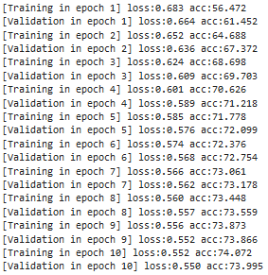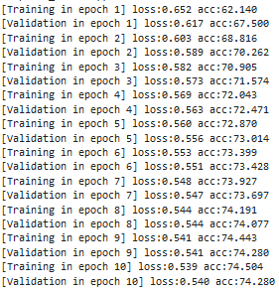

The orange line is CBOW and green one is skip-gram.

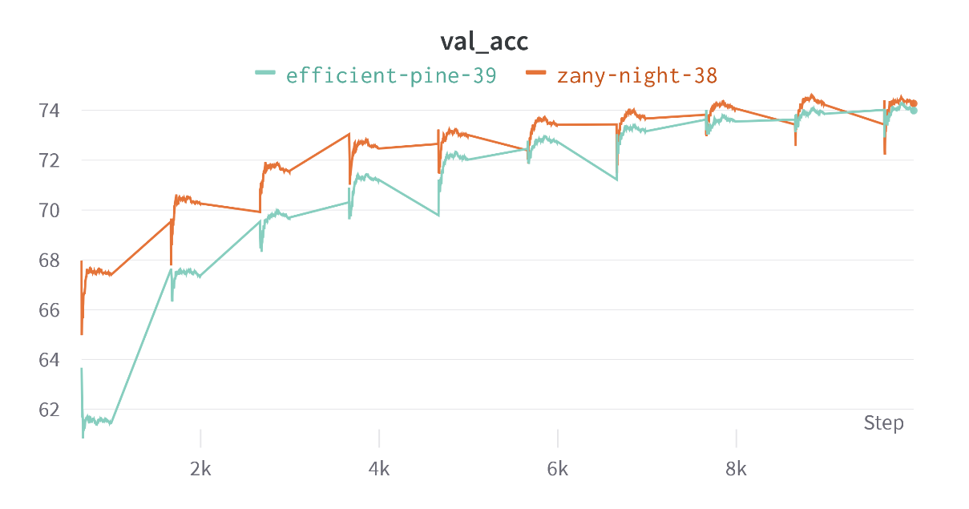

1. Play with your models!
2. (0.5%)在本題中，s1、s2互為彼此的valid permutation，若且唯若s1、s2兩句子的單字種類、數量相同、排列順序不同且各自皆為有意義並且合乎文法的句子。例如，A student is a banana 是 A banana is a student的valid permutation。請找出一組互為彼此的 valid permutation且使你的model產生相反的prediction的s1、s2。(s1、s2須具備合乎邏輯且有實際生活意義的語意)

Ans:

In my example, s1 is “Though the price is expensive, the food is excellent.” and s2 is “Though the food is excellent, the price is expensive.” Obviously, s1 is positive and s2 is negative about a restaurant.

1. (1%，bonus) 請從網路上(如FB、IG、Twitter) 找出一則能夠讓model預測錯誤的「反串」酸留言，並將截圖附於report上 (即找到一則真實世界存在的留言，使得人類知道這留言應是negative，但model outputs positive)

Ans:

In my example, the message from concern troll is “”

注：請將這兩小題的程式碼也附在繳交的code上，並截圖附上來

1. (4%) Math problem:

https://hackmd.io/@lH2AB7kCSAS3NPw2FffsGg/H1ucYOpNo