**SCHOOL HOUSE PROGRAM**

INSTALLATION

This school House Program source code is run from C# in .NET Visual Studio 2017 with the JSON Nuget package to serialize the data to text files STUDENT1.JSON, CLASSES1.JSON and TEACHER1.JSON located at C:\LIST\

STARTUP MENU

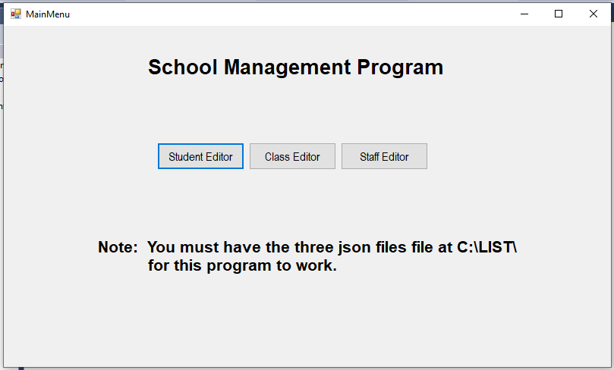

The School management program boots up to a menu allowing the user to select the Student Editor, the Class Editor or the Staff Editor.

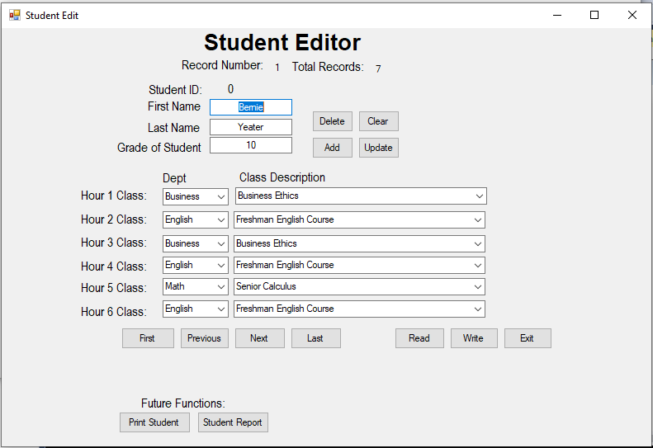

The Student Editor allows the user to edit the first name, last name, grade of student, and the classes for each hour. Selecting the department fills the combination box for the class description particular to that department. Future button “Print Student” is working, Student report is a future planned function.

Class Taught Editor

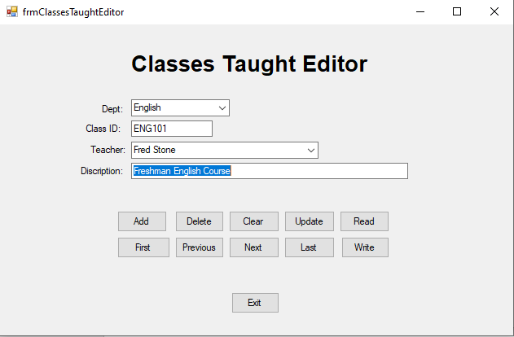

The classes taught edit allows you to create classes and assign them to a department and teacher. In the Student Editor you can then assign classes created on this form.

TEACHER EDITOR

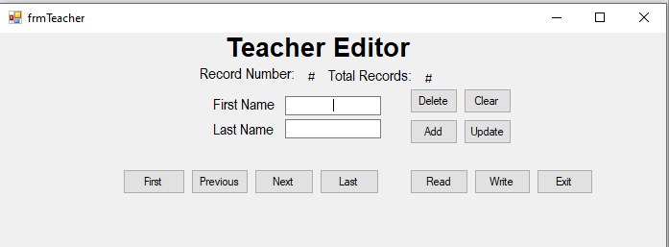

The teacher editor allows you to enter your teachers so they can be assigned to classes.