**Intro…**

**Preference profiles**

*Preference profile 1*

My overall preference is motivated by cost. Areas where costs can be reduced have the highest weight. I prefer to do as much ourselves as possible.

The categories where mosts cost reductions can be achieved are location, music and food.

In food cheap and/or handmade have the highest evaluation value whereas catering the lowest as catering is quite expensive in general.

For drinks the same motivation holds but I made an exception for cocktails because I simply prefer them strongly over other drinks.

Location most likely is the category with the highest cost as hiring a location is expensive. As my dorm cannot hold many people this has the lowest evaluation value.

Invitations I don’t care much about but a handmade plain invitation has the most personal touch which I like.

Concerning music, MP3 is a very simple and cheap solution. A DJ might be found in our network of friends but a band is too costly to consider.

For cleanup, hired help and/or equipment will increase costs therefore simple water and soap has the highest evaluation value.

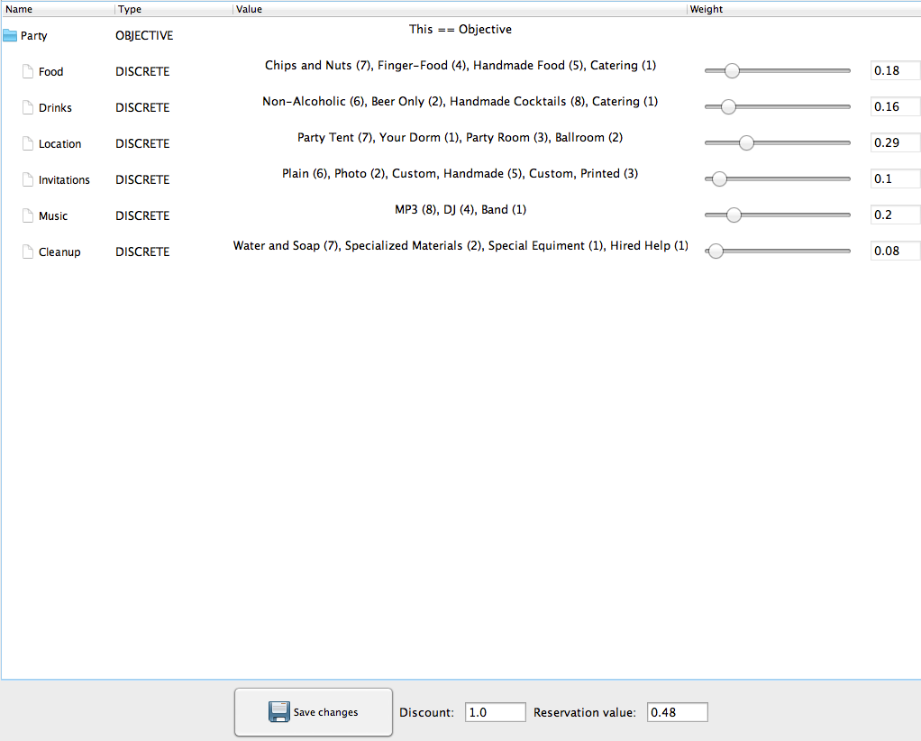

Food

Chips and Nuts

Finger-food

Handmade Food

Catering

Drinks

Non-Alcoholic

Beer Only

Handmade Cocktails

Catering

Location

Party Tent

Your Dorm

Party Room

Ballroom

Invitations

Plain

Photo

Custom Handmade

Custom PrinteD

Music

MP3

DJ

Band

Cleanup

Water and Soap

Specialized Materials

Special Equipment

Hired Help