Artificial Intelligence Techniques
IN4010

Automated Negotiation – Group 13
October 2015, TU Delft, The Netherlands

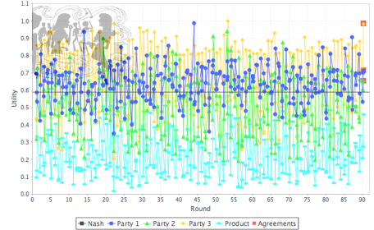

Authors:
J. Oostenbrink T. Boumans B. Foppes
4169263 4214854 9243144

Introduction

In this automated negotiation assignment we design, implement and improve a negotiating agent to be used in GENIUS. The negotiating agent starts very basic and has been gradually improved. In this improvement process different strategies have been tried out and/or fine-tuned.

Basic negotiating agent

Our very first negotiating agent has only one tactic which is to only accept a bid if it’s utility is equal to or higher than the reservation value. If the reservation value is less than 0.8, the minimum accepted utility is 0.8. The code for this very basic agent is shown below.

public class Group13 extends AbstractNegotiationParty {
private double minUtility = 0.8;
private double lastBid = 0;

public void init() {
minUtility = Math.max(minUtility, utilitySpace.getReservationValueUndiscounted());
}

@Override
public Action chooseAction(List<Class<? extends Action>> validActions) {
try {
if (validActions.contains(Accept.class) && shouldAccept(lastBid)) {
return new Accept();
} else {
return new Offer(generateBid());
}
} catch (Exception ex) {
System.err.println("Exception in chooseAction: " + ex.getMessage());
return new Accept();
}
}

@Override
public void receiveMessage(Object sender, Action action) {
super.receiveMessage(sender, action);
if (action instanceof Offer) {
lastBid = getUtility(((Offer) action).getBid());
}
}

private boolean shouldAccept(double utility) {
return utility >= minUtility; }

private Bid generateBid() throws Exception {
return utilitySpace.getMaxUtilityBid();
}

@Override
public String getDescription() {
return "Negotiator Group 13"; }
}

Although this is a very basic agent, the performance against agents, which only generate random bids and in time start to concede, is still very good.

Our first improvement was to generate a set of bids with a utility greater than 0.8. Only bids from this set are used in the negotiation. This agent is a more realistic one but performs about the same as the very first one. The main code for this first improved agent is shown below:

ArrayList<HashMap<Integer,Value>> ret = new ArrayList();
for (ValueDiscrete v : issueD.getValues()) {
for (HashMap<Integer,Value> bid : bids) {
HashMap<Integer,Value> newBid = new HashMap(bid);
newBid.put(issueD.getNumber(), v);
ret.add(newBid); }
}
return ret;
}
}

@Override
public Action chooseAction(List<Class<? extends Action>> validActions) {
try {
if (validActions.contains(Accept.class) && shouldAccept(lastBid)) {
return new Accept();
} else {
return new Offer(generateBid());
}
} catch (Exception ex) {
System.err.println("Exception in chooseAction: " + ex.getMessage());
return new Accept();
}
}

@Override
public void receiveMessage(Object sender, Action action) {
super.receiveMessage(sender, action);

if (action instanceof Offer) {
lastBid = getUtility(((Offer) action).getBid());
}
}

private boolean shouldAccept(double utility) {
return utility >= minUtility;
}

private Bid generateBid() throws Exception {
if (allowedBids == null) initBids();
return allowedBids.get(rng.nextInt(allowedBids.size()));
}

As second bot attempt to negotiate by conceding towards what the other agents want, is done by offering the best deal that concedes one item towards what the other agent wants, the code for generating these offers is shown below:

public Bid generateLeastPainfullCompromise(Bid ourLast, Offer currentOther){
Bid best=currentOther.getBid();
Iterator<Entry<Integer, Value>> it = currentOther.getBid().getValues().entrySet().iterator();
HashMap<Integer,Value> ours = ourLast.getValues();
while(it.hasNext()){
Entry<Integer,Value> issue=it.next();
if(!issue.getValue().equals(ours.get(issue.getKey()))){
Bid compromise = new Bid(ourLast);
compromise.setValue(issue.getKey(), issue.getValue());
if(getUtility(compromise)>getUtility(best)){
best=compromise;
}
}
}
return best;
}

This both works well against the random agents but against a better agent it will quickly concede all the way towards whatever is best for the other agent suggesting that maybe something like tit for tat is needed.

Improving the negotiating agent

For testing the performance of our agent we were required to use at least the agents: ANAC2015-3-ParsAgent, ANAC2015-5-Mercury and ANAC2015-6-Atlas. We started by testing the performance of our first very basic agent by running a tournament with the four agents.

The performance of our first very basic agent (just offer maximum utility bid) was not as bad as expected. In 6 out 24 sessions our agent ended up with the highest utility. A total of 6 times no agreement was reached at all. The tournament results summary is displayed below in picture 1.

Our first simple improvement was to generate a set of bids with a utility greater than 0.8 and only use this set in the bidding process. The results of this tournament are displayed in picture 2 below. In this tournament 4 times no agreement was reached and 5 out 24 times our agent ended up with the highest utility. It seems the improvement is not effective so we need more intelligence in agent.
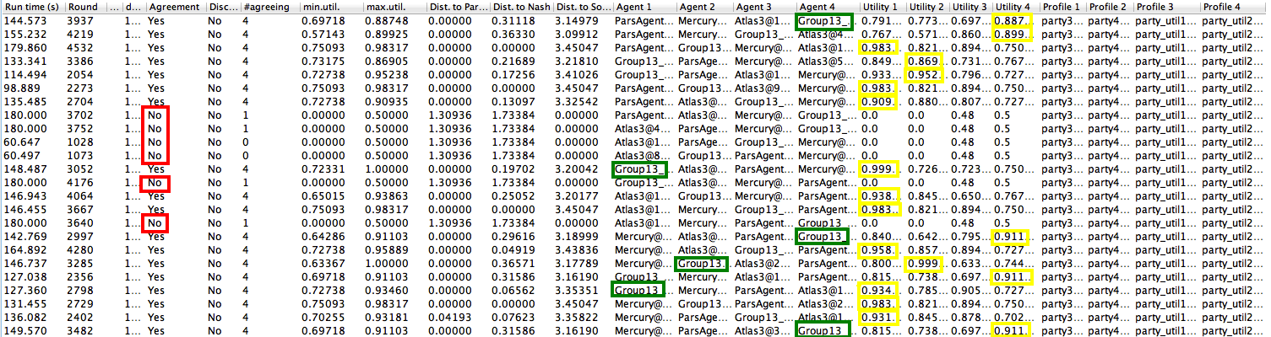

Picture 1. First very basic agent tournament results
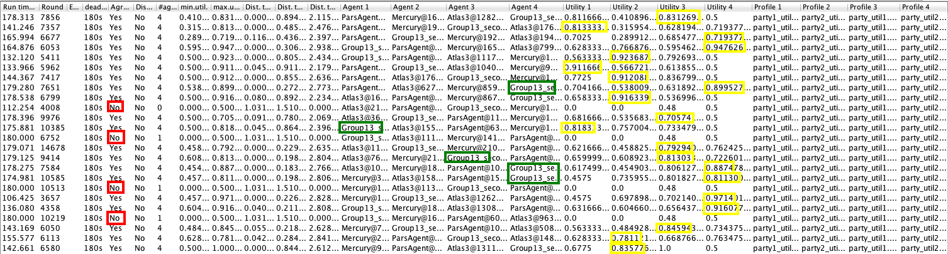
Picture 2. Second tournament with first improvement of agent

For further improvement of our agent we took the following factors into account:

- Time
The idea of using time is to adopt different strategies based upon where we are on the timeline of the negotiating session.
- Opponent modeling
What model to use in order to identify the strategies of the opponents and what parameters to model.
Our next agent only uses time without any modeling. The strategy is to implement a reverse conceder based on the assumption that other agents concede more as the session deadline approaches. The reverse conceder does the opposite as it concedes less as the deadline approaches hoping the opponents are more willing to accept less optimum bids from their perspective. Another reason the adapt this strategy is to confuse the opponents opponent modeling strategies. The main code which generates a different set of bids based on the time passed within the session is shown below:

private Bid generateBid() throws Exception {
double theTime = timeline.getTime();
System.out.println(theTime);

if (theTime < 0.5) {
minUtility = utilitySpace.getReservationValueUndiscounted() + 0.2;
maxUtility = utilitySpace.getReservationValueUndiscounted() + 0.1;
initBids();
}
else if (theTime > 0.5 && theTime < 0.95)
{
minUtility = utilitySpace.getReservationValueUndiscounted() - 0.2;
maxUtility = utilitySpace.getReservationValueUndiscounted() - 0.1;
initBids();
}
else
{
minUtility = utilitySpace.getReservationValueUndiscounted() + 0.2;
maxUtility = utilitySpace.getReservationValueUndiscounted() + 0.25;
initBids();
}
return allowedBids.get(rng.nextInt(allowedBids.size()));
}

The performance of this agent was not good at all. Only very few sessions ended up with the highest utility for this agent. The reason probably is the fact the opponents are more intelligent and accept bids less fortunate for us before the reverse concede starts to take effect. Trying to tune this moment didn't lead to better results.

Another type of modeling we experimented with was evolutionairy neural networks. It soon become clear however that is would be too complex to implement for this type problem and would probably be prone to overfitting both based on chosen training issue which can be overcome by randomly generating the training issues and training opponents which are harder to randomize.

Needing a more intelligent agent, we started to implement opponent modeling. To model the opponents we store all accepts and rejects, for the latter only 10 bids because we assume the number of times rejects occur decreases while the number of times accepts occur increases. All bids are also stored in frequency opponent models. We only store unique bids as during our tests we noticed that quite some agents offer only one bid (maximum) in at least the first half of the session. By doing so they try to let us (the model) believe that everything they offer afterwards is a concession which is the case but very minimal. It's worth noting that we also discovered that we also discovered that we can improve our opponents model if we give our top few percent bids. This can be useful when aiming at the Nash point. However as our bot negotiations relatively mean most of the time it turned out to be better to give our maximum value offers and screw with our opponent's opponent model then to help improve it.

In our acceptance code we check of the opponent's bid is higher than our generated bid and if so we accept. If not, we alternate between generating a new bid and offering our maximum bid. By applying this strategy we try to confuse the opponent modeling of the opponents (their model of our agent) and, as we noticed, ensure that some agents will concede faster.

Our strategy also included time. The elapsed time of the negotiating session is checked and as time passes we change our strategy. In the first 60% of the negotiating session time we only offer our maximum bid. This results in the fact that we only accept in this phase if the opponent offers a bid with of utility of 1 for us.

After this phase we start using the stored bids. By analyzing the bids we estimate what the minimum utility is for the opponent to accept our bid. Our own minimum utility is determined by taking the maximum of our utility function and the minimum of the opponent 's utility minus 0.05. This will ensure we don't concede to opponents that don't concede to us and by subtracting 0.05 we avoid a standoff in which both parties wait for the other to concede.

Next we try to find a bid that other agents will accept while maximizing our utility. If this bid meets our minimum utility demand we stop. If not, we generate a bid that maximizes the opponent's utility while still maintaining our minimum utility demand. Using this strategy we never generate a bid with a utility lower than what we perceive other agents would have generated at least once within the negotiating session.

When the end of negotiating session is almost there we adopt another final strategy. First we try to calculate the Nash product bid and find a bid that has been accepted or offered by the others except by us (not in rejects). The maximum of these two we offer. Even when the Nash product bid is rejected, we offer it again a couple of times as other agents tend to accept as the end of the negotiating sessions is almost there. To be sure to end up with an agreement we maintain a limit on doing so after which we switch to a safer bid that has been accepted by the other once before.

Some strategies we tried but didn't work as well as the we used in the end:
For each offer generate the nash point and use the opponent model is decrease the utlity of offers that have recently been rejected; this method almost always resulted in an agreement but often the agreement that we reached was not that great as the opponent would grow to believe we weren't conceding because it assumed that the nash values where our maximum utlities. This strategy did however inspire our final end game.

Try to mirror how much the opponent concedes. This was a strategy where we estimated our opponents utility to be equal to our own in the offer they last send us, unless that would result in a worse deal for us in which case we just accepted. This strategy fell appart however in negotiations where we shared simulair enough goals as we would quickly concede towards our opponent believing him to be conceding hard as well without this being the actual case.

Summarizing what we've learned during the process of improving our negotiation agent:

- We soon learned that conceding naively is not a good strategy for competing against most of the other agents
- For a lot of agents, actual negotiation starts late within a session. They only offer their maximum bid for the majority of the time. This makes it harder to model these opponents
- We not only changed our opponent model learning from these experiences but also adopted some of the same strategies in a combined form. For example by alternating between highest bid and other bids in the second phase of negotiation. This resulted in the biggest improvement in terms of performance
- A slight change which also generated performance improvement was to implement the momentum of 0.05 as this causes actual negotiation to start sooner (and thus also conceding strategies of opponents)
- Storing the rejects of opponents proved to be very useful. One reason is that it prevents offering the same rejected bids and another is learn the conceding rate of opponents. Implementing this resulted in a much higher average utility and probably also higher social utility
- Nearing the end of the negotiation session the performance against some other agents was still a bit poor. We learned that offering the Nash product is very beneficial although it decreases the utility is some cases, it increases the avery utility overall

Conclusion

Our experience regarding building an agent as a team is overall positive although it took some negotiations to determine our agent negotiation strategy and getting to final delivery package.

To support real-life negotiations some different strategies are required as effectively we only really negotiate in the last 20% of the time. In real-life this would probably lead to a lot more non-agreements than against other agents which do something similar.

Appendix A

