**Implementation**

Project made using VS 2019

1. Design

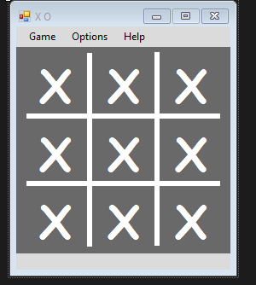

Contains of Menu bar and set of Labels

1. Form Code

* Reset function to set all back to normal

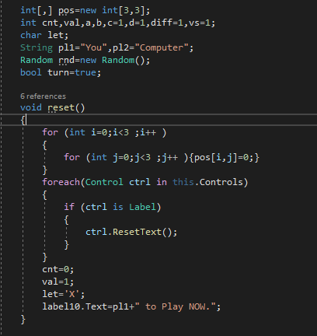

* Play function that run when click on the Labels

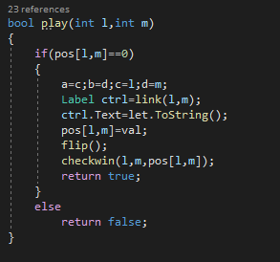

* Flip function to draw X or O

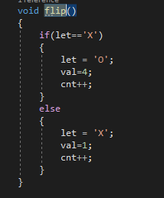

* 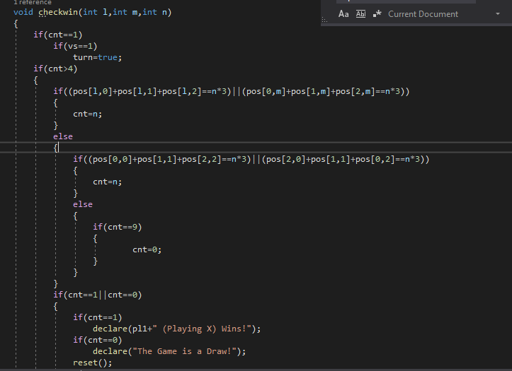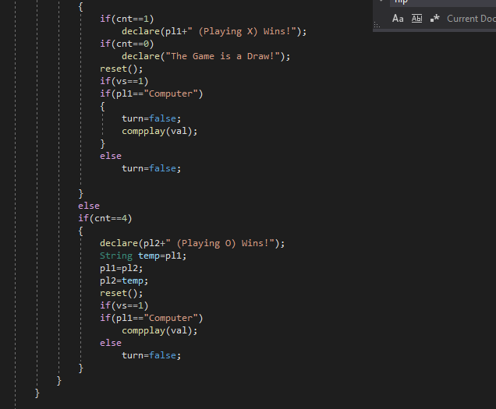Checkwin function that checks every turn if u have 3 in row or the computer have 3 in row
* Declare function is the dialog that shows when win or lose game

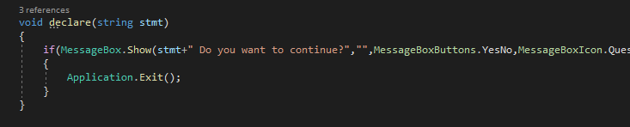

* 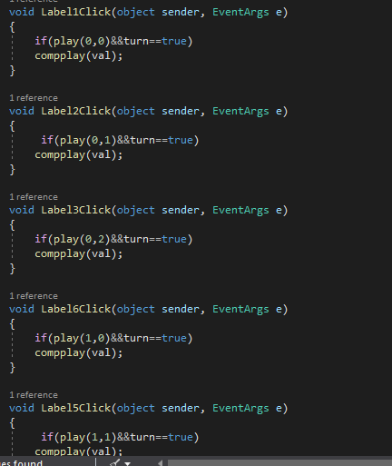Label Click functions

1. Run Screens

