Homework 2: Estimate Wine Quality, Linear Regression and 95% Prediction Intervals

I retrieved multivariate dataset considering attributes of white wine and predicted regressed wine quality based on other attributes of white wine which are;

1 - fixed acidity

2 - volatile acidity

3 - citric acid

4 - residual sugar

5 - chlorides

6 - free sulfur dioxide

7 - total sulfur dioxide

8 - density

9 - pH

10 - sulphates

11 – alcohol

I retrieved data from https://archive.ics.uci.edu/ml/datasets/Wine+Quality

﻿

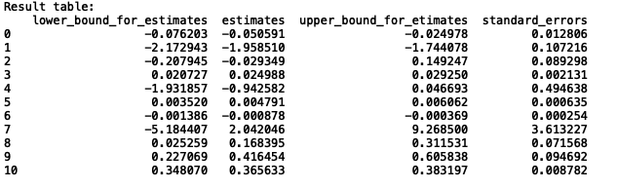

If we interpret the table;

Fixed acid is negatively correlated with wine quality which has the beta of [-0.05059062].

Volatile acidity is negatively correlated with wine quality which has the beta of [-1.95851023]

Citric acid is negatively correlated with wine quality which has the beta of [-0.02934924]

Residual sugar is positively correlated with wine quality which has the beta of [ 0.0249884 ]

Chlorides is negatively correlated with wine quality which has the beta of [-0.94258237]

Free sulfur dioxide is positively correlated with wine quality which has the beta of [ 0.00479079]

Total sulfur dioxide is negatively correlated with wine quality which has the beta of [-0.00087763]

Density is positively correlated with wine quality which has the beta of [ 2.04204607]

pH is positively correlated with wine quality which has the beta of [ 0.16839514]

Sulphates is positively correlated with wine quality which has the beta of [ 0.41645356]

Alcohol is positively correlated with wine quality which has the beta of [ 0.36563338]