**Algorithm 2: UM6P-CS**

**Cours intégré**

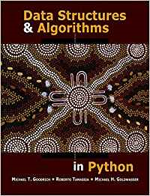

**Reference Textbook:**

* **Goodrich M.T., Tamassia R., Goldwasser M. - Data structures and algorithms in Python-Wiley (2013)**

**For slides:**

* **Stanford cs161 based on Thomas H. Cormen, Charles E. Leiserson, Ronald L. Rivest, Clifford Stein - Introduction to Algorithms 3rd Edition (2009)**

**Content**

1. Python Background (1 et 2 séances): I.B
2. Algorithm Analysis (3 et 4 séances): I.B
3. Sorting and searching algorithms on Arrays (5 et 6 séances): Y.B
4. Stacks, Queues and Deques with examples (7 et 8 séances): Y.B
5. Linked Lists (9 séance): A.K
6. Trees (10 séance): I.B
7. Map, HashTable (11 séance): A.K
8. Graphs (12 et 13 séances): A.K