

CS 319 Term Project

Analysis Report

**Team Name: Group 2H CA**

**Project Name: Settlers of Catan**

**Members:**

• Ravan Aliyev

• Berrak Taşkınsu

• Hazal Aksu

• Ayşe Nursu Savaşkan

# Table of Contents

**Table of Contents** **2**

**1. Introduction** **3**

**2. Overview** **4**

2.1 Gameplay 4

2.2 Board 4

2.3 Single player Mode 5

2.4 Multiplayer Mode 5

2.5 Settings 5

**3. Functional Requirements** **5**

3.1 Single Player 5

3.2 Multiplayer Mode 5

3.3 Settings 6

**4. Non-functional Requirements** **6**

4.1 Usability 6

4.2 Supportability 6

4.3 Game Performance 6

4.4 Extendibility 6

**5. System Models** **7**

5.1. Use Case Model 7

5.2. Dynamic Models 9

5.2.1. Sequence Diagrams 9

5.2.2. Activity Diagram 13

5.3. Object and Class Models 14

5.4. User Interface 15

5.4.1. Main Menu 15

5.4.2. How to Play Window 16

5.4.3. Settings Window 17

5.4.4. Start Game Window 18

5.4.5. Main Game Window 19

5.4.6. Game Menu Window 20

5.4.7. Trade Window 21

5.4.8. Building Window 22

**6. Glossary** **23**

**7. References** **23**

# 1. Introduction

The Settlers of Catan from Mayfair Games is an award-winning strategy game where players collect resources and use them to build roads, settlements and cities on their way to victory. The board itself is a variable, making each game a little different from the next. Each round of The Settlers of Catan is intended to keep three or four players engaged for up to 90 minutes. Fun and engaging for both children and adults, and the variable nature of the playing field really make players want to play again and again [1]. When players start pausing to contemplate their opponents' strategy and think of the probability of different dice rolls into players’ moves, the game sometimes take longer than expected. Mayfair Games markets Settlers of Catan as a game designed for everyone older than 10.

The aim of this project is developing the Settlers of Catan game for a digital environment. For this project, our number one priority is conserving the unique gameplay of the game. Because of that, the main goal of the game will be the same as the original: reaching ten points before your opponents do. After a few hours of gameplay, it is possible for the players to get bored. Therefore, our second priority is adding new features to the game in order to keep players attracted to the game, even after many hours of gameplay.

For the implementation of the game we will use the Java programming language. To be more accurate JavaFX will be used and the main goal is using the object oriented programming skills we learned in CS319.

# 2. Overview

This section contains an overview of GamePlay, Board, Single Player Mode, Multiple Player Mode and Settings.

## 2.1 Gameplay

Settlers of Catan is a game designed to be played as a board game but we are going to adapt the game into a digital environment. There are three main elements of the game: the game board, the cards and the pieces. There are two types of cards: resource and development cards. There are 4 types of pieces with different shapes: settlements, roads, cities and robber. The aim of the player is placing these pieces on the board and use the development cards to reach ten victory points. In order to place the pieces on the board, the player needs to spend a special amount of resource cards. Players will get a number of resource cards after rolling the dice if they have settlements on the hexagon which contains the number that the user gets after rolling the dice. Moreover, user will be able to trade cards with other players or use the bank to buy new cards using the cards they already have. In the beginning players have to place 2 settlements and 2 roads on the map randomly, but with accordance to the distance rule.

The main aim is to get 10 victory points before other players and win the game. Players can get these points by building settlements, cities, the longest road, having the largest army and from some development cards which also give victory points. If the total of the dice is 7 then player can move the robber to any hexagonal tile and prevent other players to get resources until the robber is moved from that tile. The robber is placed on the desert hexagonal in the beginning of the game. If the robber is being utilized, the player gets to select one random card from the players who have built structures adjacent to the tile robber is placed onto.

## 2.2 Board

The shape of the board is hexagonal. It is formed by 19 hexagonal tiles and surrounding them are 6 water tiles. These tiles are randomly placed in the beginning of the game. Hexagonal tiles contain the resource tiles or the desert tile and the surrounding water tiles have exchange ports. Number disks will also be placed on the resource tiles at the beginning of the game and numbers on these disks will correspond to the dice roll.

## 2.3 Single player Mode

The user will be playing against non-player characters (NPC) which is controlled by the game's artificial intelligence (AI).

## 2.4 Multiplayer Mode

Multiplayer Mode will allow players to play against each other. Since the game can be played with 3 or 4 players there must be at least 3 players. This mode will be played on the same computer. Each player rolls the dice in turn. During their turn they can build roads, settlements and cities, trade their cards with other players, use the bank or use their development cards if they have any.

## 2.5 Settings

The player will be able to adjust the volume of the in-game music and change the music as they wish. The user can also change the language of the game. Moreover, players should be able to turn on/off the colorblind mode.

# 3. Functional Requirements

This section contains information on the functional requirements of the Settlers of Catan Project.

## 3.1 Single Player

Players must be able to play the digital version of the Settlers of Catan board game against non-player characters. User should be able to get according cards, build pieces on the board, trade cards with NPCs and bank. User should be notified when game ends.

## 3.2 Multiplayer Mode

For Multiplayer Mode,when a new player’s turn begins, players should be notified. Players should be able to trade resource cards with each other. After the game finishes, the winner will be announced.

## 3.3 Settings

The player should be able to increase and decrease the volume of the in-game music and choose the music they want to play in the background. Settings part also must enable the user to change the language of the game. The optional colorblind mode can also be turned on and off from the settings.

# 4. Non-functional Requirements

This section explains every non-functional requirement of our software project briefly.

## 4.1 Usability

Most of the first-time players should be able to understand the game completely after the first game. In the colorblind mode all of the colors displayed must be very clear so that the color blind players can differentiate the colors. Every user with the capability of using a computer should be able to play this game. This software will be available in English, Russian, Turkish and Azerbaijani languages.

## 4.2 Supportability

The software should be portable, so that users can play it on MacOs, Windows and Linux systems in which JRE 8 is supported. Contact information of the developers of this game will be shared so that users and other developers can contact them to inform them about bugs or suggest further improvements on the software.

## 4.3 Game Performance

This software needs storage less than 0.4 GB and the response time is not to be greater than 200 ms.

## 4.4 Extendibility

After the program is implemented all of the source codes will be shared publicly so that other developers can use our code to improve our project or use it in their own projects.

# 5. System Models

## 5.1. Use Case Model

Players can start a game, view tutorials on how to play the game and change the sound settings and the language of the game. The following use case diagram shows the abilities of a player in our version of Settlers of Catan.

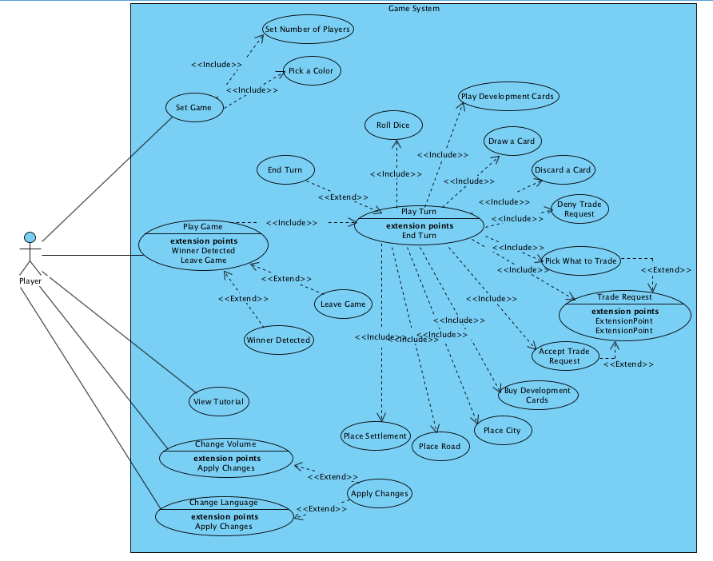

*Figure 1 - Use Cases*

|  |  |
| --- | --- |
| *Use Case Name* | Play Development Card |
| *Participating Actors* | Player |
| *Flow of Events* | * Player opens his/her deck of cards   + - Card deck view is activated in PlayFrame * Player clicks on the development card he/she wants to play.   + - Controller takes the card from Player’s hand. * Card is displayed in PlayFrame. |
| *Entry Condition* | * Player is in his/her turn. |
| *Exit Condition* | * Player plays the development card. * Player terminates the action. * Player is informed why he/she can not play the development card. |
| *Quality Requirements* | None |

|  |  |
| --- | --- |
| *Use Case Name* | Place Settlement |
| *Participating Actors* | Player |
| *Flow of Events* | * Player presses an edge of a hex to place a settlement   + - Controller confirms that such a settlement can be placed and that user has the necessary resources. * Player confirms selection and pays the necessary resources.   + - Controller gives the resources back to the Bank and updates the PlayFrame. |
| *Entry Condition* | * Player is in his/her turn. * Player has at least one hex in his/her color |
| *Exit Condition* | * Player plays the development card. * Player terminates the action. * Player is informed that he/she can not afford the settlement. * Player is informed that he/she can not place the settlement to the selected place. |
| *Quality Requirements* | None |

## 5.2. Dynamic Models

### 5.2.1. Sequence Diagrams

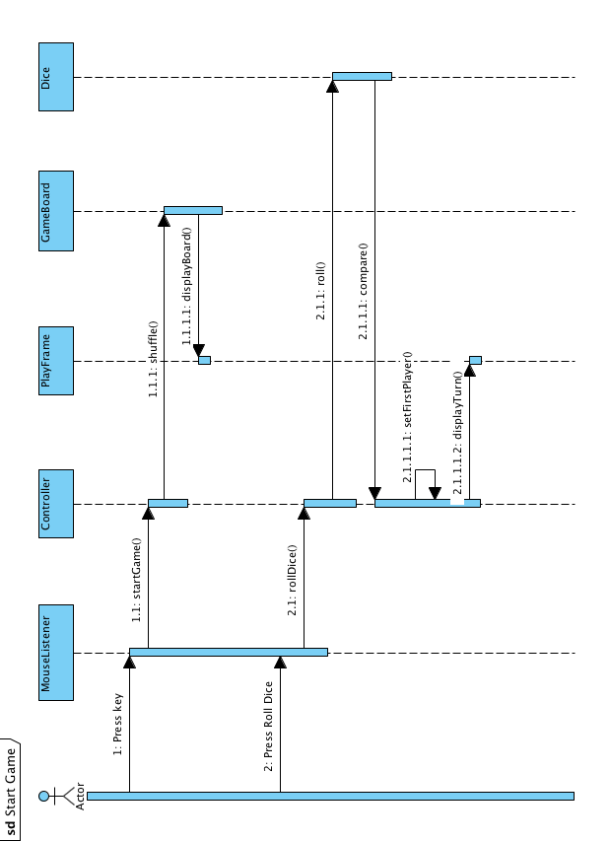

### 

### 

*Figure 2 - Sequence Diagrams*

### 5.2.2. Activity Diagram

## 

*Figure 3 - Activity Diagram*

## 5.3. Object and Class Models

### 

*Figure 4 - Object and Class Model*

## 5.4. User Interface

This section contains Main Menu, How to Play Window, Settings Window, Start Game Window, Main Game Window, Game Menu Window, Trade Window and the Building Window.

### 5.4.1. Main Menu

The Main Menu screen of our game contains three options: “Start Game”, “How to Play” and “Settings”. All three of these buttons lead to a new window.

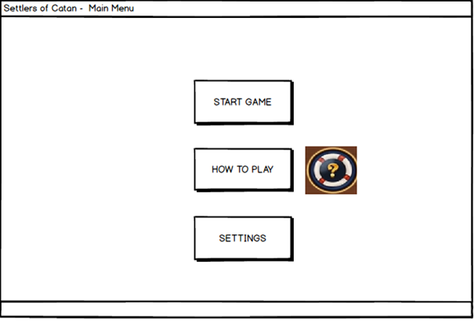

*Figure 5 - Main Menu Window*

### 

### 

### 

### 5.4.2. How to Play Window

This is a window that contains text and images, explaining the rules of the game. There is a “Back” button which returns the user to the Main Menu.

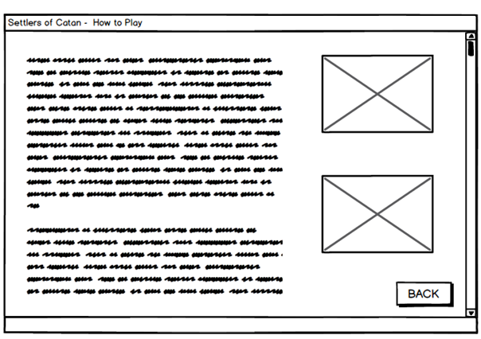

*Figure 6 - How to Play Window*

### 

### 

### 

### 

### 

### 5.4.3. Settings Window

This window lets the user adjust the volume of the sounds in the game and lets them choose the language in which they want to play the game in (English, Turkish, Russian or Azerbaijani). There is also a Colorblind Mode, which if activated, displays the game’s graphics adjusted for a person with colorblindedness. The “Back” button leads the user back to whichever window the user had open before accessing this window and the “Start Game” button leads the user into a new game window.

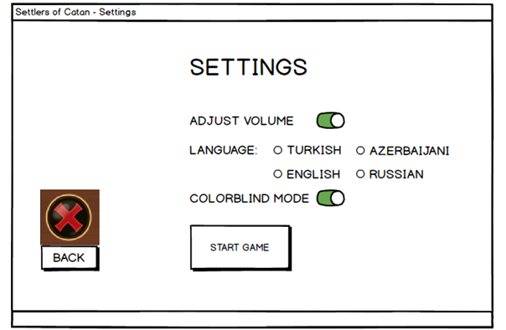

*Figure 7 - Settings Window*

### 

### 

### 

### 

### 5.4.4. Start Game Window

This is the window the user sees right before they start a new game. There are two options: a 3-player game or a 4-player game. The user can choose to play against the computer or against real people if there are multiple players wanting to play from the same computer. The user can start playing the game after choosing one of these modes and pressing the “Start” button. If the user clicks on the “Back” button, it leads them back to the Main Menu.

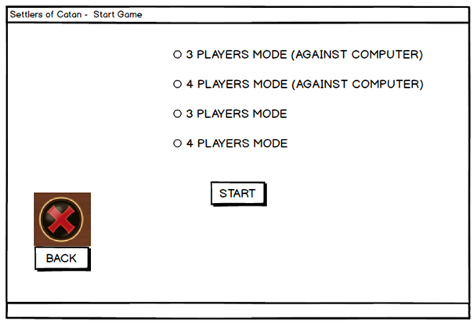

*Figure 8 - Start Game Window*

### 

### 

### 

### 5.4.5. Main Game Window

This is the main window in which the user plays the game. The user can see the main board of the game, the amount of championship points their rivals have gathered, the number of remaining Settlements, Cities, Roads both the user themselves and the other players can build, as well as the user’s cards and the cards’ quantities from this window. The user can throw the dice once its their turn, and go to the Game Menu Window from here.

(For simplicity, this mockup image shows the window after the user has chosen the 4-player mode gameplay.)

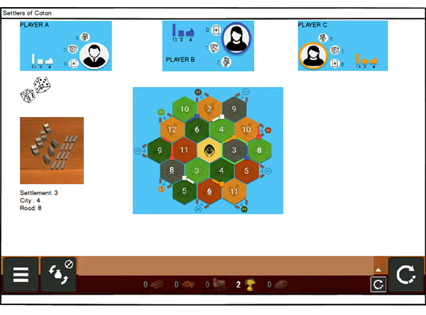

*Figure 9 - Main Game Window*

### 

### 

### 

### 5.4.6. Game Menu Window

The user can choose to go to the Trade, Build, Bank, Main Menu and/or throw the dice from here, as well as back to the Main Game Window.

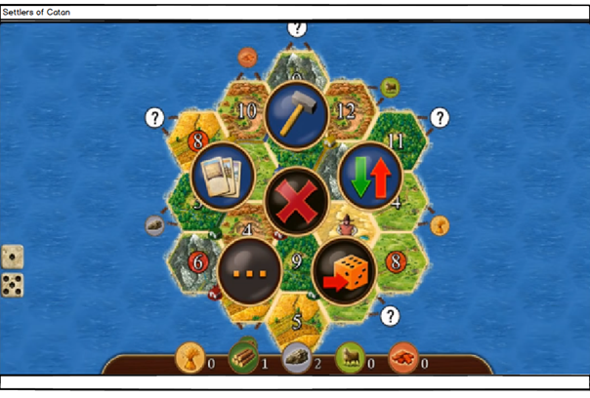

*Figure 10 - Game Menu Window*

### 

### 

### 

### 

### 

### 

### 

### 

### 5.4.7. Trade Window

The user can choose to trade cards with other players if the other players also wish to do so from this window. The user can go back to the Main Game Window and/or the How to Play Window as well.

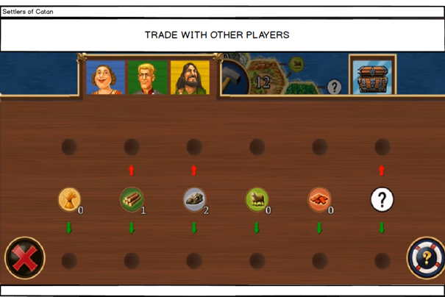

*Figure 11 - Trade Window*

### 

### 

### 

### 

### 

### 

### 

### 5.4.8. Building Window

The user can build the properties Settlement, City or Road from this window. If they wish to build something and have the necessary sources for it, they will be redirected to the Main Game Window where they will choose how and where to build their properties by clicking on the game board. This window also allows the user to go back to the Main Game Window without building anything and the How to Play Window.

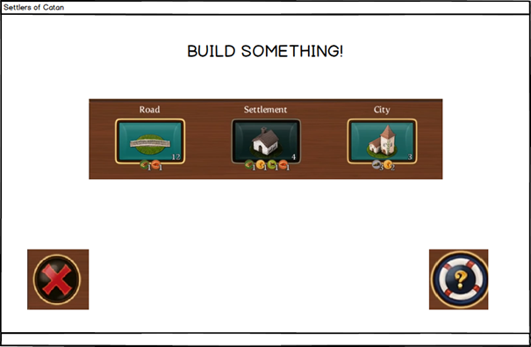

*Figure 12 - Building Window*

# 

# 

# 6. Glossary

* Development cards: build-able cards that have varying effects
* Resource cards: cards which are sorted into five sorted into five(lumber, wool, grain, brick ore)
* Robber: a piece which prevent player to get resources from hexes where it is located

# 7. References

1. <https://www.amazon.com/Mayfair-Games-MFG3061-Settlers-Catan/dp/B000W7JWUA>
2. <https://www.catan.com/en/download/?SoC_rv_Rules_091907.pdf>