

CS 319 Term Project

Analysis Report

**Team Name: Group 2H CA**

**Project Name: Settlers of Catan**

**Members:**

• Ravan Aliyev

• Berrak Taşkınsu

• Hazal Aksu

• Ayşe Nursu Savaşkan

# Table of Contents

**Table of Contents** **2**

**1. Introduction** **3**

**2. Overview** **4**

2.1 Gameplay 4

2.2 Board 5

2.3 Single player Mode 5

2.4 Multiplayer Mode 5

2.5 Settings 6

**3. Functional Requirements** **7**

3.1 Single Player 7

3.2 Multiplayer Mode 7

3.3 Settings 7

3.4 How to Play 8

3.5 Building 8

3.6 Trading 8

3.7 Buying Development Cards 8

**4. Non-functional Requirements** **9**

4.1 Usability 9

4.2 Supportability 9

4.3 Game Performance 9

4.4 Extendibility 10

**5. System Models** **10**

5.1. Use Case Model 10

5.2. Dynamic Models 15

5.2.1. Sequence Diagrams 15

5.2.1.1. Trade Scenario 15

5.2.1.2. Dice 7 Scenario 18

5.2.2. Activity Diagram 21

5.2.2. State Diagrams 23

5.3. Object and Class Models 25

5.4. User Interface 26

5.4.1. Main Menu 26

5.4.2. How to Play Window 27

5.4.3. Settings Window 28

5.4.4. Start Game Window 29

5.4.5. Main Game Window 30

5.4.6. Game Menu Window 31

5.4.7. Trade Window 33

5.4.8. Building Window 34

**6. Glossary** **35**

**7. References** **35**

# 

# 

# 

# 

# 

# 

# 

# 

# 

# 

# 

# 1. Introduction

The Settlers of Catan from Mayfair Games is an award-winning strategy game where players collect resources and use them to build roads, settlements and cities on their way to victory. The board itself is a variable, making each game a little different from the next. Each round of The Settlers of Catan is intended to keep three or four players engaged for up to 90 minutes. Fun and engaging for both children and adults, and the variable nature of the playing field really make players want to play again and again [1]. When players start pausing to contemplate their opponents' strategy and think of the probability of different dice rolls into players’ moves, the game sometimes take longer than expected. Mayfair Games markets Settlers of Catan as a game designed for everyone older than 10.

The aim of this project is developing the Settlers of Catan game for a digital environment. For this project, our number one priority is conserving the unique gameplay of the game. Because of that, the main goal of the game will be the same as the original: reaching ten points before your opponents do. After a few hours of gameplay, it is possible for the players to get bored. Therefore, our second priority is adding new features to the game in order to keep players attracted to the game, even after many hours of gameplay.

For the implementation of the game we will use the Java programming language. To be more accurate JavaFX will be used and the main goal is using the object oriented programming skills we learned in CS319.

# 2. Overview

This section contains an overview of GamePlay, Board, Single Player Mode, Multiple Player Mode and Settings.

## 2.1 Gameplay

Settlers of Catan is a game designed to be played as a board game but we are going to adapt the game into a digital environment. There are three main elements of the game: the game board, the cards and the pieces. There are two types of cards: resource and development cards. There are 4 types of pieces with different shapes: settlements, roads, cities and robber. The aim of the player is placing these pieces on the board and use the development cards to reach ten victory points. In order to place the pieces on the board, the player needs to spend a special amount of resource cards. Players will get a number of resource cards after rolling the dice if they have settlements on the hexagon which contains the number that the user gets after rolling the dice. Moreover, user will be able to trade cards with other players or use the bank to buy new cards using the cards they already have. In the beginning players have to place 2 settlements and 2 roads on the map randomly, but with accordance to the distance rule. Distance rule is there must be at least one corner of the hexes vacant between any cities and settlements nearby. If any of the adjacent corners are occupied by any other city or settlement then no new city or settlement can be built.

The main aim is to get 10 victory points before other players and win the game. Players can get these points by building settlements, cities, the longest road, having the largest army and from some development cards which also give victory points. If the total of the dice is 7 then player can move the robber to any hexagonal tile and prevent other players to get resources until the robber is moved from that tile. The robber is placed on the desert hexagonal in the beginning of the game. If the robber is being utilized, the player gets to select one random card from the players who have built structures adjacent to the tile robber is placed onto.

## 2.2 Board

The shape of the board is hexagonal. It is formed by 19 hexagonal tiles and surrounding them are 6 water tiles. These tiles are randomly placed in the beginning of the game. Hexagonal tiles contain the resource tiles or the desert tile and the surrounding water tiles have exchange ports. Number disks will also be placed on the resource tiles at the beginning of the game and numbers on these disks will correspond to the dice roll.

## 2.3 Single player Mode

The user will be playing against non-player characters (NPC) which is controlled by the game's artificial intelligence (AI). There will be just one difficulty level. which is medium, not too difficult or too easy.

## 2.4 Multiplayer Mode

Multiplayer Mode will allow players to play against each other. Since the game can be played with 3 or 4 players there must be at least 3 players. This mode will be played on the same computer. Each player rolls the dice in turn. During their turn they can build roads, settlements and cities, trade their cards with other players, use the bank or use their development cards if they have any.

## 2.5 Settings

The player will be able to adjust the volume of the in-game music and change the music as they wish. The user can also change the language of the game. Moreover, players should be able to turn on/off the colorblind mode, this mode will increase the usability of the game by enabling color blind players to play without facing any problem.

Users also will be able to choose the winning/goal score, because some users can feel that game does not take enough time when the winning score is 10 points. Users can choose in the range of 10-14 points.

In addition to classic Settlers of Catan game, there will be a “Friendly Robber” choice. By choosing this option before the new game starts, users add just one additional rule to “moving robber” scenario when 7 is rolled or Knight card is played. That rule is The Robber can not be moved to any hex tile near any settlement or city of the player with only 2 Victory Points. If there is not any player with more than 2 Victory Points then The Robber will be moved(or remain) to desert hex.

Another addition to classic Settlers of Catan game is “Pirate Ship”. If the user chooses this option, then Pirate Ship will be added to the game board. If this option is chosen then “Move the Pirate Ship” will be added to the development cards. Number of these cards will be 3. If the player plays this card, then he/she can move The Pirate Ship piece to any water hexe,(island is surrounded by the water) and that ship blocks any player to build settlements or cities to adjacent hexes to that Ship piece. The only way to build settlement or city to that hex again is to move that ship away, which can be done by playing “Move the Pirate Ship” development card.

# 3. Functional Requirements

This section contains information on the functional requirements of the Settlers of Catan Project.

## 3.1 Single Player

Players must be able to play the digital version of the Settlers of Catan board game against non-player characters. User should be able to get according cards, build pieces on the board, trade cards with NPCs and bank. There will be only one difficulty option for NPCs which is medium level, this level will not be too easy or too difficult. User should be notified when game ends.

## 3.2 Multiplayer Mode

For Multiplayer Mode, when a new player’s turn begins, players should be notified. Players should be able to trade resource cards with each other. After the game finishes, the winner will be announced.

## 3.3 Settings

The player should be able to increase and decrease the volume of the in-game music and choose the music they want to play in the background. Settings part also must enable the user to change the language of the game. The optional colorblind mode can also be turned on and off from the settings. User also should be able to activate and deactivate “Friendly Robber” and “Pirate Ship” options from this settings menu. Users also should be able to choose the winning/goal score of the game in the range of 10-14 points.

## 3.4 How to Play

This screen should give enough information about the game rules and the interface of the game like how to roll the dice or what to do when “7” is rolled. Animations and pictures should be used to make it more clear to the user.

## 3.5 Building

Users should be able to build settlements, cities and roads according to the resources they own. While building, Distance Rule* should be taken into account.

## 3.6 Trading

Users should be able to offer trading to other players(user or NPC) when it is their turn. Other users should be able to accept or reject that trading offer. Users also should be able to trade with bank, if they have appropriate number of cards then they should be able to choose according card(s) from bank

## 3.7 Buying Development Cards

Users should be able to buy development cards if they have enough number of needed resource cards.

# 4. Non-functional Requirements

This section explains every non-functional requirement of our software project briefly.

## 4.1 Usability

Usability of the game must be high that even new players should be able to understand how to play and play easily. “How To Play” screen will help the players to learn the game rules. In the colorblind mode all of the colors displayed must be very clear so that the color blind players can differentiate the colors. Every user with the capability of using a computer should be able to play this game. This software will be available in English, Russian, Turkish and Azerbaijani languages.

## 4.2 Supportability

The software should be portable, so that users can play it on MacOs, Windows and Linux systems in which JRE 8 is supported. Contact information of the developers of this game will be shared so that users and other developers can contact them to inform them about bugs or suggest further improvements on the software.

## 4.3 Game Performance

This software needs storage less than 0.4 GB and the response time is not to be greater than 200 ms.

## 4.4 Extendibility

After the program is implemented all of the source codes will be shared publicly so that other developers can use our code to improve our project or use it in their own projects.

# 5. System Models

## 5.1. Use Case Model

Players can start a game, view tutorials on how to play the game and change the sound settings and the language of the game. The following use case diagram shows the abilities of a player in our version of Settlers of Catan.

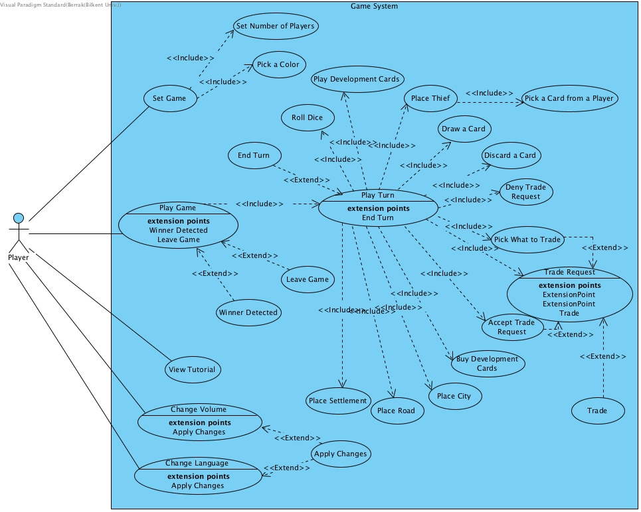

*Figure 1 - Use Case Diagram*

**case #1**

|  |  |
| --- | --- |
| *Use Case Name* | Play Development Card |
| *Participating Actors* | Player |
| *Flow of Events* | * Player opens his/her deck of cards   + - Card deck view is activated in PlayFrame * Player clicks on the development card he/she wants to play.   + - Controller takes the card from Player’s hand. * Card is displayed in GameWindow. |
| *Entry Condition* | * Player is in his/her turn. |
| *Exit Condition* | * Player plays the development card. * Player terminates the action. * Player is informed why he/she can not play the development card. |
| *Quality Requirements* | None |

**case #2**

|  |  |
| --- | --- |
| *Use Case Name* | Place Settlement |
| *Participating Actors* | Player |
| *Flow of Events* | * Player presses an edge of a hex to place a settlement   + - Controller confirms that such a settlement can be placed and that user has the necessary resources. * Player confirms selection and pays the necessary resources.   + - Controller gives the resources back to the Bank and updates the GameWindow. |
| *Entry Condition* | * Player is in his/her turn. * Player has at least one settlement at hand |
| *Exit Condition* | * Player confirms the action. * Player terminates the action. * Player is informed that he/she can not afford the settlement. * Player is informed that he/she can not place the settlement to the selected place. |
| *Quality Requirements* | None |

**case #3**

|  |  |
| --- | --- |
| *Use Case Name* | Place City |
| *Participating Actors* | Player |
| *Flow of Events* | * Player presses an edge of a hex to place a city   + - Controller confirms that player has a settlement at that hex and that user has the necessary resources. * Player confirms selection and pays the necessary resources.   + - Controller gives the resources back to the Bank and updates the GameWindow. |
| *Entry Condition* | * Player is in his/her turn. * Player has at least one city at hand * Player has a settlement at desired location |
| *Exit Condition* | * Player confirms the action. * Player terminates the action. * Player is informed that he/she can not afford the city. * Player is informed that he/she can not place the city to the selected place. |
| *Quality Requirements* | None |

**case #4**

|  |  |
| --- | --- |
| *Use Case Name* | Place Road |
| *Participating Actors* | Player |
| *Flow of Events* | * Player presses a path to place a road.   + - Controller confirms that player can place a road on the selected path and that user has the necessary resources. * Player confirms selection and pays the necessary resources.   + - Controller gives the resources back to the Bank and updates the GameWindow. |
| *Entry Condition* | * Player is in his/her turn. * Player has at least one road at hand |
| *Exit Condition* | * Player confirms the action. * Player terminates the action. * Player is informed that he/she can not afford the road. * Player is informed that he/she can not place the road to the selected place. |
| *Quality Requirements* | None |

**case #5**

|  |  |
| --- | --- |
| *Use Case Name* | Place Thief |
| *Participating Actors* | Player |
| *Flow of Events* | * Player presses a hex to place the thief.   + - Controller confirms that player can place the thief in the selected location. * Player confirms selection and places the thief.   + - Controller updates the GameBoard and GameWindow.     - Controller calculates which players have more than 7 cards, and asks those players to discard the required amount of cards. * Players select which cards to be discarded and confirm selection.   + - Controller removes the cards from players and gives them back to the bank. |
| *Entry Condition* | * Player is in his/her turn. * Player has rolled 7. |
| *Exit Condition* | * Player confirms the action and the thief is replaced. * Player is informed that he/she can not place the thief to the selected location. * Player is informed that he/she can not place the road to the selected place. |
| *Quality Requirements* | None |

**case #6**

|  |  |
| --- | --- |
| *Use Case Name* | Offer Trade Case |
| *Participating Actors* | Players |
| *Flow of Events* | * Offer trade button pressed   + - Click the button to pick what to trade * Player clicks on the button to pick a player.   + - Player clicks button to offer trade     - Accept or deny button pressed by the picked player * Controller checks whether specific amount of properties transferred between two players. * Trade is done. |
| *Entry Condition* | * Player is in his/her turn. |
| *Exit Condition* | * Picked player has to click accept or deny button. * Player is informed that he/she does not have the selected resources. |
| *Quality Requirements* | None |

**case #7**

|  |  |
| --- | --- |
| *Use Case Name* | Draw a Card From a Player |
| *Participating Actors* | Player |
| *Flow of Events* | * Player selects another player.   + - Controller confirms that the selected player has a settlement or a city near the location of the thief. * Player picks a card from the selected players hand.   + - Controller takes the selected card from the selected player, gives it to the user, and updates the GameWindow. |
| *Entry Condition* | * Player is in his/her turn. * Player has rolled 7 and has replaced the thief. |
| *Exit Condition* | * Card is transferred. * Player is informed that he/she can not draw a card from the selected player. |
| *Quality Requirements* | None |

## 

## 

## 

## 

## 5.2. Dynamic Models

### 5.2.1. Sequence Diagrams

#### 5.2.1.1. Trade Scenario

The sequence diagram for the Trade action is provided below. When the user presses the Offer Trade button, Controller object creates the OfferTradeWindow. User then selects the amount of resources or development cards that he/she wants. When the user presses the Confirm button, Controller checks whether or not the player has the selected resources in the selected amount. If the player has the resources, Controller object opens the TradeWindow, where every user can enter the amounts of resources or development cards they want in exchange, or they can simply reject the offer. When everyone confirms their selection, control is given back to the user who made a trade request. Then the user may select a player to trade with or terminate the trade. If user selects a player, than the controller checks whether or not the user has the necessary resources and processes the trade. If not, the user is allowed to choose another player or make another trade request.

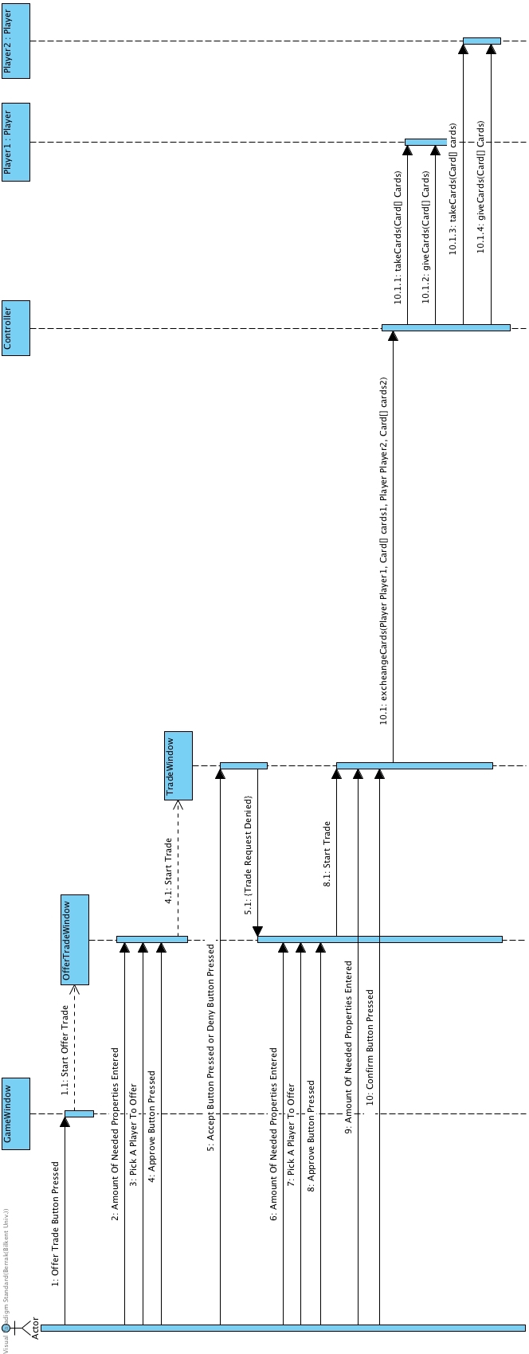

*Figure 2 - Trade Sequence Diagram Part 1*

### 

*Figure 3 - Trade Sequence Diagram Part 2*

#### 5.2.1.2. Dice 7 Scenario

When a player clicks on “roll dice” button, the controller returns the value of the dice roll. If the result is seven controller checks the players card amounts. If they have more than seven cards, they have to give half of their cards to bank. So that controller makes the list of the cards that will be received to bank and transfers those cards to bank. After that, place thief button needs to be pressed and player needs to click the hex button to place the thief. In the process of choosing hex, GameWindow gets the id of the first hex and the hex which is planned to be thief’s next hex. Current hex will be disabled where next hex will put on a state that it will be enabled.

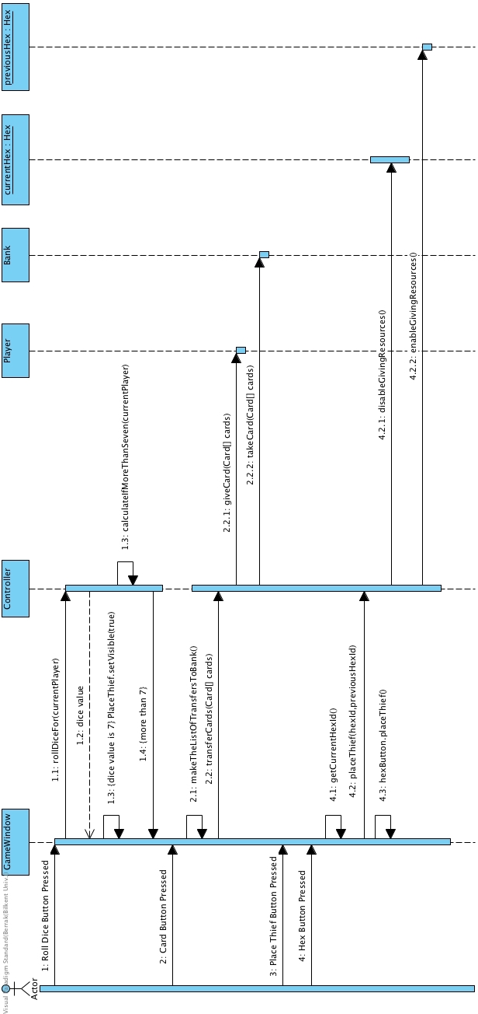

*Figure 4 - Dice 7 Sequence Diagram Part 1*

**

*Figure 5 - Dice 7 Sequence Diagram Part 2*

### 5.2.2. Activity Diagram

The diagram below shows one of the complex scenarios from the game, which is “Playing The Robber after Rolling 7” scenario. The “Friendly Robber” option is not activated in this scenario. Player rolls the dice when its his/her turn. If 7 7 is rolled then the Playin The Robber Scenario starts, otherwise it is another scenario. After 7 is rolled, the software checks whether there is any player with more than 7 resource cards or not. If there is any player with more than 7 resource cards, then the game asks that player to discard half of the cards. If the count is odd, number is rounded down. After player(s) with more than 7 resources cards choses which cards to discard, chosen cards are moved to bank from the player(s). The next step is asking the player whose turn is, to move the robber to any hex tile he/she wishes. The software moves the robber to chosen hex, and checks how many players are adjacent to that tile. If there not any player adjacent, then this scenario ends. If there is just one player then the program checks whether that player has any resource cards or not. If that player has, then one random card is robbed from that player and card is given to the player whose turn it is and the scenario ends. If there is more than one player adjacent to that hex, then the player who moved the hex is asked which player to be robbed. After selecting the player, game checks whether that player has any resource card or not, if he/she has then one random resource card is robbed from that player and card is given to the player whose turn it is and the scenario ends.

### 

*Figure 6 - Activity Diagram-The Robber Scenario from the Game*

### 5.2.2. State Diagrams

Here are two State Diagrams for our game:

**1.** The first scenario is when the player offers to trade cards with any other player that has the card they want. If no one has the card the player wants, then the offer is exited. If one or more players have the card the player wants and is/are willing to trade, the player trades cards with them and then the trade is exited.

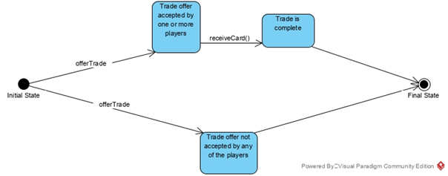

*Figure 7 - State Diagram 1*

**2.** The second scenario is for the Longest Path card in our game. Every turn, the game checks whether there is a Longest Path on the Game Board or not. If there is a Longest Path on the board, then the player who placed the roads of the Longest Path is given the Longest Path card. If another player ends up building more roads than the player who already has the Longest Path card, then the Longest Path card is taken from the player holding it and given to the new Longest Path’s holder. If there is no Longest Path on the board, state is exited.

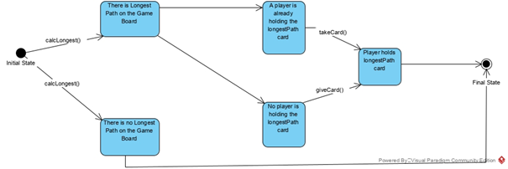*Figure 8 - State Diagram 2*

## 5.3. Object and Class Models

### 

*Figure 9 - Object and Class Model*

## 5.4. User Interface

This section contains Main Menu, How to Play Window, Settings Window, Start Game Window, Main Game Window, Game Menu Window, Trade Window and the Building Window.

### 5.4.1. Main Menu

The Main Menu screen of our game contains three options: “Start Game”, “How to Play” and “Settings”. All three of these buttons lead to a new window.

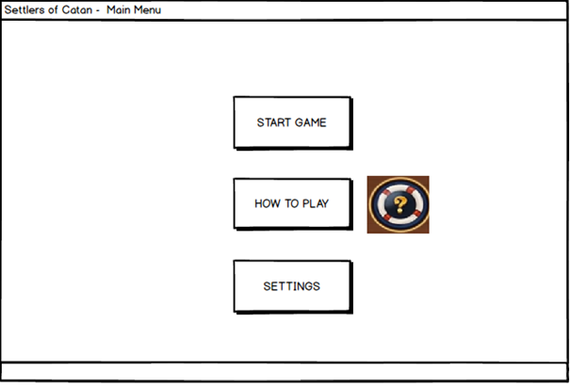

*Figure 10 - Main Menu Window*

### 

### 

### 

### 5.4.2. How to Play Window

This is a window that contains text and images, explaining the rules of the game. There is a “Back” button which returns the user to the Main Menu.

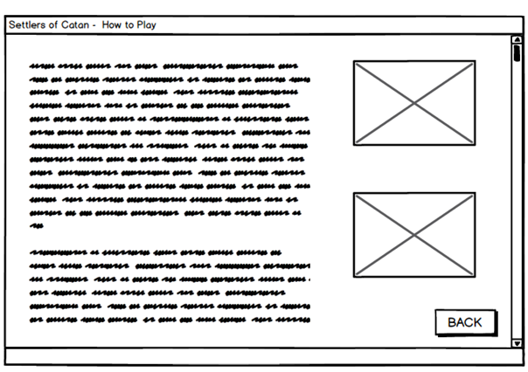

*Figure 11 - How to Play Window*

### 

### 

### 

### 

### 

### 5.4.3. Settings Window

This window lets the user adjust the volume of the sounds in the game and lets them choose the language in which they want to play the game in (English, Turkish, Russian or Azerbaijani). There is also a Colorblind Mode, which if activated, displays the game’s graphics adjusted for a person with colorblindedness. The “Back” button leads the user back to whichever window the user had open before accessing this window and the “Start Game” button leads the user into a new game window.

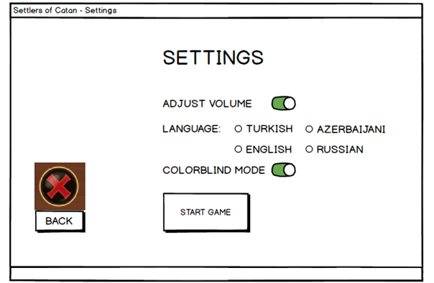

*Figure12 - Settings Window*

### 

### 

### 

### 

### 5.4.4. Start Game Window

This is the window the user sees right before they start a new game. There are two options: a 3-player game or a 4-player game. The user can choose to play against the computer or against real people if there are multiple players wanting to play from the same computer. The user can start playing the game after choosing one of these modes and pressing the “Start” button. If the user clicks on the “Back” button, it leads them back to the Main Menu.

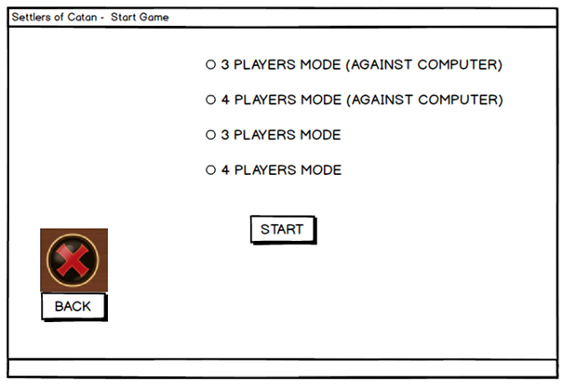

*Figure 13 - Start Game Window*

### 

### 

### 

### 5.4.5. Main Game Window

This is the main window in which the user plays the game. The user can see the main board of the game, the amount of championship points their rivals have gathered, the number of remaining Settlements, Cities, Roads both the user themselves and the other players can build, as well as the user’s cards and the cards’ quantities from this window. The user can throw the dice once its their turn, and go to the Game Menu Window from here.

(For simplicity, this mockup image shows the window after the user has chosen the 4-player mode gameplay.)

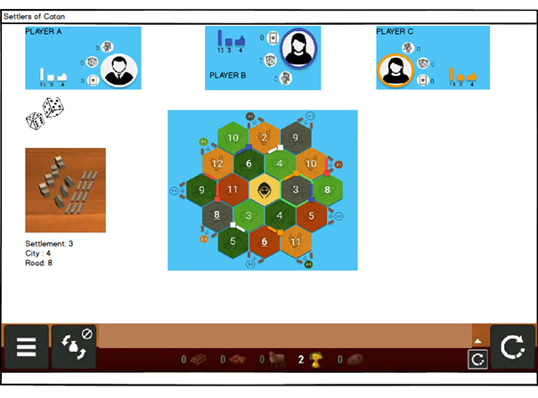

*Figure 14 - Main Game Window*

### 

### 

### 

### 5.4.6. Game Menu Window

The user can choose to go to the Trade, Build, Bank, Main Menu and/or throw the dice from here, as well as back to the Main Game Window.

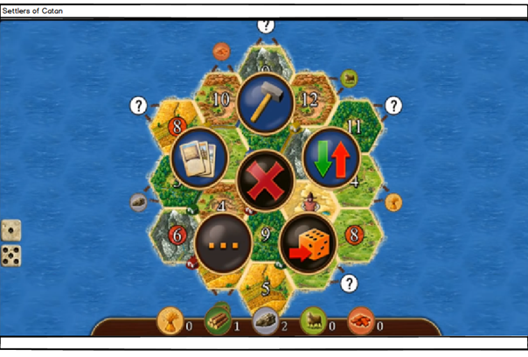

*Figure 15 - Game Menu Window*

### 

### 

### 

### 

### 

### 

### 

### 

### 5.4.7. Trade Window

The user can choose to trade cards with other players if the other players also wish to do so from this window. The user can go back to the Main Game Window and/or the How to Play Window as well.

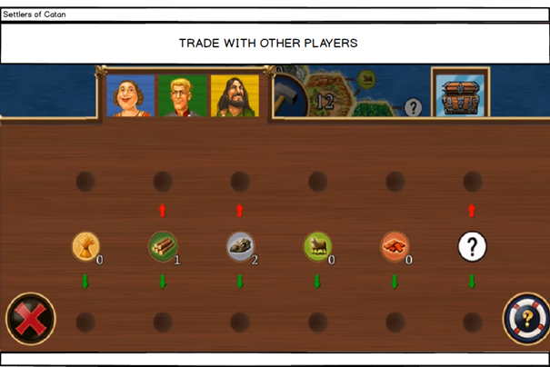

*Figure 16 - Trade Window*

### 

### 

### 

### 

### 

### 

### 

### 5.4.8. Building Window

The user can build the properties Settlement, City or Road from this window. If they wish to build something and have the necessary sources for it, they will be redirected to the Main Game Window where they will choose how and where to build their properties by clicking on the game board. This window also allows the user to go back to the Main Game Window without building anything and the How to Play Window.

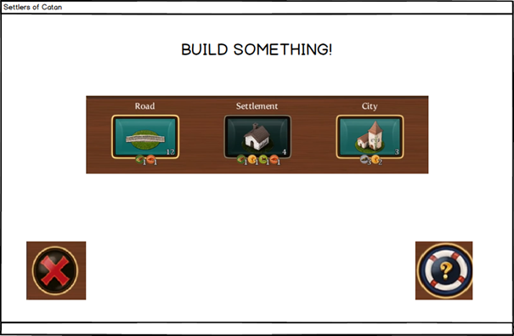

*Figure 17 - Building Window*

# 

# 6. Glossary

* Development cards: build-able cards that have varying effects
* Resource cards: cards which are sorted into five sorted into five(lumber, wool, grain, brick ore)
* Robber: a piece which prevent player to get resources from hexes where it is located
* Distance Rule: there must be at least one corner of the hexes vacant between any cities and settlements nearby. If any of the adjacent corners are occupied by any other city or settlement then no new city or settlement can be built.

# 7. References

1. <https://www.amazon.com/Mayfair-Games-MFG3061-Settlers-Catan/dp/B000W7JWUA>
2. <https://www.catan.com/en/download/?SoC_rv_Rules_091907.pdf>