Mustafa Furkan Aras 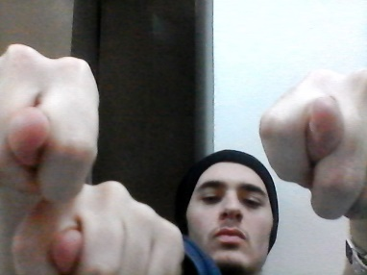

Personal Informaiton

Name : Mustafa Furkan Aras

Date of Birth : 06/24/1998

Date of place : Konya/Akşehir

Contact Information

Address : Istanbul/Kadıkoy, Turkey

Phone Number : +905436091330

Email : [furkanarass98@gmail.com](mailto:furkanarass98@gmail.com)

Linkedin : <https://www.linkedin.com/in/furkan-aras-a828a5172/>

Languages

Turkish : Native

English : ★★★★★★★★☆

Education

2013-2016 : Konya/Aksehir Anadolu Öğretmen High School

2016-2021 : Marmara University Computer Engineering (%100 english)

Technical Skills

java : I received 1 year of java education in the first year of school I developed myself in object

oriented programming

c : I received 1 year of c education in the second year of school

Html-Css : I took 20 hours of webdesign education(youtube)

Arduino : I got arduino education in robot club

Others

Hobies cooking, tasting and everything about sports