[Bro-gurt] Site Plan

[Berrett Craner]

WDD 130

Overview

Purpose
[Bro-gurt gives men a bold new way to snack. This product replaces those old outdated flavors that just don’t make you feel very manly with savory tastes and flavors that men crave. We cater to men’s appetites with flavors such as ribs, bacon, or BBQ, to completely revolutionize the yogurt industry.]

Audience
[Our audience are the men who want something better to add to their diet. The “bros” who are crave protein but don’t have a fun way to get it. The people in a hurry who just want a little snack with some extra protein and goodness for their day.]

Branding

Website Logo
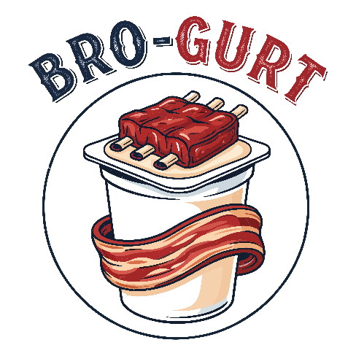

Style Guide

Color Palette
Primary | Secondary | Accent 1 | Accent 2
#C37567 | #EBE1DB | #A0A6AE | #FEFEFE

Typography

Heading Font: [Rubik Dirt]

Paragraph Font: [Nunito]

Navigation
Home About Products

Content

[Purpose
Bro-gurt exists to fuel men with high-powered, protein-packed yogurt that matches their appetite for bold flavor and bigger living. We’re here to redefine what yogurt can be—ditching the dainty and embracing the hearty with flavors inspired by the foods guys love, like ribs, bacon, and BBQ. Our purpose is simple: deliver serious nutrition with zero compromise on taste, so men can power through their day with confidence, and strength

Img 1

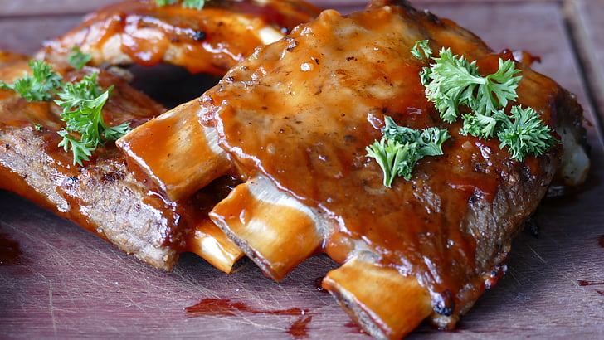
Products

img 2
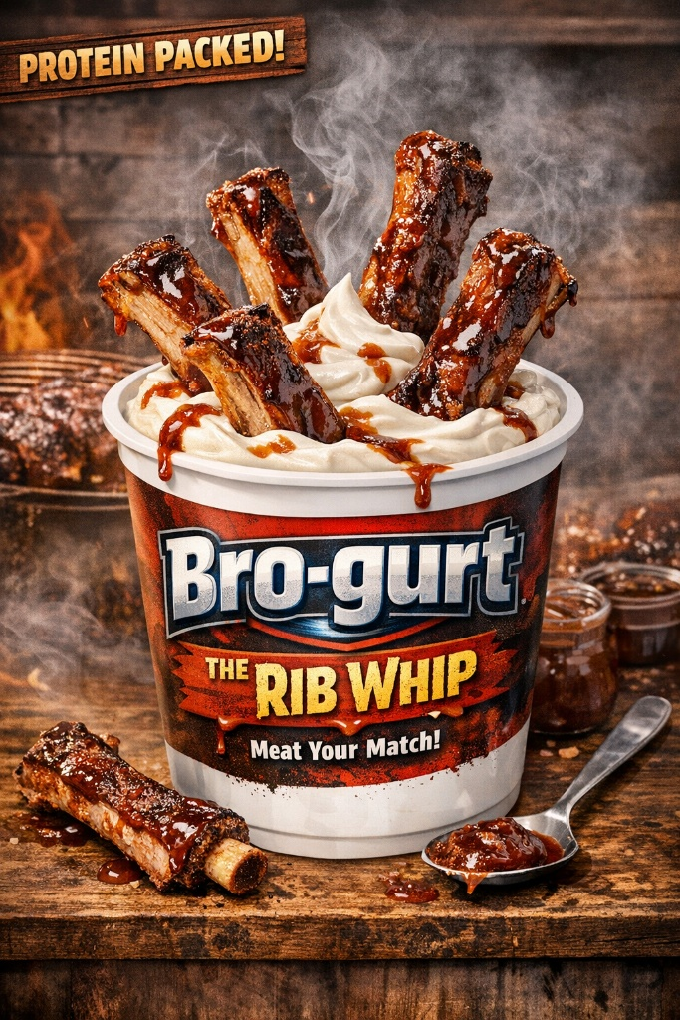

Rib Whip – Nutrition Facts
Serving Size: 1 container (170 g)
Calories: 180
Total Fat: 6 g
Saturated Fat: 3.5 g
Trans Fat: 0 g
Cholesterol: 20 mg
Sodium: 210 mg
Total Carbohydrates: 22 g
Dietary Fiber: 0 g
Total Sugars: 18 g
Includes Added Sugars: 10 g
Protein: 40 g
Micronutrients
- Vitamin D: 2 mg
- Calcium: 280 mg
- Iron: 0.2 mg
- Potassium: 330 mg

img 3
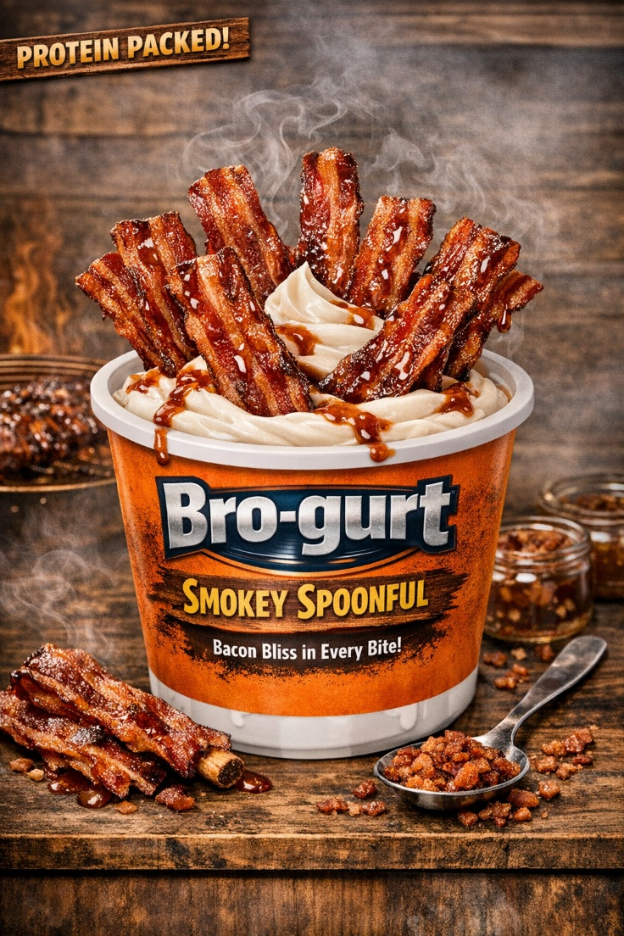

Smokey Spoonful – Nutrition Facts
Serving Size: 1 container (170 g)
Calories: 200
Total Fat: 8 g
Saturated Fat: 4 g
Trans Fat: 0 g
Cholesterol: 25 mg
Sodium: 320 mg
Total Carbohydrates: 21 g
Dietary Fiber: 0 g
Total Sugars: 17 g
Includes Added Sugars: 9 g
Protein: 38 g
Micronutrients
- Vitamin D: 2 mg
- Calcium: 280 mg
- Iron: 0.3 mg
- Potassium: 340 mg

img 4
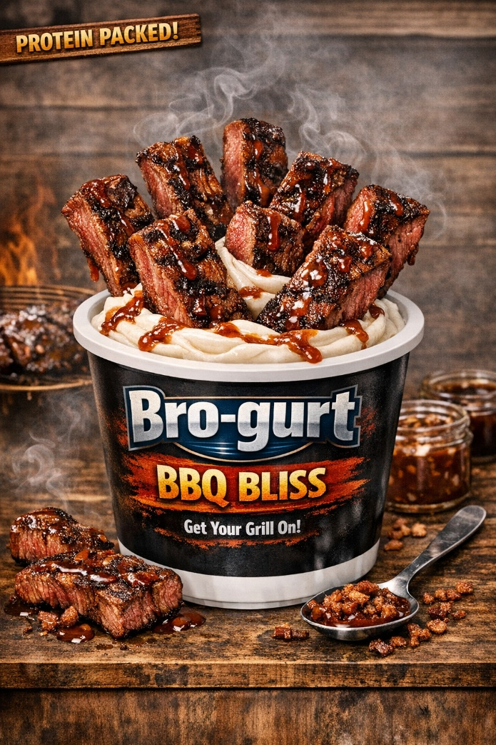

BBQ Bliss – Nutrition Facts
Serving Size: 1 container (170 g)
Calories: 190
Total Fat: 7 g
Saturated Fat: 3.5 g
Trans Fat: 0 g
Cholesterol: 30 mg
Sodium: 240 mg
Total Carbohydrates: 20 g
Dietary Fiber: 0 g
Total Sugars: 16 g
Includes Added Sugars: 8 g
Protein: 41 g
Micronutrients
- Vitamin D: 2 mcg
- Calcium: 290 mg
- Iron: 0.4 mg
- Potassium: 350 mg
img 5
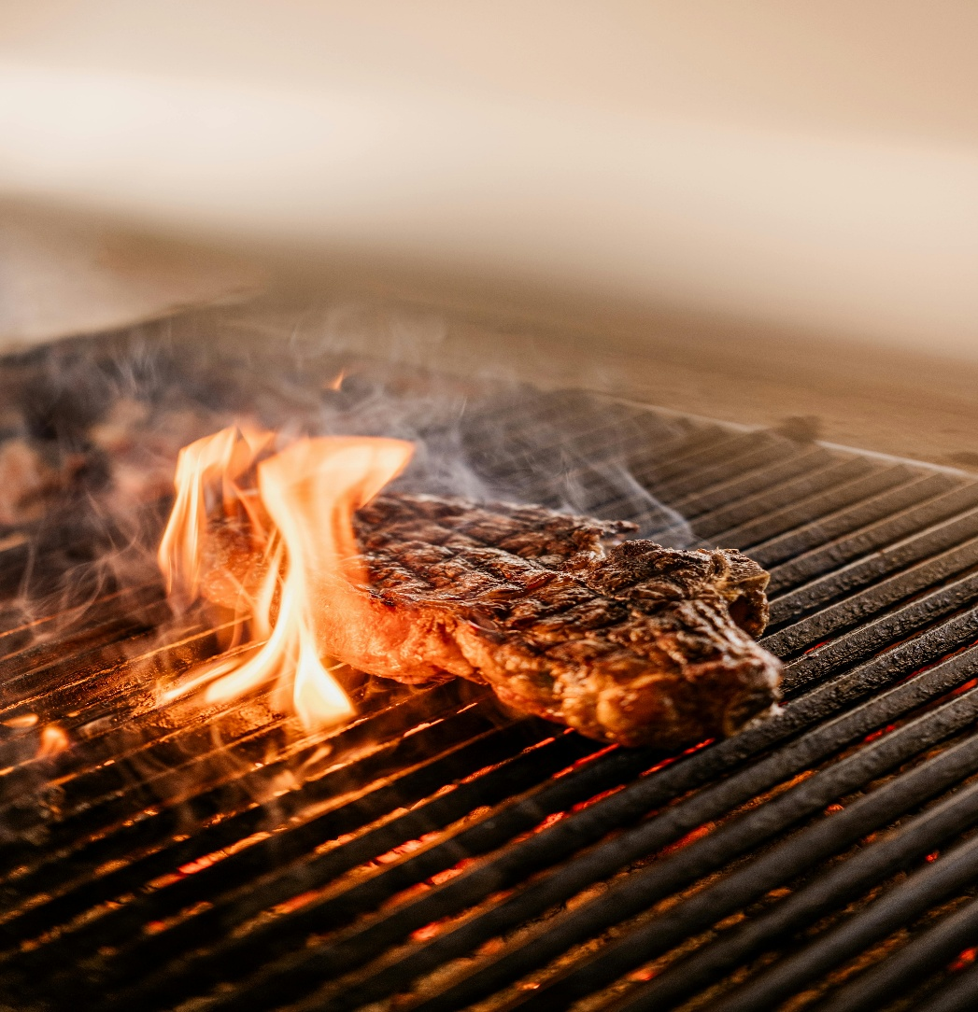

img 6
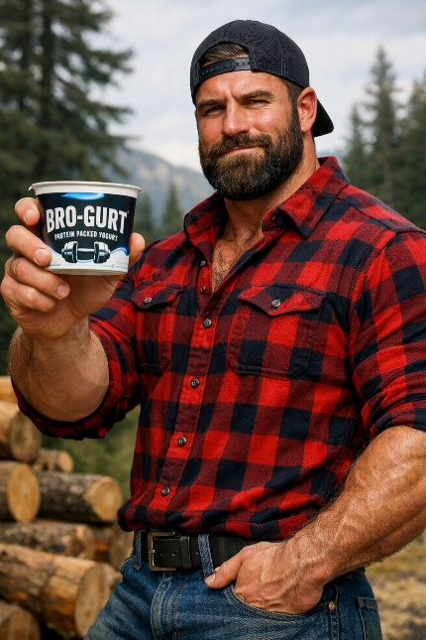

About Me
I grew up living mostly outdoors. I loved to be outside and doing something in nature. The best days though ended with a barbeque; those were the best days that I can remember. Who doesn’t love a good day outside where the flames are going, and the smell of meat hangs in the air. It’s enough to make anyone’s mouth water. I always wanted a snack other than jerky I could enjoy, so I decided to try it with yogurt. It was a huge success and I loved the flavors. That’s when I knew I had to share this with the world.

FAQ
Is there real meat in the yogurt?
Absolutely not, there is only meat flavoring with the taste of meat, but don’t worry, all of the real flavor is still there?

Is there more protein in this than normal yogurt?
Of course there is, most other “protein” yogurts have at most 20-25 grams of protein, but in our cups, it ranges from 38-41 grams of protein for a fuel packed day!

Will I get stronger if I eat this?
While you will have more energy to face your day, you will not get mass amounts of muscle just by eating our yogurt. Pair it with the gym and you’ll get massive gains.
]

Wireframes

Home

Products

About Me

