We have been collecting data from several sites mainly from the Ministry of Police, Stats NZ. data.govt.nz and NZ.Stat. This was not limited to researching for related data about crimes and covid-19 in NZ such journals, articles newspaper and news broadcast. The links to these sites is provided below. We have used two datasets for our analysis:

1. Victimisation time and place (police website)
2. Covid_calls for services (police website)

The Victimisation time and place dataset was downloaded from the information recorded in the Police dynamic operational database. ([www.police.govt.nz](http://www.police.govt.nz)) This dataset represents detailed information about where and at what times of the day and week crime victimization occur in NZ. It excludes victimization where meshblock level data and Area Unit is unknown. It includes time and place where the offence occurs, number and type of offence. This data frame contains 699705 number of observations and 17 variables. The dataset is dated from 2017 until March 2020. Most of the variables are characters and few are integer as some listed below and shown in the image.

1. Year. Month = Character
2. Month.Year = Character
3. ANZSOC.Group = Character
4. Area.Unit = Character
5. Location.Type = Character
6. Meshblock = Integer
7. Occurrence.Hour.Of. Day = Integer
8. Number. Records = Integer
9. Victimisation = Integer

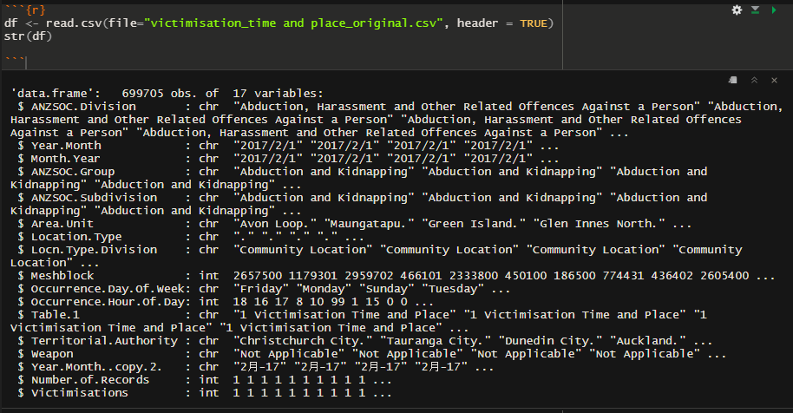

The Covid_calls for services dataset was also downloaded from the police website and it contains information about crimes during the different level of lockdown during covid-19. These include districts, level of lockdown, type of crime and the number of times a specific crime has been committed. It also shows information about the demand in call for service and prevention during lockdown. The information has been recorded starting from the lockdown period in March 2020 until July. Some of the variable and type are listed below and show in the image.

1. District = Character
2. Alert.Level = Character
3. Calls.for.service.and.Prevention = Character
4. Event.Category = Character
5. Event.Type = Character

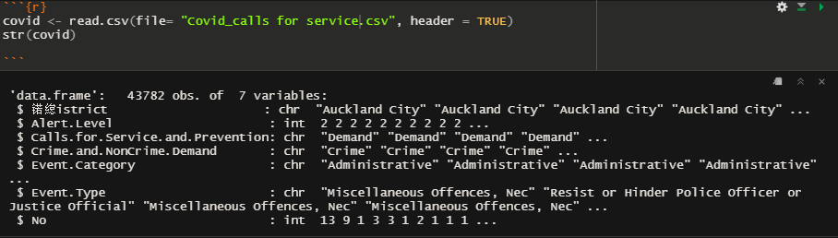

<https://www.police.govt.nz/about-us/publications-statistics/data-and-statistics/policedatanz>

<https://www.police.govt.nz/about-us/publications-statistics/data-and-statistics/policedatanz>