1. When posting service have prepay balance page throws error in production screen

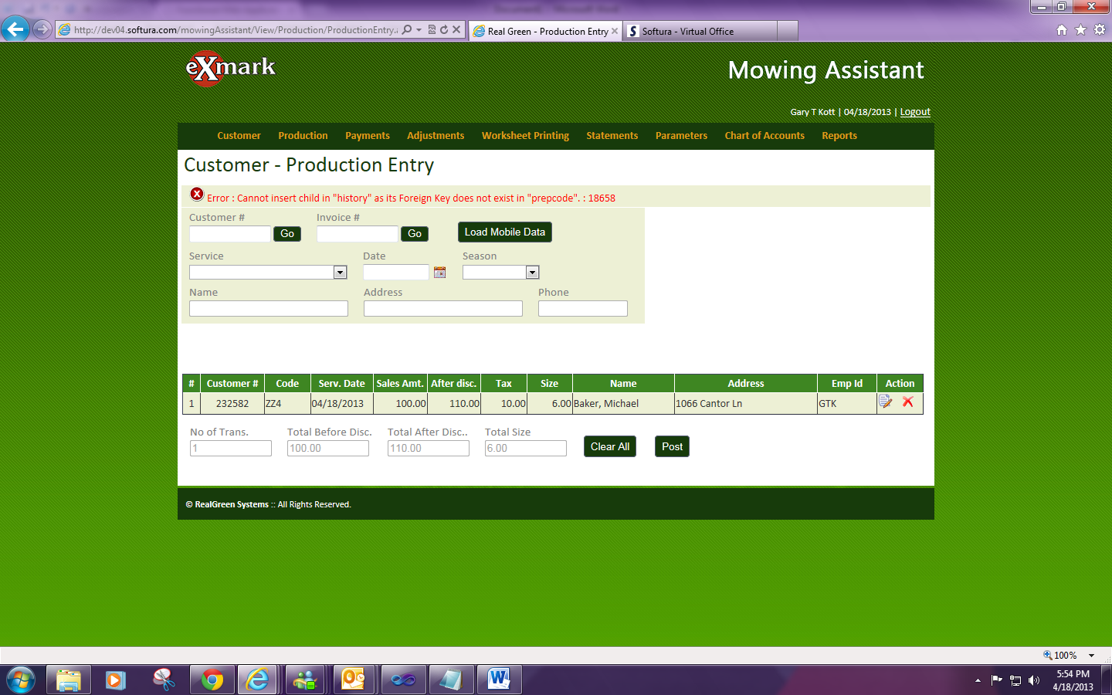

1. Prepay code discount working reverse manner. Say if apply 10% discount it not discount anything. If we apply 0% discount it deducting 10%
2. In payment screen when we try to post the service one by one remit