# CANCEL CUSTOMER AND SERVICES FUNCTIONALITY AND USER MESSAGES

1. While cancel the customer page should prompt msg for cancelling the services

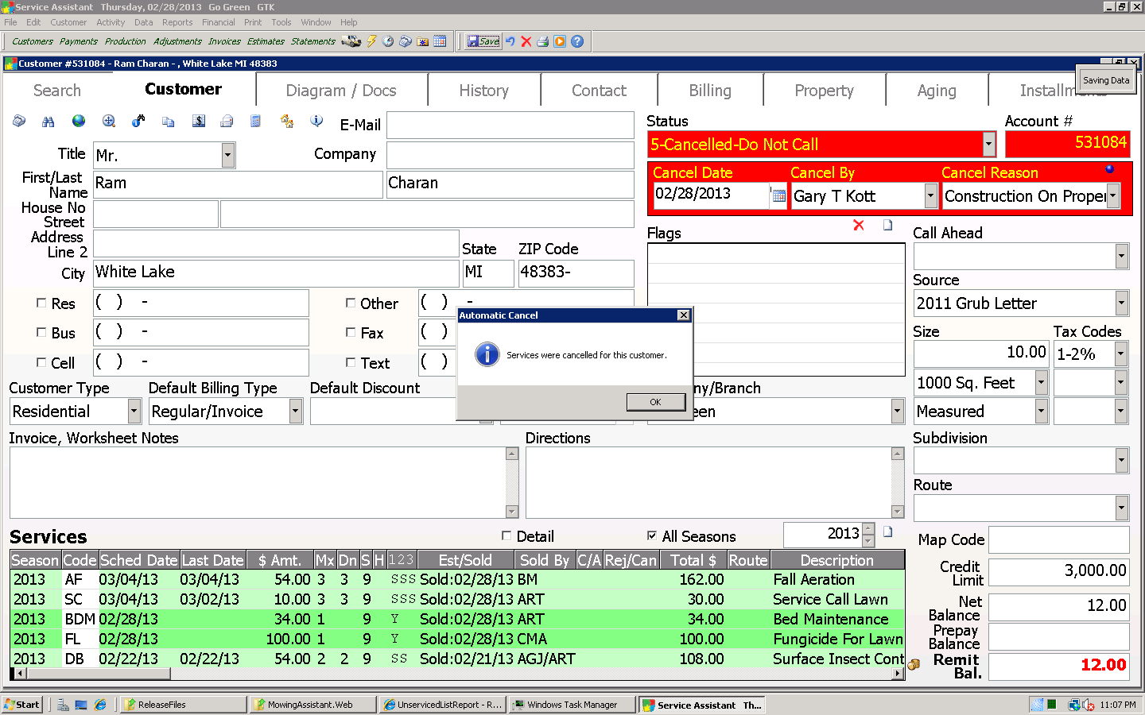

1. Once cancel has been done listed services are identified by change of color 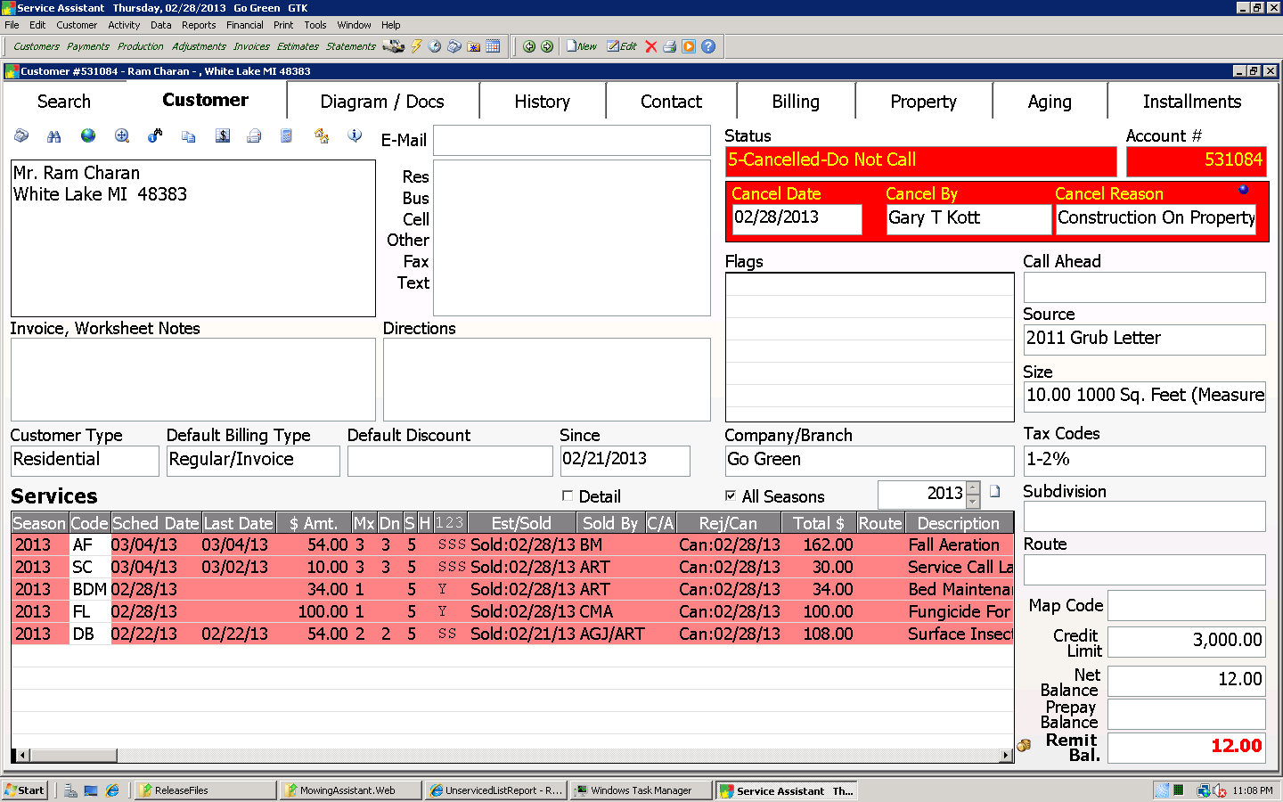
2. When we change the customer status is Active from Cancel mode page should prompt the msg as “The customer is Active but No current active services”

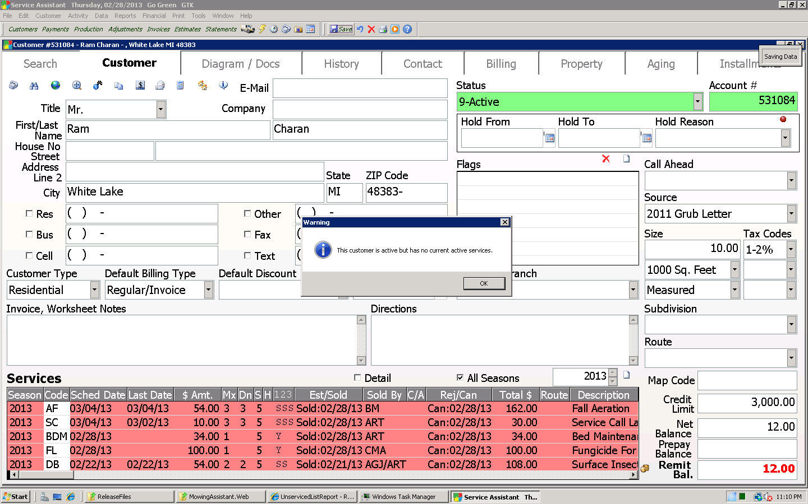

1. When try to add service for **Non Active** customer Page should prompt msg to activate customer also by default while adding active service

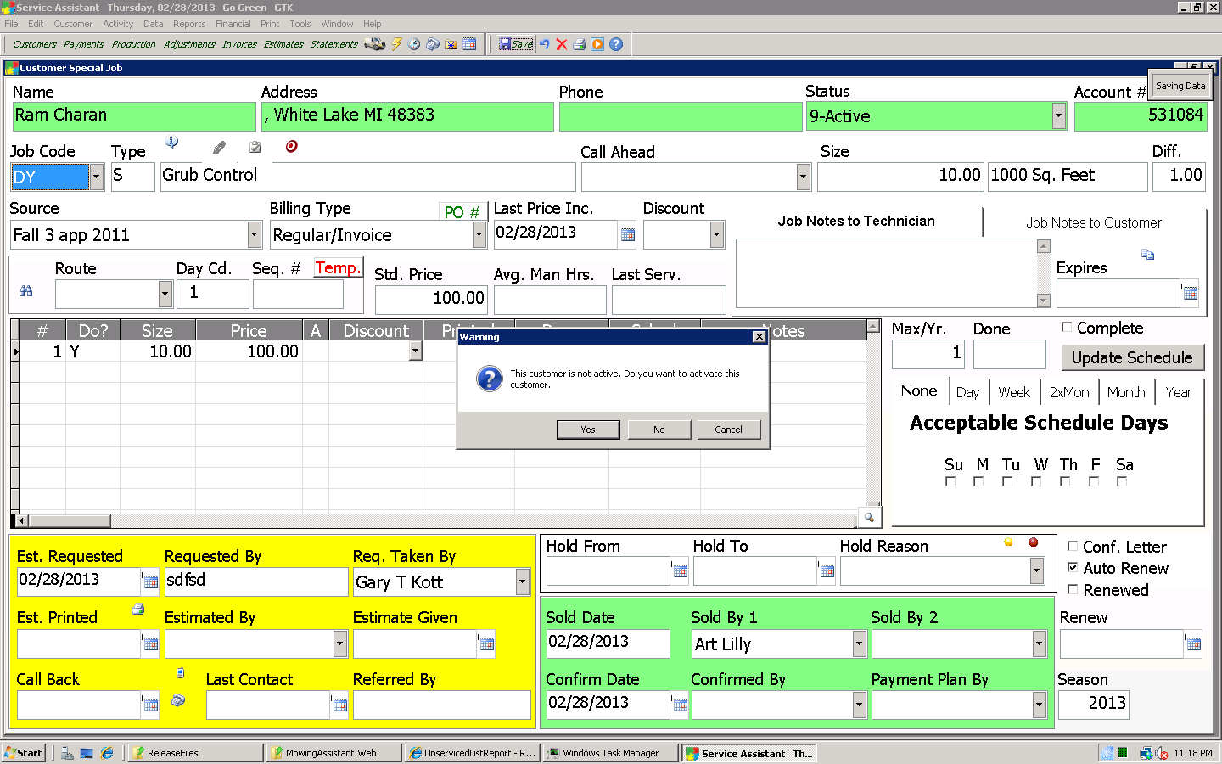

1. When try to activate the cancelled service for the customer it should be prompt msg for activate all other cancelled service to Active state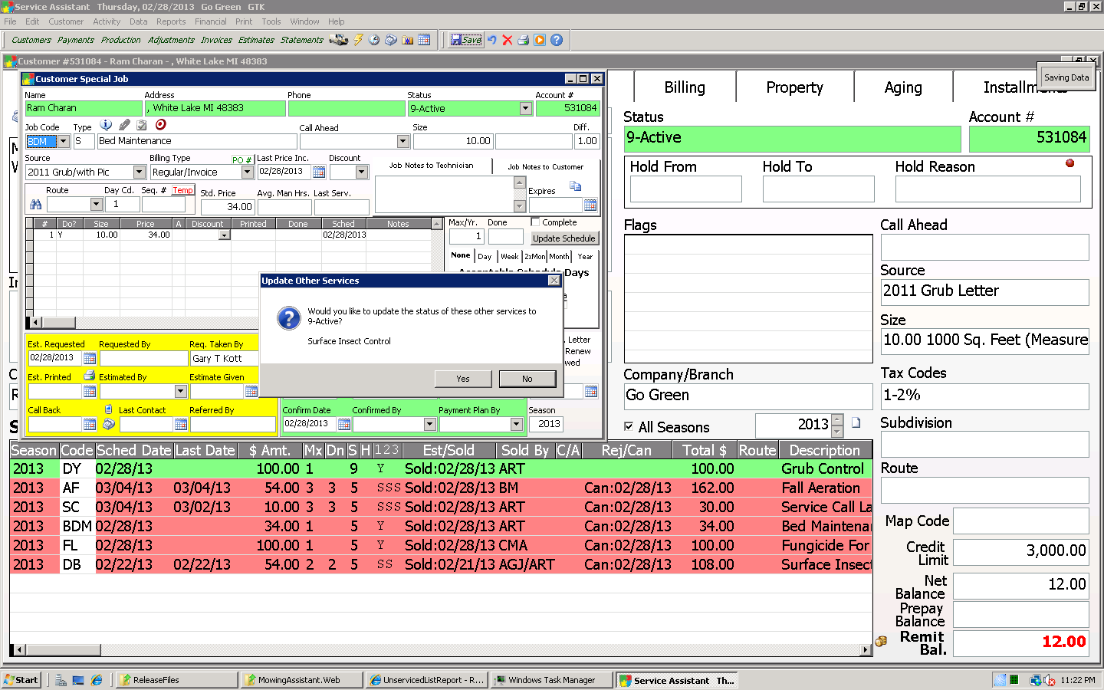

For all service one by one it should be prompt msg for activation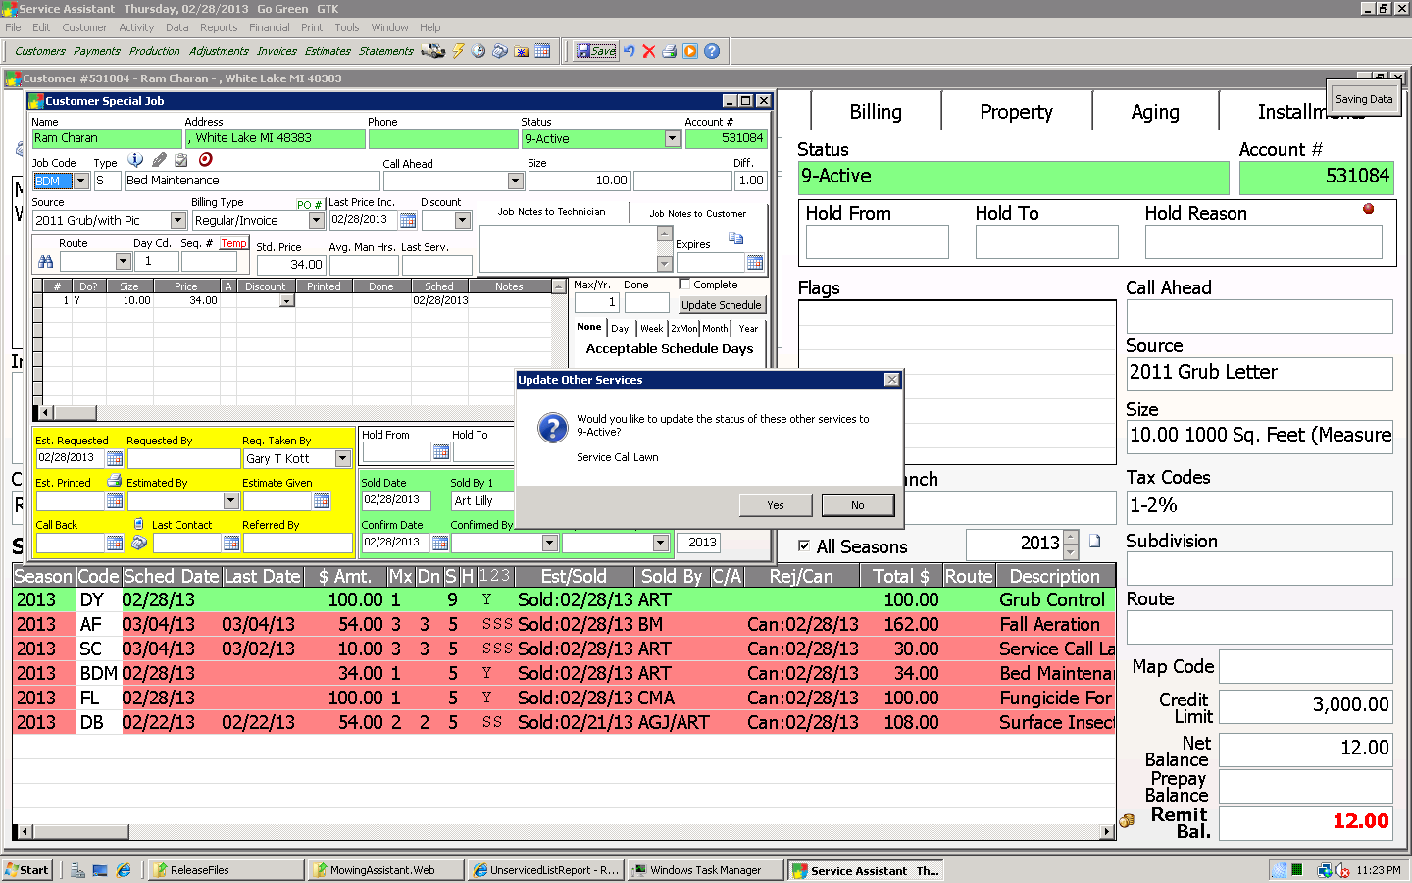

Finally all service get in to active state

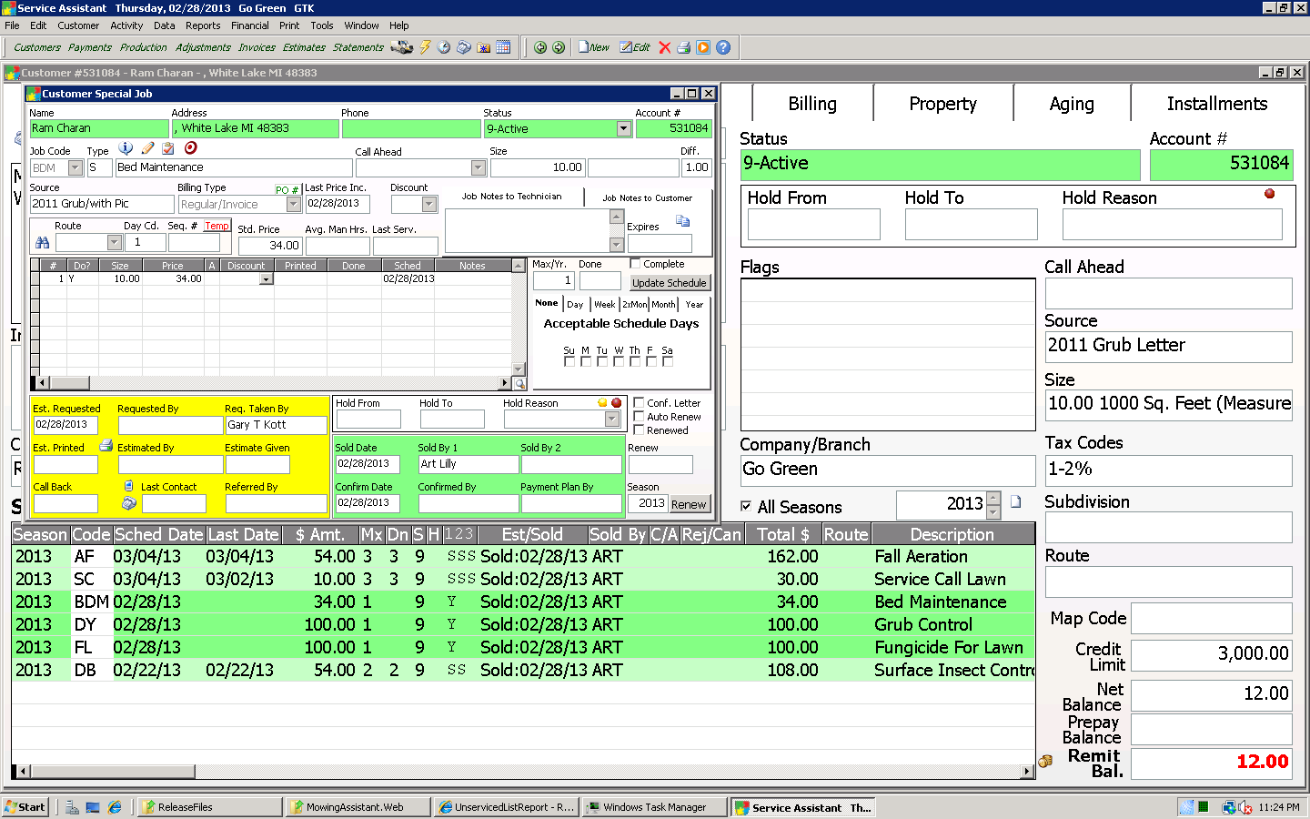

1. Customer is **Active** but when user going to **Cancel** the particular it should be prompt msg for cancel the service who have currently in the active list. If press No it should be cancel the selected service 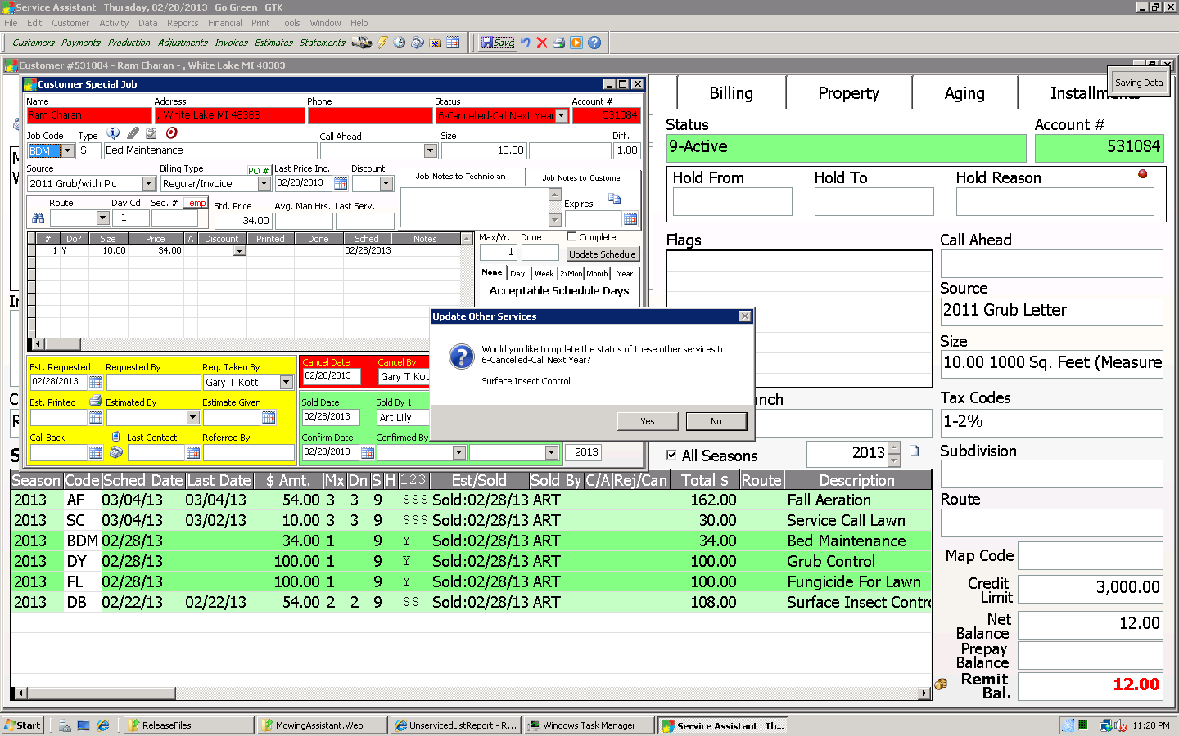
2. Service cancel mode list

