GREEK LICENSING

Release Date: 30/05/2013

Notification:

1. Notification count is missing when we select list range

2. when we select notification grid checkbox it taking long time to load.. and page also blank for few seconds and list the records.. instead of blank we can show loading panel

3. in search notification by title text box when we search with any text half of the screen is shows white for while and retrieve the result. it should be show only loading panel

4. When we click on delete option page all check box items are disappeared from the screen

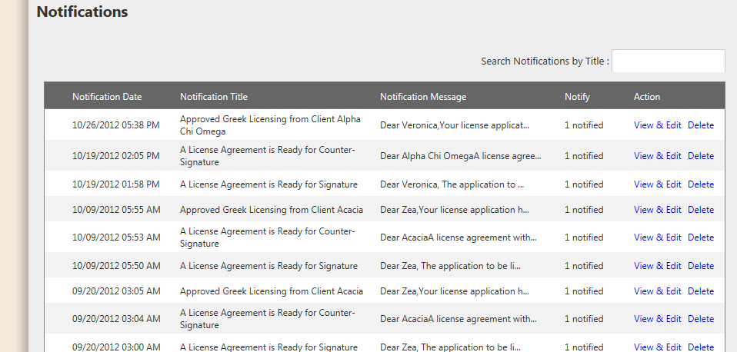

5. when click on add notification button taking long time to load

6. Enter vendor name to choose client text box taking long time to load the client name who have in the list

7. Text box length is very long.. not that much catchy.

8. Where button like add and clear is not that much attractive

9. Add client is not working.. when click add after entering client name in the it taking some time to load and finally is nothing is listed.

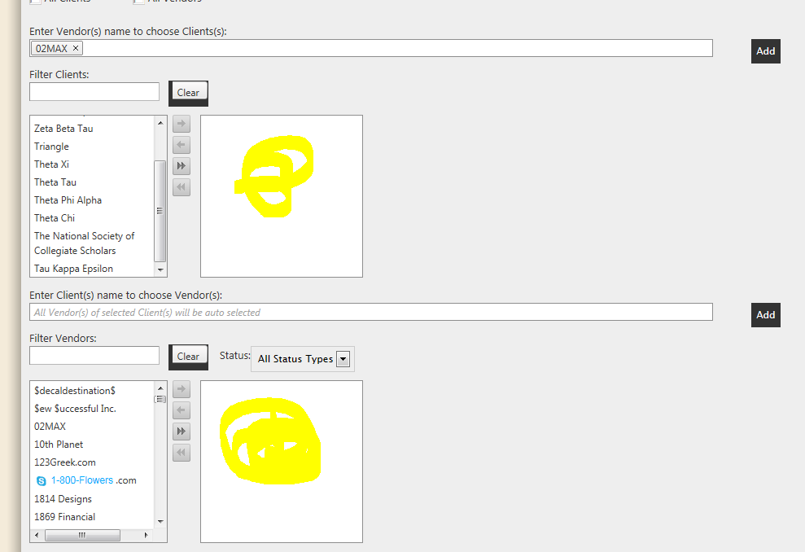

Add vendor page:

1. vendor listing page throws page breaking issue

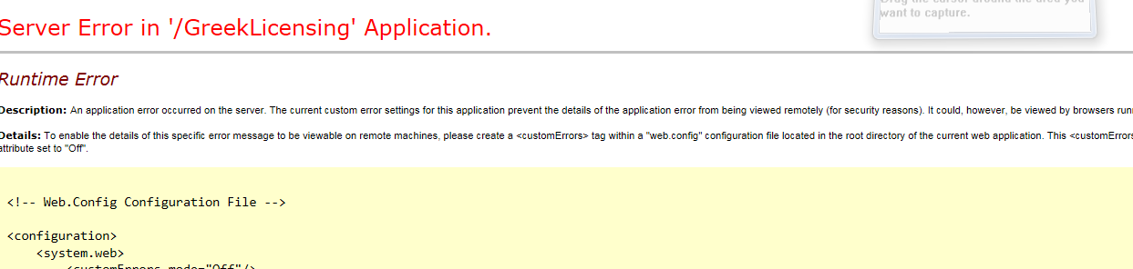

Add Client Page:

1. user msg is missing for when save each screen like setup, legal and opeartions

2. Preview in pdf button is missing in add client – lic.agreement