**Table of Contents:**

**Executive Summary: Group C Strategy – 1**

**Group C Strategic Direction – 1**

**Purpose – 2**

**Business Driver – 2**

**Scope – 2**

**Future State – 3**

**Strategic Roadmap – 3-4**

**Risks and issues – 4**

**Business Capability Mapping - 5**

**Glossary, Acronyms, and Abbreviations – 5**

### Executive Summary: Group C Strategy

#### Vision

Achieve maximum coverage of medical representative and physician interaction.

### Group C Strategic Direction

**Long Term Strategies**

* **Become exclusive resource for physician/rep scheduling and information.**
* **Increase market share to market dominance.**
* **Decrease marketing representative downtime to 0%.**
* **Reach and engage the maximum number of doctors in every city in the country.**
* **Increase digital engagement to surpass physical medical representative interactions.**

**Short Term Strategies**

* **Provide a resource to enable physician/representative scheduling and interaction.**
* **Reduce travel time necessary for medical representatives to visit multiple physicians in one trip.**
* **Increase exposure of our medicine among physicians within our market.**
* **Engage and educate physicians about the new product.**
* **Alert physicians of new products, research and other marketing material.**
* **Gather trend information based on user (physician) interaction with the product.**
* **Retrain medical representatives and marketing to make effective use of the platform.**

**Purpose**

By building exposure of marketing representatives both face-to-face and online with physician customers, we will increase product awareness (and revenue), decrease representative down-time, decrease representative-travel time, and increase overall brand awareness.

### Business Driver

### Current failure to sufficiently influence customers via marketing representatives, due largely to the inability to get face time with physicians, instructs this process and project.

### Scope

Analysis of DoctorConnect by members of Team Group C have identified critical areas within the scope, and areas without. These points are enumerated below:

**In Scope**

* Physicians within our market
* Sales representatives
* Marketing agents
* R&D contact personnel

#### 

#### Out of Scope

* Patient information

**Future State**

The vision to achieve better brand exposure with doctors has guided the digital interaction strategy. The digital interaction strategy entails social media and mobile engagement which have achieved massive ubiquity and adoption in recent years. The team considered the most engaging, scalable, and wide reaching approaches in line with the requirements of management. This allows us to leverage proven approaches to build a strong brand as well as a community/ecosystem while also allowing for evolvability with respect to changing cultural and technical landscape.

**3 Year Strategic Horizon**

* Provide per-physician marketing and trend data to roving representatives.
* Enable remote, personal connections via video platform.
* Engage multiple client physicians at once via online seminars.
* Web applications will be responsive to support multiple form factors.
* Platform & mobile applications will be developed to support some old browsers and mobile OS.
* Expose underlying data services to cloud and mobile apps via web API.

**Near Term Implications & Actions**

* Increase customer marketing engagement via mobile solution.
* Increase travel efficiency of representatives with improved physician scheduling.
* Define capability requirements and evince a source for architecture, support, development and training for mobile solution.

### Strategic Roadmap

Phase 1: 1 – 4 months

* Program Solution Architecture Defined
* Enterprise IT Capabilities
* Medicine directory
* Membership
* Application Programming Interface

Phase 2: 1 – 4 months

* Web front end
* Instant messaging
* Video calling
* Additional Enterprise IT Capabilities

Phase 3: 1 - 4 months

* Forum
* Marketing Content
* Deployment & Rollout
* 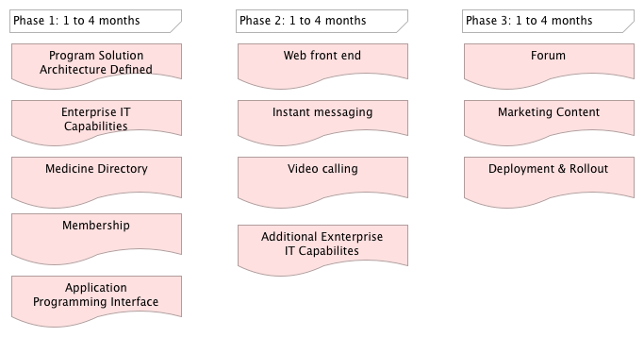

### Risks and issues

The proposed project is limited by the adoption rate of our clientele, the limitations of our IT infrastructure. Failure to perform in any of these three areas will slow down progress for all, and requires careful planning.

Poor design and/or implementation of the key elements, scheduling and communication, can lead to disastrous misuse of human resources. Representatives have very little time to communicate the brand message, in the best case scenario. A single miscommunication or schedule conflict in the current system can waste a huge portion of productive time, and company resources.

Furthermore, any online solution puts an emphasis on look, feel, usability and usefulness. Failing in any of these areas will reflect poorly and has potential to damage the brand.

Conversely, failure to utilize the online space opens the door to both competition filling the need first, and criticism for NOT entering this commercial space, and make the brand look old-fashioned. Essentially, this means doing nothing will have a negative effect.

**Business Capabilities Mapping**

|  |  |  |  |
| --- | --- | --- | --- |
| **Business Capability** | **Child Capability** | **Description** | **Strategy** |
| Market development | Advertising |  |  |
|  | Market Trend Research |  |  |
|  | Brand & Product Marketing | Market and promote brand and products |  |
|  | Sales Management | Coordinate sales actions, develop and manage sales plans |  |
|  |  |  |  |
| Research & Development | Research Documentation & Reporting | Manage product innovation catalogue |  |
|  |  |  |  |
| Personnel Management |  |  |  |
|  |  |  |  |
| IT Management | Secure Data Maintenance | Secure company data |  |
|  | Platform Administration |  |  |
|  | Platform Development | Develop and maintain platform |  |
|  |  |  |  |
| Customer Relationship Management | Physician Scheduling |  |  |
|  | Physician Tracking |  |  |

### Glossary, Acronyms, and Abbreviations

TBA