**Animation Timeline Tool**

Product Requirements Document

Author: Berta Kang

Version: 1.0

|  |  |  |
| --- | --- | --- |
| **Version** | **Date** | **Author** |
| 1.0 | 07-05-2025 | Berta Kang |

**Table of Contents**

1. Executive Summary 1

2. Stakeholders 2

3. Development Team 2

4. User Considerations 2

A. Primary (End Users) 2

B. Secondary Users 2

C. Tertiary Users 2

D. Use Case Diagrams 3

E. Work Breakdown Structures 4

5. Project Requirements 6

A. Business Requirements 6

i. Provide Certification Pathway 6

ii. Provide Registry of Cambodian Engineering Professionals 6

B. Business Rule 6

i. Government Compliance: 6

ii. Legal Documentation: 6

iii. Contracting: 6

C. User Requirements 6

D. Functional Requirements 7

E. Non-Functional Requirements 8

F. External Interfaces 10

i. Web Application 10

ii. Desktop Application 10

G. Physical Setting 11

i. Environmental Controls 11

ii. Closed Server System 11

iii. Security Cameras 11

iv. Access Control 11

v. Security Door Lock 11

H. Developer Constraints 11

i. Project Management 11

ii. Engineering 12

iii. Information Technology 12

I. Security Requirements 12

6. Risks and Assumptions 14

A. (Include details about potential risks and assumptions made) 14

7. Release Plan 14

A. To be determined 14

8. Change Log 14

A. To be determined 14

9. Approval 14

# Executive Summary

1. Introduction

The Animation Timeline Tool is designed to assist animators in efficiently tracking and logging timesheet data for animation projects, providing a centralized, user-friendly platform to manage animation timing charts and production workflow.

1. Problem Statement

The Animation Timeline Tool addresses the following challenges faced by animators and studios:

* Lack of standardized tools for creating and managing animation timing charts
* Inefficient tracking of frame-by-frame timing, leading to errors and rework
* Limited digital solutions catered specifically to traditional or hybrid animation pipelines
* A need for a tool that improves workflow clarity and production accuracy, accessible to both freelancers and studios

1. Objective

This project aims to develop a streamlined solution for animators to document, review, and adjust timing charts effectively. Key components include:

* A desktop-based application for animators to visually map and log timing breakdowns by seconds and frames
* An intuitive interface for tracking animation progress and making adjustments in real-time
* Potential integration with other production tools to support a cohesive animation workflow

1. Conclusion

We believe the Animation Timeline Tool will significantly enhance animation production by reducing manual errors, standardizing timing documentation, and providing animators with a reliable system tailored to their creative process. By improving clarity and efficiency, this tool empowers animators to focus on delivering high-quality work.

# Stakeholders

* Berta Kang
* Tommy Duch

# Development Team

* *Project Manager**:* Berta Kang
* *UI Designer:* Berta Kang
* *UX Designer:* Berta Kang, Tommy Duch
* *Web Engineer: Berta Kang*
* *Desktop Application Engineer:* Berta Kang
* *Studio Sales: Tommy Duch*

# User Considerations

1. Primary (End Users)
2. Animators (Freelancers and Studio Artists)
3. Animation Production Coordinators
4. Technical Support Staff
5. Secondary Users
6. Studio Managers and Producers
7. Use Case Diagrams
8. Use Case

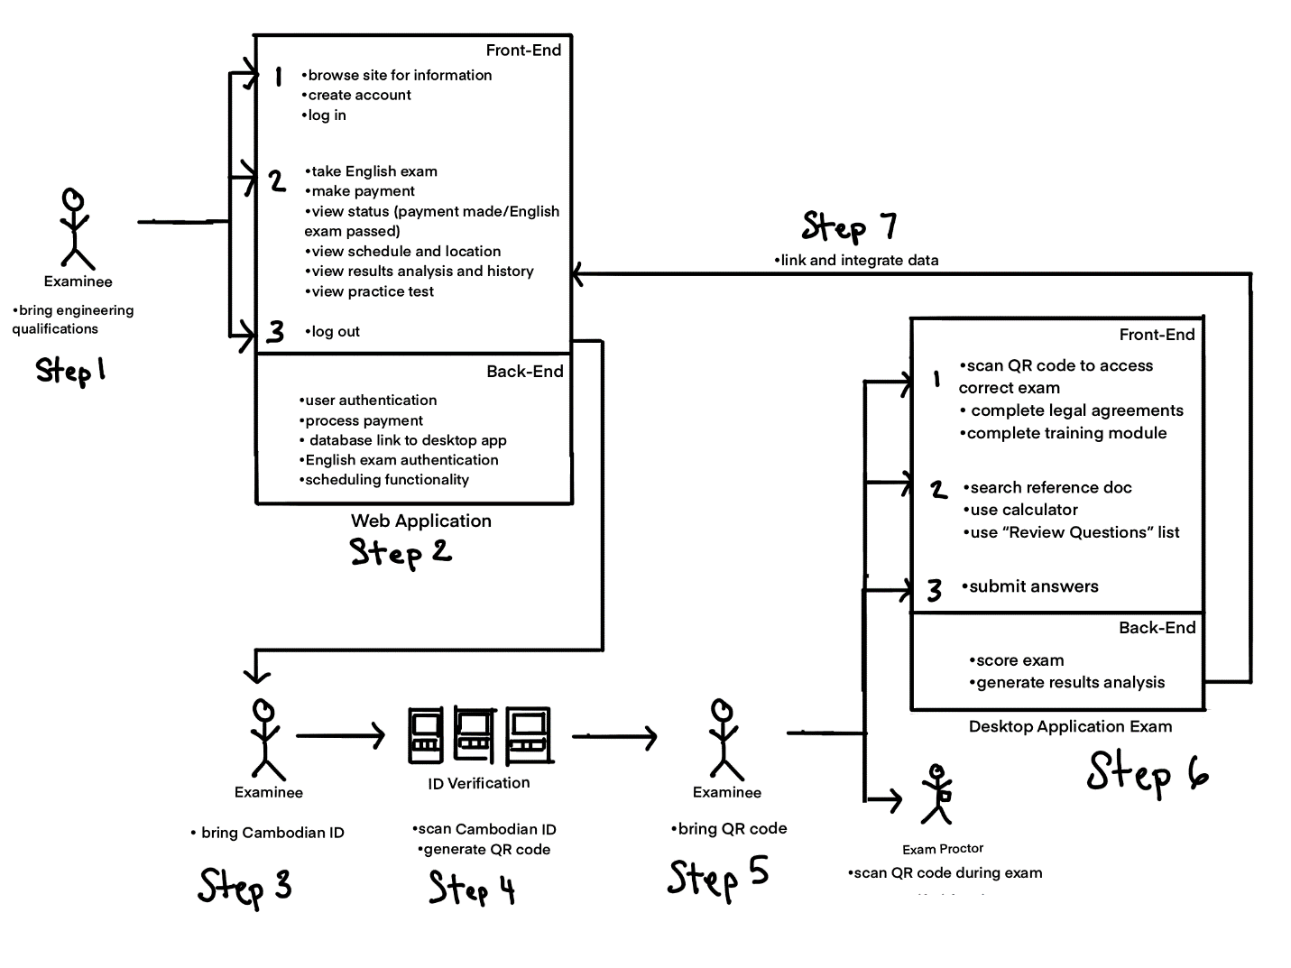

1. Work Breakdown Structures
2. Web App

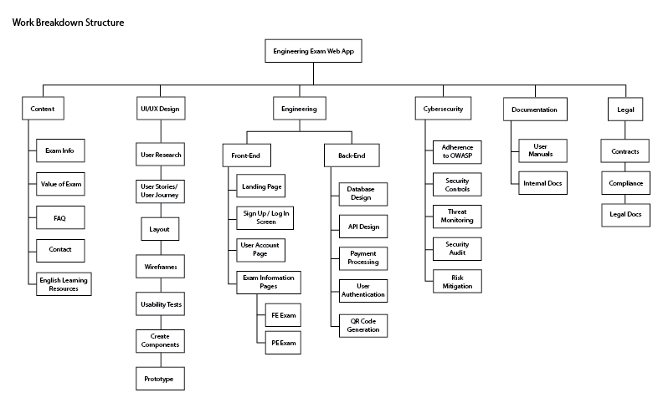

1. Desktop App

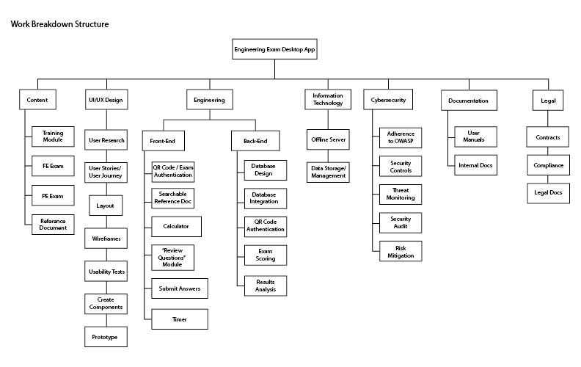

# Project Requirements

1. Business Requirements
2. Provide Certification Pathway

* Exam shall offer a professional certification pathway for engineering students and professionals in Cambodia.

1. Provide Registry of Cambodian Engineering Professionals

* The database shall update on the web application a public database of registered Cambodian engineering professionals, their license number, their field of work and their contact information.

1. Business Rule
2. Government Compliance:

* Ensure that the entire project adheres to the regulations and requirements set forth by the Cambodian government regarding computer-based exams.

1. Legal Documentation:

* Oversee the creation and review of legal documents, contracts, and agreements related to the project, ensuring that all parties involved are legally protected.

1. Contracting:

* Work on the legal aspects of contracting, ensuring that agreements with various stakeholders, including developers, cybersecurity experts, and any third-party services, are legally sound and protective of the project's interests.

1. User Requirements
2. Receive Professional Certification
   1. **Access to Database Registry of Certified Professionals**
   * Database for registry of certified professionals, their license number, their field of work and contact information shall be created and displayed on web application for public use.
3. Check Account
   1. **Access to Professional Certification Document**
   * Users in web application shall be able to access their Professional Certification Document in their account.
4. Functional Requirements
5. Web Application
   1. **Provide Exam Information**
   * Non-users and users shall be able to access features for Sign Up / Login, navigate to sections for exam information, value of the exam, scheduling and location, FAQ and contact.
   1. **Access English Learning Resources**
   * Shall provide links to English learning resources.
   1. **Sign Up / Login**
   * Non-users and users require pop-up for Sign Up / Login functionality.
   1. **Take English Exam**
   * Users require a module for the English Exam so they can qualify to register for the Engineering Exam. This function comes before making a payment.
   1. **Make a Payment**
   * Users require payment functionality for exam fees.
   1. **View Exam Status, Schedule and Location**
   * Users require access to the Exam Status (criteria: payment made and English exam passed), Schedule and Location.
   1. **View Previous Exam History and Results**
   * Users require access to Exam History (pass/fail history) and Results Analysis so they can review areas of study that may need improvement.
   1. **Provide Practice Exam Link**
   * Users require access to a Practice Exam PDF.
   1. **Contact Support**
   * Non-users and Users require information to contact support services.
6. Desktop Application
   1. **Scan QR Code for Identity and Exam Verification**
   * Examinees shall be able to scan their provided QR code to bring up the correct exam to match their identity and account.
   1. **Training Module before Exam**
   * Training module shall guide examinees on how to use the reference material, calculator, “Review Questions” list and view the timer.
   1. **Access Exam Reference Material**
   * Exam reference material shall be provided as a searchable PDF document.
   1. **Access Calculator Application**
   * Calculator application shall be provided with functionality to perform as permitted by the committee.
   1. **Submit Answers**
   * Examinees shall choose answers out of a list and be able to click on of three buttons: back, skip, and submit.
   * Examinees shall be able to select questions to add to review list.
   1. **Add Answers to “Review Question” List**
   * Examinees shall have the option to access the “Review Question” list, which includes skipped questions and questions marked for review.
   1. **Data Synchronization**
   * Desktop application data shall be synchronized to web application data, so that information depicted on the website is accurately linked to the information collected from the desktop application.
7. Non-Functional Requirements
8. Web Application
   1. **Usability**
   * Website shall be easy to navigation, information easy to find, and all endpoints performing their functions correctly.
   1. **Security**
   * Shall adhere to NIST guidelines on maintaining data security and proper user authentication techniques.
   1. **Maintainability**
   * Shall be easy to maintain, so that features are simple enough to be consistently functional, easy to update and support services are not overwhelmed.
   1. **Reliability**
   * Information on exam specifications, scheduling, location, program details shall remain up to date.
   * Server shall remain online so that non-users and users may access the website and/or account information 24 / 7.
   1. **Scalability**
   * Shall be scalable, so that additional modules, features, links and information may be added in future iterations.
9. Desktop Application
   1. **Usability**
   * Training module must be provided so that examinees have full understanding on how to use provided features such as the reference materials, calculator, “review questions” list and timer functionalities.
   1. **Security**
   * Desktop application must be securely offline, so that examinees are not able to access materials outside of what is provided.
   * Timer shall be implemented so that the exam is locked once the time runs out.
   1. **Performance**
   * Desktop application must be able to perform without lag, so that the system does not interfere with the examinee’s testing experience.
   1. **Scalability**
   * Shall be scalable, so that additional modules, features, links and information may be added in future iterations.
   1. **Revolving Questions**
   * Questions shall revolve based on year as determined by committee in charge.
   1. **Scoring System**
   * Scoring system shall be implemented from examinee answer data collected.
   1. **Results Analysis and Generation**
   * Answer data shall be collected into a database and analyzed to create a report that will be displayed in user accounts on the web application so that examinees can review study areas that need improvement, categorized by topic type.
10. External Interfaces
11. Web Application
    1. **Application Programming Interfaces (APIs)**
    * API design to include data exchange between desktop and web applications.
    1. **Single Sign-On (SSO) Integration**
    * OAuth protocols must be defined to specify endpoints and data formats to exchange authentication and user profile information on web application.
    1. **Payment Gateway Integration**
    * Web application requires a payment gateway integration for payment requests and responses, encryption protocols and error-handling mechanism to ensure safe and reliable payment processing.
12. Desktop Application
    1. **Customer Relationship Management (CRM)**
    * Identity Verification system shall provide a QR code to examinees after checking their Cambodian ID, so that examinees can enter into the examination.
    * Users will authenticate their identity and access their specified exam using QR code reader at any computer station.
13. Physical Setting
    * 1. Environmental Controls

* Ensure that the location is large enough to facilitate amount of examinees during an administered exam session.
* Implement controls so that there is minimal congestion in line queues when examinees obtain their QR codes after providing identification.
  + 1. Closed Server System
* The desktop application will be implemented in a closed server, offline system.
  + 1. Security Cameras
* Install security cameras in designated areas for monitoring during exams.
* Cameras should cover entry points, exam rooms, and other critical locations.
  + 1. Access Control
* Implement a secure access control system to where the server is located only authorized personnel.
  + 1. Security Door Lock
* Install secure and tamper-evident door locks.

1. Developer Constraints
2. Project Management
   1. **Product Requirements Document**

* The Product Requirements Document will be written and updated by the Project Manager. This document will be used as a project overview for stakeholders and guide for developers on the project.
  1. **Work Breakdown Structures**
  + The work breakdown structure shall be created by the Project Manager so that the overall goal for the project is kept in mind by the development team.
  1. **Product Backlog**
  + The product backlog will be created and maintained by the Project Manager in Trello, so that tasks are clearly outlined, organized and assigned to the development team
  1. **Project Schedule**
  + The project schedule will be maintained by the Project Manager using a Gantt chart so that timeline estimates can be estimated and iterated on to try and adhere to phase requirements.

1. Engineering
   1. **Programming Language Selection**
   * The development team is responsible for identifying the language/framework for the integrated system that is understood so that other teammates are able to check their work.
   1. **Time**
   * Due to there being many features in both of the web and desktop applications, enough expertise and time is required in order to make all functionalities be implemented correctly and database integration accurate.
2. Information Technology
   1. **Server Connections**
   * The server connections must be maintained so that data collected from the desktop application engineering exams are completely functioning and secured for the duration of the exam.
3. Security Requirements
4. Adherence to Security Framework
   1. **Open Worldwide Application Security Project (OWASP)**
      * Adhere to the OWASP security principles: minimizing attack surface area, principle of least privilege, defense in depth, separation of duties, keep security simple, fix security issues correctly, establishing secure defaults, fail securely, don’t trust services, and avoid security by obscurity
5. Security Controls
   1. **Encryption**

* Convert sensitive data such as user name, password, payment information, answer submissions, exam results, and history from readable to encoded format to ensure confidentiality
  1. **Authentication**
     + Securely verifying identity when user is logging into website and when examinee is scanning their provided QR Code to access the exam
  2. **Authorization**
     + Granting access to sensitive data categorized by types of authorized users

1. Threat Monitoring (SIEM tools)
   1. **Suricata**
      * Implement real-time network analysis and threat detection system to inspect network traffic, identify suspicious behavior and generate network logs.
      * Establish incident response protocols to address security incidents promptly.
2. Security Audits
3. **Penetration Testing**
   * Conduct a comprehensive penetration test on the project's IT infrastructure, including networks, applications, and databases.
4. Risk Mitigation
   1. **Incident Response Playbook**
      * Create and maintain a playbook to clarify what tools and methodology should be use in response to a security incident so that the team has on hand the preparation, detection and analysis, containment, eradication and recovery, IT restoration, and coordination.
   2. **SOAR Tool**
      * Automate repetitive tasks generated by SIEM such as when a user attempts to log into computer too many times with wrong password.

# Risks and Assumptions

* 1. (Include details about potential risks and assumptions made)

# Release Plan

* 1. To be determined

# Change Log

* 1. To be determined

# Approval