Scatterplot clustering for the integrative analysis
of expression and methylation data

RUIZ DE VILLA, M. CARME¹, CARMONA, FRANCESC¹, BAZZOCO, SARAH^{2,3}, ARANGO, DIEGO^{2,3}, SÁNCHEZ, ALEX^{1,4}

¹ Statistics Department, Universitat de Barcelona. Avda Diagonal 643, 08028 Barcelona, Spain.
^{2,} Group of Molecular Oncology, CIBBIM-Nanomedicine, Vall d’Hebron Research Institute (VHIR),
Passeig Vall d’Hebron, 119-129, 08035 Barcelona, Spain.
³ CIBER de Bioingeniería, Biomateriales y Nanomedicina (CIBER-BBN); Spain.
^{4,} Statistics and Bioinformatics Unit (UEB), Vall d’Hebron Research Institute (VHIR),
Passeig Vall d’Hebron, 119-129, 08035 Barcelona, Spain.

Introduction: Methylation of CpG dinucleotides in the promoter of genes involved in the oncogenic process has been shown to be a key process contributing to tumor initiation and/or progression. The identification of genes regulated by methylation can be done using differnt approaches but a reasonable one consists of looking for patterns in the relation between gene expression and methylation that suggest the known form of regulation. In practice this is done mainly by looking for genes with an L-shaped form in a scatterplot between gene expression and the degree of methylation, although other regulation patterns may be of interest. The main objectives of this work are: (1) to select an appropriate method for scatterplot clustering that can be used to mine a multiple high-throughput dataset formed by expression and methylation data and extract the desired patterns, (2) to test the methods selected on a colon cancer dataset formed by a panel of 30 cell lines derived from colorectal tumors and validate the findings based on their biological relevance.

Methods: We considered two methods to select patterns of regulation that could be attributable to methylation: (i) Conditional Mutual Information (Liu and Qiu, 2012) and (ii) Clustering based on Splines Regression (Hastie and Tibshirani, 2009). The idea underlying the use of mutual information, cMI(t), consists of computing for each gene the mutual information between methylation and expression noting that patterns of interest such as L-shapes can be detected because as one moves from smaller to higher values of regulation the cMI(t) will first decrease and then increase. This characteristic can be used to select genes adapted to this pattern. The second approach consists of fitting a spline regression model to the relation between expression and methylation and then performing a hierarchical clustering on the coefficients,. This yield distinct clusters, some of which can be associated with the desired patterns.

Results: These methods were tested on a multiple expression-methylation dataset where genes were previously filtered in order to keep only genes showing some degree of correlation with methylation. Figurde 1 and 2 show examples of genes selected by both methods. Table 1 shows the number of genes that were selected by applying each method. Two main clusters associated with methylation were identified.

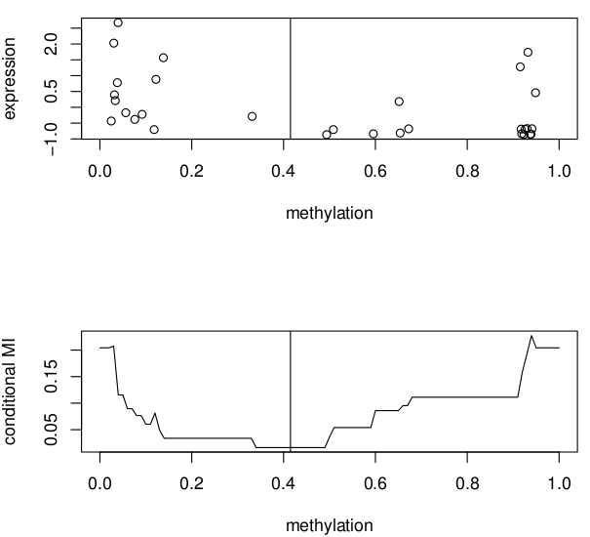Figure 1: Scatterplot depicting expression and methylation values for a selected gene (above) and plot of conditional mutual information

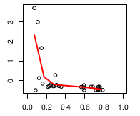Figure 2: Scatterplot of one of the genes selected using the splines method

Table 1: Number of genes selected by each method as being regulated by methylation
Cluster | Splines | cMI
1 | 140 | 102
2 | 22 | 16

In order to test the validity of the selection, a functional analysis of the genes derived was performed and some of the results such as an enrichment of zinc finger proteins suggests that the selection was not only statistical but also biological meaningful.

Discussion: The selection of genes regulated by methylation is an important process in many modern cancer analysis. Doing an integrative analysis by combining methylation and expression data is a natural way to select some of these genes but the high number of possible patterns makes it necessary to look for automatic ways of pattern extraction.

Conclusion: Methods that receive some arbitrary input on the pattern to be looked for seem to be a useful tool for selecting genes with these patterns. Besides this, the fact that, in spite of their different approaches, different methos yield similar results is an extra argument favoring their use.

References:
Bazzocco, S., Hafid Alazzouzi, M. Carme Ruiz de Villa, Alex Sanchez-Pla, John M. Mariadason, Diego Arango (2014) Genome-Wide Analysis of DNA Methylation in Colorectal Cancer. Submitted.

Hastie T., Tibshirani R., and Friedman J.H. (2009) The Elements of Statistical Learning, 2nd edition. Springer,

Liu, Y., and Qiu, P.. (2012) Integrative analysis of methylation and gene expression data in TCGA IEEE International Workshop on Genomic Signal Processing and Statistics (GENSIPS)

