
KOÇ UNIVERSITY
College of Engineering

DEPARTMENT OF MECHANICAL ENGINEERING
MECH 291

Bertan Erman 83155

Internship Company and Department:
Repkon İmalat Sanayi ve Ticaret A.Ş. / Production & Process Department
01.09.2025-26.09.2025
Total Working Days (full-time equivalent): 20
Company: Repkon Manufacturing
Department: Production and Process Department
Address: Çerkeşli OSB, İmes 3 Bulvarı A Blok No:30, 41455 Demirciler Osb/Dilovası/Kocaeli
Supervisor : Soner Öner, 05457687230, soner.oner@repkon.imalat
Signature of Supervisor: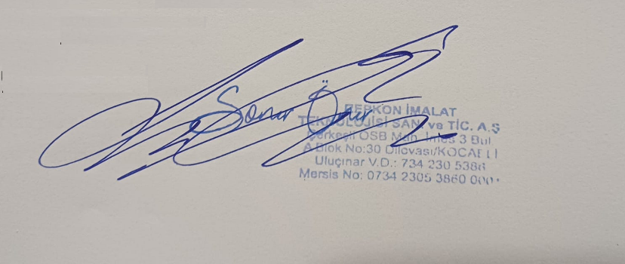

SUMMER PRACTICE REPORT

Part 1: Company Profile

Repkon Manufacturing (Repkon İmalat Sanayi ve Ticaret A.Ş.)

Repkon Manufacturing is a subsidiary of the parent company, REPKON. The parent company, REPKON, was established in 1978 and has since become a globally recognized provider of turn-key production plants and a designer of key metal forming machines. With a strong reputation for innovative solutions, REPKON has been a leader in the metal forming sector for over four decades.

To leverage its extensive manufacturing expertise and serve the broader industry, Repkon Manufacturing was established in 2021 in Dilovası, Kocaeli. This new entity focuses on applying the group's culture of effective process management and systematic approaches to meeting customer demands with high quality and on-time delivery. The company aims to become the first choice for high-precision machine part manufacturing in the region.

Repkon Manufacturing's core business is high-precision contract manufacturing custom machine parts. The company specializes in machining complex components according to customer-provided technical drawings and specifications. Its primary clients are in the defense industry, but it also serves other sectors requiring high-precision manufacturing. The company manages all its processes through an integrated Enterprise Resource Planning (ERP) system to ensure efficiency and traceability from order to delivery.

1.1. Departments within the Company

1.1.1 Process Department: The Process Department defines and optimizes the technical details of the production process. It prepares production routes, selects the appropriate tools and machines, and plans the workflow.

1.1.2 Production Department:

The Production Department is the core of the company’s manufacturing activities. It consists of universal machines and modern CNC machining centers. Each machine is selected according to the geometry of the part, the material properties, and the level of precision required.

In general, universal machines are manually controlled. Their accuracy and productivity depend highly on the operator’s skill. They are mostly used for simple geometries, repair work, or small batch production. In contrast, CNC machines are programmable and automated. They can produce complex shapes with high repeatability and efficiency, which makes them the backbone of modern manufacturing and our company.

Within machining operations, two major categories of machines are lathes and milling machines. The main difference lies in the movement of the workpiece and the cutting tool. In a lathe, the workpiece rotates around its axis while the cutting tool moves linearly to remove material. Lathes are especially suitable for cylindrical parts such as shafts, bushings, or threaded components. When working with lathes, the workpiece must be clamped securely in the chuck. If the part is not fixed tightly, it may “slip” (lose its position), which would cause dimensional errors and poor surface quality. In a milling machine, the cutting tool rotates while the workpiece remains fixed or moves along different axes. Milling machines are better for prismatic parts, slots, pockets, or flat surfaces.

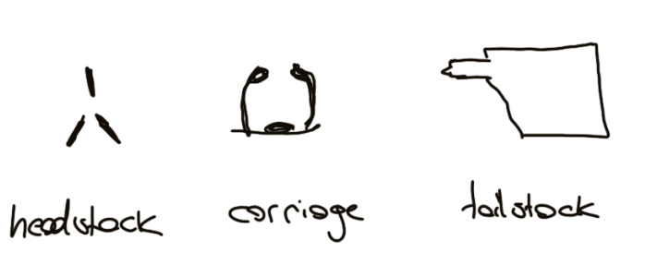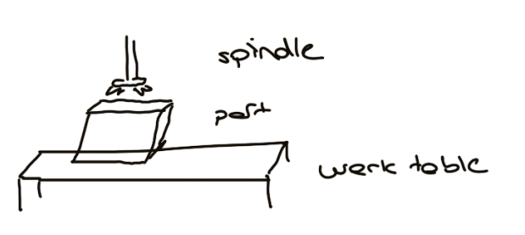
Figure Lathe and Mill Parts

Among milling machines, there are two main configurations: vertical and horizontal. In vertical milling machines, the spindle is oriented vertically, which makes them versatile for drilling, pocketing, and general machining tasks. Horizontal milling machines, on the other hand, have a horizontal spindle orientation, providing higher rigidity and efficiency in heavy cutting, especially when machining grooves or large surfaces.

Cutting Tools: They are used in machining operations to remove material from workpieces to achieve desired shape related to the technical drawing.
Milling Tools:
End Mills: Used for slotting, pocketing, profiling. They can both cut the ends and tip.
Face Mills: Designed for machining large and flat surfaces quickly. They hold multiple inserts. We commonly used in our Zayer machine
Ball Nose Cutters: Used for 3D contouring, curved surfaces and die mold machining.
Turning Tools:
External turning inserts: For reducing the diameter of a cylinder.
Boring Parts: For enlarging or finishing internal parts.

Iso material Groups: they are standard to match cutting tools with the material and each letter corresponds to specific metals.
P: For low medium carbon steels and alloyed steels.
M: For austenitic, ferritic and martensitic stainless steels.
K: For gray cast iron, nodular cast iron.
N: For aluminum, copper, brass and soft non-ferrous metals.
S: For Inconel, titanium cobalt based alloys.
H: For hardened steels (>45 HRC)
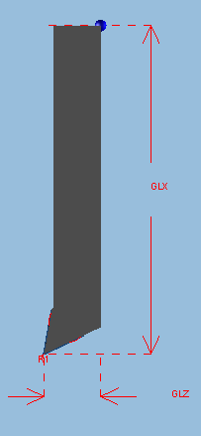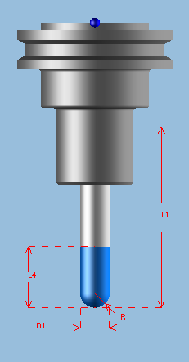 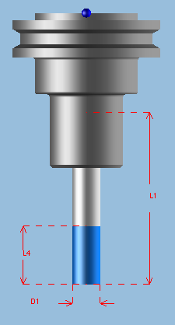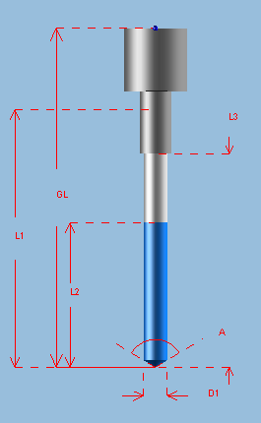 [3]
Figure SolidWorks CAM interface: Ball nose end mill ,Flat end mill, Drill

Another crucial element of production is the technical drawings. It serves as the language between design, process planning, production, and quality control. The drawing defines the geometry, dimensions, and surface requirements of the part. It also includes tolerances, which specify acceptable limits of variation. Tolerances ensure that parts from different batches or machines can fit together properly without functional problems.

Machine | Description | Capacity | Brand
MILL 1 | 3-axis CNC vertical milling. Tool moves in Z; table moves in X and Y. | X:1050mm Y:600mm Z:600mm | Mazak
MILL 2 | 3-axis CNC vertical milling. | – | Mazak
MILL 3 | 3-axis CNC vertical milling. | X:1050mm Y:530mm Z:510mm | Doosan
MILL 4 | Universal milling machine. Manually operated. | X:250mm Y:600mm Z:300mm | –
MILL 5 | 3-axis CNC vertical milling. | – | –
MILL 6 | 3-axis CNC vertical milling. | – | –
MILL 7 | 5-axis CNC milling. Table rotates around Z; tool can move in all axes. | X:2120mm Y:1200mm Z:800mm | Wele
GRINDING MACHİNE | General grinding machine, used for finishing. | – | –
LATHE 1 | 2-axis CNC lathe. | Ø500mm × 2500mm | –
LATHE 2 | 2-axis CNC lathe. | Ø400mm × 1280mm | Doosan
LATHE 3 | 2-axis CNC lathe. | Ø450mm × 2000mm | Doosan
LATHE 4 | Small universal lathe. | – | –
LATHE 5 | 3-axis CNC lathe. The table can rotate at angles. | Ø380mm × 1280mm | Doosan
LATHE 6 | Universal 2-axis lathe. | Ø500mm × 600mm | –
ZAYER | 5-axis CNC milling. The tool can move and rotate in all directions, with a large capacity. | Up to 10m in X | Zayer Tera
BORWERK 1 | 3.5-axis horizontal milling (table moves X–Y; tool Z–X). | 3000×2200×1500mm | Wele
BORWERK 2 | 3.5-axis horizontal milling. Same principle. | – | Wele
BORWERK 3 | 4.5-axis horizontal milling (table rotates around Z). | – | Wele

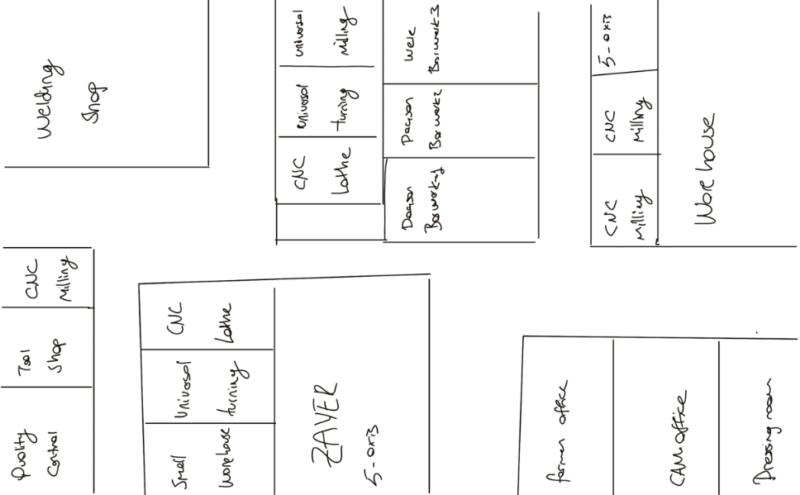
Figure Sketch of the production floor.

The CAM (Computer-Aided Manufacturing) Department plays an important role in production. After the design department finalizes the CAD model and technical drawing, the CAM team prepares the machining programs. They generate the toolpaths for CNC machines, select the cutting tools, and define cutting parameters such as feed rate and spindle speed using Esprit Edge.

The workflow typically begins when a new part design arrives from the design department of Repkon or another company. This design includes a 3D CAD model, the material specifications, and the technical drawing. The CAM operators then import this data into the CAM software Esprit Edge, where they begin preparing the machining strategy.

The CAM operators define the sequence of machining operations, known as toolpaths. These toolpaths control the cutting tool’s motion along the axes of the machine (X, Y, Z, and in 5-axis, A, B, C rotational axes). Toolpaths include operations such as facing, pocket milling, drilling, tapping, or 5-axis simultaneous machining.

Choosing the correct cutting tool is critical for efficient machining. The CAM and CNC operators select tools based on the part material, the required geometry (flat, rounded, threaded), and the desired surface quality. Cutting speed (spindle rpm), feed rate (tool advance per revolution or per minute), and depth of cut are defined according to the material properties and tool limitations. Proper selection ensures efficiency and prevents tool breakage or poor surface finish.

Before the program is sent to the machine, the CAM software simulates the machining process. This allows the operator to detect potential collisions, tool over-travel, or incorrect machining sequences. Simulation reduces the risk of damaging expensive machines, tools, and workpieces.

Each CNC machine has its own control language. The CAM software uses a post-processor to translate the generic toolpath into the specific G-code or M-code required by that machine. This ensures compatibility between the virtual model and the real machine.

The welding department in a factory is responsible for joining, reinforcing, or repairing metal components. They had 7 welding machines, and their work includes welding sheet metals, profiles, chassis, support structures, or special fixtures. In this department, workers use welding machines to assemble parts, often with the help of jigs and fixtures to keep the components aligned at the correct angle and dimensions. After welding, the parts usually go through grinding, deburring, and a quality control inspection to ensure strength and dimensional accuracy. In my internship I practiced both types of welding and TIG was clearly harder to accomplish since it can take a balloon shape. They welded parts vertically since melted material goes down.

MIG/MAG (Gas Metal Arc Welding): In this process, a consumable wire electrode is fed continuously, while a shielding gas such as CO₂ or an Argon-CO₂ mix protects the weld pool from atmospheric contamination. It is fast, efficient, and widely used for production due to its high deposition rate. In my trial I couldn’t feed the wire and then the torch became a balloon shape.

TIG (Tungsten Inert Gas Welding): This method uses a non-consumable tungsten electrode and Argon shielding gas. It provides very high-quality, precise welds with excellent control over the heat input, but it is slower and requires more operator skill compared to MIG/MAG.

1.1.3 Quality Control & Assurance Department: This department is responsible for ensuring that all products meet the required quality standards and technical specifications. The team performs inspections at stages, from incoming raw materials to the final product, using precision measurement tools like CMMs, micrometers, and gauges. They document inspection results, identify and report non-conformities, and work to find the root cause of defects.

They join the workflow at several stages. Firstly, they inspect the incoming raw materials using a spectrometer, which determines the chemical composition by analyzing the emitted light spectrum when the material is exposed to an energy source. This allows the team to confirm the exact percentage of alloying elements and verify whether the material corresponds to the required specifications.

During production, mid-control inspections are also carried out. For this purpose, portable CMM equipment such as the Romer arm is used directly at the machines to measure dimensions and tolerances without removing the parts from the production line. This helps to detect deviations early and reduce scrap rates.

Furthermore, certain parts are sent to subcontractors for heat treatment. After these parts return to the facility, the Quality Control Department performs detailed dimensional and hardness measurements again, ensuring that the outsourced processes meet the required standards. In some cases, final dimensional verification is done on stationary CMM machines such as Leica, which provide highly precise 3D measurements.

1.1.4 Planning Department: The Planning Department acts as the brain of the production operation. They are responsible for creating and managing the entire production schedule based on sales orders and forecasts. Their core tasks include calculating material requirements, scheduling machine and operator time (capacity planning), and issuing work orders to the production floor. They work to optimize workflow, minimize downtime, and ensure that all necessary resources are available to meet production targets and customer deadlines efficiently.

1.1.5 Sales Department: The Sales Department is responsible for managing customer relations, preparing quotations, and ensuring that orders are processed from the initial inquiry to delivery. In our company, they also handle the coordination of outsourcing jobs, including selecting suitable firms, arranging shipments, and tracking the progress of outsourced work. Based on the working hours and availability of machines, they prepare cost and time estimates to provide accurate offers to customers. In addition, they monitor incoming orders, negotiate prices and delivery dates, and keep close communication with the project management and planning departments to align customer needs with production capacity.

1.1.6 Project Management: The Project Management Department plans, coordinates, and monitors all stages of a project starting from the customer order. It creates the project timeline, ensures efficient use of resources, and manages communication between different departments. The department also provides regular progress reports to both internal management and the customer to maintain transparency.

1.2 Products

Repkon Manufacturing does not have a standard catalog of "typical" products. Instead, it produces a wide variety of custom-made, high-precision components based on orders from other companies, particularly in the defense sector. These are often unique, low-to-medium volume parts that serve a specific function in a larger assembly. Although the company mainly produces project-based and customer-specific parts, several typical products can be identified that reflect its expertise in defense industry manufacturing. These include:

1.2.1 Forging and Forming Dies: Front forging dies, upsetting dies, and extrusion dies are produced to shape high-strength materials into critical defense components. These dies are usually made from hot-work tool steels such as 1.2344, heat treated to around 42–46 HRC, ensuring durability under loads and temperatures.

1.2.2 Mandrel and Connector Parts: Male mandrels, mandrel connectors, and tailstock connectors are essential tooling and fixture parts that provide precision alignment and structural support during extrusion, forging, or machining operations.

1.2.3 Defense-Related Structural Parts: Ammunition racks and spindle housing parts are examples of structural products designed for defense applications, where strength, dimensional accuracy, and reliability are critical.

1.2.4 Rotating and Powertrain Components: Crank shafts and housing base parts are manufactured for machines used in the defense industry, requiring high fatigue resistance, precision machining, and rigorous quality control.

Part 2: Projects Undertaken During the Internship

2.1. Process & Production Departments

The Process Department serves as the bridge between the customer's design and the manufacturing floor. Its primary responsibility is to create a detailed, step-by-step production plan for every part.

My work in this department involved:

Production Observation: A significant part of my internship was spent on the production floor. I followed specific parts through their entire manufacturing lifecycle. This allowed me to compare the planned process with the actual execution, understand the challenges operators face, and see firsthand how machines create the features specified in the drawings. This practical experience was invaluable for creating more realistic and efficient process plans.

Analyzing Technical Drawings: I learned to read and interpret complex engineering drawings, paying close attention to dimensions, geometric tolerances, material specifications, and surface finish requirements.

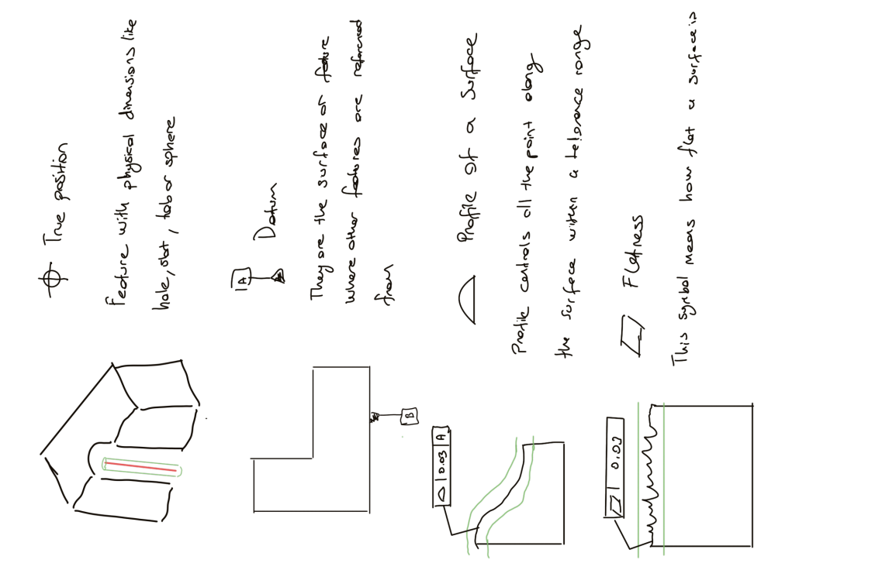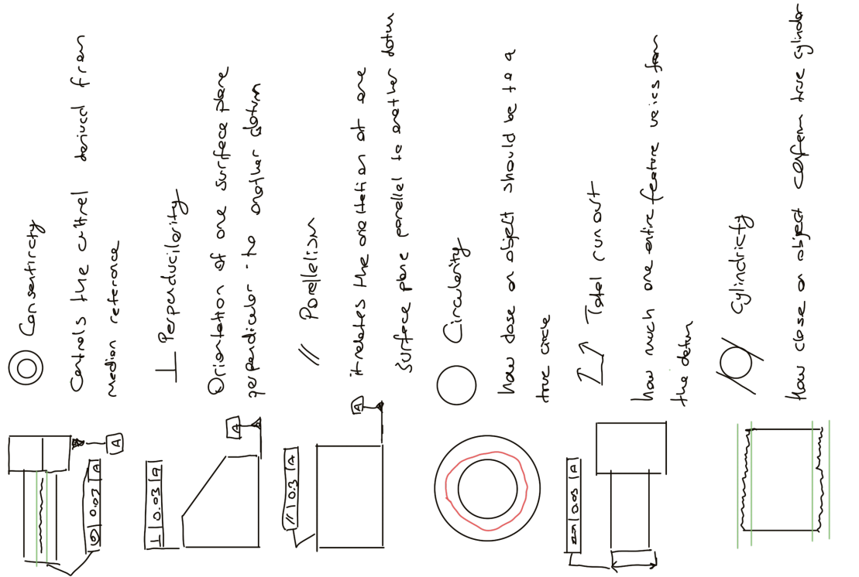
Figure Geometric Tolerances [1]

Creating Production Routes: For a given part, our department and foremen would identify the sequence of operations required. This included deciding which machine to use for each step (e.g., start with turning, then move to milling, then grinding).

Using the IFS System: Our task was to input the production routes, including the machines, estimated setup and run times, and required tooling for each operation. This data is critical for production scheduling and cost estimation. We create an Inventory item card which is a digital record of a material. This card ensures traceability of every part and prevents mistakes.

2.2. Description of Representative Products and Manufacturing Processes

Project 1: BMC ammunition rack (BMC01-2-53-00110)
i. Product Description and Use
The BMC ammunition rack is a structural component designed to store and secure ammunition inside armored vehicles. Its main purpose is to provide safe, organized, and reliable storage of different caliber ammunition while ensuring that the shells remain stable even during harsh operating conditions such as vehicle vibration, sudden braking, or cross-terrain maneuvers. This rack is typically mounted inside the vehicle’s crew compartment or designated storage section. It is engineered not only to hold the ammunition but also to protect the crew by minimizing unwanted movement or collision of shells. This part was one of the most important parts since could result in new agreements with the BMC.
ii. Technical Details:
- Technical Drawing: The official drawing is located in Appendix A.
- Dimensions and Tolerances: Stock part is 900x540x50. Before every step, we hold it with clamps and make sure the part is flat by using a comparator.
- Material: The material used is 7075 Aluminum. This material was chosen for its lightweight.
- Chemical Composition: We have measured with quality control department and spectrometer was used. Its composition contains Zn 6%, Mg 2.4%, Cu 1.3%, Cr 0.21%.
- Mechanical Properties: Tensile strength 572 MPa, Yield strength 503 MPa, Density 2.81 g/cm³ ,Elastic Modulus 71.7 GPa. Since we wanted to hold ammunition these are the important properties. This material was a soft one so it was easy to produce.
- Production Flow Chart & Processes:
Step | Operation Name | Machine Used | Description of Process
1 | CAM | Esprit Edge | .
2 | Rough Milling | Zayer 5 Axis | 50çap tarama/
3 | 5-Axis Finishing | Zayer 5 axis | 12 çap;3R 400 rpm; 800mm/m Vc /0.3 paso / çapın yüzde 10u
4 | 3-Axis Milling | Doasan 3-Axis | Since we couldn’t make angled holes to our part we moved it to another machine and process took way more than it should have been.
5 | Deburring & Cleaning | Manual Station | Removed sharp edges, burrs and leftover chips.
6 | Quality Inspection | CMM Machine
- Quality Control Methods:
  - In-Process Checks: When the aluminum came to factory we checked the material with spectrometer. After making sure it contains needed atomic compounds, By using the probe that Zayer has, we measured stock part 900.14 x 540.11 x 50.09. Before moving the part in any other direction, we measured again. With comparator we made sure our part is flat.
  - Final Inspection: When part is finished, we cleaned the part with alcohol because even small dirt could cause our measurement. We put the part on CMM machine vertically and stable and touch it manually with probe to find exact positions of the part. Then we created automatic software that touches holes, dimensions and features which took 2 hours. Then we compared the results to see if they are correct. We had one major problem, which is some holes were 0.2, 0.3 off from the technical drawing.

Project 2: Extrusion Die (HFP403-51-061)
i. Product Description and Use
My second project was an extrusion die that is being used to make howitzer shells. This dies shape and from material under high pressure and temperature ensuring dimensional accuracy and durability.
ii. Technical Details:
- Technical Drawing: The official drawing is located in Appendix A.
- Dimensions and Tolerances: Stock part is 170Qx760. Since we are going to use it on the CNC turning machines we ordered this part a bit longer so turning machine has a place to hold the material.
- Material: The material used is 1.2344 hot worked steel (X40CrMoV5) heat threaded to 42-46 HRC to withstand high thermal and mechanical stresses
- Chemical Composition: We have measured with quality control department and spectrometer was used. Its composition contains C 0.37%, Si 1.1%, Mn 0.32%, Cr 5.3%, Mo 1.5%.
- Mechanical Properties: Ultimate tensile stress 1300MPa, Yield tensile strength 1200MPa, Modulus of elasticity 215 GPa, poisson’s ratio 0.28. To make this material they heat up to 2000 F and then slowly cooling it to 1000 F. It has a good resistance to absorbsion at both low and high temperatures. Excellent hardenability with very little distortion. [2]
- Production Flow Chart & Processes:
Step | Operation Name | Machine Used | Description of Process
1 | Fason Derin Delik ?? |  | We had to send this part away since we didn’t have capability make long hole.
2 | CNC Rough Turning | CTR-3 | . (6 hours)
3 | Fason Islah |  | To get that intended HRC value we once again send part away.
4 | CNC Turning Finish | CTR-3 | We finished the part with intended diameters. (8 hours)
5 | Mid Quality Inspection | Romer CMM | We detected a form issue while part was on the machine.(6 Hours)
6 | Deburring & Cleaning | Manual Station | Removed sharp edges, burrs and leftover chips.(0.5 Hours)
7 | Quality Inspection | CMM Machine

2.3. Description of Machines and Quality Control Instruments
Coordinate Measuring Machine (CMM): During my internship I had the opportunity to observe measurement techniques in the quality control department. We used one of the most advanced tools was Coordinate Measuring Machine (CMM) and different types of it. This machines what makes our company special since it allows us to produce parts with the intended dimensions. Even some companies sent some parts to our quality control department for measuring. This room is always kept 21 degree Celsius since temperature effects dimensions we even let parts cool in that room. We also need to calibrate every probe by touching a marble sphere and told the sphere its radius and length.
When the production is finished operators send parts to quality control department. Than for every dimension software is prepared by the quality workers. To make sure we have a precise measurement we choose how many points we want to touch. After making sure parts are stable and cleaned with alcohol since even little marks could effect the measurement, they start to touch with the probe. They first manually need to find where this part is in space or zero of the part. After manually touching 4 5 points on the part, we find the origin and then PC-DMIS-CAD software prepares automatically and touches the parts. But sometimes defense industry doesn’t give us the SolidWorks model and just wants us to measure the part than most of the job is manually done.
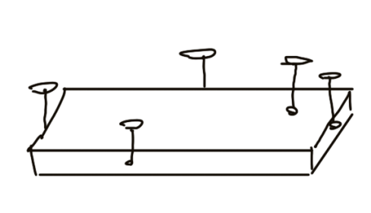
Figure Where to touch parts with probe
Leica: Laser based measuring CMM is being used for large scale parts or where romer arms couldn’t reach. Its head tracks the target that we put on to the intended place of the part. There was a big part which needed help from quality control department to measure parallelism tolerance.
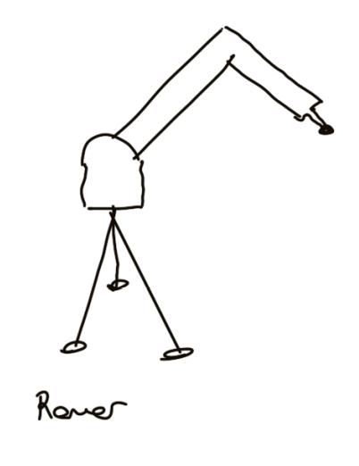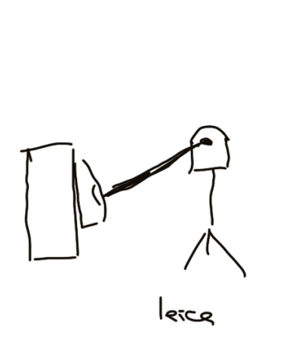
Figure romer cmm drawing and a leica cmm laser drawing

Romer: A portable measuring arm to check dimensions on the production floor. It has a advantage measuring points without moving the part from the machines. During the process of extrusion die which has important dimensions and tolerances, I had a chance to measure and find one missing dimension and gave feedback to operator luckily we fixed it.
Caliper: It was a quick tool to measure internal diameters, depths, and dimensions. I also learned how to read a manual caliper and exposed to different types of it.
Micrometer: It was more precise tool than caliper and we used it significantly on finishing parts in lathes. This tool measures thickness and diameters.
Surface Roughness Tester (Comparator): A mechanical device used for the small deviations and flatness. We used this tool especially aligning part with the machine because if the part is not flat than our program will deviate from original. For turning machines we measure runout by turning the headstock while in milling machines we make sure our part is flat or perpendicular to the given plane.
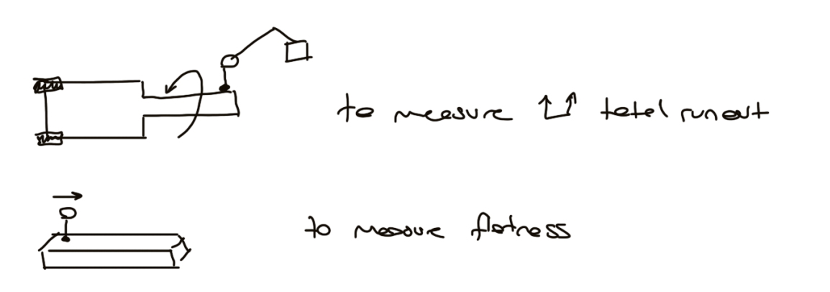
Figure How Comparator Is Being Used On Different Machines
Surface plate: Parts are placed on the surface plate to ensure they are sitting on a completely flat and stable base. This eliminates errors caused by uneven workbenches.

Project 3: IFS ERP System Efficiency Enhancement and Intelligent Quoting System Development Project

Project Background and Objectives:
During my internship period within the Process Department, I conducted a proactive analysis of the company's core operational workflows. It became evident that the existing procedures for preparing new quotes and entering manufacturing data into the IFS ERP system were significant operational bottlenecks. The process was entirely manual, requiring engineers to first compile part and routing data in Microsoft Excel spreadsheets and then painstakingly transcribe this information, line by line, into the ERP system.

My observations identified critical issues:
Severe Inefficiency: The double-entry workflow (Excel to ERP) consumed a substantial amount of engineering time, delaying the delivery of quotes to customers.
High Risk of Human Error: Manual data transcription was prone to errors, such as typos in part numbers, incorrect parameter entries, or omitted operational steps, which required time-consuming multi-departmental efforts to correct.
Loss of Competitive Agility: For quotes involving numerous components, the process could take several hours, or even days, directly impacting the company's ability to respond to customer inquiries swiftly.

After documenting these findings, I presented a proposal to the Factory Manager outlining the problems and a potential technological solution. Upon receiving his full support and approval, I was tasked with leading this project. The primary objective was twofold: first, to fully automate the data entry pipeline, and second, to develop an intelligent, data-driven support system to accelerate and standardize the quoting process.

Scope of Work and Personal Contributions:
The project was structured into distinct phases. I was responsible for the design, development, and testing of the core components for the first two phases.

Phase 1: Automation of the ERP Data Entry Pipeline
My Contribution: I architected and developed a custom ETL (Extract, Transform, Load) tool using Python and the Pandas library. This application was engineered to read data from a standardized Excel template, which I also designed to ensure data consistency.
Automated Data Parsing: The software instantly reads complex part specifications, multi-step manufacturing routes, and operation times from the Excel file.

Built-in Validation Engine: I implemented a "Poka-Yoke" (error-proofing) mechanism directly into the code. The tool automatically validates the data for correctness (e.g., checking for text in numeric fields, ensuring no critical fields are left blank) before any database transaction occurs, thus preventing data corruption at the source.
Impact: This automation tool transformed a multi-hour, error-prone task into a streamlined, near-instantaneous, and error-free operation. It effectively eliminated the need for manual data entry and subsequent verification, freeing up significant engineering resources.
Phase 2: Development of an Intelligent Quoting Support System Prototype
My Contribution: I designed and coded a proof-of-concept for a smart quoting system. This system leverages the company's historical production data to provide intelligent recommendations for new quotes. The core of this system is a custom "Weighted Penalty Scoring" algorithm I developed.
Algorithm Functionality: The algorithm systematically quantifies the "similarity" between a new part (based on its material and dimensions) and every part previously manufactured. It calculates a penalty score based on differences in geometry and material type. The part with the lowest penalty score is identified as the closest match.
Impact: This system effectively digitizes the invaluable "tribal knowledge" of the most experienced engineers. Instead of relying solely on memory or manual searches, an engineer can now instantly find a historical precedent for a new part, along with its proven manufacturing route and timings. As a tangible deliverable, I compiled the project into a standalone executable desktop application (.exe) for user acceptance testing (UAT) by the process and engineering teams.
Applied Technologies and Key Learnings:

Core Technologies: Python, Pandas (for data manipulation), SQLite (for prototype database), Oracle DB connectors, and GUI development libraries (for the desktop application).
Methodologies & Principles: I applied principles of Process Analysis, Algorithm Design, ETL Pipeline Development, and the Poka-Yoke (Error-Proofing) manufacturing philosophy.
Professional Growth: This project provided me with an end-to-end engineering experience, from identifying a critical business need and securing stakeholder buy-in to designing a technical solution, developing a functional prototype, and delivering a tangible tool that provides immediate value.
Conclusion and Impact on the Company:
This project represents a foundational step in the company's digital transformation journey. The developed tools directly address core inefficiencies, offering a clear path to significantly reducing quote lead times and improving data accuracy. By automating repetitive tasks, the project allows highly skilled engineers to redirect their focus from administrative work to value-added activities like process optimization, innovation, and R&D. The successful development of this prototype has proven the viability of leveraging software and data science to enhance operational agility and build a more robust, data-driven manufacturing environment.
3 Appendix
References
[1] “GD&T Symbols | GD&T Basics,” GD&T Basics. https://www.gdandtbasics.com/gdt-symbols/
[2] “1.2344 Hot Work Steel”, https://www.astmsteel.com
[3] SolidWorks, version 2025, Dassault Systems, Waltham, MA, USA

