Guided Capstone Project Report

After loading our model and refitting it on available data, we see that Big Mountain Resort currently charges $81 and our model suggests $95.87 for ticket price. The business leadership should take into consideration that the current price is actually in the upper end when we consider only the resorts found in Montana. 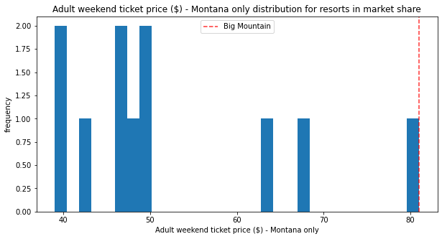

Even if BMR might be undercharging, we don’t know if others are also mispricing themselves. Going through the shortlisted options by the business to either cut costs or increase revenue, scenarios where we add a run, increase vertical drops, install additional chairs or add acres of snow making does support increase in prices. However, increasing length of runs nor simply only closing down runs do not support increase in prices as the former does not have effect and latter actually supports negative prices.

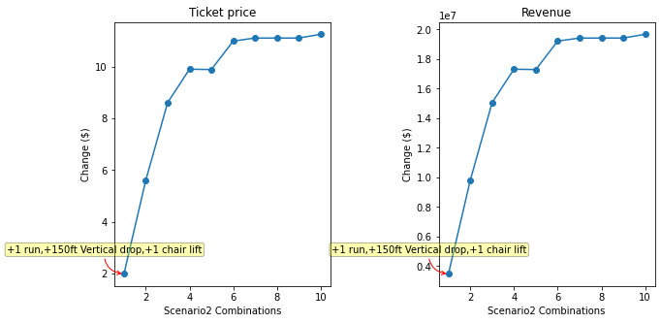

In the above figure, we can see that adding a run, increasing vertical drop by 150ft, and adding a chair lift scenario supports for ticket price increase by $1.986. Over the season, this could be expected to amount to $3474638 revenue.

In the figure below, we can see only closing runs supports negative prices.

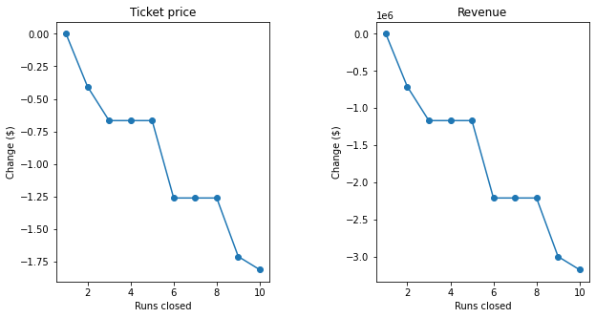

Going Forward, we need to take note that we modeled on AdultWeekend prices, and we need data to do the same on weekday prices. We would also need additional costs information other than operating cost of new chair lift. We would also need data on the average number of tickets customers buy as we assumed 5 tickets in this model. But the good thing about this model is the customers can play around the different scenario parameters combinations and see which changes support their desired price increase.