**Group 12**

**Extended Analysis**

# **Introduction**

The goal of this project is to examine the details of Homeownership in the State of Illinois, and how it is represented across the “White”, “Black”, “Asian”, and “Latino”. We analyzed the family “composition” within the demographic data in the homes to see if numbers of individuals had any effect on ownership, and analyzed the rates of homeownership to understand its correlation to the income data.

# **Comparison and Correlation**

2.1. Home composition in Illinois.

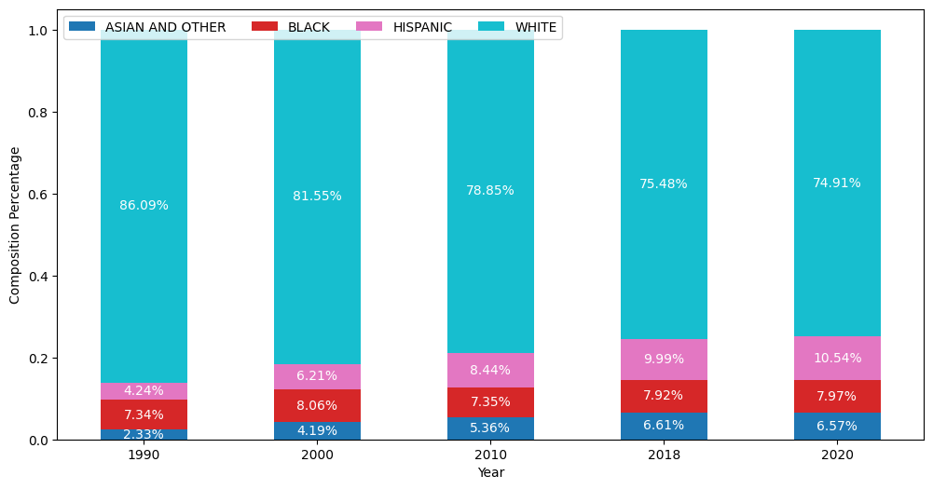

The results of our findings when analyzing the home composition (figure 2.1) is that over time, the number of individuals in the white households have decreased over time, the numbers in the Black households decreased in 2000 and is slowly increasing again, while the numbers in the Asian and Latino Households have only gone up or stayed around the same level. These numbers could mean many things, at face value, they simply indicate that the composition of what is considered a family for those that are white, and black in a home has shrunk over the years, meanwhile the others have grown. It could also mean that more white and black homeowners are selling/losing their homes as the other races are purchasing them.

2.2. Rates of Homeownership in Illinois.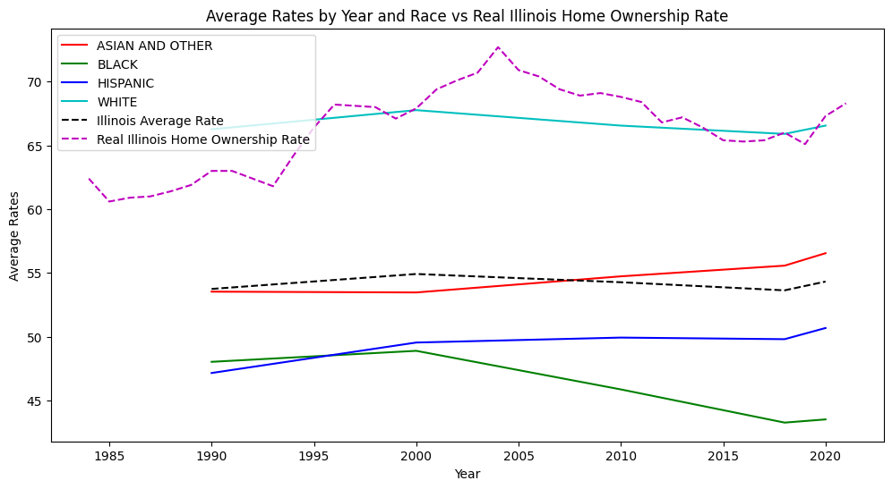

The figure above examines the data of homeownership rates by race, plus the average of all those races combined, and the real Illinois homeownership rate for the entire population. We can see that all races except for the Black population have similar trajectories. The White population shows a trajectory from the year 2000 to 2017 that is similar to the Black population, but less extreme. The Real Illinois Home ownership rate looks unequal and wavering across the board unlike our other data, but when taken into account that the timeframe of data collection was taken by decade for the average rate by year, and the real Illinois rate was taken on a yearly basis and also did not leave out races or individuals that were not classified in our race data, it sheds a new light.

2.3. Household income for Illinois combined with Homeownership rates

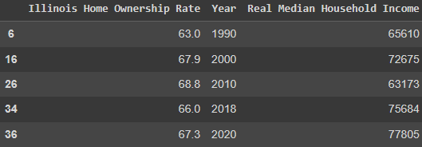

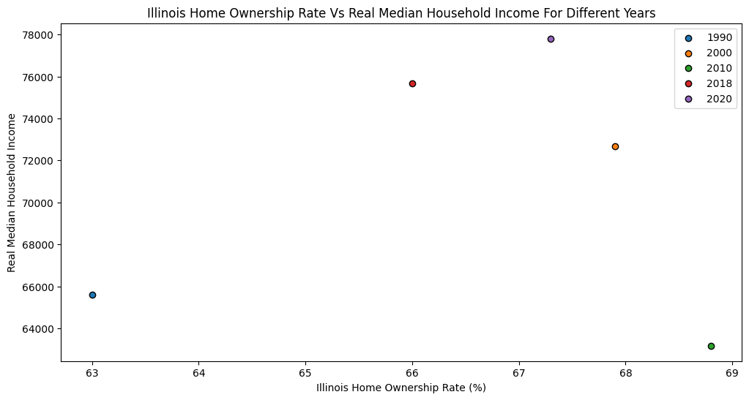

These tables help illustrate that homeownership has fluctuated over the decades but remained around the mid 60 percentage. What we can see from examining this is that when the median household income goes up, the results of homeownership in the next decade is an increase as well, when the median household income is lowered, the homeownership rate is lower as well in the following decade. From this we can conclude that income has a direct effect on homeownership.

## **3. Conclusion**

When we examine all the gathered data, it all ties in together. We can conclude that the median income in Illinois has an effect on the rates of homeownership due to the fact that the data shows homeownership rates falling over time after it’s reported that income has fallen as well. The hispanic population, and Asian population have proven resilient by increasing their home composition, and ownership rates during the years (2000-2018) where income had declined and the other races were showing the opposite results. According to the data, it seems as though homeownership for the next decade is increasing, and unless the is another factor at play besides income to effect it, the results in 2030 should yield an upward trajectory as well.