Bert Darnell
Kenneth Dewey
03/25/23

HW4: Programming Exercises

Submit answers for all of the following questions.

- (2 pts) Given the functions in Exercise 28 of chapter 6, decide the type of each function parameter: /*IN*/, /*OUT*/, /*INOUT*/
void sunny(int& a, int b);
-a is INOUT, b is IN
void cloudy(int u, int& v);
-u is IN, v is INOUT

- (5 pts) Exercise 28 of chapter 6 (p447). Please explain the execution of the program such that why it will generate specific outputs. You will receive at most 1 pts if you only show the output result without any explanation.

Script:
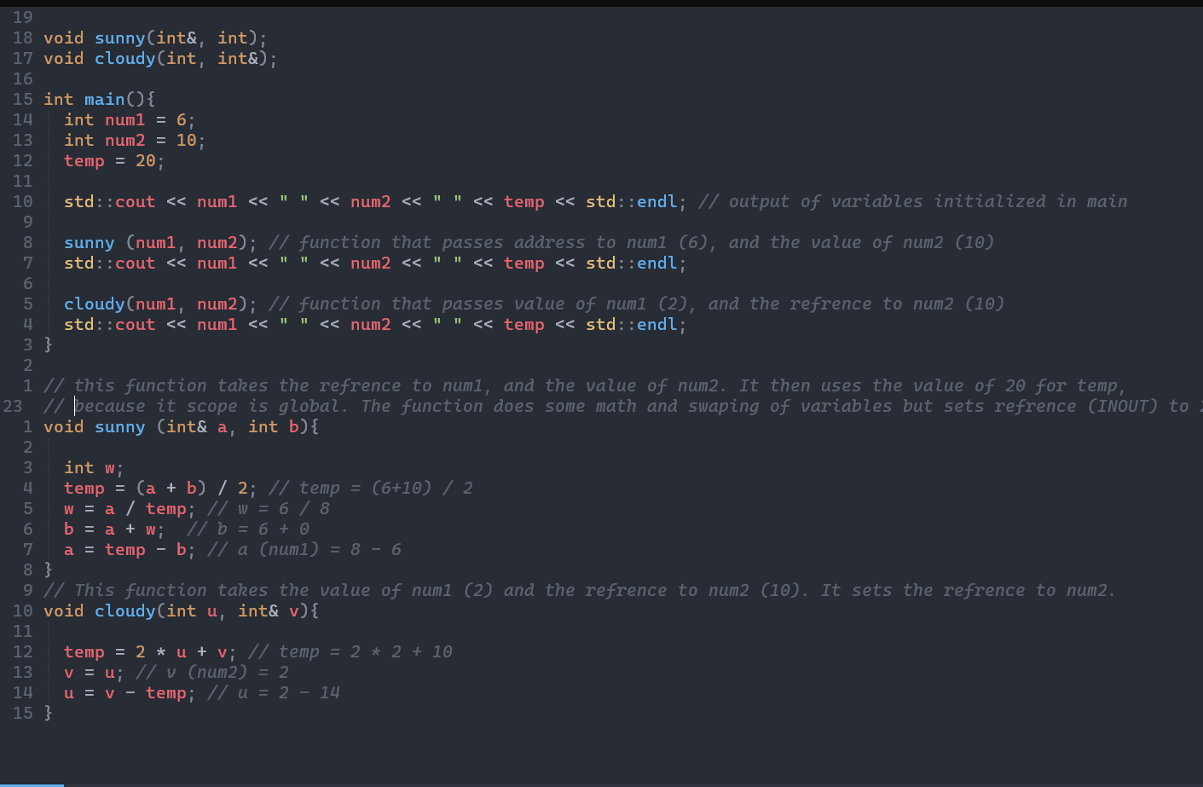

Output:
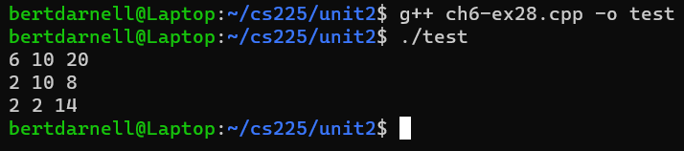
- (3 pts) Study the function prototype of istream.ignore()http://www.cplusplus.com/reference/istream/istream/ignore/ , and describe what each of the following statements does:
std::cin.ignore();
-Ignores the first character of the input-stream.

std::cin.ignore(100);
-Ignores the first 100 characters of the input stream.

std::cin.ignore(50, 'x');
-Ignores the first 50 characters or until the char ‘x’.

- (10 pts) Dave wants to write a function to compare two parameters. This function should return a negative value (the value should be meaningful if possible; otherwise just make sure it’s negative) if the first parameter is smaller, 0 if they are equal, and a positive value if the first parameter is larger (the value should be meaningful if possible; otherwise make sure it’s positive). This function should work with int, char, double, and string types. Here are some examples of how this function will be used:
std::cout << compare(5, 5) << std::endl; // ==, return 0

std::cout << compare('A', 'a') << std::endl; // <, return neg (prefer the diff between the two char)

std::cout << compare(4.5, 4.0) << std::endl; // >, return pos (prefer the diff)

std::string str1 = "dave", str2 = "peter";
std::cout << compare(str1, str2) << std::endl; // <, return neg (prefer -1)
// strings should be compared by alphabetic order (as in dictionary)

Help Dave decide whether he can use only overloaded functions, only function template, or either one would work. Provide a rationale for your choice and an implementation of your choice in a complete program with the examples given above in the main. If your answer is either one would work, just provide an implementation for one of the approaches.

-I chose to go with the function template, as it could be used with all the data types listed in the prompt. It also saved me from having to write the condition and function for each data type listed; it saved a lot of coding.
#include <iostream>
#include <string>

template<typename T>
int compare(T a, T b) {
if (a < b) {
return -1;
}
else if (b < a) {
return 1;
}
else {
return 0;
}
}

int main() {
std::cout << compare(5, 5) << std::endl;
std::cout << compare('A', 'a') << std::endl;
std::cout << compare(4.5, 4.0) << std::endl;
std::string str1 = "dave", str2 = "peter";
std::cout << compare(str1, str2) << std::endl;
return 0;
}

Submission: 1 file
- In one word/pdf document:
  - Answers to exercise 1-4
  - Paste a copy of your source code for exercise 4 into this document. Set font to Courier New to have indentation shown clearly.

- Use the rubric below to check the completeness of your work before turning it in.

Rubric: CS225, HW4

Item | Max  (Pts) | Received  (Pts)
Exercise (20 pts)
E1. Function parameter type: IN/OUT/INOUT | 2
E2. Trace Function Execution | 5
E3. Function Default Parameter Value | 3
E4. Function Overloading vs. Template  - Answer and rationale: 3 pts  - Code: 1 pts for main(), 6 pts for additional functions | 10
Total: | 20

- END -

