HW3: Project

Write a program to convert the time from 24-hour notation to 12-hour notation and vice versa. Your program must be menu driven, given the user the choice of converting the time between the two notations. Your program should accept user input repeatedly until the quit option is chosen.
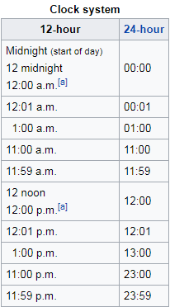

Your program must contain at least the following functions:
- a function to display the menu,
- one function to get the input (if hard, use two functions, one for 12-hour input and one for 24-hour input),
- one function to convert the time between 12-hour notation and 24-hour notation (again use two functions if this is hard), and
- one function to display the results (again you may use two functions). Time should be displayed in hh:mm format (2 digits for both hh and mm). For 12-hour time notation, your program must display AM or PM.

Your program should work like this:
- Startup screen:
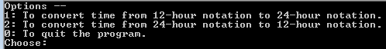

- User chooses option 1 and enters 12 0 a (should accept a/A for AM, and p/P for PM)
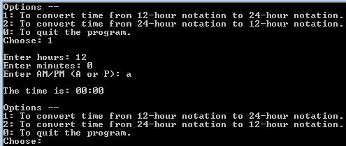

- User chooses option 2 and enters 18 40
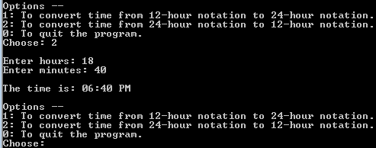

- User chooses option 0
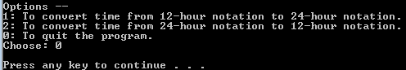

Do not use global variables (a 10% penalty).

Document each function. Record the purpose of each function as comment to each function declaration (function prologue comments). Provide Pre- and Post- condition comments. Add /*IN*/, /*OUT*/, /*INOUT*/ comments to each parameter. For example,

// given a total amount and coin type as coin value,
// calculate and return # of coins of that type could
// get out of that total
int calculateChange(int& total/*INOUT*/, int coinValue/*IN*/);
// Pre: total and coinValue initialized
// total>=0, coinValue > 0
// Post: total <- total – (max # of coins of coinValue)* coinValue
// total >= 0

Provide at least three testing cases (sample input and expected output for each testing case) and explain why you pick those three (how they test different parts/functionality of your program). Provide screenshots of the execution matching your three testing cases.

Comment your program appropriately. Pay attention to the standard stuff like coding style, indention, heading, and curly braces.

Submission: 2 files
- In one word/pdf document:
  - Three testing cases and rationale
  - Screenshot(s) of execution
- One .cpp files: name it HW3_YourLastName.cpp

- Use the rubric below to check the completeness of your work before turning it in.

Rubric: CS225, HW3

Item | Max  (Pts) | Received  (Pts)
Project (35 pts)
A function to display menu options | 2
Function(s) to take user input | 5
Function to convert 12-hour notation to 24-hour notation | 5
Function to convert 24-hour notation to 12-hour notation | 5
A function to display result | 5
main() code to call functions properly | 3
Allow repeated user input | 3
Function prologue comment  Pre- and Post- condition comments  function parameter type comment on each parameter | 3
Three testing cases and rationale. | 3
Your project compiles and runs | 1
Programming style (5 pts)  - File Prologue comments  - Consistent indentation: preferred 2 spaces for each level  - Meaningful names for constants and variables; Proper comments in the program | 1  1  3
Penalty
using namespace std; | (- 4)
Global variable(s) | (- 4)
Missing required screenshot(s) | (- 4)
Total: | 40

- END -

