HW5: Programming Exercise and Project

EXERCISE
Submit answers for the following question.

- (4 pts) Assume the following declarations:
char name[21];
char yourName[21];
char studentName[31];

Mark each of the following statement as valid or invalid. If a statement is valid, explain what it does. For an invalid statement, explain what’s wrong and correct it.
a. yourName[0] = '\0';

b. yourName = studentName;

c. if (yourName == name) // if contain same words
std::cout << "Same word in " << yourName << " and " << name;

d. for (int j=0; j < name.length; j++)
std::cout << name[j];

PROJECT: Image Processing

Write a program to simulate image processing (blur an image, see Unit 3_3_ch8_2dArray slides). An image file is simulated by a 2D array of ints. Shell code is provided in HW5_image_shell.cpp, which includes the following functions:
- Process an image file (blur the image).
- Print out blurred image on screen.

The screenshot below shows a sample image:
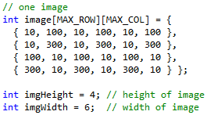

Remember, image blurring is done by calculating the weighted average of each pixel (each element of the 2D array). The weights are specified by a predefined 3 by 3 weight mask:
1 2 1
2 2 2
1 2 1
The center weight 2 (highlighted) is applied to a pixel itself and the other weights are applied to its 8 neighbors.
New value of a pixel = [ sum (weight for itself/neighbor × value of itself/neighbor) ] / sum of weights

We will use approach 1 for pixels with less than 8 neightbors:
- Approach 1: pixels with fewer than 8 neighbors are not processed

Blurred result: 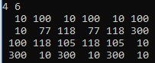

For example, new value for pixel[1][1] (in yellow rectangle) would be calculated based on itself and 8 neighbors.

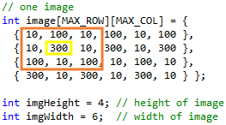

new value for pixel[1][1]
= (1 * 10 + 2 * 100 + 1 * 10 +
2 * 10 + 2 * 300 + 2 * 10 +
1 * 100 + 2 * 10 + 1 * 100) / 14 // 14 is the sum of the weights: 1+2+1 + 2+2+2 + 1+2+1
= 1080 / 14
= 77.14… → 77 is kept as the result

You need to add code to ADD #1-2:
- ADD #1: declaration of function blur. Be sure to add IN/OUT/INOUT comment to each parameter.
- ADD #2: implementation of function blur

You’re not supposed to modify the given code otherwise (at least 10% penalty).

Submission: 2 files
- In one word/pdf document:
  - Answers to exercise 1
  - Project: screenshot of program execution
- One cpp file: HW5_image_YourLastName.cpp

- Use the rubric below to check the completeness of your work before turning it in.

Rubric: CS225, HW5

Item | Max  (Pts) | Received  (Pts)
Exercise (4 pts)
E1. C-string: for each one, ½ pts for answer, ½ pts for explanation | 4
Project (14 pts)
function declaration for function blur with param type comments | 1
implementation of function blur  - Old value of each pixel is used when calculating new values  - all pixels with 8 neighbors are processed correctly  - approach 1: all pixels with fewer than 8 neighbors use old value | 3  6  3
Your project compiles and runs. | 1
Programming style (2 pts)  - Consistent indentation: preferred 2 spaces for each level  - Meaningful names for constants and variables; Proper comments in the program | 0.5  1.5
Penalty
Modified given .cpp file in unspecified ways | At least (-2)
Missing required screenshot(s) | (-2)
Total: | 20

- END -

