Bert Darnell
Kenneth Dewey
CS225
04/9/23

Unit4 – HW7

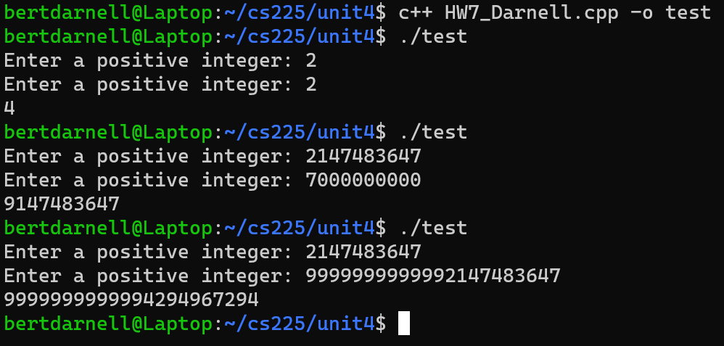
My first testing case was to check to see if basic addition function worked. Then for my second case checked that the overflow worked properly, so I used the max integer size and added 7x10^9. The last case checked to see if the addition could add numbers higher than 10 digits.

