Bert Darnell
Kenneth Dewey
CS225
04/18/23

Unit – HW9

Part 1 Output:
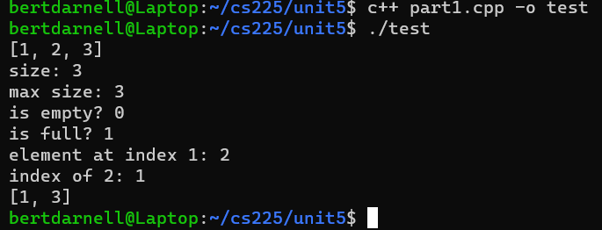

Part 2 Output:
