Bert Darnell
Kenneth Dewey
CS225
04/23/23

Unit 6 – HW10

Part 1 output:
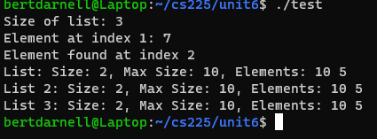

Part 2 output:
