HW10: Project OOP – Dynamic array based class

Part 1
Build a class dynListType based on dynamic array. Its declaration is provided below:

// no more MAX

class dynListType
{
public:

private:
int* dataPtr;
int size;
int maxSize;
};

Follow example in Unit 6 PPT 1 (ch12-ch13 Classes with Dynamic Data), add:
- a (default) constructor with an int param (default value 5) and
- a destructor.

Add those 10 functions from HW9 into dynListType. Be sure to change each occurrence of dataArr (HW9) into dataPtr. Make additional necessary changes.
- getSize()
- getMaxSize()
- isEmpty()
- search()
- at()
- two inserts
- remove()
- operator +
- operator << (output insertion operator)

At this point your program should be able to compile, but may crash during execution. That’s because copy constructor and overloaded assignment are required to handle dynamic data members.

Now add:
- Copy constructor
- Overloaded assignment operator =

Your program should work perfectly now. dynListType provides the same functionality listType (HW9) does, except that dynListType doesn’t have any capacity cap (i.e. there is no MAX for maxSize).
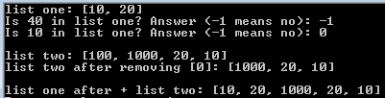

Test your class thoroughly before proceeding to Part 2.

Part 2
Modify your dynListType program from Part 1.
- Overload == operator (comparison operator, as in if (obj1 == obj2) ): return true if two list objects contain the same data items in a same order. Values of maxSize don’t matter. For example, given obj1 {maxSize 10, <10, 20, 30>} and obj2 {maxSize 5, <10, 20, 30>}, the comparison should return true. Given obj3 {maxSize 5, <20, 10, 20, 30>}, (obj1 == obj3) should be false.
- Modify the two insert functions so a list will never be full, like how Java ArrayList and the STL vector class work. Whenever an insertion reaches the maxSize cap, double maxSize, and reallocate storage space. Here is the suggested pseudo code:

If size before insertion is equal to maxSize // current maxSize reached
maxSize <- 2 * maxSize
allocate a new dynamic array with maxSize slots
copy data pointed by dataPtr over to new array
delete the dynamic array currently pointed by dataPtr
let dataPtr point to the newly allocated dynamic array
End if

Insert as normal

Modify your driver accordingly to test the new/modified functions. Here is the output of my sample driver. I hard-coded data in the driver and generate some data using loops. You may do it differently, as long as it tests EACH new/modified function.
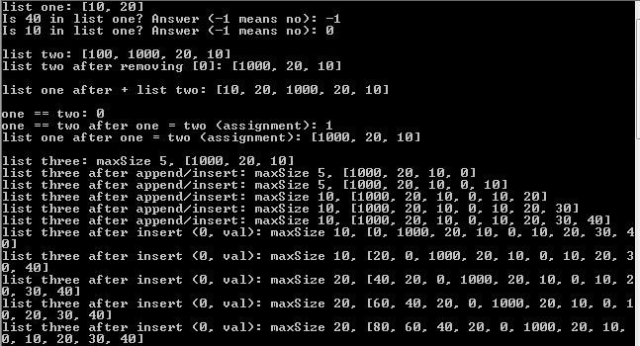

Additional requirements for Part 1 and Part 2
- Organize your program into header file (interface), implementation file, and driver file. Use #include guard with the header file.
- Pre- and Post- condition comments for each new/updated function. Pre- condition may be skipped if the pre-condition is just “xx is initialized” (not requiring any specific values) for value or const reference parameters. Such a prerequisite will be enforced by compiler.

Comment your program appropriately. Pay attention to the standard stuff like coding style, indention, heading, and curly braces.

Submission: 4 files
- In one word/pdf document:
  - Project: Screenshot(s) of execution
- Source code files:
  - One .h and two .cpp at the end of part 2

- Use the rubric below to check the completeness of your work before turning it in.

Rubric: CS225, HW10

Item | Max  (Pts) | Received  (Pts)
Project (55 pts)
Default constructor | 3
Copy constructor | 7
Destructor | 2
Assignment operator | 7
10 functions copied from HW9  -1 pts penalty for each function that doesn’t work properly | 5
== operator (comparison) | 7
Modified insert(int) | 7
Modified insert(int, int) | 7
main: test all new/updated functions | 5
Three file structure with #include guard | 2
Pre- and post- comments on each new/updated function | 2
Your project compiles and runs | 1
Programming style (5 pts)  - File Prologue comments  - Consistent indentation: preferred 2 spaces for each level  - Meaningful names for constants and variables; Proper comments in the program | 1  1  3
Penalty
using namespace std; | (- 6)
Global variable(s) | (- 6)
Missing required screenshot(s) | (- 6)
Total: | 60

- END -

