Appendix
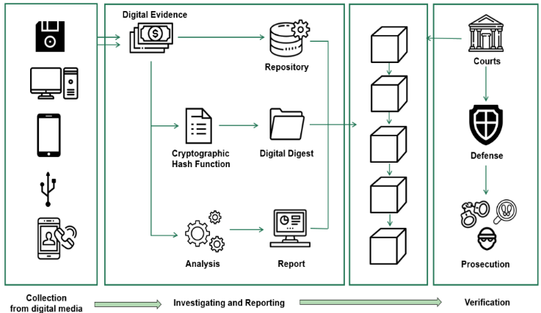
- General framework of blockchain based digital forensic investigation adapted from.

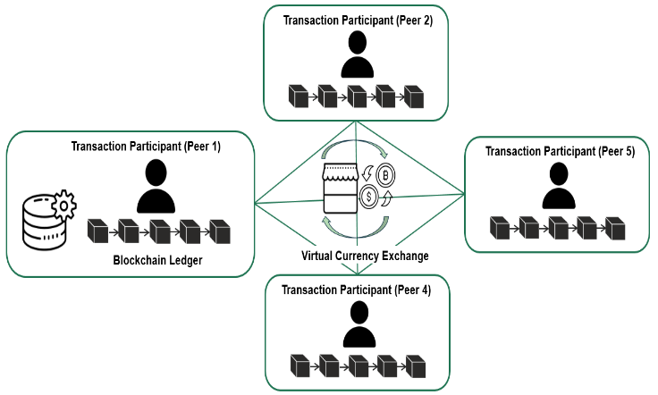
- Conceptual framework of blockchain P2P network.

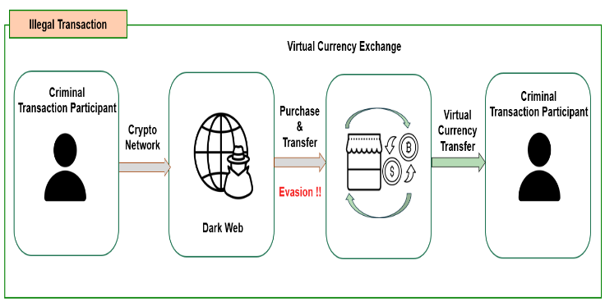
- Typical illegal virtual asset transaction procedure using crawling.

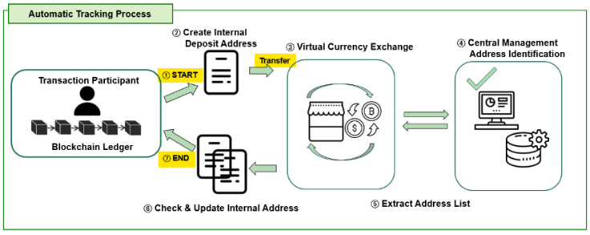
- Proposed automatic tracking process interface of the virtual asset transaction for an illegal transaction.

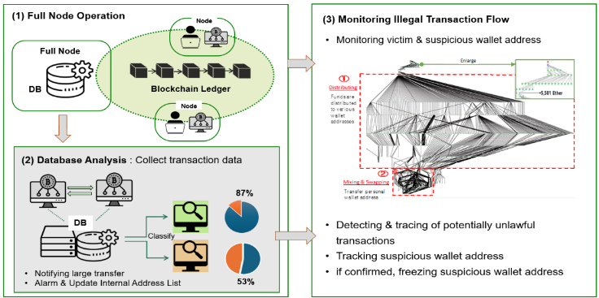
- Architecture of the proposed automatic tracking system utilizing blockchain forensics with three phases.

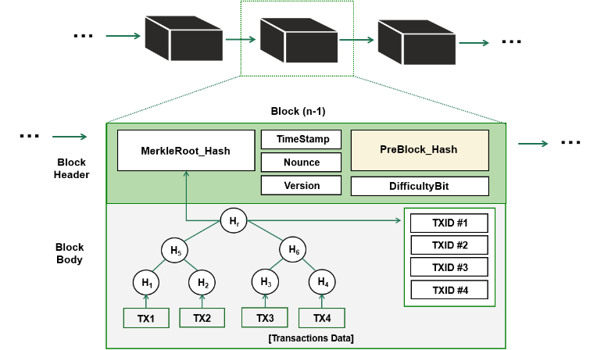
- Operation process of blockchain structure.


- Operation process of transaction date generation and propagation; illustrating transaction propagation of a blockchain network to which a virtual asset illegal withdrawal prevention method.

- A virtual asset flow diagram of the laundering exploited virtual assets.

- A magnified flow diagram of mixing and swapping exploited virtual assets.

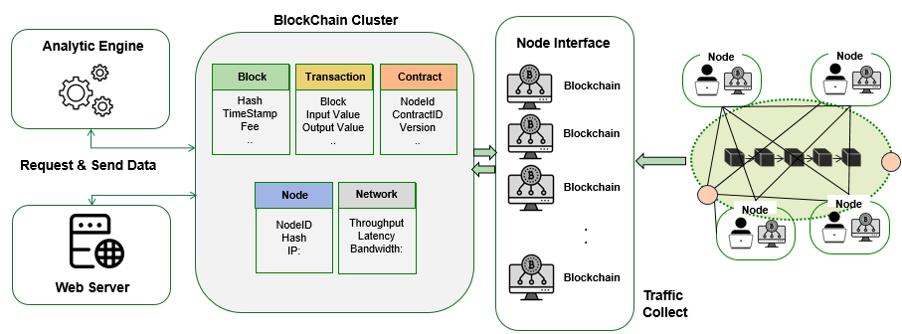
- Structure of Blockchain Cluster for Transaction analysis and monitoring illegal activities.

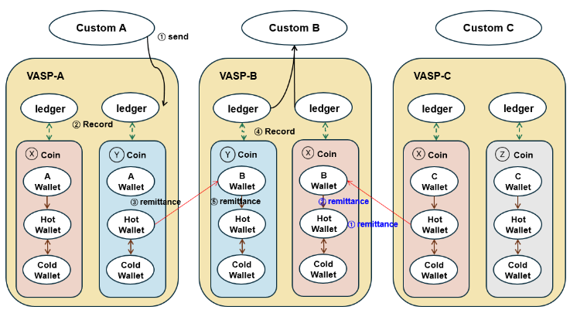
- Transaction between cash and additional virtual assets.

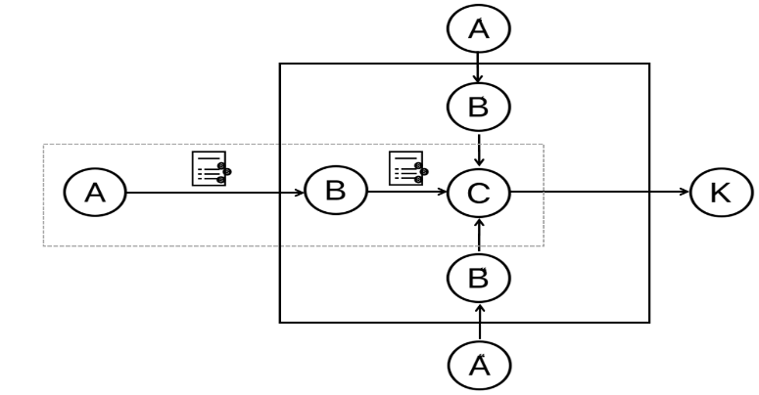
- Automated tracking diagram and process.

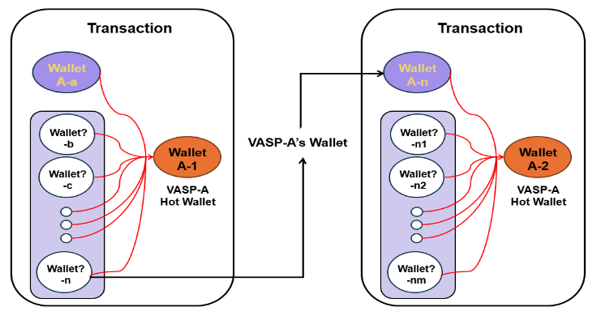
- Automated tracking of heuristic node.

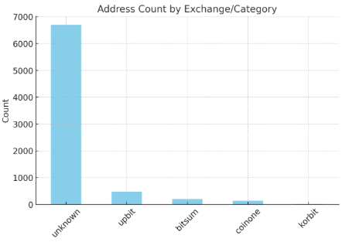

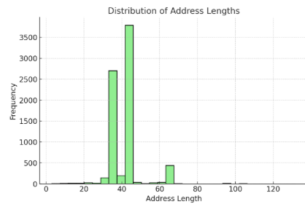

- Automated tracking Case by Heuristic Tracking.

TABLE I
detailed information of comparison function
Feature | Chainalysis | TRM | Qlue
Real-time Monitoring | Yes | Yes | Yes
Transaction Tracking | Comprehensive | Comprehensive | Comprehensive
DRisk assessment | Detailed risk scoring | Detailed risk scoring | Detailed risk scoring
User Interface | Advanced, feature-rich | Advanced, feature-rich | Advanced, feature-rich
Focus Areas | Financial fraud, Money laundering, terrorism | Financial fraud, Money laundering, terrorism | Financial fraud, Money laundering, terrorism
Customization | Extensive with many predefined scenarios | Extensive with many predefined scenarios | Extensive with many predefined scenarios
Integration | Broad integration options | Broad integration options | Broad integration options

TABLE Ⅱ
sample of transaction detail analysis
Time (UTC) | Block | Information Classification | Information
2023-06-29 01:34:14 | 645791 | Transaction ID (TXID) | 46bd4b8936bf1edd99fcee8a32095b94ad25bd40e264a4eed0e74ba09a4c9671
 |  | Sender Address | 1EYwhBkaTXgT8BHobHEN4me5FCin3t8jbh
 |  | Recipient Address | 1P781nj85kxwdGhvnhL6ZJmc8NzdrM4qdz
2023-06-29 01:34:14 | 645791 | Transaction ID (TXID) | c5f5a70ba9011aa09aa22ca9687f0b9a806aa027900c12918147eeeb3465f6c0
 |  | Sender Address | 1P781nj85kxwdGhvnhL6ZJmc8NzdrM4qdz
 |  | Recipient Address | 1LTbKwz1Hnm8hVeJVFVFG3Hi8EtsAugRUR
2023-08-05 09:20:13 | 646811 | Transaction ID (TXID) | f0d9c9e6764316a307de7db967ede18641dbb52d059caafb850c699b56453081
 |  | Sender Address | 18bu6CsxdFucLVvyryYhSt6NeEhFCckRf
 |  | Recipient Address | 1P781nj85kxwdGhvnhL6ZJmc8NzdrM4qdz
2023-08-05 09:20:13 | 646811 | Transaction ID (TXID) | fba54fa4433ea9d6620d3a0ed2aa464ad991c9048c25c1ea719c396fb31d6281
 |  | Sender Address | 1P781nj85kxwdGhvnhL6ZJmc8NzdrM4qdz
 |  | Recipient Address | 32FYp7cntbYfJQVvF356DhypREcREXeqV1

TABLE Ⅲ
Detailed information obtained from the case of exploiting the virtual assets
Classification | Details
Transaction ID | 0xca4e0aa223e3190ab477efb25617eff3a42af7bdb29cdb7dc9e7935ea88626b4
Date and Time (KST) | 2019-11-27 13:06:41
Sender’s wallet address (victim’s address) | 0x5e032243d507c743b061ef021e2ec7fcc6d3ab89
Recipient’s wallet address (suspect’s address) | 0xa09871aeadf4994ca12f5c0b6056bbd1d343c029
Amount | 342,000 Ether
Verifying URL | https://etherscan.io/tx/0xca4e0aa223e3190ab477efb25617eff3a42af7bdb29cdb7dc9e7935ea88626b4

