# INFO 153 – Final Project

**Name of Team:**

SLWCbest

**Team Members (Lastname, Firstname):**

1. Shi Bowen
2. Liu Yunong
3. Wang Qi
4. Chao Zichen

**Problem Chosen (Major or Activity):**

Activity

**Name of Product:**

actHunter

**URL of Product:**

**Github URL of Code:**

<https://github.com/berwen/FinalProjectFori153>

**Product Discovery and Development:**

Create a list of all steps your team went through to complete the final project (e.g. definition of problem, initial user interview, brainstorming of potential solutions, etc.)

Additionally, list the responsibilities each of the team members had for each step. Please indicate whether a specific member or the team as a whole has completed that step:

1. We choose the Problem about Activity.

2. We ask ourselves for question:

(1)What problem exactly are you trying to solve?

Ans:

1) Some students feel bored, but do not know the day's activity arrangements, and do not know what activities they can participate

2) Many activities released through various channels, causing students to miss some interesting activities.

3) Event organizers in the campaign, it tends to be a lot of poster printing, but also posted everywhere, which cost a lot manpower and resources. Through this platform, the organizers can quickly and simply publish event information, and to collect information on applicants.

(2)Who exactly are you trying to solve this problem for?

Ans:

Students who want to participate in extracurricular activities, but do not know where to find information and the event organizers who want to post the information

(3)What are the goals you are trying to satisfy with this product?

Ans:

Help university students to find the extracurricular activities easily and event organizers post their activities with less effort.

(4)What is the relative priority of each goal? (if multiple)

Ans:

1. display the activities
2. event organizers can post events
3. participant can sign up
4. search events by different tags
5. share event information to social network

3. develop Persona

(1)**Name:** Petter

**Gender:** male

**Location (City, Country):**Berkeley

**Profession (education, current position):**EE

**Computer Skills:** skilled user of internet

**What is this person's problem (story):**

Petter is always stay at home because he is busy with his course and don’t know where to find interesting events, but he really want to participant in some event to make more friends.

**Why is this problem for the person?**

He don’t have time to hung around campus to find posters

**What goal does the person have?**

Find the interesting event with least time

**What would the person value most / what would make the person really excited?**

A website that can help him to find interesting event in shortest time

(2) **Name:** Betty

**Gender:** female

**Location (City, Country):** Berkeley

**Profession (education, current position):** economy

**Computer Skills:** skilled user of internet

**What is this person's problem (story):**

Betty want to hold a debate competition, she want more people know it. But there is not enough people to help her to advertise this competition.

**Why is this problem for the person?**

She doesn’t have enough people to advertise this event.

**What goal does the person have?**

Advertise her event with least people

**What would the person value most / what would make the person really excited?**

She just need to type information in our website and people will know this event

1. Because we are users, so we don’t do feedback on persona.
2. Brainstorm potential solutions.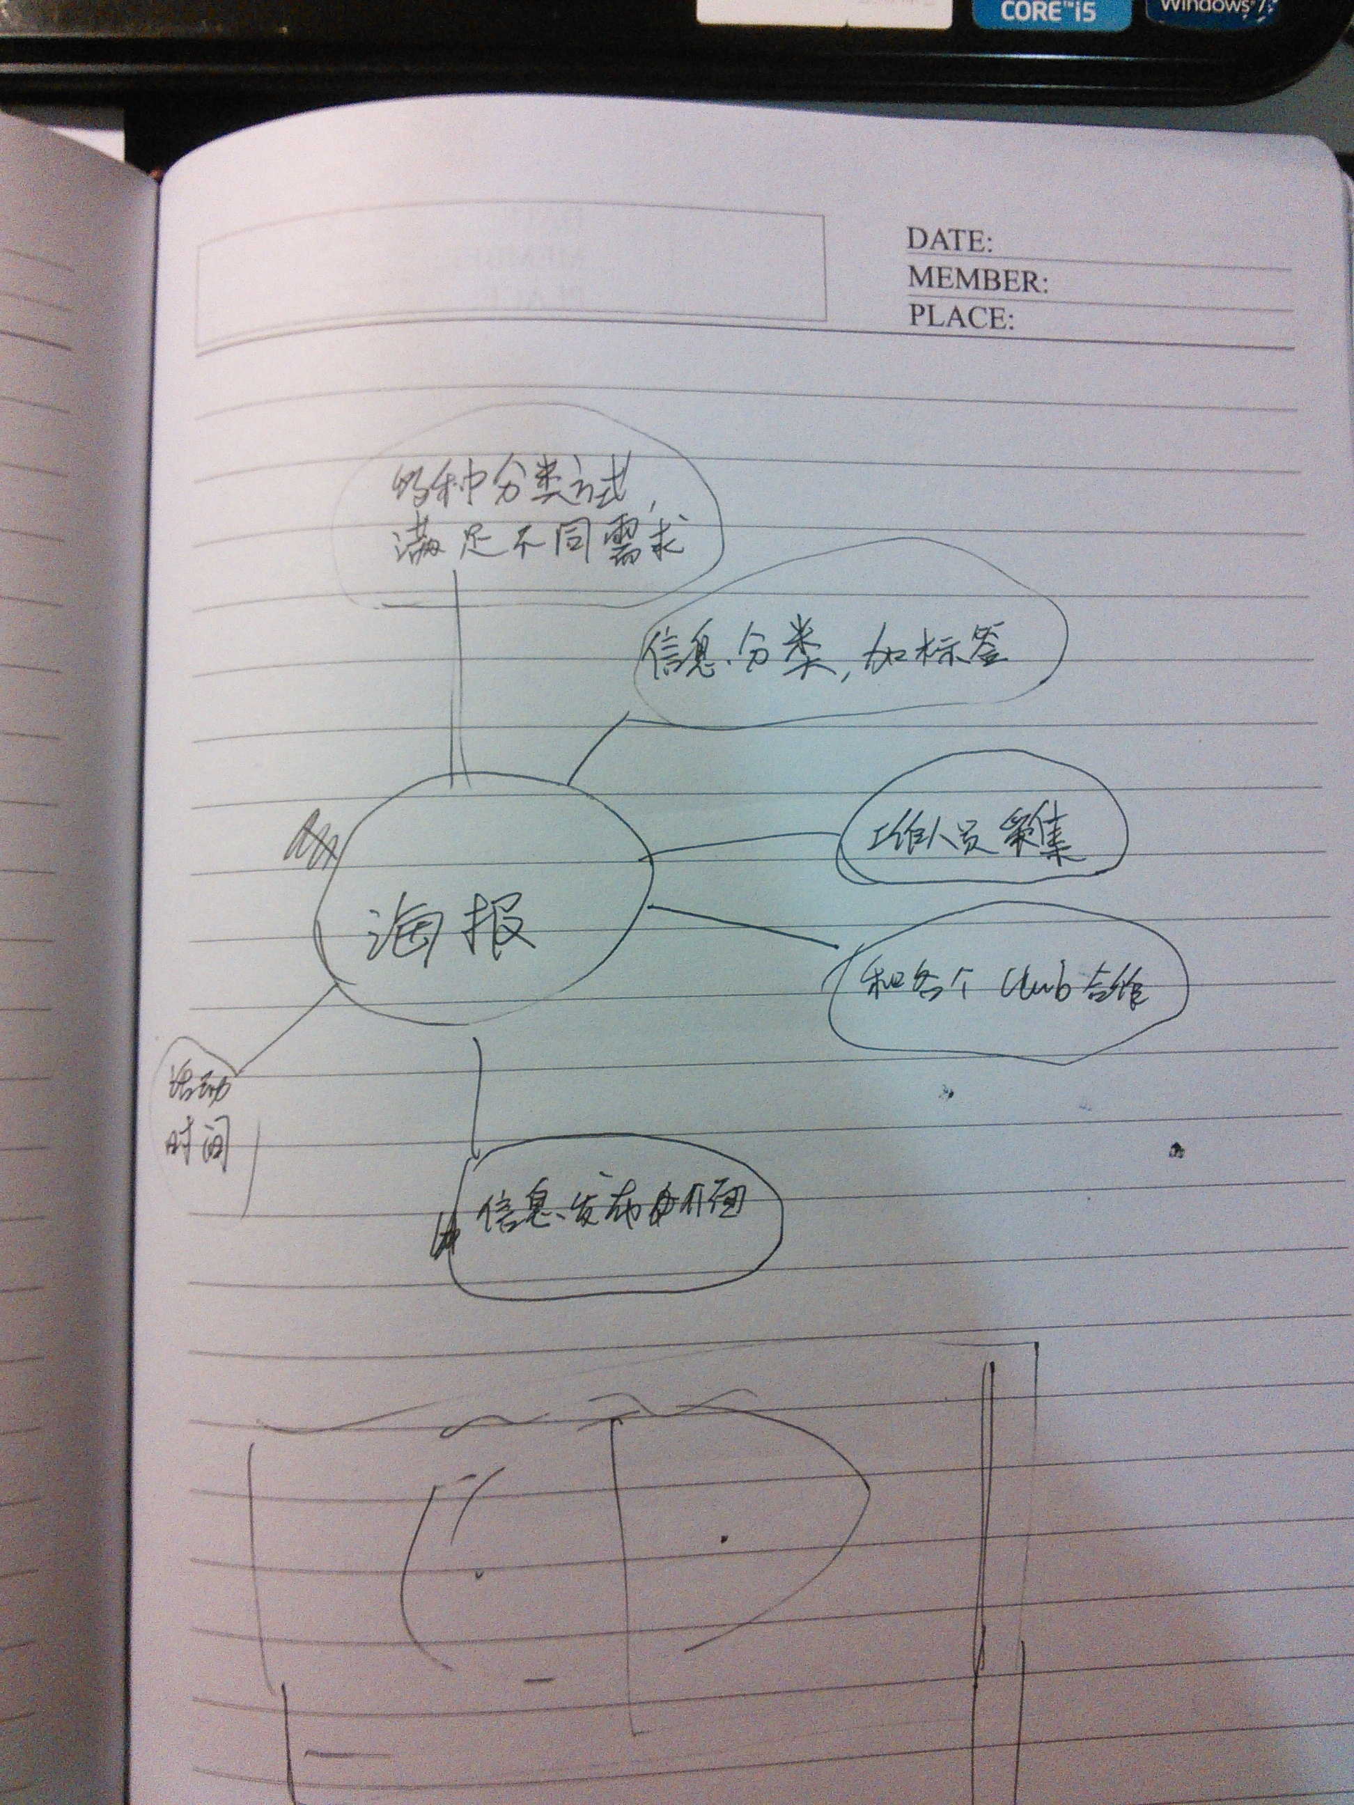

7. Then we start to draw storyboard and prototype.

8.We user story board and prototype to get feedback on-line(by QQ ) and off-lineBusiness Idea

Please provide a description of the problem you are trying to solve (be specific), what target users you are addressing (use your persona) and for what reason this is a problem worth solving. Try to limit your response to 200 words or less:

## Ideation Process

Please describe in detail a) what process you went through in order to find a suitable solution for the problem above, b) what options you traded off (did you consider multiple solutions?) and c) what response you received from users.

Do not talk about the solution itself; focus on the process and user feedback. Feel free to add quotes or insights from users. Try to limit your response to 300 words or less:

## Solution

Outline in-depth what solution you came us with. Please provide a) an overview what your solution does using the storyboard, b) how a user would use your solution, c) what design tradeoffs you made, and d) what user input you received

Please describe a) and b) only briefly, and c) and d) in detail. Try to limit your response to 200 words or less:

## Implementation

Give a quick overview of a) how you implemented the product, b) how you organized your code, c) and what functionality it includes. Please also describe functionality that you hard coded such as user login.

Try to limit your response to 200 words or less:

## Hypothesis and Metrics

Please define your Value and Growth Hypothesis. For each of the hypothesis, describe what metric you will use to track how successful the product is and at what point (time, value) you know you are on the right track.

Value Hypothesis:

Metric:

Threshold:

Growth Hypothesis:

Metric:

Threshold: