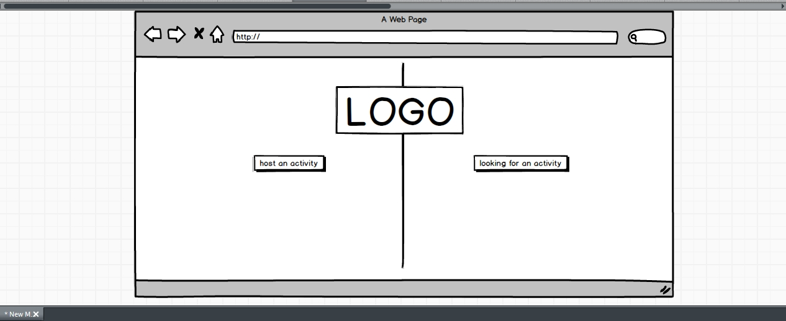

G1

This is home page, if you want to host an activity, you click left button then go to G2; if you want to find a activity to join in, click right button ,then go to G3.

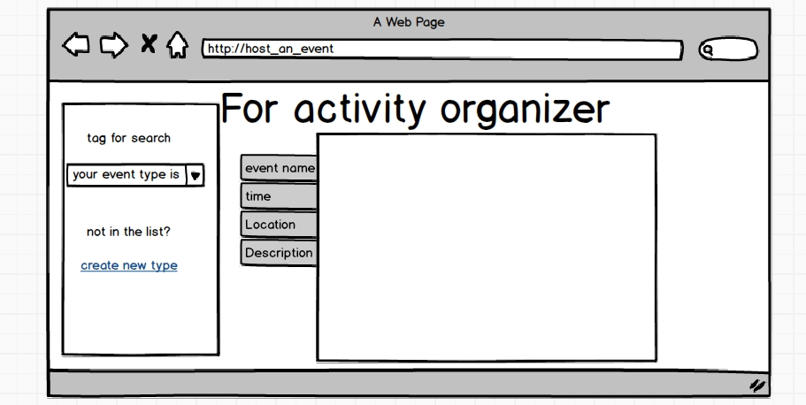

G2

Organizer use this page to post a activity, and this activity will appear on the activity list.

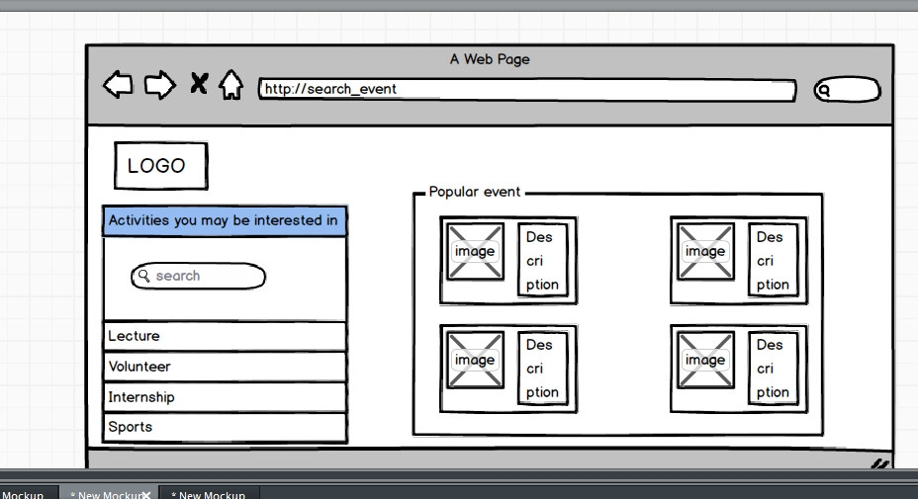

G3

This is activities list, you can find activity here. And if you want to see detail, just click the image. Then go to G4.

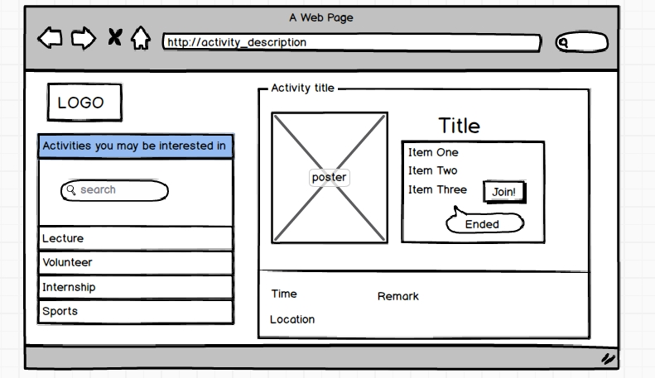

G4

This is activity detail page. If you are interested in it , just click Join if you are registered users.