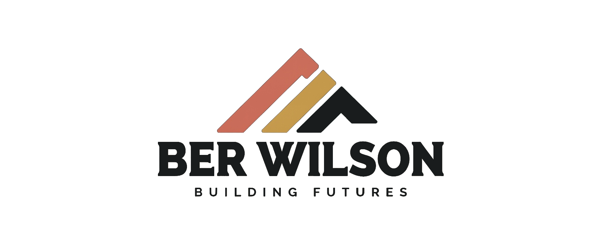
MIRA VISTA
PREFAB STEEL FRAMING QUOTE
PROJECT | QUOTE INFORMATION
Location | 500 South 1040 East, American Fork, Utah
Owner | Four Amigos Development, LLC
Building | 44,400 square feet • 3 floors
Conversion | Wood framing converted to engineered prefab steel panels
Estimator | Ericson Tua’one
Contact | info@berwilson.com • 385-436-5507
Quote date | September 16, 2026

BUILD FASTER WITH PREFAB STEEL
The framing arrives as coordinated, labeled prefab steel panels. If Ber Wilson installs the system, the anticipated panel-installation duration is 4–6 weeks versus approximately four months for standard wood framing.

BER WILSON TURNKEY QUOTE
$2,131,200 — includes engineering conversion, MEP channeling, all defined prefab framing materials, insulation within the panels, builder’s risk, and Ber Wilson installation at $15.00 per square foot, including framing equipment and crane.

Quote Price
Scope | Area | Rate | Amount
Engineering conversion and complete prefab panel material package | 44,400 SF | $33.00/SF | $1,465,200
Ber Wilson installation, equipment, and crane | 44,400 SF | $15.00/SF | $666,000
TOTAL TURNKEY QUOTE | 44,400 SF | $48.00/SF | $2,131,200

Included in Turnkey Quote
- Engineering conversion of the existing wood-framed plans into an engineered cold-formed steel prefab panel system.
- Panel engineering, framing layouts, fabrication drawings, connection details, and coordinated panel schedules.
- MEP engineering and channeling integrated into the panels, including service chases, pathways, prepunched holes, sleeves, openings, inserts, and penetrations for MEP routing.
- Concrete-to-steel coordination for embeds, anchors, hold-downs, bearing points, and panel connections.
- Complete defined prefab steel framing material package for approved wall, floor, and roof panels, including tracks, clips, bridging, blocking, bracing, fasteners, and required accessories.
- Insulation furnished and installed within the prefab panel assemblies according to the approved panel schedule.
- Simpson Strong-Tie branded hold-downs, straps, anchors, fasteners, and structural connectors included in the approved framing scope.
- Builder’s risk included.
- Ber Wilson field installation at $15.00 per square foot, including framing-specific lifts, telehandlers, rigging, material handling, crane, operator, panel hoisting, assembly, bracing, fastening, and erection.
PANEL DELIVERY
Wall, floor, and roof framing will be fabricated and delivered as labeled, sequenced panels or panelized assemblies according to the approved fabrication package.

Schedule Comparison
Measure | Ber Wilson prefab installation | Standard wood framing
Field framing duration | 4–6 weeks anticipated | Approximately 4 months
Projected advantage | Approximately 2.5–3 months faster | Baseline
MEP field time | 40%–50% projected reduction | Field layout/cutting baseline
Site work | Panel setting and connections | Field measuring, cutting, and assembly

SCHEDULE BASIS
The 4–6 week timeframe applies when Ber Wilson performs installation and assumes approved drawings, timely material release, complete concrete work, clear crane access, sequenced deliveries, timely inspections, and uninterrupted work areas.

Delivery Options
The prices below separate the turnkey Ber Wilson installation from the Owner-installed option. Materials with crew training are to be quoted after Ber Wilson reviews the Owner’s crew, equipment plan, schedule, supervision needs, and requested field support.
Option | Scope | Price
A — Ber Wilson turnkey installation | Engineering conversion, complete prefab panel materials, builder’s risk, equipment, crane, and Ber Wilson installation. | $2,131,200
B — Materials + Owner-crew training | Engineering conversion, complete prefab panel materials, training, installation planning, and agreed field support so the Owner’s crew can install. | TBQ
C — Separate Ber Wilson installation | Installation requested separately from the material/training package; equipment and schedule confirmed at quote. | $15.00/SF, subject to final scope
D — Wood-frame alternate | Separate wood-framing quotation for comparison. | TBQ

OWNER-CREW INSTALLATION — TBQ
The materials-and-training option is not priced in this quote. Ber Wilson will issue a separate TBQ proposal identifying the material package, training days, trainer count, on-site technical supervision, travel, crane/equipment responsibility, crew qualifications, installation schedule, and quality-control responsibilities.

BER WILSON INSTALLATION
If Ber Wilson installs, the rate is $15.00 per square foot, totaling $666,000 for 44,400 square feet. The price includes framing installation equipment and crane, with an anticipated 4–6 week prefab steel panel-installation timeframe.

Exclusions
- MEP equipment, fixtures, ductwork, piping, conduit, wiring, controls, rough-in, installation, testing, balancing, and commissioning. MEP engineering and panel channeling are included; MEP construction is excluded.
- Concrete materials, reinforcement, formwork, placement, finishing, foundations, slabs, walls, and concrete labor. Concrete interface coordination is included.
- Exterior cladding and finishes, including siding, masonry veneer, stucco, exterior metal panels, rainscreen, trim, flashings, and coatings.
- Drywall, gypsum board, taping, mudding, sanding, texture, painting, and interior finishes. These may be quoted separately.
- Roofing, waterproofing, weather-resistive barriers, glazing, windows, doors, storefront, sealants, and firestopping unless specifically listed.
- Sitework, demolition, excavation, utilities, paving, landscaping, stairs, rails, canopies, finish carpentry, and structural steel outside the prefab package.
- Insulation outside the prefab panels, permits, fees, taxes, bonds, testing, special inspections, project-wide temporary services, extraordinary crane access, and abnormal site conditions.

Payment Terms
PREFAB MATERIALS
100% of the prefab material amount is due upon receipt of invoice and before fabrication or material release. Fabrication begins after cleared funds and approved production documents.

Ber Wilson installation milestone | Percent | Amount
Contract execution / mobilization | 50% | $333,000
50% framing completion | 25% | $166,500
90% framing completion | 20% | $133,200
Successful completion and framing inspection | 5% | $33,300
TOTAL INSTALLATION | 100% | $666,000
The materials-and-training option will have separate payment terms in the TBQ proposal.

Quote Terms
- Quote valid for 30 calendar days and subject to final plans, approved engineering conversion, final takeoff, schedule, site review, and executed agreement.
- Changes, concealed conditions, incomplete concrete, inaccurate anchors, restricted access, abnormal weather, overtime, trade interference, or remobilization may adjust price and schedule.
- Fabrication begins after required approvals, production documents, and material payment are received.
- Materials with Owner-crew training, drywall, cladding, MEP construction, concrete construction, and wood framing require separate written quotes.

Acceptance
TOTAL BER WILSON TURNKEY QUOTE
$2,131,200

CLIENT ACCEPTANCE | BER WILSON
Company: Four Amigos Development, LLC | Estimator: Ericson Tua’one
Name: ______________________________ | Email: info@berwilson.com
Title: _______________________________ | Phone: 385-436-5507
Signature: ___________________________ | Signature: ___________________________
Date: _______________________________ | Date: _______________________________
Requested option: ☐ Ber Wilson turnkey installation ☐ Materials + crew training (TBQ) ☐ Wood-frame alternate (TBQ)

