Reference:

**This assignment is a continuation of the previous assignment.**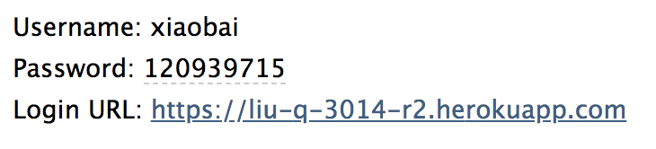

**After user got this email of password the users can use the URL to login their account.**

**This homework totally revised 6 main documents on the basis of the previous one, each of them are:**

1. **Moviesdetalis.php**

**After users login the system, they will see the movies they can search, and the details of the movie, like name, cover picture, country etc.**

1. **Addmovie.php and admin_addmovies.php**

**This documents allow admin to add movies of the system and use this page to add movie.**

1. **Deletemovie.php and admin_deletemovie.php**

**This documents allow admin to delete movies of the system.**

1. **Showallmovie.php**

**This documents will shows the movies details like name, country etc. after admin delete one or more movies. It will looks like a control panel of the content.**

The overall database idea:

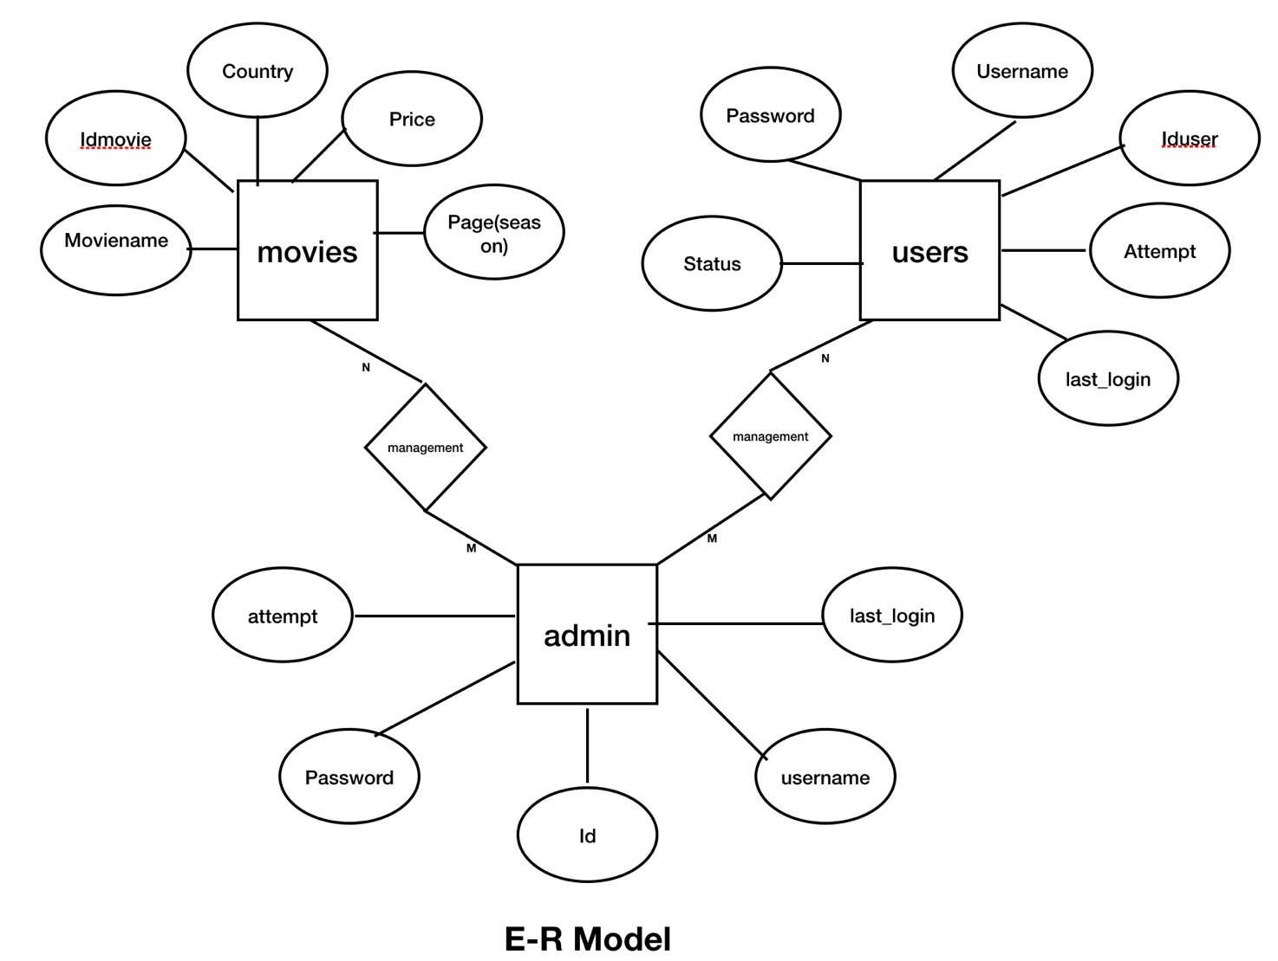

Allows admin and users check the movies from the mysql database of the website.

**http://php.net/manual/en/mysql.php**

[**http://www.php.net/manual/zh/reserved.variables.post.php**](http://www.php.net/manual/zh/reserved.variables.post.php)

**http://php.net/manual/zh/reserved.variables.get.php**

**https://blog.csdn.net/ParanoidYang/article/details/66614605**

Tutorials:

[**https://www.youtube.com/watch?v=Pz5CbLqdGwM**](https://www.youtube.com/watch?v=Pz5CbLqdGwM)

**https://www.youtube.com/watch?v=b95bJtgCTog&list=PLnWrVWj1APWsYsc1tQoIjraaB10CRsjBr**

**https://www.youtube.com/watch?v=QNxU3Qa6QZs&t=199s**