Reference:

demo url:

https://liu-q-3014-r2.herokuapp.com/

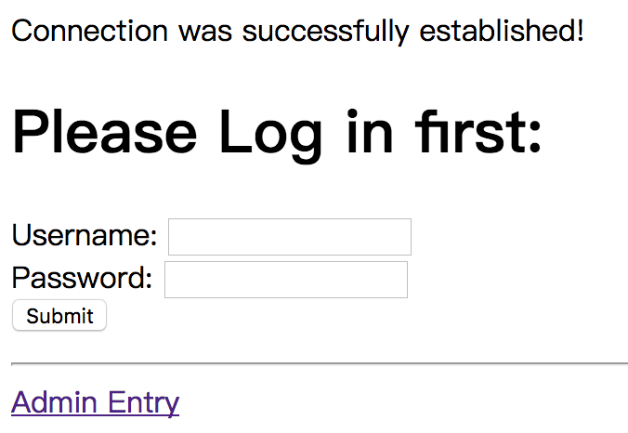

Click Admin Entry

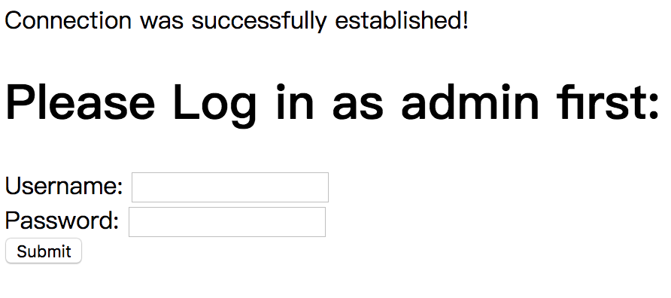

Use username admin and password admin login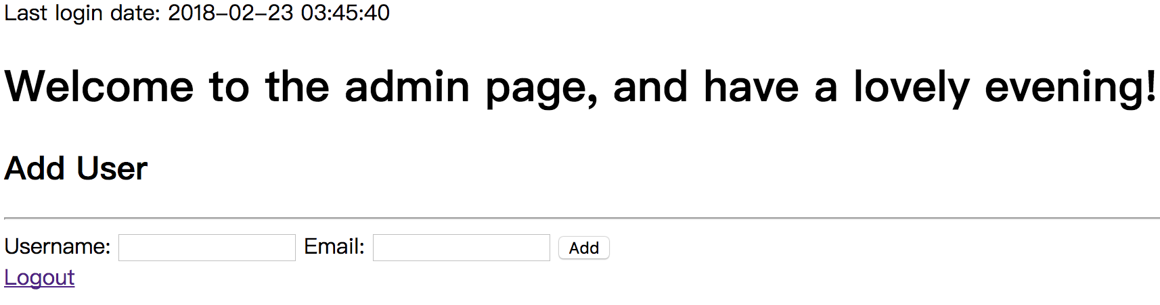

This page can be used to add users. After adding the new user, the username and password will send to the email user left in 5 min.

Allows admin to login and create a new user:

http://php.net/manual/en/function.mt-rand.php

<http://php.net/manual/en/function.openssl-random-pseudo-bytes.php>

After new user is created an email is sent letting them know their username, password and url to login：

<https://sendgrid.com/>

New users password is generated by the system not the admin：

http://php.net/manual/en/refs.crypto.php

<http://php.net/manual/en/ref.password.php>

<http://php.net/manual/en/function.password-verify.php>

New users generated password is encrypted and stored in the database：

<http://php.net/manual/en/book.math.php>

<http://php.net/manual/en/function.mt-rand.php>

Tutorials:

<https://www.youtube.com/watch?v=aIsu9SPcGbU>

<https://www.youtube.com/watch?v=xb8aad4MRx8>

<https://www.youtube.com/watch?v=C--mu07uhQw>

<https://www.youtube.com/watch?v=Na_Y0qYPSE0>

<https://www.youtube.com/watch?v=U7futvzivRo>

<https://www.youtube.com/watch?v=cKUZhjlvOT8>

<https://www.youtube.com/watch?v=JVy0JpCOuNI>

<https://www.youtube.com/watch?v=mf5rM3SP-hg>

<https://www.youtube.com/watch?v=ZHg-h7bZhbo>

<https://www.youtube.com/watch?v=LJJXCni8mNc>

<https://www.youtube.com/watch?v=YhCUMIsqI1E&index=18&list=PLfdtiltiRHWGKUvioJly40RJZchSG2-34>

<https://www.youtube.com/watch?v=AEUGb09ohbI&index=33&list=PLfdtiltiRHWGKUvioJly40RJZchSG2-34>