Reference:

**This assignment is a continuation of the previous assignment.**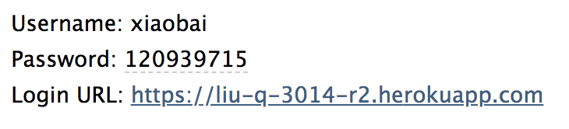

**After user got this email of password the users can use the URL to login their account.**

**This homework totally revised two documents on the basis of the previous one, each of them are:**

1. **login.php**

**Setup the user login page, and check the DateTime.**

**If the user is already login in then the website will shows welcome page.**

**If the time in last_login is a new date, the jump to the page edit_user page and ask them to change their password( send them to the page change their password).**

**And use function fetch_object takes a row from the result set of attempt as the object, and link with data_add function what set in 48 hours to check of the user account status.**

1. **edit_user.php**

**This documents allow users login and edit their account and if users are first time login then they will jump into this page to change the password.**

Allows user to login and edit their account and when new user logs in for the first time they are sent to edit their account, skipping the admin page.

**<http://php.net/manual/en/datetime.add.php>**

**<http://php.net/manual/en/class.datetime.php>**

**<http://php.net/manual/en/dateinterval.createfromdatestring.php>**

**<http://php.net/manual/en/function.password-verify.php>**

New user has a time limit to log in after their account has been created. If they do not login before the time expires their account is suspended.

**<https://www.w3schools.com/php/func_mysqli_fetch_object.asp>**

Allows user to login and edit their account。

**<http://php.net/manual/en/ref.password.php>**

**<http://php.net/manual/en/function.password-verify.php>**

**<http://php.net/manual/en/function.password-needs-rehash.php>**

Tutorials:

**<https://www.youtube.com/watch?v=Pz5CbLqdGwM>**

**<https://www.youtube.com/watch?v=xb8aad4MRx8>**

**<https://www.youtube.com/watch?v=Na_Y0qYPSE0>**

**<https://www.youtube.com/watch?v=U7futvzivRo>**