ROBOFEST EGYPT 2026 · EXHIBITION SENIOR
Souly
Source code documentation for judge review
An AI study companion for children with learning differences. Souly teaches from the real Ministry of Education textbooks, gives hints instead of answers, and reports what a child actually did to both their teacher and their parents.
COMPLETE SOURCE CODE
github.com/beshoywael-him/souly-backend

TEAM | Heliopolis Robocards |   Scan to open the repository
TEAM NUMBER | 404
CATEGORY | Exhibition Senior
SUBMISSION | Requirement 3 — source code for judge review
LANGUAGE | Python 3.12 · JavaScript · SQL
SIZE | 87 files · 30,463 lines · 206 automated tests
SUBMITTED | 28 August 2026
CONTENTS

What is in this document
Souly is 30,463 lines across 87 files. Printing all of it would be unreadable, so this document is a guided tour: the structure of the codebase, the technologies behind each layer, and thirteen extracts of the actual source chosen because each one shows a decision we made and why. The complete code is at the address on the cover.
 | SECTION | WHAT IT COVERS
1 | What Souly is, and how the parts fit together | System overview and the three zones
2 | How the files are organised | Every folder, what it holds, and why
3 | Tools and technologies | What we chose, and what we rejected
4 | Following one request through the system | A quiz answer, from tap to database
5 | The code, with commentary | Thirteen extracts from the repository
5.1 | The database layer | app/db.py
5.2 | The flag lifecycle as data | app/models.py
5.3 | Receiving a classroom detection | app/routers/flags.py
5.4 | Refusing an illegal move | app/routers/flags.py
5.5 | One writer for every number | app/economy.py
5.6 | Finding the right page of the book | app/services/rag.py
5.7 | Canon, rendition and path | app/services/tutor.py
5.8 | Why Souly never gives the answer | app/services/llm.py
5.9 | What happens when the network fails | app/services/llm.py
5.10 | Security sized to the user | app/routers/auth.py
5.11 | The front end holds no truth | static/student/api.js
5.12 | The test that protects the demo | tests/test_learning.py
5.13 | The whole suite, running | 206 tests in five seconds
6 | Database design | 41 tables, seven migrations
7 | How we write and check our code | Conventions, comments, 206 tests
8 | What runs today, and what is still ahead | An honest scope statement
9 | Running the system yourself | Setup, in order
10 | Complete file inventory | All 87 files with line counts

How to read the code extracts
Every extract in section 5 is a screenshot of the real file, with the file path and the exact line numbers shown in the header bar. Nothing has been retyped, shortened or tidied for this document — if an extract shows lines 146 to 192 of app/routers/flags.py, those are the lines you will find at that path in the repository. Comments are shown as they are written in the source, because how the code is commented is part of what is being submitted.
A NOTE ON WHAT IS NOT HERE
The classroom computer-vision code is owned by a separate team and lives in a separate repository. This document covers the backend, the two front ends, the database and the tests.
SECTION ONE

1 What Souly is, and how the parts fit together
Souly closes a loop that no existing product closes: a child’s difficulty is noticed at school, re-taught at home the same evening, and the result is visible to their teacher and their parents. Three zones, one database, one contract between them.
MEASURE | VALUE | MEASURE | VALUE
Lines of code | 30,463 across 87 files | Database tables | 41 and 9 views
API operations | 83 on 77 paths | Automated tests | 206 all passing
Textbook pages | 106 from 2 Ministry books | Lessons mapped | 14

1.1 The three zones
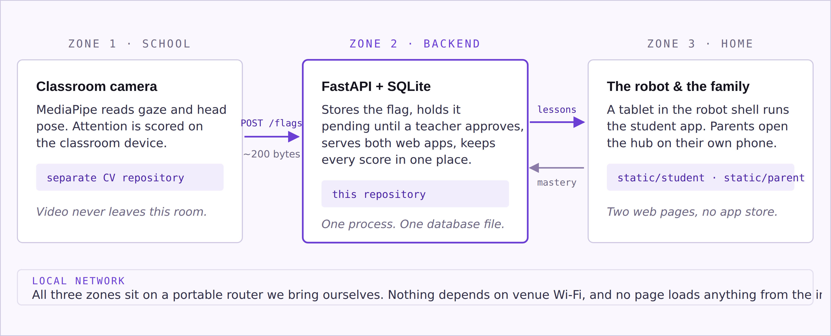
FIG 1 The system in three zones. The contract between zone 1 and zone 2 is deliberately tiny — a small JSON event, never an image — which is what lets us promise that video never leaves the classroom.

1.2 What each part is responsible for
PART | RESPONSIBILITY | WHERE IT LIVES
Classroom vision | Scores attention from the camera and publishes a small flag event when focus drifts past that child’s threshold. | separate repository
Flag spine | Receives flags, filters noise, holds them pending, records every state change. | app/routers/flags.py
Curriculum library | Maps each lesson to its pages in the real Ministry PDFs and reads the page text at study time. | app/services/curriculum.py
Tutor | Writes the explanation for this page for this child, and runs the four-step hint ladder. | app/services/tutor.py
Economy | The only code allowed to change a child’s stars, XP, level or mastery. | app/economy.py
Student app | Ten screens the child uses, drawn entirely from live API data. | static/student/
Parents’ hub | Progress, teacher notes and messaging, scoped strictly to that parent’s own children. | static/parent/
SECTION TWO

2 How the files are organised
The repository has one rule behind its shape: a file should be findable from the thing you want to change. If you want to change what a screen looks like you open a page file; if you want to change what a star is worth you open one constants block; if you want to add a table you add one migration file.
FOLDER | FILES | LINES | WHAT IS IN IT
app/ | 28 | 10,627 | The backend. Config, database access, the economy, eleven routers and six services.
static/ | 13 | 8,304 | Both front ends — the student app and the parents’ hub — as plain HTML, CSS and JavaScript.
tests/ | 8 | 3,763 | 206 automated tests plus two scripts that drive the app in a real browser.
scripts/ | 16 | 3,178 | Setup and operations: database creation, seeding, textbook ingest, key checks, the demo walkthrough.
schema*.sql | 7 | 2,184 | The database, as seven migrations applied in order.
docs/ | 6 | 1,823 | The stack decision record, the curriculum guide and the integration contract for the vision team.
data/curriculum/ | 3 | 134 | The two Ministry PDFs and the human-approved map of lesson to page.
(root) | 6 | 450 | README, requirements, and the launch scripts for Windows, Linux and HTTPS.
Counts exclude generated caches. The full per-file listing is section 10.

2.1 Inside app/
FILE | LINES | PURPOSE
main.py | 118 | Registers the eleven routers, serves both front ends, runs the migrations on start-up.
config.py | 125 | The only file in the project that reads environment variables.
db.py | 134 | Opens SQLite with foreign keys and WAL on. Extract 5.1.
models.py | 215 | The request and response shapes for the flag API — the contract three teams share. Extract 5.2.
economy.py | 557 | Stars, XP, levels, streaks, badges, mastery. Extract 5.5.
security.py | 58 | PBKDF2 hashing for parent access codes and picture passwords.
deps.py | 47 | Resolves a student from the URL, or returns 404 — used by every student route.
onboarding_items.py | 323 | The entry activity’s items and their fixed prompt ladders.
routers/learning.py | 1,217 | Subjects, the lesson plan, lesson pages, practice generation, quizzes.
routers/parent.py | 965 | The whole parents’ hub API.
routers/onboarding.py | 498 | The one-time activity that learns how a child likes things explained.
routers/tutor_api.py | 426 | Chat, hints, re-explain, and the one-request voice loop.
routers/gamification.py | 423 | Games, the rewards shop, badges, the daily challenge.
routers/flags.py | 375 | The classroom spine. Extracts 5.3 and 5.4.
routers/auth.py | 357 | The face picker and picture password. Extract 5.10.
routers/student.py | 316 | Profile, the home screen in one call, settings.
routers/parent_auth.py | 303 | Parent sign-in, with its own separate token table.
routers/progress.py | 179 | The progress dashboard, derived entirely from the activity log.
routers/health.py | 49 | One call that reports whether keys are present and curriculum is loaded.
services/tutor.py | 1,967 | Explanations, hints, question generation. Extract 5.7.
services/llm.py | 886 | The Gemini client and the offline fallback. Extracts 5.8 and 5.9.
services/curriculum.py | 437 | Reads the real textbook pages from disk; renders and extracts them at ingest time.
services/tts.py | 251 | Text to speech behind a swappable provider interface.
services/rag.py | 250 | Finds the most relevant textbook page for a question. Extract 5.6.
services/stt.py | 147 | Speech to text through ElevenLabs.
SECTION THREE

3 Tools and technologies
Every choice below was made against the same two constraints: eight students had to be able to read each other’s code, and the whole system had to run on a laptop and a portable router with no internet. Several times that meant choosing the less powerful option on purpose.
LAYER | WHAT WE USE | WHY THIS, AND WHAT WE REJECTED
Language | Python 3.12 | Not the newest release. MediaPipe, which the vision team needs, supports 3.9 to 3.12 only — so the whole team pins to the version the hardest dependency allows.
Web framework | FastAPI + Uvicorn | Chosen partly for /docs: FastAPI generates a live, clickable API page from the code itself, so a teammate can test an endpoint without writing a client. That page is also how we hand the API to the interface squad.
Database | SQLite, raw SQL | One file, no server to install or start, nothing to go wrong at a venue. Rejected: SQLAlchemy and every other ORM — an ORM would hide the SQL, and on a team learning databases this term the SQL is the part we want visible.
Front end | Plain HTML, CSS, JavaScript | Rejected: React and any build step. No npm install, no compilation — edit a file, refresh the browser. Any member can contribute on day one instead of spending a week on a toolchain.
Reasoning | Gemini 2.5 Pro | Called over its plain REST API with httpx. Rejected: the official SDK — one less package to install at a venue, and the request stays visible in our own file where we can debug it.
Retrieval | Our own TF-IDF search | Roughly a hundred textbook pages is small. Rejected: ChromaDB with sentence-transformers — a vector database and a downloaded model would add setup and offline risk for no measurable gain at this size. The interface is written so we can swap the search without touching anything that calls it.
Speech in | ElevenLabs Scribe | The key stays on the server; the browser only sends audio. A key shipped to a tablet is a key on the open internet.
Speech out | Provider-independent | Three providers are implemented behind one interface and selected by a single environment variable, including the browser’s own voice, which needs no network at all.
Content | Ministry PDFs + OCR | The textbooks stay as PDFs on disk and the database stores only which lesson is on which page. Copying the prose into the database would create a second version that quietly drifts from the book.
Testing | pytest + Playwright | 206 tests against a temporary database, plus browser scripts that click through every screen and fail on any console error.
Security | PBKDF2 (standard library) | Rejected: bcrypt and argon2 — both need compiling. The stored format keeps its algorithm prefix so we can upgrade later without breaking old rows.
Network | Portable router | Neither front end loads a font, a framework or an image from the internet. The pages render identically with the router’s upstream unplugged.

THE DEPENDENCY LIST, IN FULL
The backend needs six packages: fastapi, uvicorn, pydantic, pydantic-settings, python-dotenv and httpx, plus pytest for the tests. That is the entire installation. We specify minimum versions rather than exact pins because exact pins broke on newer Python releases — pip then tried to compile Pydantic from Rust source, which needs a toolchain nobody should have to install to run a study app.
SECTION FOUR

4 Following one request through the system
This is the densest path in the app and the best one to follow: a child taps an answer in a quiz. Nine steps, four files, and eight database writes — every one of which has to agree with every screen that reads it afterwards.
01 The child taps an option. app.js immediately disables all four buttons, so a double-tap cannot submit twice.
02 One request goes out. POST /api/students/stu-01/quiz/7/answer carrying only the index of the option chosen.
03 The server finds the current question and compares the chosen index with the correct one. The correct index has never been sent to the browser.
04 The answer is recorded against the quiz, and the child’s streak and remaining lives are updated on the quiz row.
05 Mastery moves. economy.update_mastery() raises the child’s mastery of that topic on a correct answer, and lowers it by less than half as much on a wrong one.
06 The reward is granted. economy.award() writes the activity log row, adds stars and XP, applies any streak multiplier, extends the daily streak, re-checks every badge and recalculates the level — all in one place.
07 A permanent attempt row is written, so the child’s history survives even if the quiz is later deleted.
08 If that was the last question, the quiz is marked complete, the completion bonus is awarded and the daily challenge is advanced.
09 One response comes back describing everything that changed, so the screen knows whether to show a star toast, confetti, or a new badge — without having to ask the server again.

WHY ONE REQUEST AND NOT SEVEN
The app runs on a tablet sharing a portable router with a camera feed. Every extra round trip is another chance to be visibly waiting while a judge watches. The home screen is built the same way: one call returns the profile, today’s lesson, the timetable, the daily challenge and the child’s settings together.

4.1 The flag lifecycle
The classroom side has its own path, and it is a state machine rather than a sequence. A flag can only move along the arrows below; anything else is refused with an HTTP 409 and nothing is written.
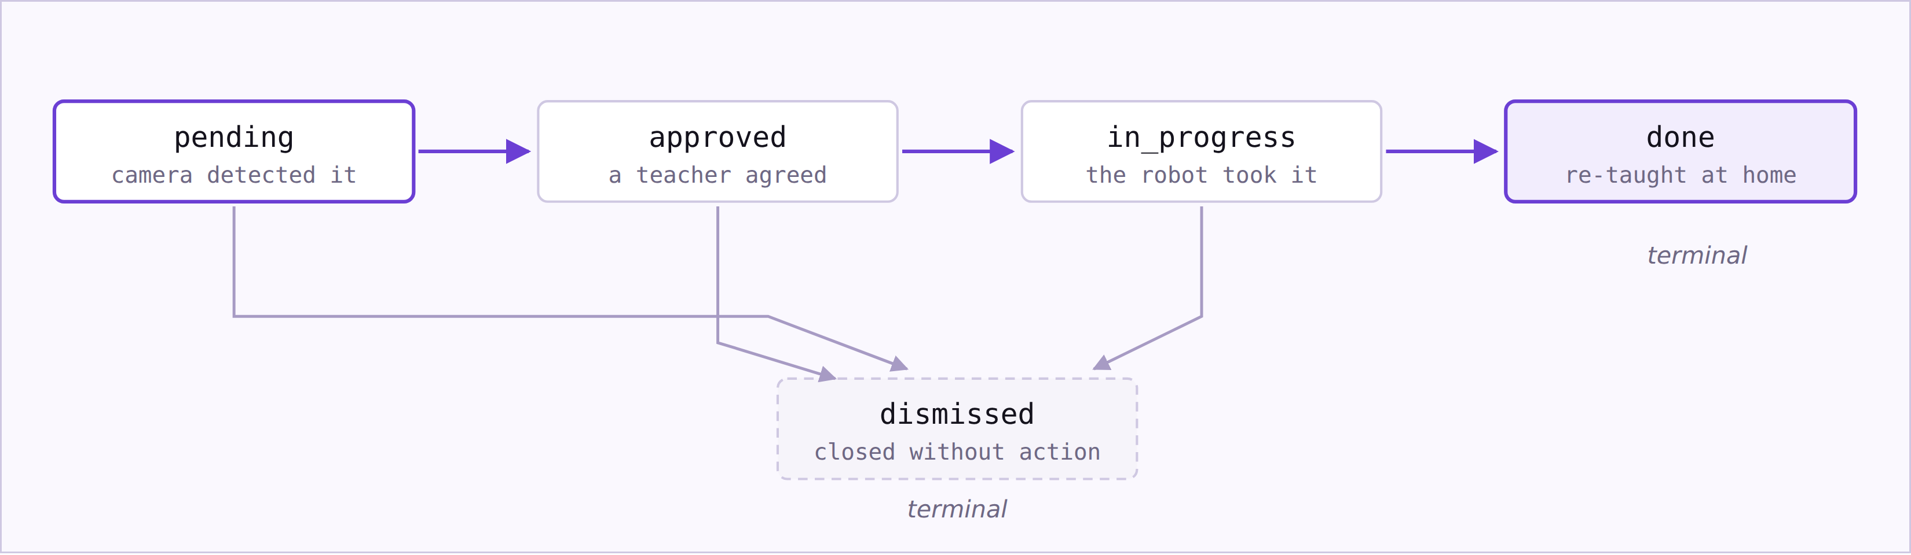
FIG 2 The flag state machine. Both done and dismissed are terminal — a closed flag can never be reopened. Section 5.2 shows how this diagram exists in the code as a single data structure rather than as scattered conditions.
SECTION FIVE

5 The code, with commentary
Thirteen extracts, each chosen because it shows a decision rather than routine work. Every one is a screenshot of the real file at the line numbers shown. The complete source is in the repository on the cover.

5.1 The database layer
app/db.py · lines 1–37 · whole opening of a 134-line file
Two settings in this file prevent bugs that are very hard to find later. SQLite has foreign keys switched off by default, so without line 35 a flag could be stored against a student who does not exist and nothing would complain until a demo. WAL mode on line 36 lets the camera write a flag at the same moment a dashboard is reading one, instead of the two blocking each other.
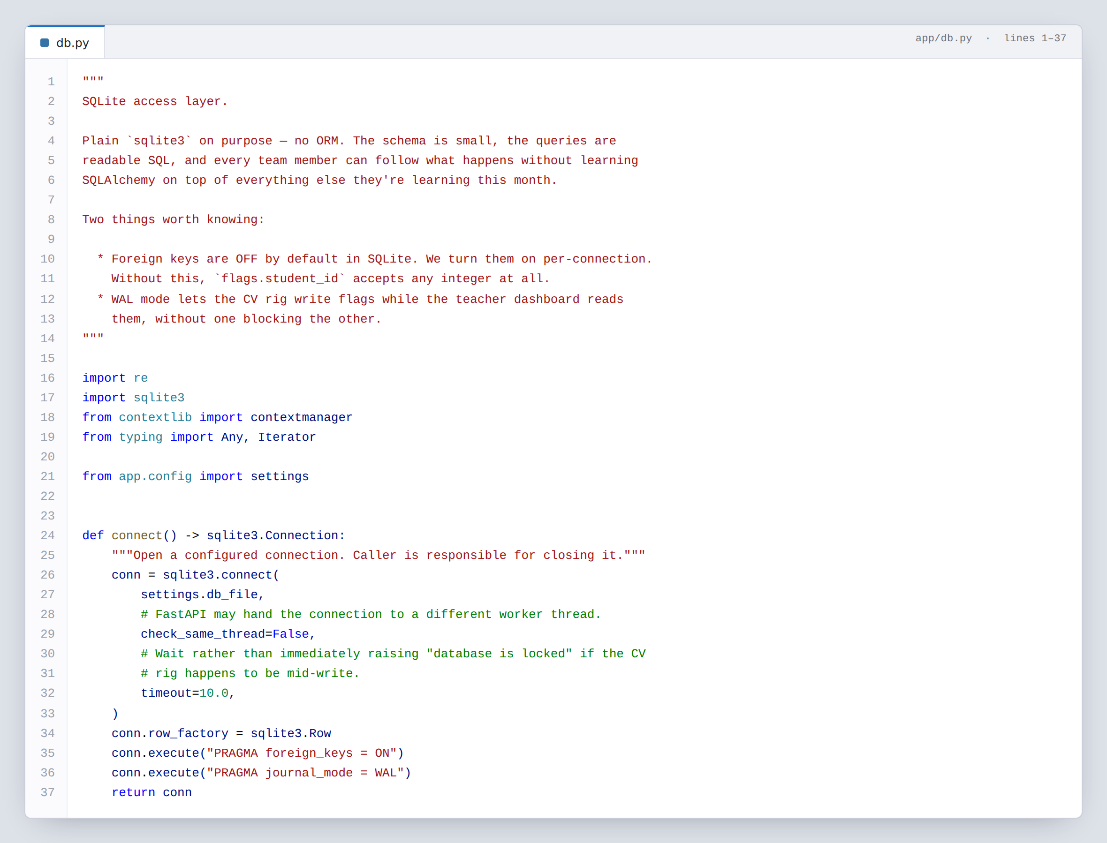
EXTRACT 5.1 app/db.py — the comment at the top explains why there is no ORM, which is the kind of decision a reader six months later cannot recover from the code alone.

5.2 The flag lifecycle, written as data
app/models.py · lines 48–65
This is figure 2 turned into code. The obvious way to enforce a lifecycle is a chain of if statements inside the route that changes a flag — but then the rule lives in one function, and the next feature that touches flags has to reimplement it. Written as a dictionary, the rule is a value that any part of the system can read, and the live push layer we add next can use it unchanged.
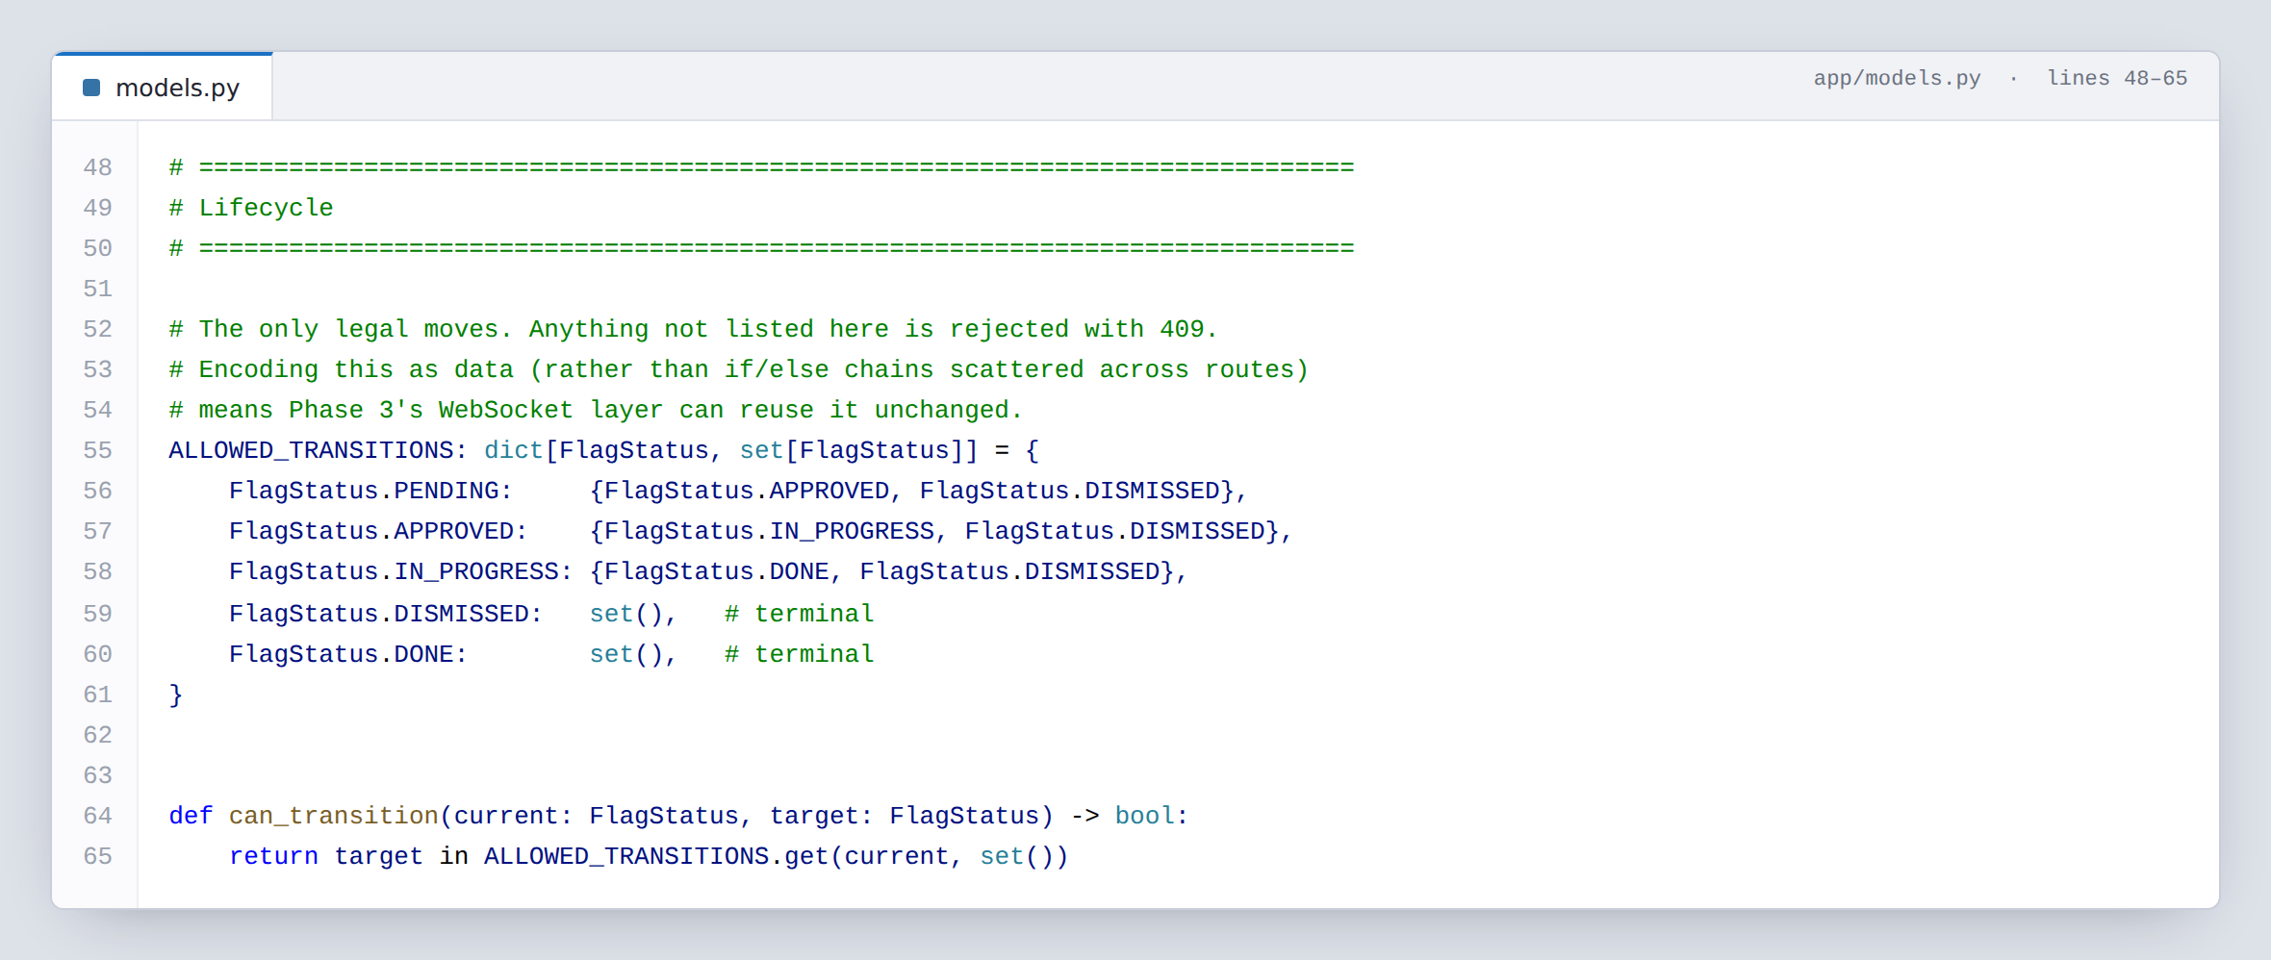
EXTRACT 5.2 app/models.py — five states, four legal moves and two terminal states, held as one dictionary. The two empty sets are what make a closed flag impossible to reopen.

5.3 Receiving a detection from the classroom
app/routers/flags.py · lines 146–192
A camera is not a reliable narrator. Some detections are confident, some are barely above noise, and a teacher’s queue full of false alarms is a queue a teacher stops reading. Rather than filtering inside the vision code — where changing the threshold means editing detection logic at the venue — every detection is stored, and low-confidence ones are stored already closed, with the reason written into the row.
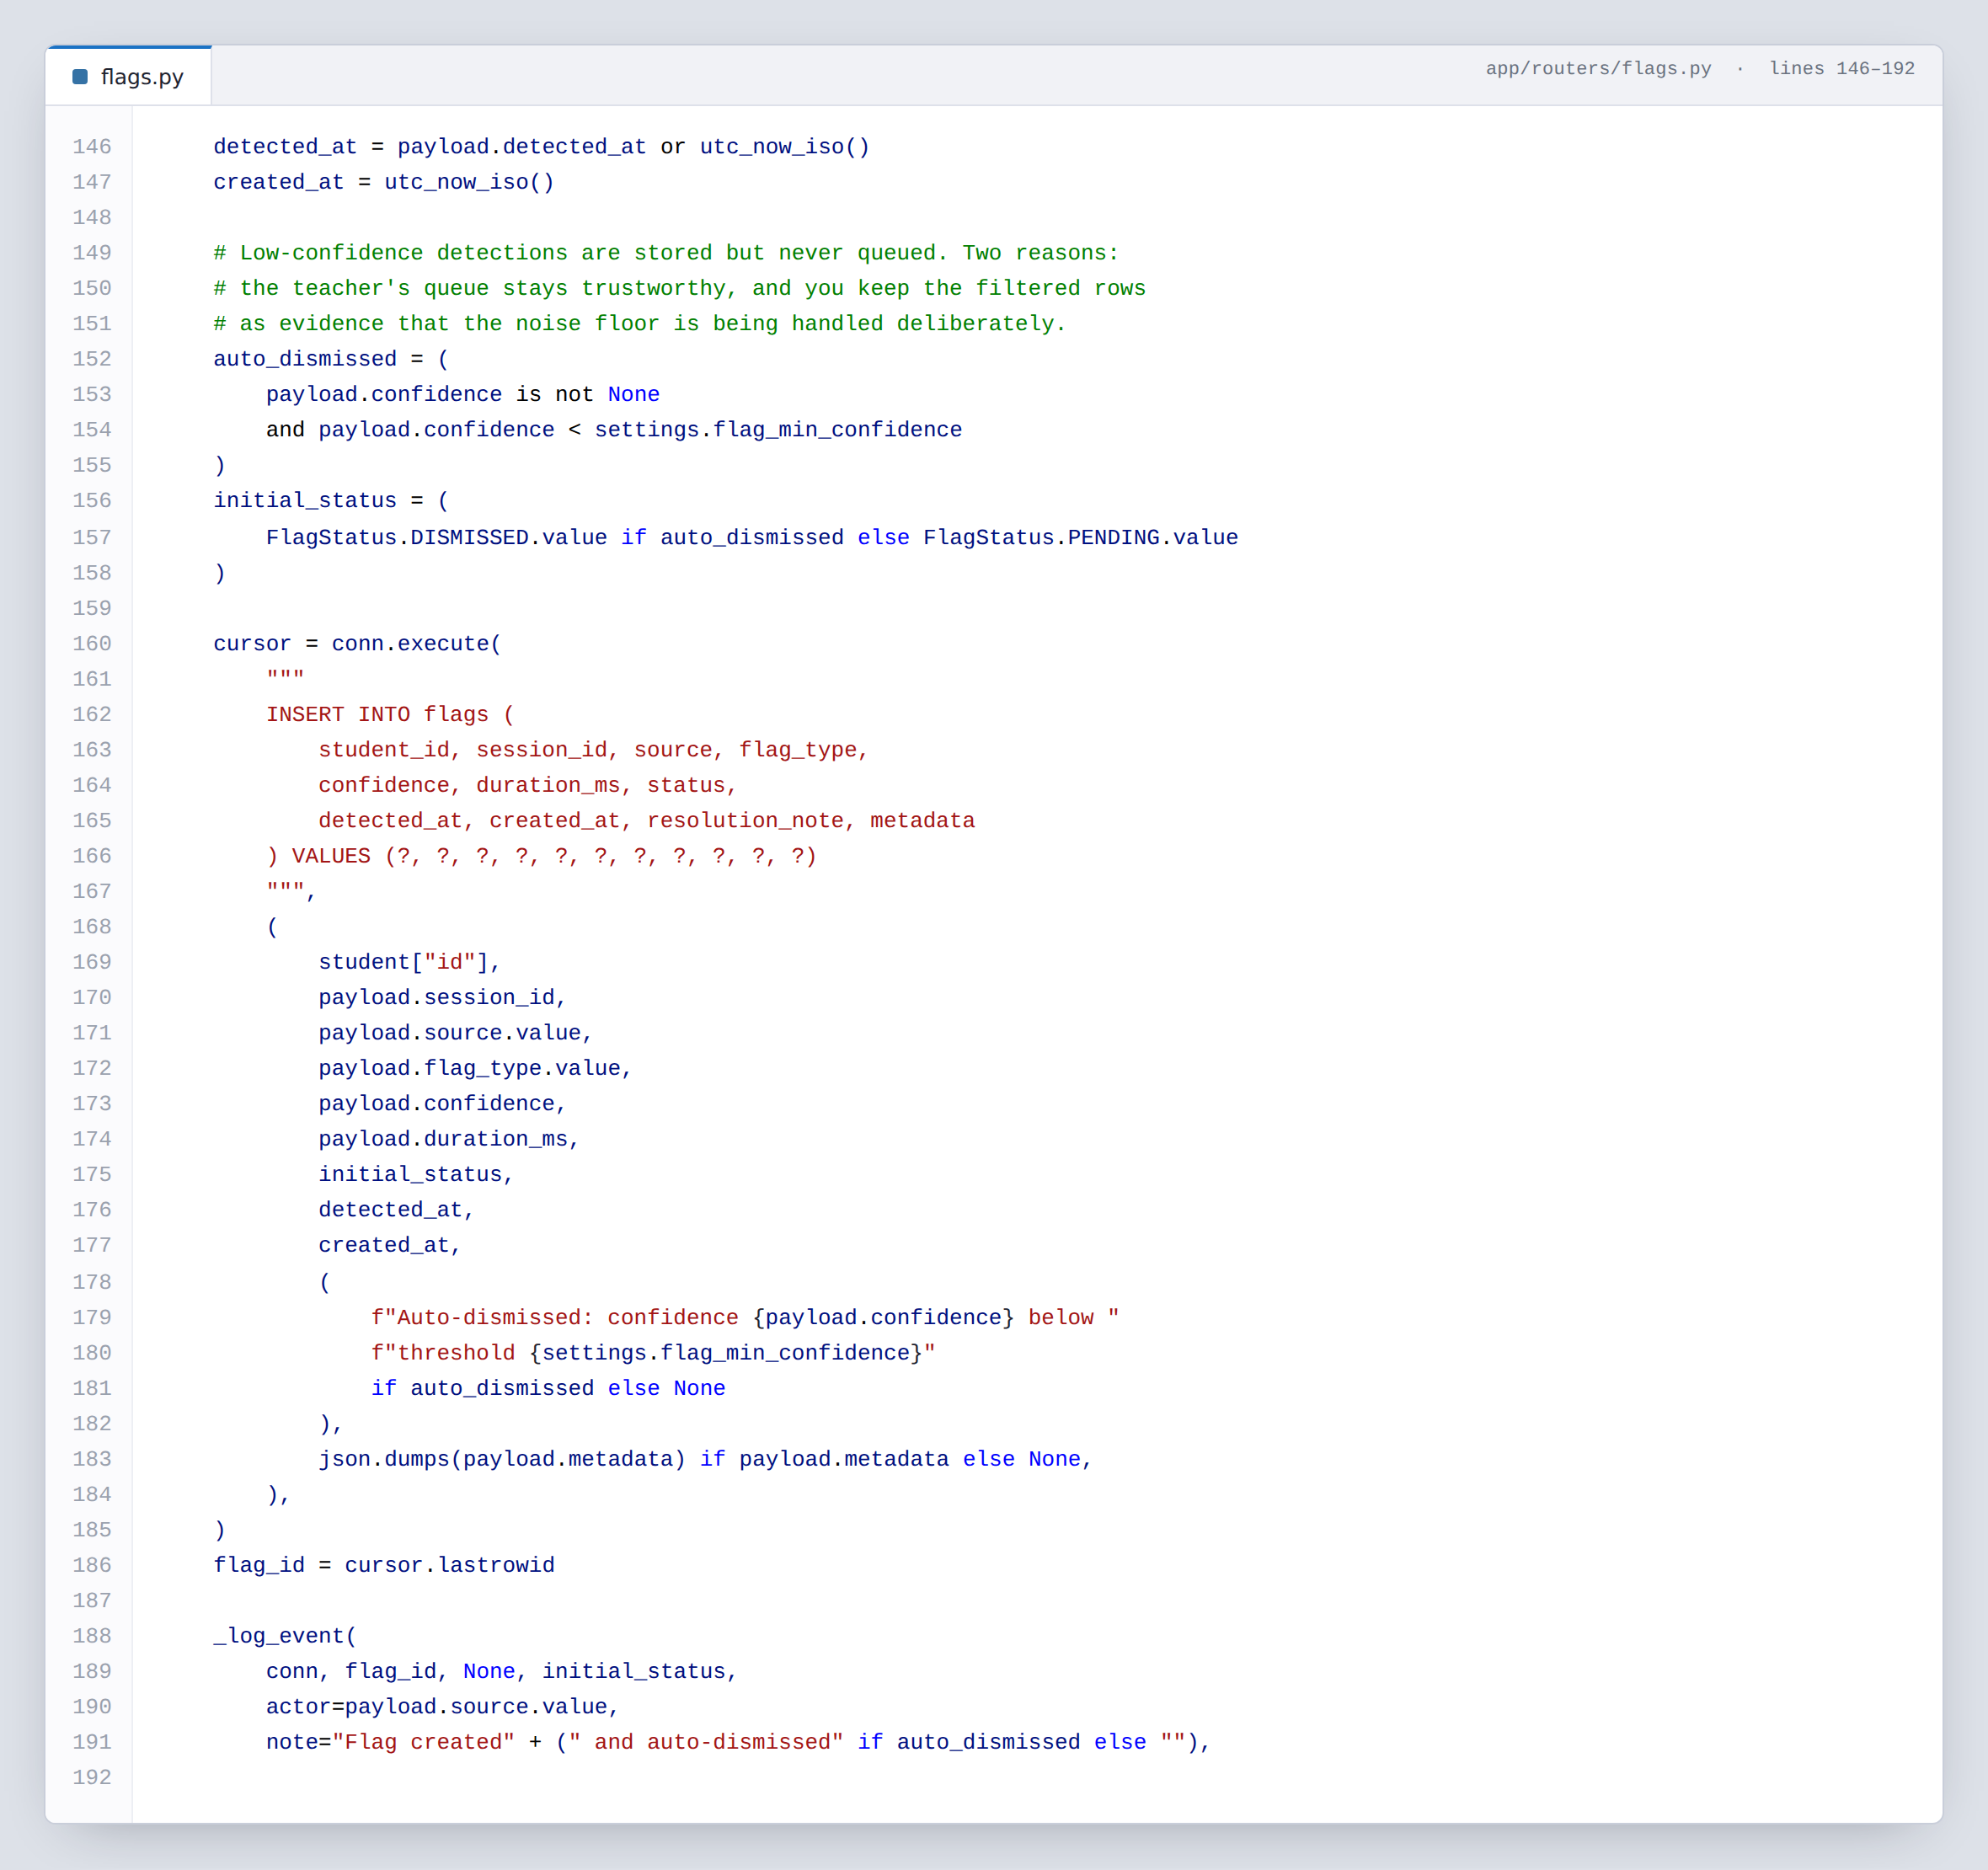
EXTRACT 5.3 app/routers/flags.py — note the SQL: every value is passed as a ? parameter, never built into the query string. That is the rule that makes SQL injection impossible, and it is followed everywhere in the project without exception.

5.4 Refusing an illegal move
app/routers/flags.py · lines 289–323
This is the other half of 5.2. A front end with a bug — or a teammate testing with a REST client — could try to move a flag straight from pending to done, skipping the teacher entirely. The system refuses, and the error names both the state the flag is in and the moves that are allowed from it, so whoever hit the error can fix it without reading the source.
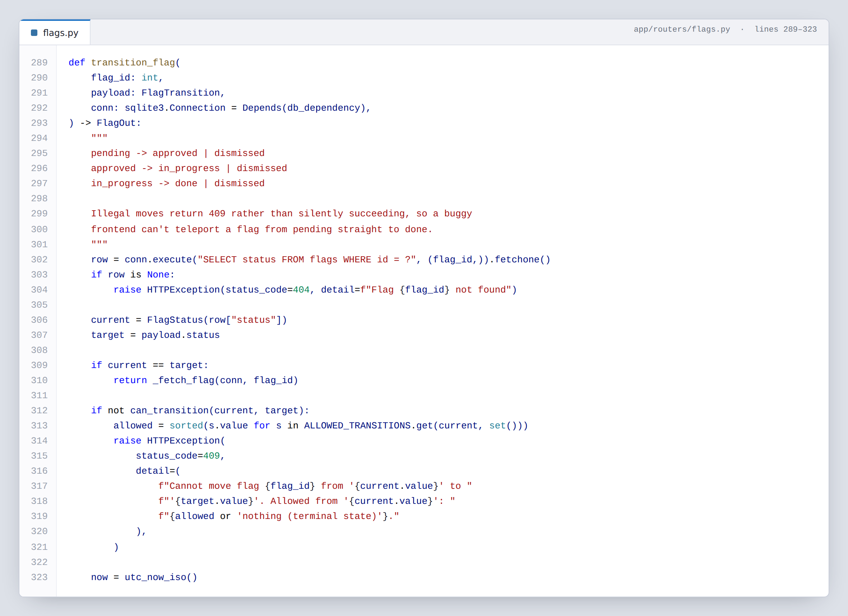
EXTRACT 5.4 app/routers/flags.py — the same request twice in a row returns the flag unchanged rather than failing, because a retry after a dropped connection should not be an error.

5.5 One writer for every number
app/economy.py · lines 19–58 and 176–196
A child’s star count appears on the home screen, in the weekly chart, on the progress page and in their parents’ report. If five different route handlers could each add stars, those four figures would disagree within a week and we would be hunting the difference the night before the competition. So exactly one function is allowed to change a total, and every screen reads from the log that function writes.
The values themselves sit in one block at the top of the file. Two of them are deliberate: a wrong answer is worth 2 stars rather than 0, because for a child who already struggles, zero reward for effort teaches them to stop trying; and mastery rises by 0.12 on a correct answer but falls by only 0.05 on a wrong one, so a single mistake never wipes out visible progress.
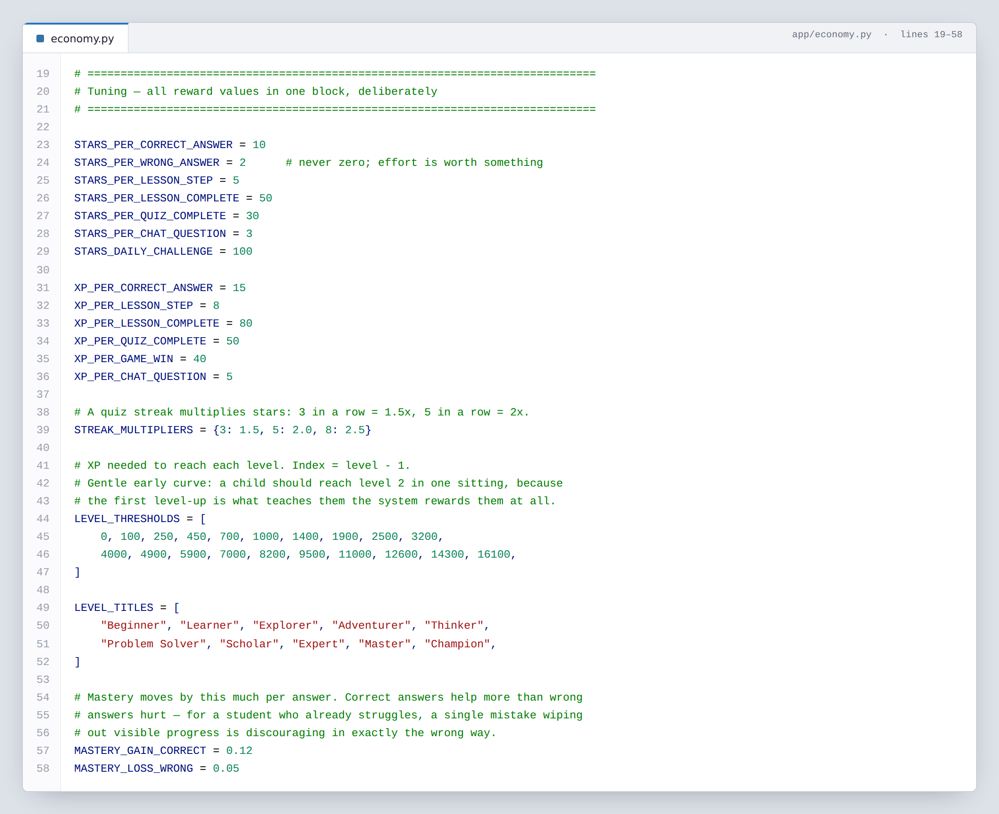
EXTRACT 5.5a app/economy.py — every tunable value in the game economy, in one screen. Balancing the rewards means editing here and nowhere else.
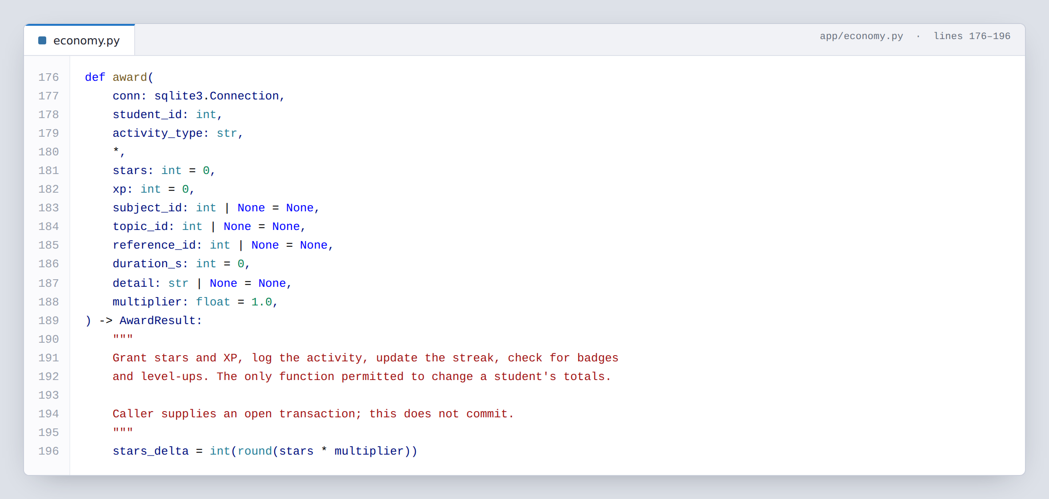
EXTRACT 5.5b app/economy.py — the docstring states the rule the whole design depends on. It does not commit; the caller owns the transaction, so a failure part-way through leaves no half-granted reward.

5.6 Finding the right page of the book
app/services/rag.py · lines 163–216
Before Souly explains anything, it has to find which page of the real textbook the child’s question is about. This is our own scoring function: how often a word appears on a page, weighted down if it appears on every page, plus a bonus when the word matches the lesson title — because a child’s question is usually a topic name rather than a sentence. A page we cannot read is skipped outright at lines 169 to 172 — the comment there is the rule: retrieval must not invent a page it cannot read.
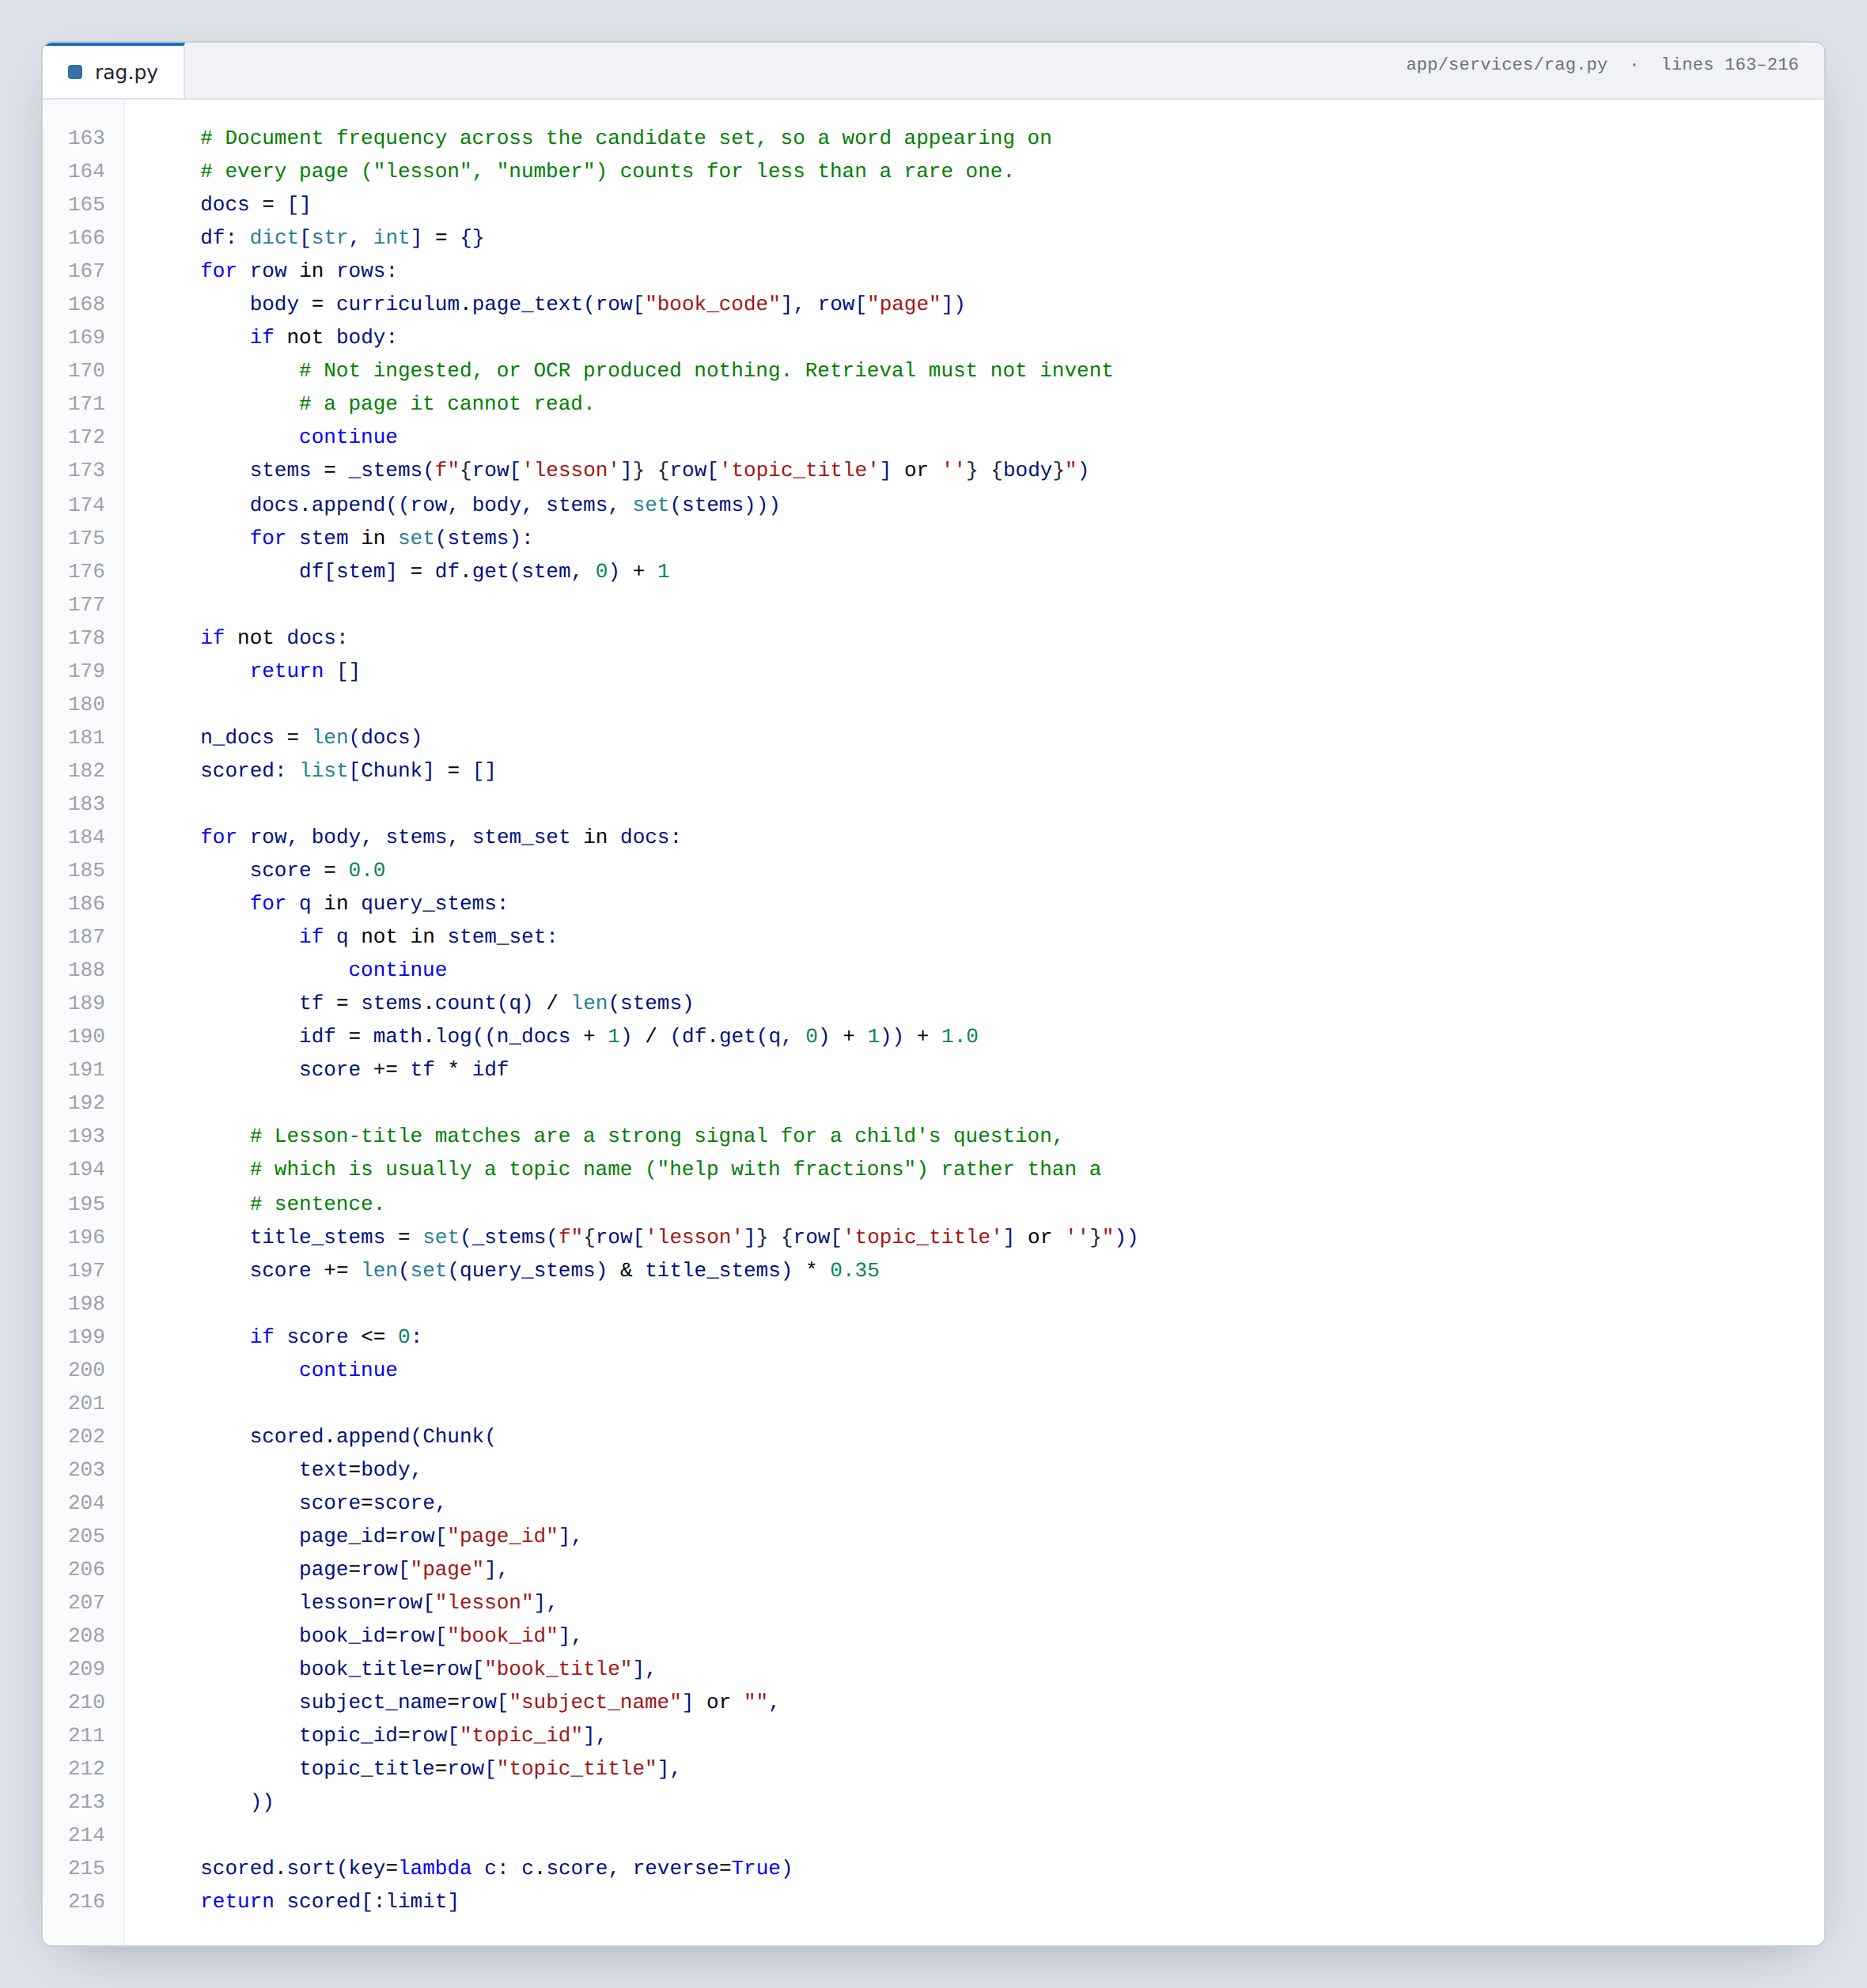
EXTRACT 5.6 app/services/rag.py — the search only ever looks at books a human has marked as verified, so the tutor physically cannot teach from material nobody checked.

5.7 Canon, rendition and path
app/services/tutor.py · lines 14–44 · from a 1,967-line file
This comment is the central idea of the whole project, so it is written down where the code that implements it lives. The textbook page is the canon and nothing may change it. The explanation is the rendition, written for one particular child at the moment they open the page. The order of lessons is the path, and it is decided by plain rules over their mastery, not by the model.
The reason the canon is frozen matters more than it sounds: a wrong step invented inside a mathematics procedure is invisible to a child who is already struggling, because they assume the mistake is theirs.
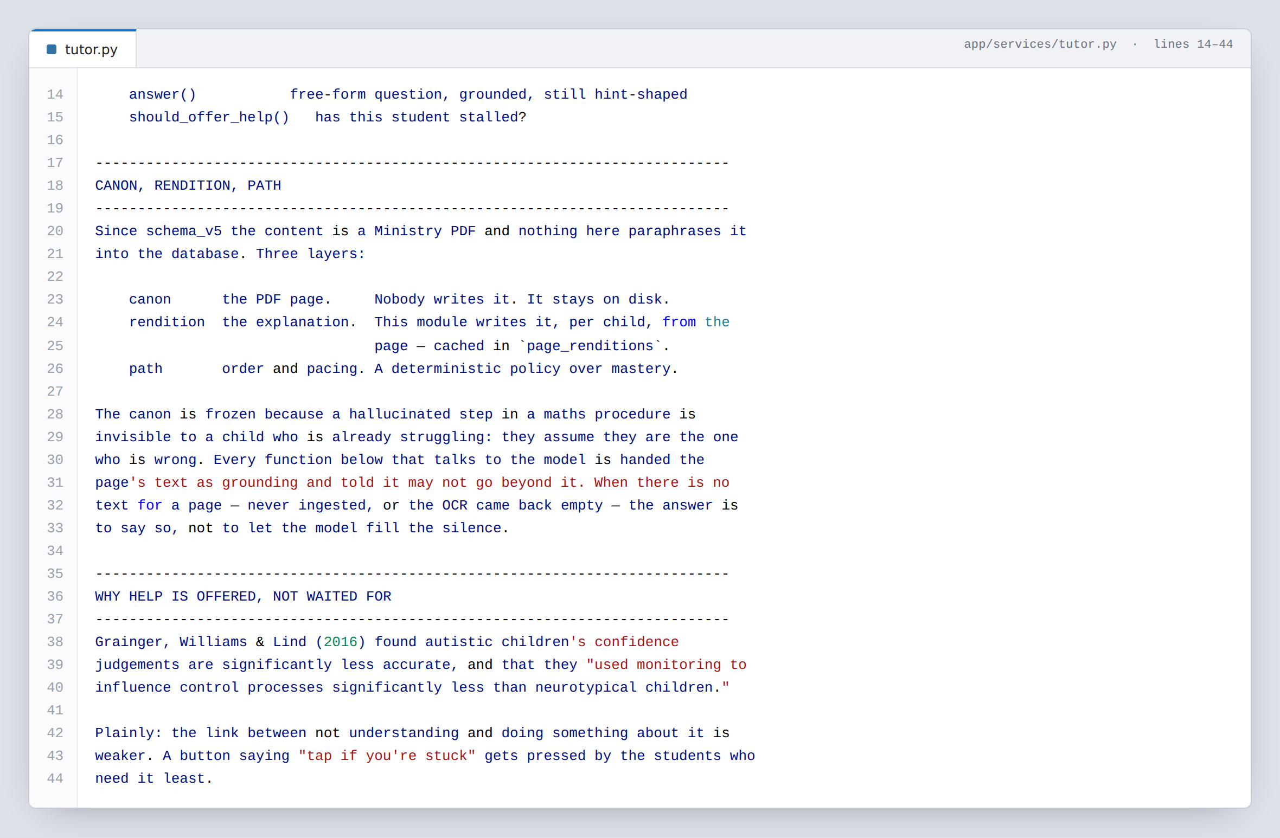
EXTRACT 5.7 app/services/tutor.py — two children on the same page get the same facts in different words. That is the design, stated in the file that implements it.

5.8 Why Souly never gives the answer
app/services/llm.py · lines 19–49
This is the single design rule we would most want a judge to ask us about. A study tool that answers questions makes practice look better and learning worse — and there is published evidence for that, which is why the finding is recorded in the file that enforces the rule rather than only in a slide. Souly is given the worked solution so it can steer, and is forbidden from repeating it.
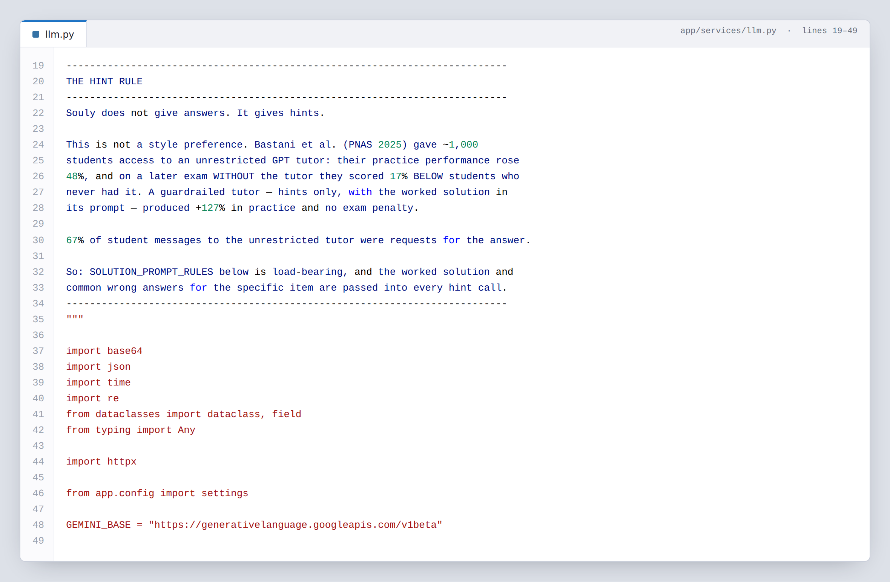
EXTRACT 5.8 app/services/llm.py — a comment that explains a constraint by citing why it exists. Anyone tempted to relax it later reads the reason first.

5.9 What happens when the network fails
app/services/llm.py · lines 634–668
At a competition venue the network will fail at least once. A tutoring app that returns an error because an upstream service hiccupped is worse than one that answers more plainly, so every call has a defined fallback: the retrieved textbook page itself, delivered in Souly’s voice. The reply is tagged with which engine produced it, so the screen can show an honest indicator and we always know which path ran.
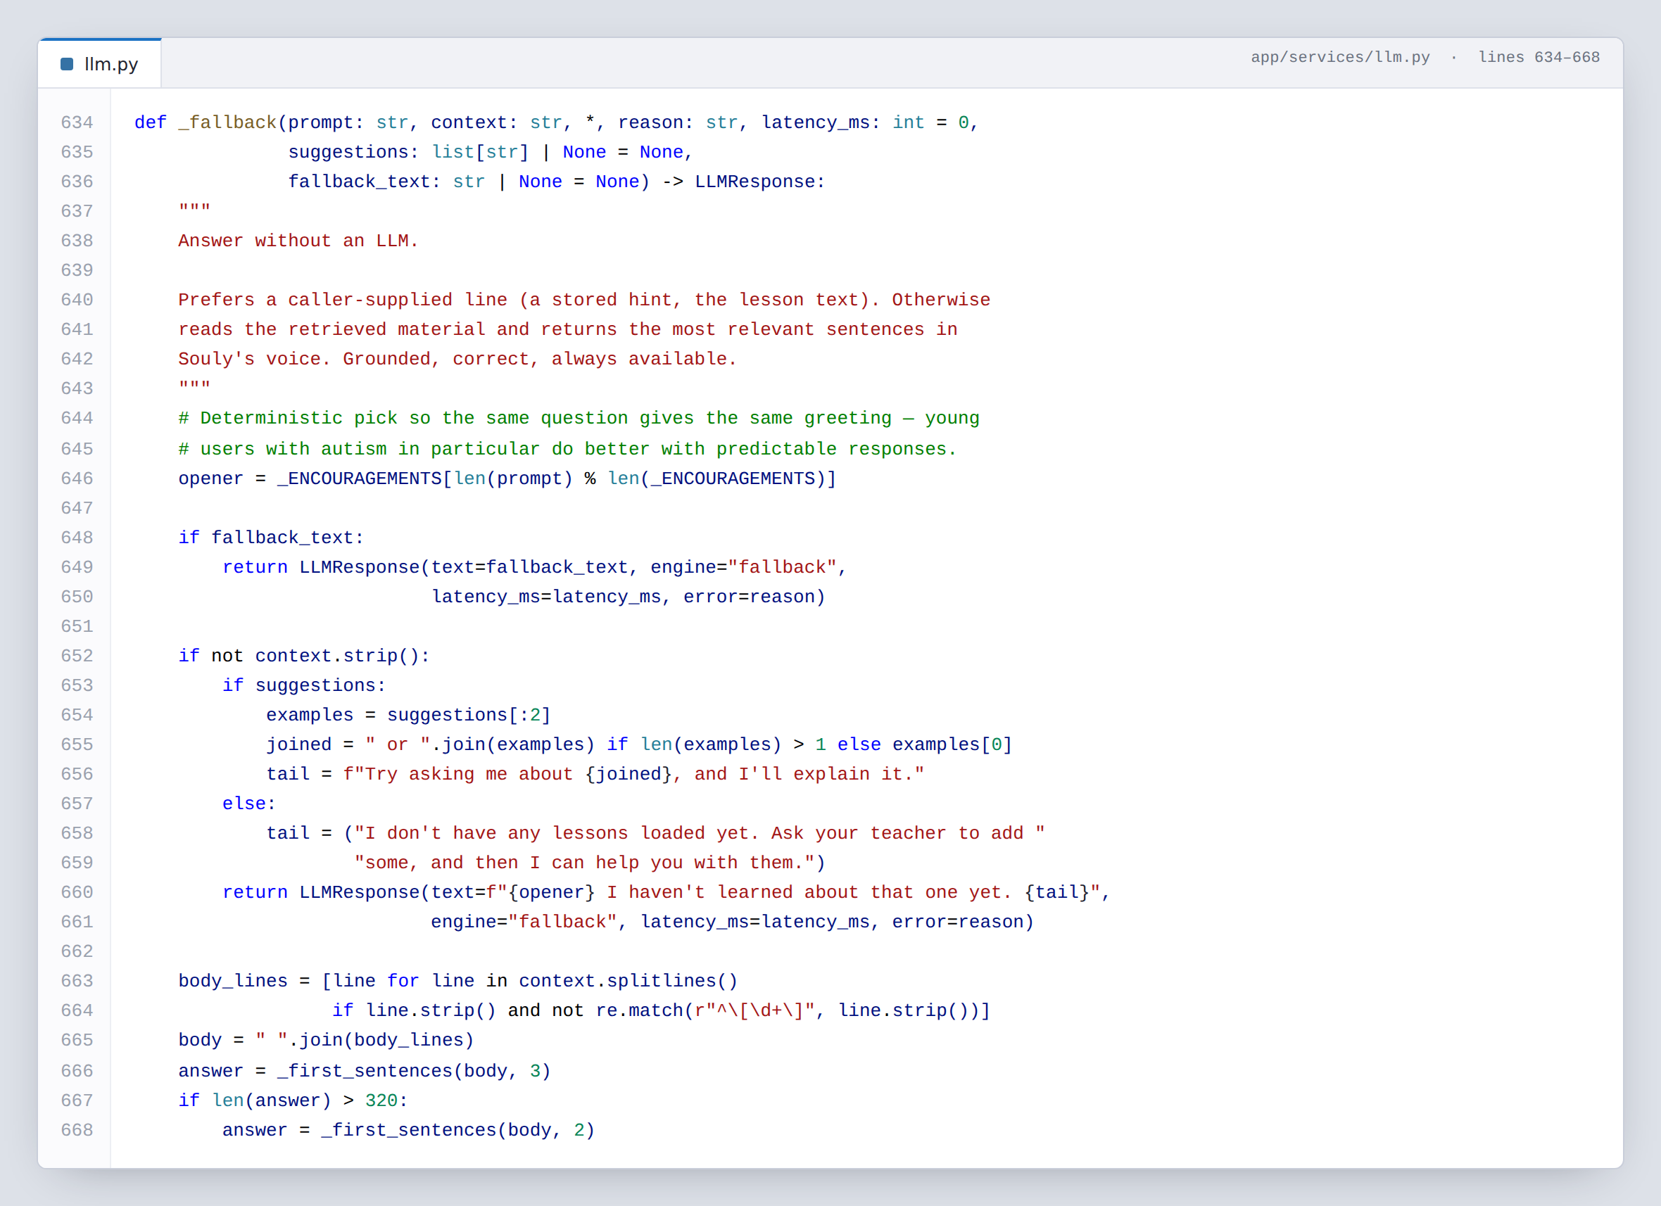
EXTRACT 5.9 app/services/llm.py — the failure path is designed, not accidental. It is chosen in advance instead of improvised on stage.

5.10 Security sized to the user
app/routers/auth.py · lines 9–27
A child signs in by tapping three pictures from a grid of twelve. That is 1,320 combinations — trivial for a computer to guess, and we say so in the file. It is the right choice anyway, because the attacker we are actually defending against is the classmate at the next desk, a nine-year-old cannot type a password ten times a day, and five wrong tries lock the tile for three minutes.
The parents’ hub is a different problem and gets a different answer. It holds a child’s assessment data, so it uses a long random access code hashed with PBKDF2, stores no plaintext, and shows no list of parent names — publishing a school’s family list to anyone who loads the page would be a worse leak than a weak password. The two systems also use separate token tables, so a student’s token cannot satisfy a parent’s check no matter how a query is written. There is a test for exactly that.
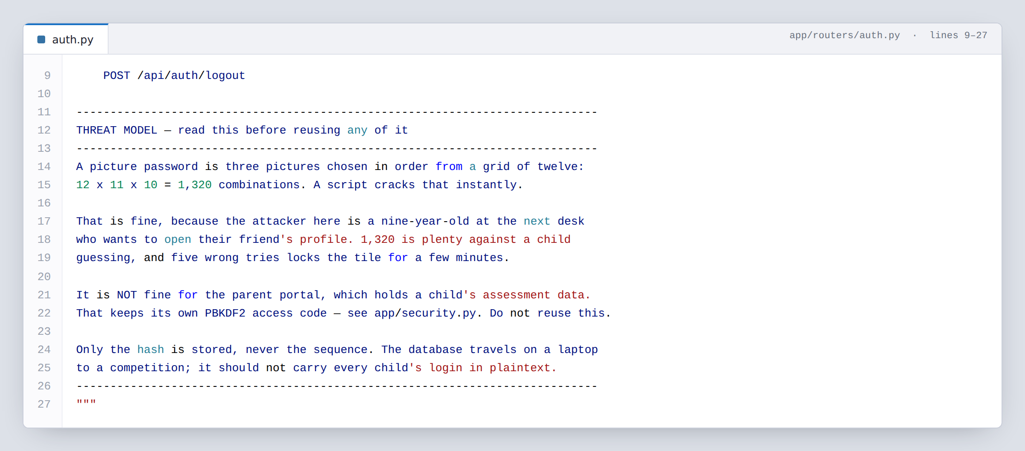
EXTRACT 5.10 app/routers/auth.py — the comment names the threat the design defends against, and names the case where reusing it would be wrong.

5.11 The front end holds no truth
static/student/api.js · lines 54–80
Every network call in the student app goes through this one function, so retries, timeouts, the offline indicator and the session token are handled once instead of in ninety places. The small rewrite on lines 56 to 58 lets every screen ask for /api/me/… while the server only ever sees a real student id, which means switching which child is signed in changes one variable and no screens.
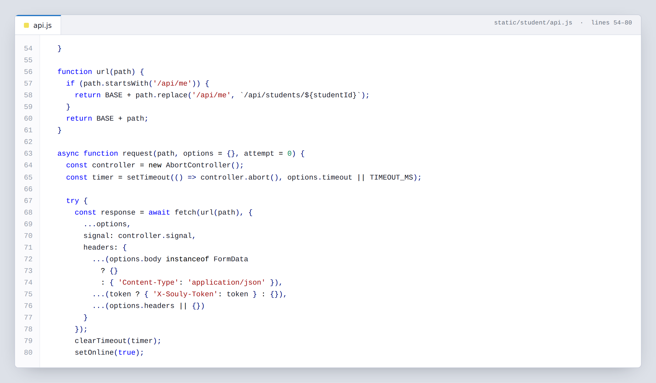
EXTRACT 5.11 static/student/api.js — none of the ten screens holds a hardcoded number. A figure that cannot disagree with the database is a figure that cannot be wrong in front of a judge.

5.12 The test that protects the demo
tests/test_learning.py · lines 236–250
A quiz question travels to the browser as JSON. If the correct answer travelled with it, any child could open the developer tools and read it — and every score in our demonstration would be meaningless. So the correct index is never sent until after the answer is submitted, and this test fails the build if that ever changes.
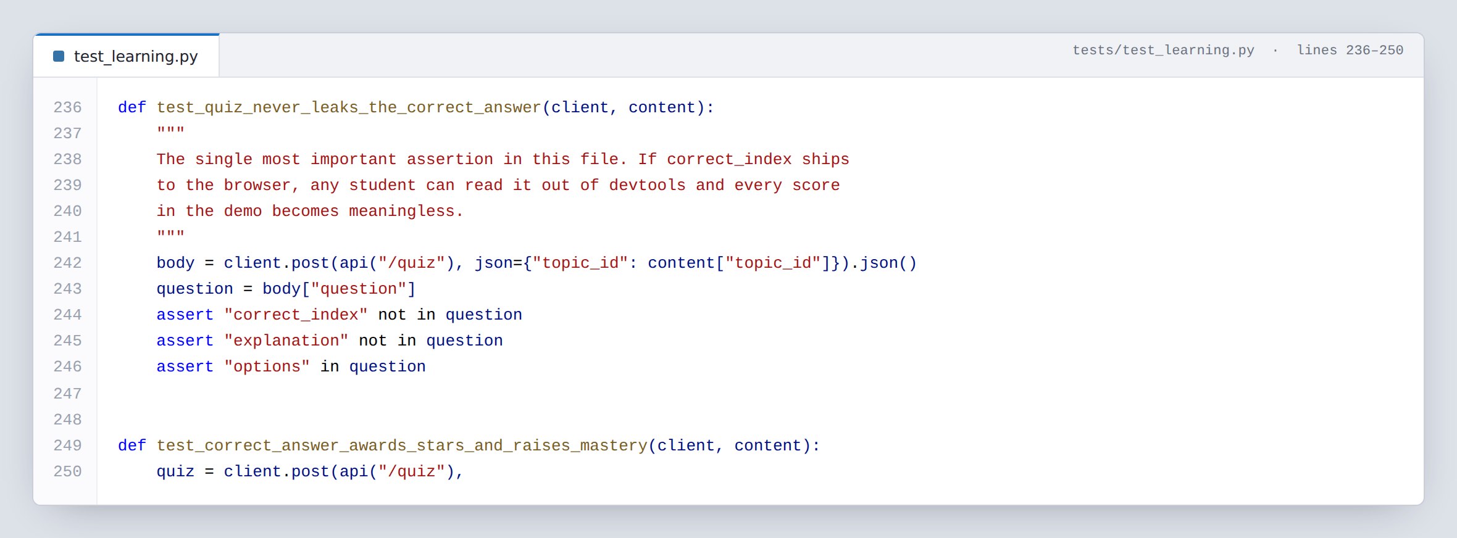
EXTRACT 5.12 tests/test_learning.py — the test’s name is a sentence describing the guarantee. A failing test then reads as a statement about what broke.

5.13 The whole suite, running
206 tests · 5.0 seconds · clean checkout
Tests are only worth writing if they are fast enough to run constantly. The whole suite finishes in five seconds against a temporary database, and a guard aborts the run if it ever touches the real one — because the first version of our fixtures silently wiped a development database, and we would rather that fail loudly than quietly.
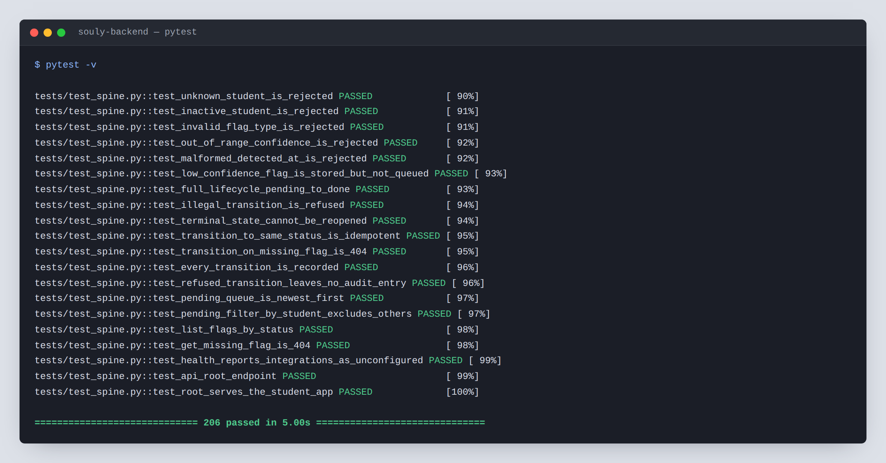
EXTRACT 5.13 The end of a full run. The test names are readable as sentences: a low-confidence flag is stored but not queued, an illegal transition is refused, a terminal state cannot be reopened.
SECTION SIX

6 Database design
One SQLite file holds 41 tables and 9 views. They are built by seven migration files applied in order, every one of them safe to run again — which is why nobody on the team can break their database by running setup twice.

6.1 The five groups
GROUP | TABLES | WHAT IT ANSWERS
People | students, teachers, parents, parent_student, auth_tokens, parent_tokens | Who is who, and which parent may see which child.
Curriculum | subjects, topics, curriculum_books, curriculum_pages, page_renditions, questions | What gets taught, and which page of which book it is on.
Activity | sessions, attempts, quizzes, quiz_questions, lesson_progress, page_activity, game_plays, chat_messages, hint_requests | What the child actually did.
Progress | mastery, activity_log, student_skills, badges, student_badges, rewards, student_rewards, weekly_goals, daily_challenge_progress | How they are doing, and what they have earned.
Classroom | flags, flag_events | What the camera noticed, and everything that happened to it since.
Plus student_settings, learner_profiles, onboarding_responses, teacher_notes, conversations and schedule_items.

6.2 Seven migrations, in order
FILE | LINES | WHAT IT ADDS
schema.sql | 390 | People, sessions, and the flag spine.
schema_v2.sql | 492 | Everything the student screens need — quizzes, badges, rewards, the activity log.
schema_v3.sql | 341 | The data the hint ladder needs, and a record of every help request so we can show the ladder works.
schema_v4.sql | 264 | Sign-in: avatars, picture passwords, tokens, and the learner profile.
schema_v5.sql | 492 | Replaces our written lesson text with a map into the real Ministry books.
schema_v6.sql | 37 | Makes a cached explanation expire when what we know about the child changes.
schema_v7.sql | 168 | The parents’ hub: its own tokens, teacher notes, and per-child message threads.

6.3 Two habits worth pointing at
Bad data fails loudly. Columns that can only hold a few values carry a CHECK constraint, so a typo becomes an error at the moment of writing rather than a fifth flag status nobody notices for a month. Timestamps are stored as ISO-8601 text, which sorts correctly as text and reads correctly to a human.
Access control lives in the schema, not in the routes. A parent’s link to a child is a row in parent_student, and every parent-facing query joins through it. If the join returns nothing, the answer is 404. The alternative — trusting a child id that arrived from a browser — is one forgotten check away from showing a parent someone else’s child.
WHY MIGRATIONS RATHER THAN ONE FILE
The schema changed six times as the design settled, and each change had to work against databases that already had data in them. Keeping the history as separate files means the reason for each change is recorded next to the change, and a teammate whose database is three versions old catches up by running setup again.
SECTION SEVEN

7 How we write and check our code

7.1 Comments explain decisions, not syntax
A comment that says # loop through the students above a loop through the students is noise. The comments in this project answer the question a reader cannot answer from the code: why is it like this? Every module opens with a short statement of what it is for and what was decided; inline comments appear where a line would otherwise look arbitrary or wrong.
Extracts 5.7, 5.8 and 5.10 are all comments rather than logic, and they are three of the most valuable things in the repository — they are the only record of arguments the team had and settled.

7.2 The rules we hold to
RULE | WHAT IT MEANS IN PRACTICE
One writer per fact | Only economy.py changes a score. Only config.py reads the environment. Only the ingest script writes the curriculum map.
No magic numbers | Every threshold and reward is a named constant in one block, not a bare number buried in a function.
Parameterised SQL, always | Values are passed as ? placeholders. No query is ever built by joining strings together.
Fail with a useful message | An error says what was wrong and what would have been valid — see extract 5.4.
The browser holds no truth | Screens draw from live API data. Refreshing the page loses nothing, because nothing was only in the browser.
Names are sentences | test_low_confidence_flag_is_stored_but_not_queued needs no comment to explain it.
Every layer degrades | No key, no network, no OCR text — each has a defined behaviour that is not a crash.

7.3 What the tests cover
FILE | TESTS | AREA
tests/test_learning.py | 138 | Lessons, pages, practice generation, quizzes, hints, the economy, the tutor.
tests/test_parent.py | 35 | The parents’ hub, including that a parent can only ever reach their own children.
tests/test_spine.py | 24 | The flag lifecycle: validation, the noise floor, every legal and illegal transition, the audit trail.
tests/test_schema.py | 9 | The database builds correctly and its constraints actually reject bad data.
tests/ui_smoke.py | — | Drives all ten screens in a real browser, buys a reward, checks the stars really left the balance, screenshots everything. Any console error fails the run.
tests/gate_smoke.py | — | Drives sign-in and the entry activity from a cold start, the way a child would meet it.
206 automated tests in total, running in five seconds against a temporary database.
THE CHECK THAT MATTERS MOST
Two tests exist purely to protect promises we make out loud: test_quiz_never_leaks_the_correct_answer and test_parent_sees_only_their_own_child. If either ever fails, a claim in our presentation has stopped being true — and we find out in five seconds rather than on stage.
SECTION EIGHT

8 What runs today, and what is still ahead
Everything in the left column can be demonstrated on our own hardware. Everything in the right column is designed and partly built, and we would rather say so here than have it discovered.
CAPABILITY | STATE | DETAIL
Flag pipeline | WORKING | Receive, filter by confidence, queue, approve, claim, resolve, with every transition recorded. 24 tests.
Real curriculum | WORKING | Two Ministry books, 14 lessons, 106 mapped pages, cited by book and page number.
Student app | WORKING | Ten screens, all drawn from live data: sign-in, entry activity, lessons, quizzes, games, rewards, badges, progress, profile.
Parents’ hub | WORKING | Eight screens, multiple children per code, teacher notes and per-child message threads.
Tutor and hints | WORKING | Explanations written per child from the real page, four-rung hint ladder, full voice loop.
Offline behaviour | WORKING | Every external service has a defined fallback. The app runs with no keys at all.
Classroom vision | SEPARATE | Owned by another team, in another repository. Our side of the contract is finished, documented in docs/CV_INTEGRATION.md, and testable today with a simulator we wrote.
Teacher dashboard | AHEAD | The API it needs exists and is tested. The screen itself is not built yet.
Live push | AHEAD | Flags are read by polling today. The state machine in extract 5.2 was written so a live push layer can reuse it without changes.
Speech vendor | OPEN | Three providers implemented; which one we ship is one environment variable and is still being decided on cost and offline behaviour.

8.1 Two constraints we chose to keep
Souly reports engagement, never emotion. The classroom system measures where a child is looking and for how long. It does not claim to detect how they feel. Inferring emotion from a face is scientifically contested, and a system that tells a teacher a child is "sad" is making a claim it cannot support about a child it is supposed to protect.
A teacher approves before anything reaches a classroom. The system never acts on a flag by itself. A detection is a suggestion to an adult, and no screen visible to a whole class ever shows an individual child’s name next to a difficulty.
WHY WE ARE STATING THE GAPS
Every one of these is a decision about where six weeks of eight students’ time went, and we would rather explain that reasoning than have the list read as an oversight. The pieces that are finished are finished properly — tested, documented and demonstrable — which we think is worth more than a wider surface that only works when nothing goes wrong.
SECTION NINE

9 Running the system yourself
Everything below works from a clean checkout on Windows, macOS or Linux. No database server, no build step, no account required — the app runs without any API keys, using its offline paths.
01 Get the code and create an environment. git clone https://github.com/beshoywael-him/souly-backend then python -m venv .venv, activate it, and pip install -r requirements.txt — six packages.
02 Build the database. python scripts/init_db.py creates 41 tables and 9 views from the seven migration files.
03 Add the people and the scaffolding. python scripts/seed_students.py, then seed_content.py, then seed_parents.py — which prints the parent access codes.
04 Load the textbooks. python scripts/render_pages.py then python scripts/ingest_curriculum.py. Reads the two Ministry PDFs and the approved lesson map. Add --dry-run to see what it would do without writing anything.
05 Start the server. run.bat on Windows, ./run.sh elsewhere. It binds to all interfaces, so every device on the router reaches it.
06 Open the student app at localhost:8000/student. Choose a face, tap three pictures, and confirm them. The entry activity runs once.
07 Open the parents’ hub at localhost:8000/parent and sign in with any access code printed in step 3.
08 Inspect the system. localhost:8000/docs is the live API contract — all 83 operations, generated from the code, with a working test button on each. localhost:8000/health reports which services have keys and how much curriculum is loaded.
09 Watch the classroom pipeline without any camera hardware: python scripts/fake_cv_publisher.py --watch --interval 3 in one terminal and python scripts/poll_pending.py --watch in another.
10 Run the tests. pytest — 206 tests, about five seconds. python tests/ui_smoke.py drives every screen in a real browser.

IF YOU ONLY HAVE FIVE MINUTES
Steps 1, 2, 3 and 5, then open /student. You will reach the sign-in screen and the whole app; the lessons need step 4 because the content is the textbooks themselves and they are read from disk, not stored in the database.
SECTION TEN

10 Complete file inventory
Every file in the repository, excluding generated caches and the two textbook PDFs. This is the whole of what is at the address on the cover.

Backend — app/
FILE | LINES
app/__init__.py | 3
app/config.py | 125
app/db.py | 134
app/deps.py | 47
app/economy.py | 557
app/main.py | 118
app/models.py | 215
app/onboarding_items.py | 323
app/routers/__init__.py | 0
app/routers/auth.py | 357
app/routers/flags.py | 375
app/routers/gamification.py | 423
app/routers/health.py | 49
app/routers/learning.py | 1,217
app/routers/onboarding.py | 498
app/routers/parent_auth.py | 303
app/routers/parent.py | 965
app/routers/progress.py | 179
app/routers/student.py | 316
app/routers/tutor_api.py | 426
app/security.py | 58
app/services/__init__.py | 1
app/services/curriculum.py | 437
app/services/llm.py | 886
app/services/rag.py | 250
app/services/stt.py | 147
app/services/tts.py | 251
app/services/tutor.py | 1,967
subtotal | 10,627

Front ends — static/
FILE | LINES
static/parent/api.js | 246
static/parent/app.js | 447
static/parent/base.css | 908
static/parent/index.html | 49
static/parent/pages.js | 1,203
static/student/api.js | 361
static/student/app.css | 1,462
static/student/app.js | 1,173
static/student/base.css | 516
static/student/games.js | 270
static/student/gate.js | 620
static/student/index.html | 113
static/student/pages.js | 936
subtotal | 8,304

Operations — scripts/
FILE | LINES
scripts/__init__.py | 0
scripts/check_image.py | 106
scripts/check_keys.py | 104
scripts/clear_curriculum.py | 129
scripts/demo_spine.py | 173
scripts/fake_cv_publisher.py | 172
scripts/generate_practice.py | 193
scripts/ingest_curriculum.py | 559
scripts/init_db.py | 65
scripts/make_cert.py | 287
scripts/poll_pending.py | 94
scripts/render_pages.py | 324
scripts/seed_content.py | 318
scripts/seed_demo_lesson.py | 29
scripts/seed_parents.py | 299
scripts/seed_students.py | 326
subtotal | 3,178

Tests — tests/
FILE | LINES
tests/__init__.py | 0
tests/conftest.py | 118
tests/gate_smoke.py | 272
tests/test_learning.py | 2,169
tests/test_parent.py | 452
tests/test_schema.py | 163
tests/test_spine.py | 328
tests/ui_smoke.py | 261
subtotal | 3,763

Documentation — docs/
FILE | LINES
docs/ARCHITECTURE.md | 433
docs/CURRICULUM.md | 206
docs/CV_INTEGRATION.md | 172
docs/PERSONALISATION-DESIGN.md | 468
docs/RESEARCH-EVIDENCE.md | 458
docs/STACK.md | 86
subtotal | 1,823

Curriculum — data/
FILE | LINES
data/curriculum/5th primary math.pdf | —
data/curriculum/5th primary science.pdf | —
data/curriculum/curriculum_map.json | 134
subtotal | 134

Project root
FILE | LINES
pytest.ini | 6
README.md | 333
requirements.txt | 28
run-https.bat | 46
run.bat | 26
run.sh | 11
schema_v2.sql | 492
schema_v3.sql | 341
schema_v4.sql | 264
schema_v5.sql | 492
schema_v6.sql | 37
schema_v7.sql | 168
schema.sql | 390
subtotal | 2,634

