**Topics: Descriptive Statistics and Probability**

**ASSIGNMENT NO 2**

1. Look at the data given below. Plot the data, find the outliers and find out $μ, σ, σ^{2}$

|  |  |
| --- | --- |
| **Name of company** | **Measure X** |
| Allied Signal | 24.23% |
| Bankers Trust | 25.53% |
| General Mills | 25.41% |
| ITT Industries | 24.14% |
| J.P.Morgan & Co. | 29.62% |
| Lehman Brothers | 28.25% |
| Marriott | 25.81% |
| MCI | 24.39% |
| Merrill Lynch | 40.26% |
| Microsoft | 32.95% |
| Morgan Stanley | 91.36% |
| Sun Microsystems | 25.99% |
| Travelers | 39.42% |
| US Airways | 26.71% |
| Warner-Lambert | 35.00% |

**Ans:- measure.mean()**

**Mean=33.27**

**measure.std()**

**Standard deviation=16.94**

**measure.var()**

**Variance=287.14**

**Outlier is present at 91.36% for Morgan Stanley.**

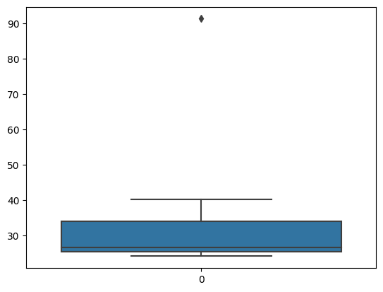

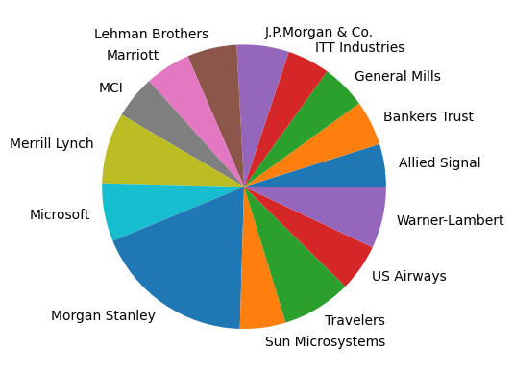



Answer the following three questions based on the box-plot above.

1. What is inter-quartile range of this dataset? (please approximate the numbers) In one line, explain what this value implies.

**Ans:- Q3=12, Q1=5 ; Inter quartile range (IQR)=Q3-Q1=12-5=7 IQR= 7.**

**second quartile range Q2 is median value.**

1. What can we say about the skewness of this dataset?

**Ans:-** **As the distance between median and maximum is greater the distribution is not**

**Normal its positively skewed.**

1. If it was found that the data point with the value 25 is actually 2.5, how would the new box-plot be affected?

**Ans:- In that case there will be no outlier present and the data will distribute normally.**

0

Answer the following three questions based on the histogram above.

1. Where would the mode of this dataset lie?

**Ans:- The mode of the data set will lie between 4 to 10.**

1. Comment on the skewness of the dataset.

**Ans:- The data is positively skewed(right skewed) as the tail is on the positive side.**

1. Suppose that the above histogram and the box-plot in question 2 are plotted for the same dataset. Explain how these graphs complement each other in providing information about any dataset.

**Ans:- They both are right skewed, median is easily visible in boxplot whereas in histogram mode is visible.**

1. AT&T was running commercials in 1990 aimed at luring back customers who had switched to one of the other long-distance phone service providers. One such commercial shows a businessman trying to reach Phoenix and mistakenly getting Fiji, where a half-naked native on a beach responds incomprehensibly in Polynesian. When asked about this advertisement, AT&T admitted that the portrayed incident did not actually take place but added that this was an enactment of something that “could happen.” Suppose that one in 200 long-distance telephone calls is misdirected. What is the probability that at least one in five attempted telephone calls reaches the wrong number? (Assume independence of attempts.)

**Ans:-**

**IF 1 in 200 long-distance telephone calls are getting misdirected.**

**probability of call misdirecting = 1/200**

**Probability of call not Misdirecting = 1-1/200 = 199/200**

**The probability for at least one in five attempted telephone calls reaches the wrong number**

**Number of Calls = 5**

**n = 5**

**p = 1/200**

**q = 199/200**

**P(x) = at least one in five attempted telephone calls reaches the wrong number**

**P(x) = ⁿCₓ pˣ qⁿ⁻ˣ**

**P(x) = (nCx) (p^x) (q^n-x) (n - r)!**

**P(1) = (5C1) (1/200)^1 (199/200)^5-1**

**P(1) = 0.0245037**

**the probability that at least one in five attempted telephone calls reaches the wrong number IS = 0.0245037.**

1. Returns on a certain business venture, to the nearest $1,000, are known to follow the following probability distribution

|  |  |
| --- | --- |
| x | P(x) |
| -2,000 | 0.1 |
| -1,000 | 0.1 |
| 0 | 0.2 |
| 1000 | 0.2 |
| 2000 | 0.3 |
| 3000 | 0.1 |

E(X) =Sum X.*P(X) | E(X^2) =X^2*P(X)

-200 | 400000

-100 | 100000

0 | 0

200 | 200000

600 | 1200000

300 | 900000

Total: 800 | 2800000

1. What is the most likely monetary outcome of the business venture?

**Ans:-** **The most likely monetary outcome of the business venture is 2000$ As for 2000$ the probability is 0.3 which is maximum as compared to others**

1. Is the venture likely to be successful? Explain

**Ans:-** **Yes, the probability that the venture will make more than 0 or a profit p(x>0)+p(x>1000)+p(x>2000)+p(x=3000) = 0.2+0.2+0.3+0.1 = 0.8 this states that there is a good 80% chances for this venture to be making a profit**

1. What is the long-term average earning of business ventures of this kind? Explain

**Ans:- The long-term average is Expected value = Sum (X * P(X)) = 800$ which means on an average the returns will be + 800$**

1. What is the good measure of the risk involved in a venture of this kind? Compute this measure

**Ans:- The good measure of the risk involved in a venture of this kind depends on the Variability in the distribution. Higher Variance means more chances of risk**

**Var (X) = E(X^2) –(E(X))^2**

**= 2800000 – 800^2**

**= 2160000**

**And standard deviation for the same is 1469.69.**