<https://www.kaggle.com/hhs/health-insurance-marketplace>

(PlanAttributes.csv)

The Centers for Medicare & Medicaid Services (CMS) Center for Consumer Information and Insurance Oversight (CCIIO) is committed to increasing transparency in the Health Insurance Exchange. While health plan information including benefits, copayments, premiums, and geographic coverage is publically available on Healthcare.gov, CMS also publishes downloadable public use files (PUFs) so that researchers and other stakeholders can more easily access Exchange data.

The Exchange PUFs include plan and issuer level information for certified Qualified Health Plans (QHPs) and stand-alone dental plans (SADPs) offered to individuals and small businesses through the Health Insurance Exchange. The Exchange PUFs include data from states participating in the Federally Facilitated Exchanges (FFE), State Partnership Exchanges (SPEs) and states whose State-based Exchanges rely on the federal information technology platform for QHP eligibility and enrollment functionality (SBE-FP). The PUFs also include data on Multi-State Plans (MSPs) and certified off-exchange SADPs. The Exchange PUFs exclude information from SBEs that do not rely on the federal platform for QHP eligibility and enrollment functionality.

The Exchange PUFs consist of ten separate files as described below:

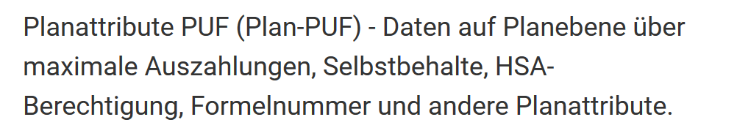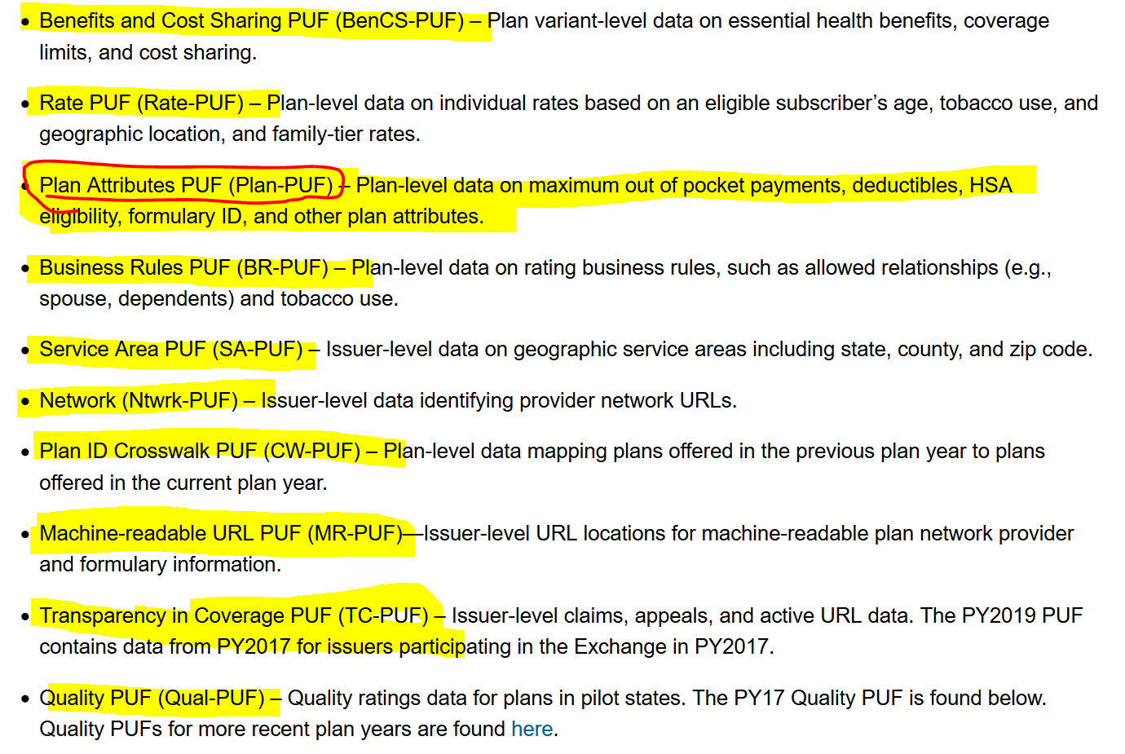

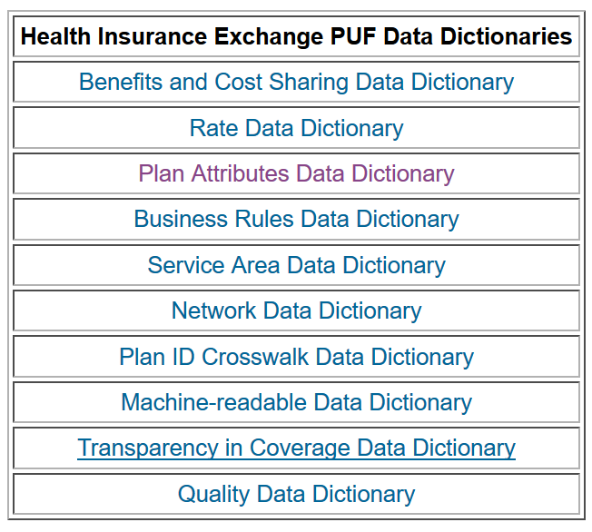

|  |  |
| --- | --- |
| Glossar | |
| Qualified Health Plans | An insurance plan that’s certified by the Health Insurance Marketplace, provides essential health benefits, follows established limits on cost-sharing (like deductibles, copayments, and out-of-pocket maximum amounts), and meets other requirements under the Affordable Care Act. All qualified health plans meet the Affordable Care Act requirement for having health coverage, known as “minimum essential coverage.” |
| Health insurance marketplace | In the [United States](https://en.wikipedia.org/wiki/United_States), health insurance marketplaces,[[1]](https://en.wikipedia.org/wiki/Health_insurance_marketplace#cite_note-1) also called health exchanges, are organizations in each state through which people can purchase [health insurance](https://en.wikipedia.org/wiki/Health_insurance_in_the_United_States). People can purchase health insurance that complies with the [Patient Protection and Affordable Care Act](https://en.wikipedia.org/wiki/Patient_Protection_and_Affordable_Care_Act) (ACA, known colloquially as "Obamacare") at ACA health exchanges, where they can choose from a range of government-regulated and standardized health care plans offered by the insurers participating in the exchange. |
| HMO | Hinter der Bezeichnung Health Maintenance Organizations (HMO) verbergen sich Netzwerke, die gleichzeitig Krankenversicherung sind und eigene Ärzte beschäftigen |
| PPO | Einen Alternativtyp mit wachsendem Marktanteil bilden die Preferred Provider Organizations (PPO), die es den Patienten erlauben, auch zu Ärzten zu gehen, die nicht dem Netzwerk angehören. Netzwerke wie HMOs und PPOs werden, da sie über reine Versicherungsleistungen weit hinausgehen, als Formen von Managed Care bezeichnet. |
| QHP | A qualified health plan (QHP) is a major medical health insurance plan that covers all the mandatory benefits of the Affordable Care Act (ACA or “Obamacare”). |
| SHOP | The Small Business Health Options Program (SHOP) helps businesses provide health coverage to their employees.  SHOP insurance is generally available to employers with 1-50 full-time equivalent employees (FTEs). If you have fewer than 25 employees, you may qualify for the Small Business Health Care Tax Credit, if you buy SHOP insurance. [Learn more about SHOP eligibility](https://marketplace.cms.gov/outreach-and-education/who-can-use-shop.pdf) rules and the [Small Business Health Care Tax Credit](https://www.healthcare.gov/small-businesses/provide-shop-coverage/qualify-for-shop-marketplace/).  If you're a sole proprietor or [self-employed](https://www.healthcare.gov/what-if-im-self-employed) with no employees, you can get individual coverage through the [Health Insurance Marketplace](https://www.healthcare.gov/marketplace/individual). |
| SADP | A type of dental plan offered through the Marketplace that’s not included as part of a health plan. You may want this if the health coverage you choose doesn’t include dental, or if you want different dental coverage. |
|  |  |
|  |  |
|  |  |
|  |  |
|  |  |

Die beiden öffentlichen Krankenversicherungssysteme, *Medicaid* und *Medicare*. Ersteres ist ein Programm für sozial Schwache, letzteres versorgt Rentner und Behinderte. In *Medicare* zahlen Sie, wenn Sie bei einem amerikanischen Arbeitgeber beschäftigt sind, zwar Beiträge ein, Leistungen können Sie vorläufig jedoch noch nicht in Anspruch nehmen.