SERVICE ORIENTED ARCHITECTURE
Smart Parking API
Final Project Documentation

Field | Details
Student | Besnik Emini
Technology | .NET 8 Web API
Database | SQL Server LocalDB
Project Type | RESTful Web API / Backend Service

Academic Year: 2025/2026

Table of Contents
- 1. Introduction
- 2. Project Scenario and Motivation
- 3. Related Work and Similar Systems
- 4. System Users and Roles
- 5. Functional Requirements and API Features
- 6. Technologies Used
- 7. Database Design and ER Diagram
- 8. System Architecture and Request Flow
- 9. DTOs and AutoMapper Implementation
- 10. Pagination, Sorting, and Filtering
- 11. Logging and Exception Handling
- 12. Unit Testing
- 13. Future Work
- 14. Conclusion

1. Introduction
The Smart Parking API is a RESTful Web API developed using .NET 8. The purpose of the project is to provide a backend service for managing parking lots, parking spots, users, and reservations. The API can be used by a website, mobile application, or admin dashboard that needs parking-related functionality.
The system follows the main concepts of Service Oriented Architecture because it exposes its functionality through independent HTTP endpoints. Other applications do not need to know how the database is implemented. They only need to send requests to the API and receive JSON responses.
The project was developed to demonstrate practical knowledge of Web API development, authentication, authorization, Entity Framework Core, DTOs, AutoMapper, repository pattern, pagination, sorting, filtering, logging, exception handling, third-party API integration, and unit testing.

2. Project Scenario and Motivation
The project scenario is based on a city parking company that wants to digitalize parking management. In a traditional parking system, drivers often waste time searching for available spaces, and parking owners may not have a centralized way to manage parking lots, parking spots, and reservations.
The Smart Parking API solves this problem by acting as the central backend system. It allows parking data to be stored in one database and accessed by different clients such as mobile applications, websites, and admin panels.
A typical usage scenario is the following:
- An administrator logs in and creates a parking lot.
- The administrator adds parking spots to that parking lot.
- A guest or user views available parking spots.
- A registered user logs in and creates a reservation.
- After the reservation is created, the parking spot becomes unavailable.
- The system can also provide weather information for a city through a third-party API.

3. Related Work and Similar Systems
Similar systems exist in many modern smart city applications. Parking applications usually allow users to search for parking locations, view available spaces, reserve a place, or pay for parking. Examples include mobile parking systems, smart garage management systems, and city parking applications.
The novelty of this project is not that it is a complete commercial smart parking platform, but that it demonstrates the backend structure required for such a system. It focuses on a clean RESTful API architecture, authentication, authorization, reusable DTOs, AutoMapper, database management, and external API integration.

4. System Users and Roles
The system uses role-based authorization. Different users have different permissions depending on their role.
Role | Capabilities
Guest | Can view parking lots, available parking spots, and weather information. No login is required for public information.
User | Can register, log in, and create/manage reservations after receiving a JWT token.
Admin | Can manage parking lots and parking spots, including create, update, and delete actions.

This separation is important because not every user should have permission to change parking data. For example, a normal user can make a reservation, but only an administrator can add or delete parking lots.

5. Functional Requirements and API Features
The Smart Parking API includes the following main features:
- User registration and login
- JWT authentication
- Role-based authorization
- CRUD operations for parking lots
- CRUD operations for parking spots
- Reservation creation, update, listing, and deletion
- Parking spot availability management
- Pagination, sorting, and filtering for parking lots
- Logging of important API actions
- Global exception handling middleware
- Third-party weather API integration
- Unit tests for controller behavior

Main API Endpoints
Method | Endpoint | Purpose
POST | /api/Auth/register | Creates a new user account.
POST | /api/Auth/login | Authenticates a user and returns a JWT token.
GET | /api/ParkingLots | Returns parking lots with optional pagination, sorting, and filtering.
POST | /api/ParkingLots | Creates a new parking lot. Admin role required.
GET | /api/ParkingSpots/available | Returns available parking spots.
POST | /api/Reservations | Creates a new reservation. Logged-in user required.
GET | /api/Weather/Skopje | Gets weather information for Skopje using an external API.

6. Technologies Used
Technology | Purpose
.NET 8 Web API | Main backend framework used to create RESTful endpoints.
Entity Framework Core | Used as ORM to communicate with the database.
SQL Server LocalDB | Local relational database used during development.
JWT Bearer Authentication | Used to secure protected endpoints.
Swagger / OpenAPI | Used to document and test API endpoints.
AutoMapper | Used to map models to DTOs and DTOs to models automatically.
Repository Pattern | Used to separate data access logic from controller logic.
Dependency Injection | Used to inject DbContext, repositories, loggers, AutoMapper, and HttpClient.
Open-Meteo API | Third-party API used for weather information.
xUnit, Moq, FluentAssertions | Used for unit testing.

7. Database Design and ER Diagram
The project uses a relational database with four main entities: Users, ParkingLots, ParkingSpots, and Reservations. Entity Framework Core creates and manages these tables through migrations.
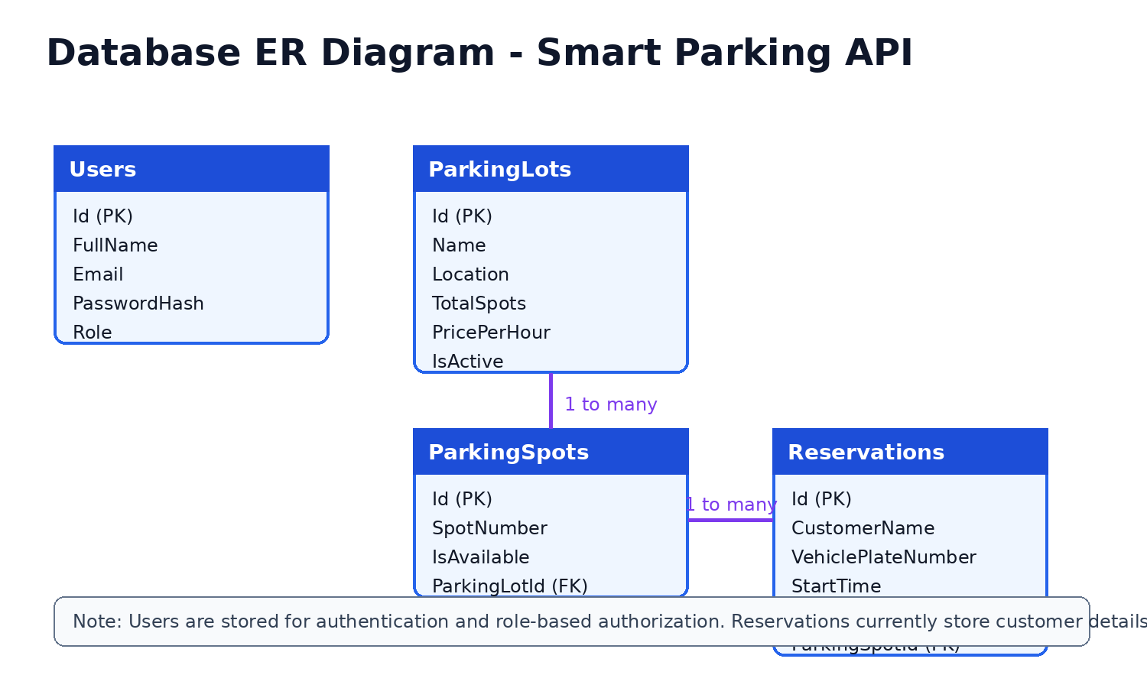

Database Entities
Entity | Description
Users | Stores account information such as full name, email, password hash, and role.
ParkingLots | Stores parking lot information such as name, location, total spots, price per hour, and active status.
ParkingSpots | Stores individual parking spaces and whether they are available. Each spot belongs to a parking lot.
Reservations | Stores reservation data including customer name, vehicle plate, start/end time, and parking spot ID.

8. System Architecture and Request Flow
The API is organized into layers. Controllers receive HTTP requests, DTOs carry request and response data, AutoMapper converts between DTOs and models, repositories handle database operations, and Entity Framework Core communicates with SQL Server LocalDB.
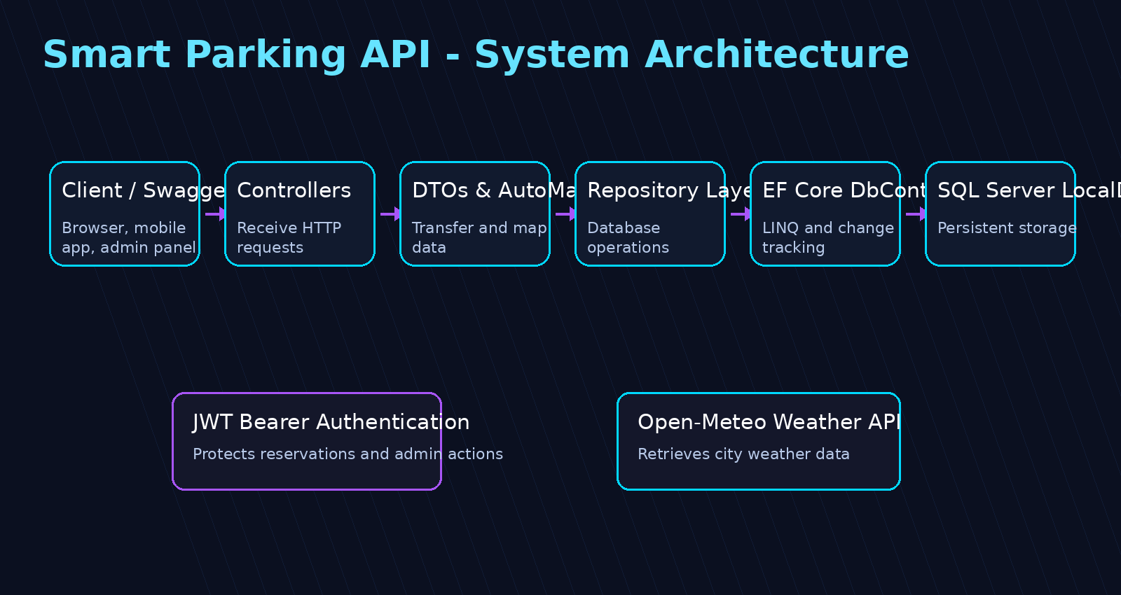

Request Flow Example
When a user creates a reservation, the system performs the following steps:
- The client sends a POST request to /api/Reservations.
- The controller receives the CreateReservationDto.
- The API checks if the end time is after the start time.
- The API checks if the parking spot exists and is available.
- AutoMapper maps the DTO to a Reservation model.
- The reservation is saved in the database.
- The parking spot is marked as unavailable.
- The API returns a JSON response to the client.

9. DTOs and AutoMapper Implementation
DTOs (Data Transfer Objects) are used to transfer data between the client and the API without exposing the full database models. This keeps the API cleaner and safer. For example, CreateParkingLotDto contains only the data needed to create a parking lot, while ParkingLotDto represents the response returned to the client.
AutoMapper is used because it was covered during lectures and it reduces repetitive manual mapping code. Instead of creating DTOs manually inside controllers, the project uses a MappingProfile class that defines how models and DTOs are converted.
Example mapping configuration:
CreateMap<ParkingLot, ParkingLotDto>();
CreateMap<CreateParkingLotDto, ParkingLot>();
CreateMap<ParkingSpot, ParkingSpotDto>();
CreateMap<CreateParkingSpotDto, ParkingSpot>();
CreateMap<Reservation, ReservationDto>();
CreateMap<CreateReservationDto, Reservation>();
Example controller usage:
var parkingLotDtos = _mapper.Map<IEnumerable<ParkingLotDto>>(parkingLots);
var parkingLot = _mapper.Map<ParkingLot>(createDto);

10. Pagination, Sorting, and Filtering
Pagination, sorting, and filtering are implemented for the ParkingLots endpoint. This is important when the database contains many parking lots because the client should not always request every record at once.
Parameter | Description
search | Filters parking lots by name or location.
sortBy | Sorts results by id, name, location, price, or total spots.
descending | Controls ascending or descending order.
pageNumber | Selects the requested page.
pageSize | Controls how many records are returned per page.

Example request:
GET /api/ParkingLots?search=Skopje&sortBy=price&descending=true&pageNumber=1&pageSize=5
This request returns parking lots related to Skopje, sorted by price in descending order, with only five records on the first page.

11. Logging and Exception Handling
Logging is implemented using the built-in ILogger interface. The API logs important events such as retrieving parking lots, creating parking lots, updating records, deleting records, and invalid requests.
Example logging statement:
_logger.LogInformation("Created parking lot with ID: {ParkingLotId}", createdParkingLot.Id);
Exception handling is implemented with a global ExceptionHandlingMiddleware. This middleware catches unexpected errors and returns a clean JSON response instead of exposing technical error details to the client. This makes the API safer and easier to maintain.
Example error response:
{ "statusCode": 500, "message": "An unexpected error occurred. Please try again later." }

12. Unit Testing
The project includes unit tests using xUnit, Moq, and FluentAssertions. The tests focus on the ParkingLotsController because it includes repository usage, DTO responses, pagination validation, and CRUD behavior.
Test Name | Purpose
GetParkingLots_ReturnsOk_WithParkingLots | Checks that the API returns OK when parking lots exist.
GetParkingLots_InvalidPageNumber_ReturnsBadRequest | Checks validation for invalid page number.
GetParkingLot_NonExistingId_ReturnsNotFound | Checks NotFound response for missing parking lot.
CreateParkingLot_ValidData_ReturnsCreatedAtAction | Checks that a valid create request returns CreatedAtAction.
DeleteParkingLot_NonExistingId_ReturnsNotFound | Checks NotFound response when deleting missing parking lot.

The test result was: total 5 tests, failed 0, succeeded 5. This confirms that the tested controller behavior works as expected.

13. Future Work
The current version focuses on the backend API. In the future, the system could be expanded with:
- Mobile application integration for Android and iOS users.
- Camera-based or IoT sensor detection for real-time parking spot occupancy.
- Payment gateway support for online parking payments.
- Email or push notifications for reservation updates.
- Admin dashboard with charts and analytics.
- Cloud deployment using Azure, AWS, or another hosting provider.
In a real-world deployment, the API would be hosted on a cloud server and connected to a cloud database. Mobile apps, websites, and admin dashboards could then communicate with the same centralized API.

14. Conclusion
The Smart Parking API provides a modern backend solution for parking management. It allows users to search parking lots and available spots, create reservations, and use protected endpoints through JWT authentication. Administrators can manage parking lots and parking spots through role-based authorization.
The project demonstrates the main requirements of the course, including RESTful API development, Entity Framework Core, SQL Server LocalDB, DTOs, AutoMapper, repository pattern, dependency injection, pagination, sorting, filtering, logging, exception handling, third-party API integration, and unit testing.
Overall, the project shows how a Service Oriented Architecture can be used to create a reusable backend service that can support different clients such as websites, mobile applications, and admin dashboards.

