https://github.com/bespokewd1/nocdashboard
This is the idea, to make it simpler, let's follow the layout here
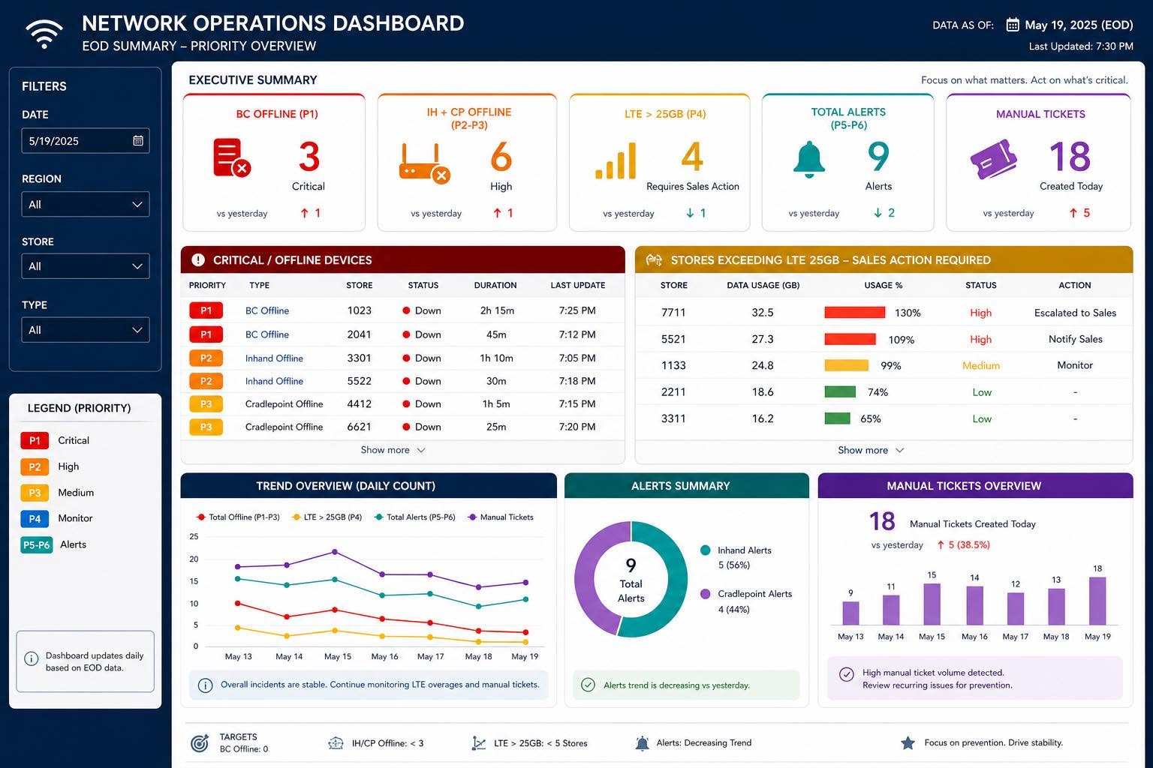

Dashboard Goal
Create a modern dashboard that provides quick, clear data insights for executives, sales teams, and IT operations.
This is a cross-team collaboration tool designed for quick understanding of operational status, specifically for quick service restaurant (QSR) management environments.
The goal is to improve visibility and decision-making speed across teams.

Data Source (Initial Phase)
Initially, all data will come from Excel files (or CSV exports).
- Data is sourced from external systems
- There is currently no API available
- We need an efficient way to input and update data

Preferred input methods:
- CSV/Excel file upload (preferred for speed and simplicity)
- Optional CMS-based manual entry for specific updates or notes
File upload should be the primary workflow.

Future Phase (Scalability)
In the future, if API access becomes available:
- The system should support real-time data ingestion
- Existing dashboard UI should not require changes
- Data layer should be easily replaceable (Excel → API)

Design Reference
A simple reference image has been provided. The design should remain clean and straightforward, focused on clarity rather than complexity.

📊 Sample Data Structure

Priority 1 — Business Central Offline (PBX)
- PBX refers to the store phone system
- Indicates critical communication outage

Priority 2 — InHand Offline
- InHand is a backup cellular device
- Used for failover connectivity

Priority 3 — Cradlepoint Offline
- Cradlepoint is a backup network router/device
- Indicates backup connectivity failure

Priority 4 — Stores on LTE Backup
- These stores have lost primary internet connectivity
- System automatically switches them to LTE backup
- LTE usage must be tracked (data consumption monitoring is important)

Priority 5 — CP and InHand Alerts
- Represents intermittent connectivity issues
- Often causes:
  - Increased data usage
  - Temporary service disruption
  - Poor VoIP call quality
  - Network instability

🎯 Key Requirement
The dashboard should allow users to quickly understand:
- What is down
- How many stores are affected
- Severity of issues
- Network or device type causing the issue
- Overall operational status at a glance

Try looking for NOC dashboard templates, or test with Claude or any AI tool and link it to the repository. If none are available, you can use your own judgment and design.
Gemini is able to generate an image like the one above, and it already looks clean. We just need something similar to that.
Please push the updates, and I will publish it by tomorrow so we can review it.
Mock Data:
Here's a mock data that's usually in the report, just download it as csv then that's what's needed to be uploaded, once we have nice dashboard and get approved, we can use real data as next
https://docs.google.com/spreadsheets/d/1ckdpzRVKXjXywFZQNhpkSZu7VD66zecTPDqUoVulZ_0/edit?usp=sharing

